Measuring the Resilience of Ireland’s Seafood Sector

Contents
Preface: 12
Reconciling the Two Resilience Frameworks 12
1 Towards a Conceptual Foundation for Sectoral Resilience Assessment 15
1.1 How the IPCC Risk Framework Has Evolved 15
1.2 Applying the Framework Beyond Climate Change 16
1.3 Why This Framework for This Sector 17
1.4 Connecting Risk Assessment to Resilience Assessment 18
1.5 Two Traditions of Resilience Thinking 18
1.6 Resilience as a Multi-Dimensional Capacity 19
1.7 From Risk Equations to Resilience Indices 19
1.8 Hallegatte's Welfare-Risk Framework 20
1.8.1 External Validation: Hallegatte et al. (2017), Unbreakable 22
1.9 Instantaneous and Dynamic Resilience – a worked example. 22
1.10 Resilience as a Policy Lever 23
1.11 The Independence of Rmacro and Rmicro 24
1.12 Implications for the Framework 25
1.12.1 Retention Rate as a Unified Measurement Principle 26
1.13 Mapping to the Multi-Scale Index Architecture 26
2 Measuring Resilience in Practice 28
2.1 How existing BIM reports and the survey feed the analysis 29
2.2 Section A: Port-level resilience (Rmacro) from the Port Report 29
2.2.1 Purpose and starting point 29
2.2.2 Source figures from the BIM Port Report 30
2.2.3 Channel 1: Processing loss 30
2.2.4 Channel 2: Ancillary loss 32
2.2.5 Channel 3: Household loss (induced) 32
2.2.6 Result: aggregate consumption loss and Rmacro 33
2.2.7 What future Port Reports could capture to make Rmacro direct 33
2.3 Section B: Vessel-level resilience (Rmicro) 34
2.3.1 Hallegatte's welfare mechanism, mapped to the fishery 35
2.3.2 Deriving the Hallegatte welfare loss 35
2.3.3 Applying Hallegatte to a single vessel 36
2.3.4 Vessel A: RSW-Pelagic 37
2.3.5 Vessel B: Tier 1 polyvalent. 37
2.3.6 Vessel C: Polyvalent whitefish 38
2.3.7 The 2026 convergence 40
2.4 Result: the same shocks, three outcomes 40
2.5 Sources and assumptions 41
3 Measuring Vessel-Level Resilience: STORI and LTCRI 42
3.1 Introduction 42
3.2 Conceptual Framework 42
3.2.1 The Share System and Shock Transmission Mechanism 43
3.3 3.3 Scoring Principle: Retention Rates 44
3.4 Short-Term Operational Resilience Index (STORI) 45
3.4.1 Definition and Rationale 45
3.4.2 Component Measures 45
3.4.3 Composite Formula and Weightings 46
3.5 Long-Term Capital Resilience Index (LTCRI) 47
3.5.1 Definition and Rationale 47
3.5.2 Component Measures 47
3.5.3 Composite Formula and Weightings 48
4 The Fleet Survey: Linking Theory to Evidence 50
4.1 Introduction 50
4.2 Part A: Why the Survey is Needed 50
4.3 Survey Structure and Theoretical Alignment 51
4.4 Capturing the Past: The Survey's Historical Shock Module 52
4.4.1 Design Rationale 52
4.4.2 The Shock Catalogue 52
4.4.3 The Impact Assessment Module 53
4.4.4 Connecting Historical Experience to the Worked Examples 53
4.5 Looking Forward: Future Hazards and Prospective Risk 54
4.5.1 Connecting Future Hazards to the Analytical Aims 55
4.5.2 Climate Hazards and the Ecological Resilience Challenge 55
4.6 Role of Public Support: Grant Aid, Training, and Technical Services 56
4.6.1 Support Programmes as Rmicro Policy Levers 56
4.6.2 What the Survey Measures and What It Enables 56
4.6.3 Industry Self-Help: Section E 57
4.7 Deriving the Resilience Indices: STORI and LTCRI 57
4.7.1 Measurement Principle 57
4.7.2 The Short-Term Operational Resilience Index (STORI) 57
4.7.3 The Long-Term Capital Resilience Index (LTCRI) 58
4.7.4 The Vulnerability Quadrant Framework 59
4.8 Survey Analysis 61
4.8.1 Actions Taken in Response to Shocks (Aim i) 61
4.8.2 Patterns and Trends in Shock Impacts (Aim ii) 62
4.8.3 Break-Even Revenue Analysis 62
4.8.4 Future Shock Simulation (Aim iv) 62
4.8.5 Critical Thresholds and Early Warning Indicators (Aim v) 63
4.9 Part B: Results 63
4.9.1 Resilience indices and cross-set themes: the pooled returns (Section G) 64
4.10 Past shocks: severity and recovery (Section B) 65
4.11 Methodology: how severity and priority are calculated 65
4.12 Future shocks: likelihood, concern and priority (Section F) 68
4.13 The persistent shocks: past impact and future worry 70
4.14 Resilience Indices 71
4.15 Short-term operational resilience (STORI): the evidence pooled 72
4.15.1 ST4 Fishing activity retention (days at sea) 73
4.15.2 ST1 Gross profit retention 73
4.15.3 ST2 Crew wage retention, and the share-system channel 73
4.15.4 ST5 Crew retention, and the minimum-manning threshold 74
4.15.5 ST3 Financial independence (short-term borrowing) 74
4.15.6 ST6 Recovery speed 74
4.16 Long-term capital resilience (LTCRI): the evidence pooled 74
4.16.1 LT1 Net profit retention 75
4.16.2 LT2 and LT3 Loan term and debt structure 75
4.16.3 LT4 Vessel renewal timeline 75
4.16.4 LT5 Asset value retention 75
4.16.5 LT6 Investment plan retention, and deferred maintenance 76
4.17 Reading the returns through the vulnerability quadrant 76
4.18 Cross-set resilience themes 77
4.18.1 A common shock spine: Brexit, Hague Preferences and quota 77
4.18.2 The share system as shock amplifier 77
4.18.3 Crew and generational renewal as a binding, non-financial constraint 78
4.18.4 Climate-driven stock redistribution and the spatial squeeze 78
4.18.5 Public support judged misdirected rather than merely insufficient 78
4.18.6 Adaptation: consolidation, diversification and value capture 79
4.18.7 Institutional and structural risk above the vessel 79
4.19 What the set implies for the STORI and LTCRI framework 79
4.20 Conclusion 81
5 Resilience in the Processing and Aquaculture Sectors 83
5.1 Methodology employed for the industry consultation 83
5.2 Selection of industry participants 83
5.3 Profile of the participants 85
5.4 Design of the survey instruments 88
5.4.1 Overview of the rationale underpinning the Survey Questionnaire structure 88
5.5 Results and discussion arising from the industry consultations 89
5.6 Part 1. Seafood Processing 90
5.6.1 The Retrospective view 90
5.6.2 Focussing on the shock ranked as Number 1 by the Irish Seafood Processors: Brexit 91
5.6.3 Summary of the insights on the impacts of Brexit gained from the industry consultation 96
5.7 Responses by the Seafood Processors to the Brexit shock 96
5.7.1 New Markets 96
5.8 Focussing on the shock ranked as Number 2 by the Irish Seafood Processors: Covid 19 99
5.9 Summary of the insights on the impacts of Covid 19 gained from the industry consultation 104
5.10 Analysis of the Irish seafood processors’ responses to Covid 19. 105
5.10.1 Summary of the insights on the responses of the Irish seafood processors to Covid 19 gained from the industry consultation 107
5.11 Focussing on the shock ranked as Number 3 by the Irish Seafood Processors: The Great Economic Depression (GED) of 2010 108
5.11.1 Financial Impacts of GED2010 108
5.11.2 Summary of the financial impacts 109
5.11.3 Summary of the general marketing and logistics impact of GED 2010 110
5.11.4 Summary of the general marketing and logistics impact of GED 2010 110
5.11.5 Summary of the actions taken by the processors in response to the GED 2010 111
5.11.6 Summary of the actions taken by the seafood processors in response to the GED 2010 111
5.12 General Summary Seafood Processing 112
5.13 Seafood Processing 112
5.13.1 A qualitative, semi-quantitative review of state-led actions to mitigate the impacts of the shocks 112
5.14 Seafood Processing: The prospective view emerging from the Irish seafood processing sector 114
5.14.1 Probability of recurrence and potential severity of impact 114
5.14.2 1.2.4 Likelihood 114
5.15 Severity of Impact 115
5.15.1 Preparedness (Adaptive Capacity) of Seafood Processors for Future Shocks 115
5.15.2 Climate Change 117
5.15.3 Future management of Human Resources 118
5.16 Business Sentiment 119
5.17 Part 2. The Aquaculture Sector 120
5.18 Part 2A: Resilience within the Irish Farmed salmon sector 120
5.18.1 The Retrospective view – Salmon Farming 120
5.19 Summary 124
5.20 The prospective view emerging from the Irish Salmon Farming Sector 125
5.20.1 Probability of recurrence and potential severity of impact 125
5.21 An evaluation of the level of Preparedness (adaptive capacity) of the respondents 127
5.22 Salmon Growers attitude towards Climate Change 128
5.23 Summary of findings from the farmed salmon sector 131
5.24 Resilience in the Irish Oyster Farming Sector 131
6 Part 3 CREST Bio-economic Model 165
6.1 Purpose and scope 165
6.1.1 Model class and architecture 165
6.1.2 Relation to established bio-economic frameworks 165
6.1.3 Equilibrium scope 166
6.1.4 Shocks, resilience and validation 166
6.2 Biological Module 168
6.3 Stock-level TAC and landings-volume projection 170
6.3.1 Introduction 170
6.3.2 TAC projection 172
6.3.3 Estimating the EU Quota 174
6.3.4 Estimating the Irish Quota 175
6.3.5 Landings-volume projection 175
6.3.6 Outputs and the link to the bycatch-ratio bridge 177
6.3.7 Hand-off to next module 178
6.3.8 Editable parameters and scenario configuration 179
6.3.9 Summary 179
6.4 A bycatch-ratio bridge from assessed to total landings value 179
6.4.1 Introduction 179
6.4.2 Segmentation 180
6.4.3 Functional form 180
6.4.4 Interpretation 182
6.4.5 Calibration 182
6.4.6 Uncertainty quantification 183
6.4.7 Editable parameters and scenario configuration 184
6.4.8 Outputs and the link to the fleet allocation module 184
6.4.9 Limitations 185
6.4.10 Summary 185
6.5 A bio-economic allocation framework for the Irish capture fleet 186
6.5.1 Introduction 186
6.5.2 Fleet partition and aggregation 186
6.5.3 Catch production function 187
6.5.4 Calibration of catchability 188
6.5.5 Effort projection 188
6.5.6 Allocation and reconciliation 189
6.5.7 Out-of-sample validation 190
6.5.8 Properties and limitations 190
6.5.9 Position in the bio-economic literature 191
6.5.10 Summary 192
6.6 A biomass-indexed days-at-sea forecast for the Irish capture fleet 192
6.6.1 Introduction 192
6.6.2 Fleet partition and catchability 193
6.6.3 Catch production function 193
6.6.4 Catchability calibration 194
6.6.5 Effort closure: the basket-CPUE rule 194
6.6.6 Effort closure: the TAC-inversion rule 194
6.6.7 Price-independent effort inversion: separation of volume and revenue 195
6.6.8 Choice of effort closure method and reference-year calibration 196
6.6.9 Converting from kWFD to days at sea 196
6.6.10 Cross-method consistency check 197
6.6.11 Worked example: 2024 forecast under TAC-inversion 197
6.6.12 Analyst note: selection of TAC-inversion as the preferred closure method 198
6.6.13 Goodness-of-fit analysis 199
6.6.14 Final output table 199
6.6.15 Out-of-sample validation 199
6.6.16 Properties and limitations 200
6.6.17 Summary 200
6.7 Fleet-level cost - profitability forecast 200
6.7.1 Introduction 200
6.7.2 Notation 201
6.7.3 Variable cost scaling 201
6.7.4 Non-variable costs 202
6.7.5 Opportunity cost of capital 202
6.7.6 Total costs and gross profit 203
6.7.7 Baseline calibration 203
6.7.8 Projection periods and exogenous inputs 203
6.7.9 Segments covered 203
6.7.10 Ex-vessel price of North-East Atlantic mackerel 203
6.7.11 Properties and limitations 205
6.7.12 Summary 206
6.8 Port-level allocation of projected fisheries landing value 206
6.8.1 Introduction 206
6.8.2 Port coverage 207
6.8.3 Port allocation shares 207
6.8.4 Static share assumption 208
6.8.5 Calibration and validation 208
6.8.6 Downstream use: Killybegs regional impact module 209
6.8.7 Outputs 209
6.8.8 Limitations 210
6.8.9 Summary 210
6.9 Linking to Socio-economic estimates 210
7 Response Effectiveness, Roadmap and Recommendations 211
DRAFT - INCOMPLETE 211
7.1 Grading the Effectiveness of Responses 211
7.2 A Roadmap of Actions for Future Shocks 211
7.3 Policy Recommendations 212
7.4 A Tiered Menu of Resilience Instruments 212
8 References 214
9 Appendices 217
9.1 List of Contributors – Seafood Processing 217
9.2 List of Contributors – Aquaculture 218

Preface:
The Irish seafood sector, including the fleet, aquaculture sector, ports, and the processing and ancillary businesses that depend on them, operates in an environment of repeated and often unpredictable disruption. Fuel price spikes, quota cuts, regulatory change, storms, disease, and trade shocks such as Brexit and Covid have each, in turn, tested the sector's ability to absorb a blow and keep functioning. The central question this report addresses is how well placed the sector is to withstand such shocks, and what would make it stronger. That capacity to absorb disturbance, recover, and adapt is what we mean by resilience.
This is the second of two reports commissioned by Bord Iascaigh Mhara (BIM) to examine that question. The first, a scoping study (Keatinge, 2024), asked what resilience means for the seafood sector and how it might be assessed. This report, the second phase, builds a practical framework for measuring it. The remainder of this preface explains how the two reports fit together, so that a reader can see where the ideas come from and how they have developed.
The Phase 1 scoping study established the groundwork in three ways. It set out a taxonomy of the shocks facing the sector (supply, demand, policy, biological, technology, and financial), it introduced engineering resilience (Reng) and ecological resilience (Reco) as complementary lenses, and it demonstrated resilience thinking qualitatively through three case studies: fleet exposure during fuel crises, the regulatory shock of the EU driftnet ban on the tuna fleet, and the farmed shellfish sector during Covid. Phase 1 concluded by recommending a second phase: a more systematic vulnerability assessment that would apply this case-study method across the range of shocks the sector faces, among them spatial squeeze and climate change.
This report is that second phase. Where Phase 1 was descriptive and illustrative, Phase 2 is quantitative and predictive. It takes the same concepts and makes them measurable, comparable across scales, and capable of supporting forward planning. The shock taxonomy of Phase 1 becomes the hazard dimension of a formal risk decomposition. The qualitative resilience of the Phase 1 case studies becomes a set of measurable indices, each scored on a simple “retention rate” or the share of pre-shock function a vessel, port, or sector keeps after a shock, where 100% is full retention and 0% is total loss, which is simply the plain-language form of the macroeconomic (R_{macro}) and microeconomic (R_{micro}) resilience terms introduced in Chapter 1- so that resilience can be calculated, compared across scales, and tracked over time. This retention-rate principle is set out in full in Chapter 1.
The two reports use compatible language. The robustness emphasised in Phase 1, the avoidance of permanent damage, is captured in Phase 2 by a long-term capital resilience index (LTCRI) developed for the project. The vulnerability assessment recommended in Phase 1 is operationalised in Phase 2 through the Intergovernmental Panel on Climate Change (IPCC) decomposition of risk into hazard, exposure, and vulnerability, with resilience embedded in the adaptive-capacity component of vulnerability. A reader moving from one report to the other should find the concepts continuous, even though the second report expresses them in a more formal vocabulary.

Reconciling the Two Resilience Frameworks
This report draws on two distinct resilience frameworks, and it is important to be clear that they are complementary rather than competing. They describe different properties of the same system, and they combine rather than substitute for one another.
Holling's distinction between engineering resilience (Reng) and ecological resilience (Reco) was introduced in the first reliance report and concerns the nature of the system's recovery. Engineering resilience is the capacity to absorb a temporary shock and bounce back to the pre-shock equilibrium. Ecological resilience is the capacity to withstand a disturbance without being pushed across a threshold into a different, and often permanently worse, state (for example decommissioning or the permanent closure of a processing plant or fish farm). Holling's axis therefore distinguishes bounce-back from regime-shift.
Introduced in Chapter 1, Hallegatte's distinction between macroeconomic resilience (Rmacro) and microeconomic resilience (Rmicro) represents a second but equally important resilience framework but one that concerns the scale at which resilience operates. Macroeconomic resilience is the capacity of the wider system, in this report the port and the sector, to prevent a direct loss from cascading into broader economic damage. Microeconomic resilience is the capacity of the individual unit, the vessel or the farm, to prevent an aggregate shock from translating into disproportionate welfare harm. Hallegatte's axis therefore distinguishes the system scale from the unit scale.
Because one axis describes the nature of recovery and the other describes the scale of resilience, the two may be thought of as perpendicular: every resilience capacity has both a Holling character and a Hallegatte scale. This produces a simple grid. A vessel that absorbs a temporary fuel spike and recovers the following season is exhibiting engineering resilience at the micro scale; a vessel pushed past its viability threshold into crew loss, debt, and exit (decommissioning) is exhibiting an ecological regime-shift at the micro scale. The same two outcomes, bounce-back and regime-shift, occur at the macro scale when a port either recovers once landings normalise or settles permanently into a smaller economy (for example after Brexit). The indices developed in this report populate this grid directly: the short-term operation resilience index (STORI) measures engineering resilience at the vessel level, while the proposed long-term capital resilience index (LTCRI) is designed to measures the ecological (structural) dimension at the vessel level. The proposed Port and Sectoral Resilience Indices carry the same logic to the macro scale.
Finally, the term “socioeconomic resilience” is central to this report. This is simply Hallegatte's two components combined. Overall socioeconomic resilience is the product Rmacro × Rmicro, and it is this product that appears as the divisor in the welfare risk equation, W = direct loss ÷ (Rmacro × Rmicro). It is not a third, separate form of resilience but the total amount by which the two scales together reduce welfare harm. The connection to Holling is therefore both technical as well as conceptual: as resilience falls and the amplification factor 1/Rmicro rises above one, the system crosses precisely the elasticity threshold that Holling described as the boundary between recovery and regime-shift. Hallegatte's framework quantifies the welfare arithmetic; Holling's framework characterises the qualitative tipping point. They are two views of the same event.
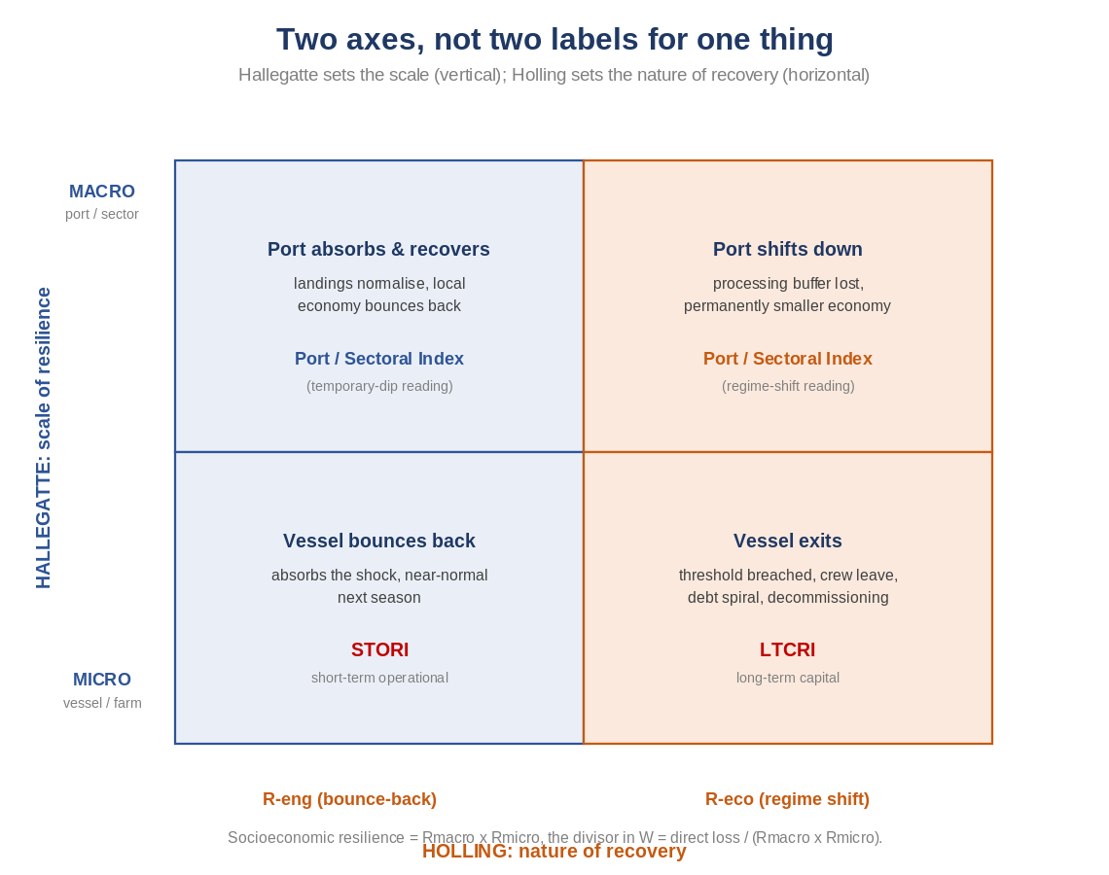
Figure 1 The two resilience frameworks combined. Hallegatte's axis sets the scale (macro/micro); Holling's axis sets the nature of recovery (engineering/ecological). The four indices populate the grid.

Towards a Conceptual Foundation for Sectoral Resilience Assessment
A comprehensive assessment of risk and resilience in a complex sector like seafood requires a framework that is both analytically sound and flexible enough to accommodate the full range of threats the sector faces. The risk framework developed by the Intergovernmental Panel on Climate Change (IPCC), refined across successive assessment cycles and most recently updated in the Sixth Assessment Report (AR6), provides exactly this capability.
This chapter advocates for the adoption and extension of the IPCC AR6 risk framework as the organising structure for a comprehensive resilience assessment of Ireland's seafood sector. Building on the Phase 1 scoping study (Keatinge, 2024), we integrate two complementary measures of resilience: engineering resilience (R_{eng}), the ability to return to equilibrium after temporary perturbation; and ecological resilience (R_{eco}), the capacity to absorb disturbance without shifting into an alternative configuration. We then embed these measures within the broader IPCC framework to create a unified system in which the identification of future threats, the assessment of who and what is at risk, and the measurement of adaptive capacity are all conducted within the same analytical structure and expressed in the same language.

How the IPCC Risk Framework Has Evolved
The IPCC's understanding of climate-related risk has evolved substantially over the past two decades, shifting from a vulnerability-focused approach to one that explicitly decomposes risk into three interacting components (see figure) . In the Third and Fourth Assessment Reports (TAR 2001, AR4 2007), the focus was on vulnerability as a single concept encompassing exposure, sensitivity, and adaptive capacity (panel a below). This approach had practical limitations: it did not clearly separate the characteristics of the system at risk from the external drivers of that risk.
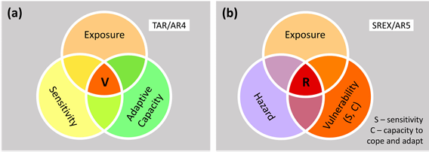
For example, under the older approach a port might be described simply as "highly vulnerable to fuel price shocks." That single judgement bundles together two distinct things: the severity and frequency of the fuel spikes (an external driver) and the fleet's own fragility, such as ageing fuel-hungry engines and thin margins (a characteristic of the system at risk). Because the two are merged, the assessment cannot say whether the port is at risk because the hazard is unusually severe or because the fleet is unusually ill-equipped to absorb it, even though the two diagnoses call for very different responses. The later decomposition into hazard, exposure, and vulnerability separates the external driver from the system's characteristics, making that distinction explicit (panel b).
The Special Report on Managing the Risks of Extreme Events and Disasters (SREX 2012) and Fifth Assessment Report (AR5 2014) thus marked a significant shift. These reports moved the analytical focus from vulnerability to risk itself, expressing risk as a function of three distinct components: hazard, vulnerability, and exposure. The key change was treating exposure as a separate dimension rather than incorporating it within vulnerability. Here exposure is the presence of people, assets, and livelihoods in settings that could be adversely affected.
The AR6 (2021–2022) retained this tripartite structure and refined it further. Risk is defined as "the potential for adverse consequences for human or ecological systems, recognising the diversity of values and objectives associated with such systems." Crucially, AR6 recognises that hazard, vulnerability, and exposure are not fixed quantities but change over time (and space) in response to exogenous changes like climatic trends, or socio-economic development, or even human decision-making. AR6's most significant evolution, however, is to extend the concept of risk to cover not only the impacts of a shock (for example climate change in the case of the IPC) but also the responses to it (Reisinger et al., 2020). A response introduced to manage one risk can generate a second, distinct risk through trade-offs or negative side-effects on other objectives.
A Marine Protected Area illustrates the point: designating an MPA to protect a vulnerable seabed habitat is a sound conservation response to an ecological impact risk, but the closure generates a separate response risk for the fishing fleet, which loses access to those grounds, must steam further to alternatives, or crowds into the remaining open areas. The first is an impact risk; the second is a response risk, and AR6 brings both under a single analytical concept. This matters for the seafood sector, where many of the most consequential shocks (MPAs, offshore renewable energy zones, decommissioning and effort-reduction schemes) are regulatory responses rather than direct (e.g. climate) impacts. The framework's treatment of responses makes it not just a descriptive tool but a practical instrument for managing risk.

Applying the Framework Beyond Climate Change
Although developed primarily for climate change impacts, the IPCC framework's analytical logic generalises well. The decomposition of risk into hazard, vulnerability, and exposure can accommodate any class of shock (climatic, regulatory, economic, or geopolitical), provided that the hazard can be defined, exposed elements identified, and vulnerabilities characterised.
The Irish fishing fleet and broader seafood sector face a convergence of hazard types that few other primary production sectors experience simultaneously:
- Climate-related hazards: ocean warming, acidification, shifts in species distribution, and increasing storm frequency, all affecting fish stock abundance, availability, and catchability.
- Regulatory hazards: changes to Total Allowable Catches (TACs), quota allocations, the post-Brexit loss of Hague Preferences, and the expanding designation of Marine Protected Areas (MPAs) and Offshore Renewable Energy (ORE) zones.
- Economic hazards: fuel price volatility, market disruptions, inflationary cost pressures, and shifts in global trade patterns.
These hazards do not act in isolation. They interact and compound: a quota reduction coinciding with elevated fuel costs and reduced market access can produce cascading effects that single-hazard assessments would miss. The framework's insistence on specifying what is exposed, and to which hazards, pushes analysis beyond aggregate sectoral statistics toward the granular, differentiated reality of individual vessels and port communities.
Consider Brexit as a worked illustration of how the three components apply to a non-climatic shock. The hazard is the regulatory and trade rupture set in train by the UK's departure from the EU. In concrete terms, it is the quota transfers and loss of access negotiated under the Trade and Cooperation Agreement, a discrete, datable event with a definable magnitude (the share of each stock reallocated away from the Irish fleet), exactly the properties the framework requires of a hazard.
The exposure is the set of people, assets, and livelihoods standing in the path of that hazard: the Irish vessels, the licensed enterprises whose access to publicly owned quota is shared out by the state, the crews, and the processing businesses dependent on the stocks and waters affected by the reallocation. Exposure here is differentiated and measurable. The pelagic fleet landing mackerel and horse mackerel, and the demersal vessels reliant on transferred whitefish quotas (including Hague transfers), sit squarely in the path of the shock, while a vessel targeting unaffected inshore shellfish is barely exposed at all.
Vulnerability in this context is shaped by operational factors (vessel age, fuel efficiency, gear adaptability), economic factors (profit margins, debt levels, species concentration), social factors (crew availability, skipper age, succession planning), and governance factors (access to support programmes, institutional responsiveness, regulatory predictability). The share system, the distinctive mechanism by which revenues are divided between vessel owners and crew, acts as both a shock absorber and a transmission mechanism, distributing the impact of reduced landings value across stakeholders while potentially pushing crew wages below viable thresholds.
Ultimately vulnerability is the propensity of each exposed enterprise to be harmed, and will reflect both its sensitivity and its adaptive capacity. Sensitivity is set by how concentrated the enterprise is on the transferred quotas: a vessel deriving most of its income from a single reallocated stock (for example mackerel) loses a large share of its earnings, while a diversified vessel loses little. Adaptive capacity is set by what the enterprise can do in response: switch to alternative species, fish different grounds, or draw on financial reserves to bridge the transition. A highly specialised, heavily indebted pelagic vessel is therefore both highly sensitive and low in adaptive capacity, making it acutely vulnerable; a diversified, well-capitalised polyvalent vessel facing the same hazard and similar exposure is far more resilient.
None of these elements involves a climatic driver, yet the hazard, exposure, and vulnerability decomposition organises the analysis exactly as it would for a marine heatwave or fuel cost spike, or an acidification trend. This is precisely the generality the framework claims, and it is what allows a single analytical structure to span the full range of shocks the seafood sector faces.

Why This Framework for This Sector
Four considerations motivate the adoption of the IPCC AR6 framework:
- Common analytical language: It connects the resilience of the Irish seafood sector to international discourse on climate adaptation and risk management, supporting dialogue with EU policy frameworks.
- Policy entry points: The decomposition of risk into hazard, exposure, and vulnerability creates distinct intervention pathways. Hazards can be mitigated, exposure reduced, and vulnerability addressed through different instruments.
- Dynamic change: The framework's treatment of temporal change and the role of responses fits the forward-looking orientation of this assessment, which measures current resilience while identifying pathways to stronger resilience under future conditions.
- Multi-scale flexibility: The framework accommodates the multi-scale architecture of this report, which operates across vessel, port, and sectoral levels, each with its own hazard-exposure-vulnerability profile.
The remainder of this report operationalises the framework through a suite of quantitative resilience indices spanning vessel-level indices (STORI and LTCRI), a Port Resilience Index, and a Sectoral Resilience Index that translate the components of the IPCC risk model into measurable, policy-relevant indicators grounded in the realities of Ireland's seafood sector.

Connecting Risk Assessment to Resilience Assessment
The IPCC AR6 risk framework is a powerful tool for identifying the sources of risk facing a system. However, the central concern of this assessment is not risk-identification but resilience measurement: the capacity of the Irish seafood sector to absorb, recover from, and adapt to the shocks and stresses it faces.
In the IPCC AR6 framework, resilience is not a fourth component of risk alongside hazard, exposure, and vulnerability. Instead, it is embedded within and forms the active counterpart of the vulnerability dimension. AR6 defines vulnerability as the propensity or predisposition to be adversely affected, encompassing a) sensitivity to harm and b) lack of capacity to cope and adapt. A system with high adaptive capacity is less vulnerable; one with low adaptive capacity is more vulnerable. Resilience, understood as the capacity to maintain essential function in the face of disturbance or to recover and reorganise after disruption, operates along the same axis.
This relationship has a critical implication for assessment design. A risk assessment that characterises hazards and exposure but treats vulnerability as a static property will identify where risk exists but offer limited guidance for action. A resilience assessment opens the vulnerability component and examines the dynamic capacities (operational, financial, social, institutional) that determine whether a system buckles under pressure or bends and recovers. This capacity-oriented perspective makes resilience assessment inherently actionable and useful for policy.

Two Traditions of Resilience Thinking
Resilience is not unidimensional or uniform. This report draws deliberately on two major intellectual traditions: the distinction between engineering resilience (R_{eng}) and ecological resilience (R_{eco}), first established by Holling (1973).
Engineering resilience focuses on a single equilibrium state and measures how quickly a system returns to that equilibrium after perturbation. It is about stability, speed of recovery, and maintaining predictable performance. For a fishing vessel, this addresses short-term operational concerns: when a fuel price shock compresses margins, how rapidly can the vessel adjust (through altered fishing patterns, reduced steaming distances, or gear switching) to restore viable profitability?
Ecological resilience takes a different view. Rather than assuming a single equilibrium, it recognises multiple possible system states and defines resilience as the magnitude of disturbance a system can absorb before shifting into an alternative configuration, potentially one from which return is difficult or impossible. This maps onto longer-term structural challenges: can a vessel enterprise sustain its capital investment cycle, renew its assets, and hold its place in the industry when confronted with the cumulative pressure of declining quotas, an ageing fleet, rising regulatory costs, and shifting species distributions?
Zampieri (2021) has demonstrated the mathematical equivalence of these two definitions under certain conditions: when perturbations are measured by their return period, ecological and engineering measures of resilience converge. This theoretical backing supports a framework that integrates both short-term operational recovery and long-term structural persistence within a single assessment architecture.

Resilience as a Multi-Dimensional Capacity
The broader resilience literature identifies three core attributes that describe a system's full response trajectory to adversity (Grafton et al. 2019):
- Resistance: the ability to maintain functionality during a shock
- Recovery: the process of returning toward pre-shock performance
- Robustness: the degree to which permanent damage is avoided
Asheim et al. (2020) emphasise that resilience is fundamentally a process concept, revealed in what happens after an adverse event rather than in the static characteristics of the system before it.
The World Bank framework developed by Hallegatte (2014) provides a crucial bridge between risk and resilience by formally embedding resilience within the risk equation. In this formulation, welfare risk depends not only on hazard, exposure, and physical vulnerability but also on macroeconomic resilience (the ability to limit aggregate losses for a given level of asset damage) and microeconomic resilience (the ability to limit household or firm-level welfare losses for a given level of aggregate disruption). This decomposition maps directly onto the multi-scale structure of this report: macroeconomic resilience corresponds to sectoral and port-level indices, while microeconomic resilience corresponds to vessel-level indices.

From Risk Equations to Resilience Indices
This section formalises the relationship between risk and resilience mathematically, using Hallegatte's (2014) economic resilience framework and showing how it maps onto the multi-scale resilience index architecture. The IPCC AR6 framework expresses risk as emerging from three principal elements (Hazard, Exposure, Vulnerability) while vulnerability has two distinct elements, sensitivity and adaptive Capacity:
Risk = f(Hazard, Exposure, Vulnerability) [1]
Vulnerability = f (Sensitivity, Adaptive Capacity) [2]
Sensitivity describes how much an exposed system is affected by a given hazard. For example, a vessel's profitability loss from a fuel price increase will differ markedly between a fuel-efficient modern trawler and an older vessel with high consumption. Adaptive capacity describes the system's ability to adjust, switching target species, altering fishing patterns, or tapping alternative income sources.
Importantly the decomposition also identifies distinct pathways for reducing risk, each calling for different policy interventions:
- Hazards can be mitigated through stock management, emissions reduction, and international negotiation on quotas.
- Exposure can be reduced through fleet diversification, spatial reallocation, and managed withdrawal from high-risk fisheries.
- Sensitivity can be lowered through fuel efficiency improvements, cost reduction, and gear modernisation.
- Adaptive capacity can be strengthened through training, financial reserves, institutional support, and livelihood diversification.
However, this formulation does not include resilience as an explicit, measurable term. Resilience remains implicitly within adaptive capacity. For risk assessment, this may suffice; for resilience assessment (one that aims to measure the system's capacity to absorb, recover from, and adapt to shocks), the implicit treatment of resilience is a limitation. What is needed is a formulation that makes resilience an explicit, separable component of the risk equation.

Hallegatte's Welfare-Risk Framework
Hallegatte's (2014) economic resilience framework addresses this gap by introducing a critical insight: direct financial losses caused by a shock are not the same as the welfare losses actually experienced by affected people and businesses. The gap between direct losses and welfare losses is determined by resilience. In the standard risk framework, direct asset or income losses (ΔK) for a given hazard event can be expressed as:
ΔK = p × E × V [3]
where p is the probability of the hazard occurring, E is the exposed capital or income, and V is the vulnerability of that capital (the fraction lost when the hazard strikes). Most risk frameworks stop here. Hallegatte goes further by introducing two additional stages through which direct losses translate into welfare impacts, each mediated by a distinct form of resilience.
Stage 1: Direct Losses ΔK to Aggregate Consumption Losses ΔC̃. When a fishing vessel, for example, suffers reduced landing value from a quota cut, the immediate income loss may be amplified or dampened depending on the broader economic context: whether local processing can compensate by sourcing alternative raw material, whether government provides transitional support, and how quickly the port economy can reorganise. The ratio of direct losses to aggregate consumption losses defines macroeconomic resilience (R_{macro}):
R_{macro} = ΔK / ΔC̃ (Direct losses / Aggregate consumption losses) [4]
Hallegatte decomposes macroeconomic resilience into two sub-components: instantaneous resilience (the ability to limit immediate production losses) and dynamic resilience (the ability to reconstruct and recover quickly). To illustrate, consider a €1.0 Million quota-driven loss of mackerel landing value at a pelagic port. Instantaneous resilience determines how much of that loss converts immediately into reduced local activity: a port whose processors can at once source alternative raw material keeps throughput, wages, and ancillary trade close to normal, while a port with no substitute supply sees the loss translate straight into idled plant and lost shifts. Dynamic resilience then determines how quickly the port reconstructs: one port arranges quota swaps, re-tools for alternative species, and returns toward normal within a season, while another, lacking that flexibility, remains depressed for years as contracts lapse and skilled workers leave. The first component sets how deep the immediate fall is; the second sets how long the port stays there. The aggregate consumption loss (ΔC̃), and therefore Rmacro, depends on both.
Stage 2: Aggregate Consumption Losses to Welfare Losses. Even when aggregate losses are moderate, the welfare impact depends on how those losses are distributed: whether they fall hardest on those least able to absorb them, whether affected businesses can smooth the shock through savings, borrowing, or insurance, and whether risk-sharing mechanisms exist. The ratio of aggregate consumption losses to welfare losses defines microeconomic resilience (R_{micro}):
R_{micro} = ΔC̃ / W = Aggregate consumption losses / Welfare losses [5]
From equation [5] W = ΔC̃ / R_{micro}
From equation [4] ΔC̃ = ΔK / R_{macro}
Combining W = ΔK / R_{macro} / R_{micro} [6]
The complete welfare risk equation can now be formulated. Economic resilience is the product of the two components (R_{macro} x R_{micro}), and solving for W (welfare loss) gives:
From equation [3] ΔK = p × E × V
Combining W = p × E × V × (1 / R_{macro}) × (1 / R_{micro}) [7]
Equation 7 demonstrates that the two resilience terms act as divisors; they reduce how much of the direct loss translates into welfare harm. A system with high resilience can absorb the same direct hit as one with low resilience yet emerge with far less damage.
This equation also shows that welfare risk can be reduced through four distinct, independently targetable pathways:
- Reduce hazard probability or severity (lower p)
- Reduce exposure or vulnerability (lower E × V)
- Increase macroeconomic resilience (raise R_{macro})
- Increase microeconomic resilience (raise R_{micro})
The first two pathways involve actions taken before a hazard materialises as a shock. The latter two reflect impacts after the shock but can be affected in advance through careful planning.

External Validation: Hallegatte et al. (2017), Unbreakable
The welfare-resilience logic above is set out in full in the World Bank study “Unbreakable” (Hallegatte, Bangalore, Bonzanigo, Fay, et al., 2017). This places socioeconomic resilience as the ratio of asset losses to well-being losses: if resilience is 50 per cent, then well-being losses are twice the asset losses. This is the same divisor structure used here, risk to well-being = (hazard x exposure x vulnerability) / resilience. The study's headline finding is the external counterpart of this report's detection-failure argument: across 117 countries, well-being losses from disasters are about 60 per cent larger than the reported asset losses, precisely because losses fall on those least able to absorb them and are therefore understated by aggregate figures. The mechanism the World Bank measures nationally is the one this report exposes at vessel resolution, where an aggregate average records a vessel as coping while its owner absorbs the loss onto the capital account. “Unbreakable” also documents that un-absorbable risk changes behaviour before any shock arrives, low-return, low-risk choices and deferred investment, the developing-country analogue of the whitefish owner who defers vessel renewal because a further shock would be terminal. The figures are for natural disasters in developing economies and are cited here for the structure of the argument, not as magnitudes applying to Ireland.

Instantaneous and Dynamic Resilience – a worked example.
Following Hallegatte (2014), macroeconomic resilience (R_{macro}) is the ratio of direct losses to aggregate consumption losses – a measure of how far the wider economy amplifies or dampens a given initial shock:
R_{macro} = ΔK / ΔC̃ = Direct losses / Aggregate consumption losses
A value above 1 means the economy dampens the shock (consumption falls by less than the direct loss); a value below 1 means it amplifies it. Hallegatte decomposes this resilience, R_{macro,} into two sub-components: Instantaneous resilience, the ability to limit the magnitude of the immediate income/output loss for a given initial loss (how deep the dip is), and Dynamic resilience, the ability to reconstruct and recover quickly (how long the dip lasts). Instantaneous resilience sets the depth of the loss; dynamic resilience sets its duration. Total consumption loss, and hence the resilience ratio, depends on both.
Consider a shock to a local fishing community (a quota cut ) that causes an immediate direct loss of €1,000,000 in landing value in year one (ΔK). Whether that €1m direct loss becomes a larger or smaller hit to the local economy depends on the ripple factor (1+α) applied to output:
- High instantaneous resilience: the processor sources alternative raw material, vessels switch effort to unrestricted species, and crews redeploy. The loss is dampened (e.g. α = −0.2), so the immediate wider loss is only ~€800,000.
- Low instantaneous resilience: the processor has no alternative supply and sheds staff, and the loss ripples to hauliers, fuel suppliers and the harbour (e.g. α = +0.3), giving ~€1,300,000.
- High dynamic resilience: quota is restored next season, or effort is permanently re-allocated within about a year. Short recovery time, so the integrated loss is small.
- Low dynamic resilience: vessels are tied up, skippers leave the fleet, and the processor closes and does not reopen. The annual loss compounds over several years (some activity never returns).
Scenario | Direct loss (ΔK) | Aggregate consumption loss (ΔC̃) | R_{macro}
Strong instantaneous + quick recovery (shock dampened) | €1,000,000 | €800,000 | 1.25
Weak instantaneous + slow recovery (shock amplified) | €1,000,000 | €2,000,000 | 0.50
The two sub-components combine to give the aggregate consumption loss, and hence the resilience ratio. The same €1m direct loss can produce very different outcomes:
In the first case the economy dampens the shock (R_{macro} ≈ 1.25); in the second it amplifies it, roughly halving resilience (R_{macro} = 0.5). The same €1m direct loss swings from €0.8m to €2.0m of consumption loss purely on the two sub-components: instantaneous resilience moving the immediate figure (€800k vs €1.3m) and dynamic resilience determining how that figure accumulates over the recovery period.
In the context of a socioeconomic assessment of an offshore windfarm for example, instantaneous resilience corresponds to factors such as whether displaced pot fishermen can move to a holding ground without causing knock-on crowding, and whether processors can maintain their crab and lobster supply. Dynamic resilience corresponds to whether the fishery and its shore-side businesses recover over the survey and construction window or suffer lasting attrition. This maps directly onto the avoid-minimise-mitigate–redress logic of the National Marine Planning Framework - Fisheries Management and Mitigation Strategy.
Note on application: Hallegatte (2014) formulates this framework for asset-destroying disasters, where the direct loss term denotes physical capital losses. A quota cut or survey/construction displacement is primarily an income and access shock rather than destruction of capital. The decomposition transfers directly, but the direct loss is interpreted here as the loss in landing value rather than destroyed capital. Reference: equation [4] corresponds to equation 14 in Hallegatte, S. (2014), Economic Resilience: Definition and Measurement, World Bank Policy Research Working Paper 6852.

Resilience as a Policy Lever
Equation [7], the welfare risk equation $W=\frac{pEV}{R_{macro} R_{micro}}$shows that resilience works as a divisor: higher resilience means less of the direct loss translates into welfare harm. This section examines practical mechanisms through which macroeconomic and microeconomic resilience can be increased in the Irish fishing fleet.
Macroeconomic resilience is the system-level capacity to prevent direct losses from snowballing into larger aggregate economic disruption. In this report's architecture, R_{macro} operates at the port and sectoral levels. Consider a concrete case: the impact of a 20% mackerel quota cut on Killybegs. The direct loss (the drop in landing value) is fixed by the hazard, exposure, and vulnerability. What R_{macro} determines is whether that landing value loss stays at the quayside or cascades through the local economy.
A port with high macroeconomic resilience has several dampening mechanisms. Processing plants, which often handle volumes well above local landings, can compensate by sourcing raw material from other ports or importing foreign landings. A high processing-to-production ratio acts as a buffer, keeping employment and value-added activity going when local landings fall. Port infrastructure stays utilised, and ancillary services (fuel, gear, transport) maintain most of their business. The aggregate consumption loss becomes much smaller than the direct landing value loss.
A port with low macroeconomic resilience for example Dunmore East (48.2% on the Port Resilience Index and with minimal processing integration) experiences the same quota cut cascading almost unmediated into the local economy. There is no processing buffer, little or no alternative raw material source, and the narrow species base means lost landings cannot easily be replaced. The aggregate economic impact becomes a large multiple of the direct loss.
To increase R_{macro}, strengthen the structural characteristics that act as shock absorbers. At the port level, this means investing in processing capacity utilisation (where appropriate), diversifying the species portfolio (where possible), creating options for flexible reallocation of fishing effort (where consistent with national policy), and building institutional mechanisms for rapid response (where allowed). At the sectoral level, it means reducing species concentration, maintaining fiscal capacity for transitional support, and ensuring institutional architecture can mobilise quickly when shocks arrive.
The key insight is that the amplification factor (1/R_{macro}) captures how much a direct loss grows as it cascades through the local economy. For a fishing port, this can be decomposed into three observable transmission channels:
- Processing channel: Can local processing source alternative raw material, or does it lose throughput? This is captured by the processing integration ratio and substitution capacity.
- Ancillary services channel: How much local economic activity (fuel, ice, gear, transport, maintenance) depends on the affected vessels?
- Household spending channel: How much of the lost crew and owner income would have been spent locally, generating further economic activity?
Each channel either amplifies or dampens the direct loss. The total amplification factor is the sum of the direct effect plus the net contribution of each channel.

The Independence of Rmacro and Rmicro
One of the most important insights from Hallegatte's framework is that macroeconomic and microeconomic resilience are independently variable. A port can have high R_{macro} (strong processing integration, diversified landings, good institutional support) while containing vessels with low R_{micro} (heavily leveraged, narrow species portfolios, ageing skippers with no succession plan). The reverse also holds: a well-capitalised modern vessel can have high R_{micro} but sit in a port with low R_{macro}. This maps directly onto the vulnerability quadrant framework developed in this report and derived from the cross-tabulation of short (STORI) and long-term (LTCRI) indices of resilience. Each quadrant calls for a different policy lever because each targets a different component of the resilience equation. Port-level investment in processing capacity increases R_{macro} for every vessel using that port, regardless of individual characteristics. Vessel-level support (grant aid for diversification, young fisher entry schemes, fuel efficiency programmes) increases R_{micro} for targeted vessels. Effective resilience strategy requires action at both levels.

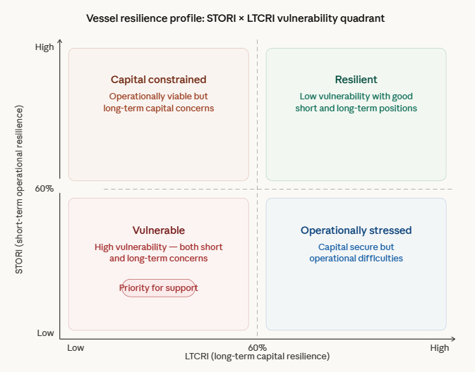

Implications for the Framework
Three critical properties of the welfare risk equation matter for this report's resilience indices, and they are demonstrated in the worked examples of Chapter 2. First, resilience is not merely desirable; it is a quantifiable economic variable with a measurable welfare return. This gives a clear economic rationale for investing in resilience and provides a basis for cost-benefit analysis of policy interventions. Second, Rmacro and Rmicro work multiplicatively. Low resilience at both levels compounds the amplification. The greatest welfare gains from resilience investment come where both levels are currently weak: precisely the ports and vessels in the vulnerable quadrant of this report's framework. Third, the distinction between Rmacro and Rmicro indicates where to intervene. Port-level investment increases Rmacro for every vessel using that port. Vessel-level support increases Rmicro for targeted vessels. Effective resilience strategy requires action at both levels.

Retention Rate as a Unified Measurement Principle
All indices in this report use a single measurement principle: the retention rate, where 1.0 (100%) means full retention of pre-shock function and 0.0 (0%) means total loss. This ensures consistent interpretation across all levels. A score of 0.75 means the same thing whether it describes a vessel's gross profit retention, a port's employment retention, or the sector's aggregate landing value retention. In Hallegatte's terms, a retention rate of 0.75 means 75% of pre-shock function was preserved: the system's resilience limited the welfare loss to 25% of the initial shock impact. This retention rate is the direct counterpart of the resilience terms in Hallegatte's welfare equation. Because welfare loss equals direct loss divided by the product of macroeconomic and microeconomic resilience (Rmacro × Rmicro), the share of function retained is governed entirely by those two terms: a retention rate of 0.75 describes a system whose combined resilience held its welfare loss to 25% of the initial shock. Rmacro and Rmicro say how much of a shock is absorbed; the retention rate states how much function survives. They are the same quantity viewed from opposite ends.

Mapping to the Multi-Scale Index Architecture
The Hallegatte decomposition maps directly onto the multi-scale resilience index architecture proposed in this report. Macroeconomic resilience (the capacity of the broader system to limit aggregate consumption losses for a given level of direct asset losses) is captured using sectoral-level and port-level indices. Microeconomic resilience (the capacity of individual units to limit welfare losses for a given level of aggregate disruption) is captured using two vessel-level indices (STORI and LTCRI).
The Short-Term Operational Resilience Index (STORI), developed in Chapter 3, captures instantaneous resilience at the vessel level. Its six components (gross profit retention, crew wage retention, financial independence, fishing activity retention, crew retention, and recovery speed) measure the vessel's capacity to keep going and bounce back from short-term disruption. This is engineering resilience (Reng) in the Holling tradition.
Framework | Type | Level | Focus
Port Resilience Index | System | Port | Local economic absorption
Sectoral Resilience Index | System | Sector | National sectoral absorption
STORI | Instantaneous | Vessel | Operational absorption & recovery
LTCRI | Dynamic | Vessel | Structural adaptation & persistence
The Long-Term Capital Resilience Index (LTCRI), also developed in Chapter 3, captures the dynamic and structural dimension: whether the vessel enterprise can maintain its capital investment cycle, manage its debt, and sustain its long-term position. Its six components (net profit retention, loan term stability, debt structure stability, vessel renewal timeline retention, asset value retention, and investment plan retention) measure whether the vessel is settling into a new sustainable equilibrium or being pushed toward permanent exit. This is ecological resilience (Reco) in the Holling tradition.
The Port Resilience Index captures the structural characteristics that determine whether a shock to landing values cascades through the local economy: processing integration, species diversity, the scale of the local seafood economy, and the quality of infrastructure and support.
The Sectoral Resilience Index operates at the highest level, capturing the resilience of the national seafood sector to systemic shocks. It integrates information from all lower scales to provide a single, sector-wide measure.
This architecture (originating in the IPCC risk framework, extended through Hallegatte's explicit treatment of resilience, grounded in Holling's distinction between engineering and ecological resilience, and operationalised through retention-rate scoring across vessel, port, and sectoral levels) provides the formal foundation for the resilience assessment that follows.

Measuring Resilience in Practice
The starting point for this Chapter is the IPCC AR6 definition of risk, which this report adopts in Chapter 1. Risk is decomposed into three interacting elements: the hazard (the shock itself), the exposure (the people, assets and livelihoods in its path), and the vulnerability (how badly an exposed unit is affected, comprising its sensitivity and its adaptive capacity). Resilience is not a fourth element standing beside these; it is the active, dynamic core of vulnerability, the adaptive-capacity component that determines whether an exposed unit buckles or bends.
Holling's distinction sharpens what resilience means. Engineering resilience (Reng) is the capacity to absorb a temporary shock and bounce back to the pre-shock equilibrium; ecological resilience (Reco) is the capacity to withstand a disturbance without being pushed across a threshold into a different, often permanently worse, state. Holling therefore tells us what kind of recovery is in question: a bounce-back, or a regime shift.
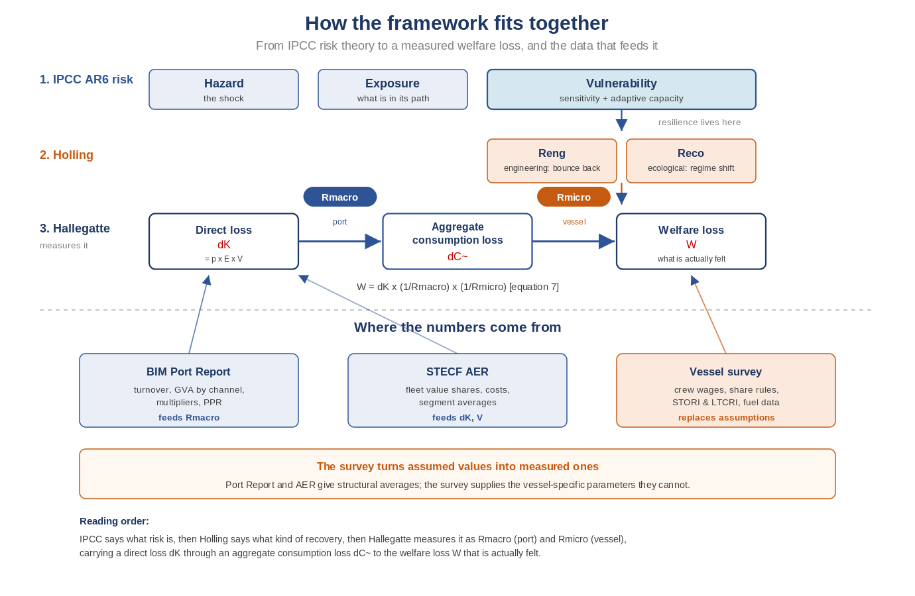
Hallegatte (2014) makes these ideas measurable by expressing the welfare impact of a shock as a chain. A direct loss, ΔK, equal in the IPCC terms to probability times exposure times vulnerability (p × E × V), cascades through the wider economy into an aggregate consumption loss, ΔC̃, and that aggregate loss is finally translated into a welfare loss, W, the harm actually felt by people. Two resilience ratios connect the three quantities. Macroeconomic resilience, Rmacro = ΔK / ΔC̃, measures how far the direct loss is dampened as it cascades through the port economy. Microeconomic resilience, Rmicro = ΔC̃ / W, measures how far the aggregate loss is dampened before it becomes welfare harm at the level of the individual vessel and crew. Combining the two gives the complete welfare-risk expression of equation 7: W = ΔK × (1/Rmacro) × (1/Rmicro).
The two Holling ideas live inside the two Hallegatte ratios. Reng and Reco are each visible at both scales: a port can bounce back or shift to a permanently smaller economy (Reng or Reco within Rmacro), and a vessel can recover or be pushed past its viability threshold into exit (Reng or Reco within Rmicro). In this report Rmacro is captured by the Port and Sectoral Resilience Indices estimated below, and Rmicro by two vessel-level indices; a short-term operational resilience index (engineering-resilience measure) and a long-term capital resilience index (ecological-resilience measure) both developed as part of a research instrument. To show how these combine to give an overall measure of socio-economic resilience we use a worked example that traces a single €1.0 million loss of mackerel quota along the whole value chain of Killybegs: Section A derives Rmacro at the port, Section B derives Rmicro.

How existing BIM reports and the survey feed the analysis
The framework developed in this report come from three sources with a clear division of labour. The first two are existing BIM and EU data sources (STECF Annual Economic Report, and BIM Port Reports) that supply the structural averages used in to estimate key resilience parameters. The third, is the survey, developed as part of this project, that is designed to capture vessel-specific parameters the others cannot. It is the means by which the assumptions in the worked example are progressively replaced by evidence.

Source | What it supplies | Where it enters the chain
BIM Port Report | Sub-sector turnover, gross value added by channel (direct, indirect, induced), local multipliers, and the processing-to-production ratio. | The Rmacro derivation (Section A): the processing, ancillary and household transmission channels are built almost entirely from these lines.
STECF Annual Economic Report (AER) | Fleet value shares by species and segment, cost structures, and segment-average economic performance. | The direct loss ΔK and the vulnerability term V: the species income shares and the scale of the mackerel loss are anchored to AER fleet figures.
Vessel survey (Sections B-G; STORI and LTCRI) | Crew wages, the share-system rules, owner smoothing capacity, fuel consumption and invoices, and the STORI and LTCRI resilience scores for each vessel. | The Rmicro derivation (Section B): the survey replaces assumed wage, smoothing and threshold values with measured ones, and supplies the engineering (STORI) and ecological (LTCRI) readings directly.
Note: in the following worked example, where a value is tagged [ASSUMPTION], it is a quantity the Port Report and AER do not currently supply at vessel level: this includes smoothing fractions, the viability threshold, and species income shares. Instead, these are values that the survey measures. As survey returns accumulate, the assumed values are replaced one by one, and the calculation that starts out as illustrative becomes evidenced. The survey is therefore not a separate exercise but the mechanism that tightens the whole framework, turning a transparent set of assumptions into a defensible, vessel-specific estimate of resilience.

Section A: Port-level resilience (Rmacro) from the Port Report

Purpose and starting point
The worked example that traces a single €1.0 million quota loss along the whole value chain typical of Irish fisheries: we wish to measure macroeconomic resilience (Rmacro) at the port level. In the Hallegatte framework, Rmacro is the ratio of the direct loss to the aggregate consumption loss, Rmacro = ΔK / ΔC̃. It measures the port economy's capacity to dampen a direct loss as it cascades through processing, ancillary services, and household spending. A high Rmacro means most of the direct loss is absorbed locally; a low Rmacro means it is amplified.
The BIM Port Report does not state Rmacro. It provides the structural raw material: sub-sector turnover, gross value added (GVA) by channel, and the multipliers from which the channels can be reconstructed. The task is therefore to derive Rmacro for a standardised shock by tracing that shock through the port economy using only Port Report figures, plus a small number of clearly labelled assumptions. The standardised shock used throughout is a direct loss of ΔK = €1.0 million in landed value.
The aggregate consumption loss is the direct loss plus the losses transmitted through three channels:
ΔC̃ = ΔK + Processing loss + Ancillary loss + Household loss
and Rmacro = ΔK / ΔC̃. The three channels are derived in turn below. Every input is tagged with its Port Report source or marked [ASSUMPTION] where it is not yet a Port Report line.

Source figures from the BIM Port Report
All structural figures below are taken from the Killybegs Port Report. They are gathered here so the derivation can be followed line by line.
Port Report source | Value | Used for
Table 2 (p. 8): Commercial fishing turnover | €63.5m | Primary production; fishing share
Table 2 (p. 8): Aquaculture turnover | €31.8m | Primary production
Table 2 (p. 8): Fish processing turnover | €175.7m | PPR; raw-material cost
Table 2 (p. 8): Total port turnover | €271.0m | Fishing share of activity
Table 8 (p. 17): Fish processing direct GVA | €48.8m | Processing value-add per €1 raw
Table 10 (p. 19): Direct GVA | €93.6m | Channel ratios; multiplier
Table 10 (p. 19): Indirect GVA | €70.2m | Ancillary channel
Table 10 (p. 19): Induced GVA | €15.2m | Household channel
Table 10 (p. 19): Total GVA | €179.0m | Type II multiplier

Channel 1: Processing loss
The processing channel asks: when €1.0m of local landings is lost, how much GVA do processors lose? The answer depends on two things, i) the value-add processors derive per euro of raw material, and ii) whether they can substitute the lost raw material from elsewhere.
Processing loss = ΔK × (processing value-add per €1 raw material) × (1 − substitution rate)
Parameter 1: Processing value-add per €1 of raw material
The Port Report gives processing turnover (€175.7m) and processing direct GVA (€48.8m), so GVA is 28% of sales (48.8 / 175.7). That 28% figure is the value-add per €1 of processed-fish sales, which is the wrong basis here. ΔK is a loss of raw fish input, not of sales. We need value-add per €1 of raw material.
Intermediate consumption (all input costs) = €175.7m − €48.8m = €126.9m, which is 72% of turnover. Raw fish is one component of intermediate consumption alongside energy, packaging, and maintenance. We assume raw fish accounts for 60% of intermediate consumption [ASSUMPTION: a typical pelagic-processing ratio, to be confirmed by industry interview]. Raw-material cost is therefore €175.7m × 0.72 × 0.60 = €75.9m.
Processing value-add per €1 of raw material = €48.8m / €75.9m = 0.64. This is the correct basis: for every €1 of raw fish that fails to arrive, processors lose €0.64 of GVA, before any substitution.
Parameter 2: Substitution rate
The next parameter needed is the substitution rate. This is the share of lost local landings that processors can replace by buying raw material from outside the port. It runs from 0 to 1. At 1.0 (100%) processors fully replace the missing fish from elsewhere, so they keep working and the processing loss is near zero. At 0 they cannot replace any of it, so the loss passes through almost in full.
To estimate the substitution rate we first calculate a Processing-to-Production Ratio (PPR) where PPR is processing turnover / primary production, in the case of Killybegs this is €175.7m / (€63.5m + €31.8m) = €175.7m / €95.3m = 1.84.
A PPR above 1.0 means processors already handle more raw material than the port lands locally, so they already operate external supply lines. The baseline external share is 1 − (1 / 1.84) = 0.458, that is, Killybegs processors already source about 46% of their raw material from outside the port under normal conditions. The amount they can substitute when local landings fall is governed by a transparent rule, set out below, together with a distinction central to this analysis: whether the shock is a Type I (localised) or a Type II (systemic) event.
The headroom rule. The maximum a port can substitute is 100%. Starting from a 46% baseline, the maximum scaling factor is 1 / 0.458 = 2.19; any factor above this caps at 100%. Substitution can therefore rise from 46% to 100% only if additional raw material is actually available to purchase.
Whether it is available depends on the nature of the shock:
- A Type I (localised) shock is one affecting this port alone. In that sense it is an idiosyncratic shock. The lost mackerel is still being landed elsewhere, and Killybegs processors can scale external sourcing to the 100% ceiling. The substitution rate approaches 1.0 and the processing loss approaches zero.
- A Type II (systemic) shock is a correlated, sector-wide event, such as the 2026 mackerel reduction or the post-Brexit reallocation. The external supply that processors would otherwise draw on is short of the same species, so external substitution is largely unavailable. The substitution rate approaches zero and the processing loss is transmitted almost in full. This distinction is material to the analysis. The PPR indicates that Killybegs is resilient to a localised disruption, but that resilience does not extend to a correlated, sector-wide shock of the kind the pelagic fleet faces. A single substitution figure would obscure this difference; presenting the two cases separately makes it explicit.
- A third substitution channel partially offsets the Type II case: attracting foreign landings into Killybegs. Even when the Irish mackerel quota is cut, the port's processing capacity can be fed by landings from non-Irish vessels, whether mackerel or other pelagic species such as blue whiting. Ireland does not need to catch the fish to recover the processing value-added; it needs only to attract the raw material to the quayside. To the extent that foreign landings can be drawn in, the processing loss from a systemic quota reduction is recovered even though the catching loss is not, and the substitution rate rises above the near-zero floor that own-fleet shortage alone would imply. This channel depends on relative price, port competitiveness, and access arrangements, so it is a partial offset rather than a guaranteed one.

Shock type | Substitution | Calculation | Processing loss
Type I (localised) | 100% | €1.0m × 0.64 × (1 − 1.00) | €0.000m
Type II (systemic) | 0% | €1.0m × 0.64 × (1 − 0.00) | €0.643m

Channel 2: Ancillary loss
The ancillary channel captures supply-chain businesses, fuel, ice, gear, repairs, and transport, that lose trade when fishing activity falls. The Killybegs Port Report (Table 10, p. 19) gives indirect GVA of €70.2m against direct GVA of €93.6m, an indirect-to-direct ratio of 0.75.
Not all ancillary activity is lost, because these suppliers also serve aquaculture, processing, and foreign vessels, and some operate under standing contracts. Two Port-Report-grounded checks bound the loss. First, fishing is €63.5m of €271.0m total turnover, only 23% of port activity, so a large share of ancillary trade is not tied to the catching sector at all. Second, the AER reports indicate that fuel, ice, gear, and similar inputs amount to roughly 25% of landing value [ASSUMPTION drawn from AER, not the Port Report].
We therefore apply a continuation rate, the share of ancillary trade that survives the shock. For a well-diversified port such as Killybegs, processing, alternative species, and foreign landings could reasonably keep 60% of ancillary services busy [ASSUMPTION; a low-resilience port might retain only 20%].
Ancillary loss = ΔK × 0.25 × (1 − continuation rate) = €1.0m × 0.25 × (1 − 0.60) = €0.100m.

Channel 3: Household loss (induced)
The household channel captures the induced effect of the quota loss, that is, when crew wages and owner income fall, the people who would have earned that money spend less in local shops and services, and that lost spending reduces activity across the wider port economy. The aim here is to estimate how much local consumer spending is lost when landings of value ΔK fail to arrive.
We begin with the share of landing value that reaches households as income. Assume that crew wages and owner income are a percentage (e.g. 38%) of landing value. Of that income, not all is spent in the port therefore we assume a local-spend proportion (e.g. 60%). That local spending then circulates, generating further activity through the induced multiplier.
Next we calculate the induced multiplier for Killybegs using the most recent Port Report: this is the total GVA divided by direct GVA, €179.0m / €93.6m = 1.91. In input-output terms this is a Type II multiplier, one that includes this household-spending round on top of direct and supply-chain effects. The induced portion is the multiplier minus one, 0.91.
Finally, an institutional offset is applied. This recognising that quota swaps and alternative fishing opportunities can restore a percentage of lost income. Assume this is of 50% so only half of the potential induced loss actually feeds through as a genuine loss.
Putting these steps together, the household loss can be estimated as the direct loss, ΔK, scaled by the factors set out above: ΔK × (income share 0.38) × (local-spend 0.60) × (induced multiplier 0.91) × (1 − institutional offset 0.50) = €0.104m.

Result: aggregate consumption loss and Rmacro
Summing the channels for the standardised €1.0m shock at Killybegs gives the two cases below.
Component | Type I (localised) | Type II (systemic) | Source
Direct loss ΔK | €1.000m | €1.000m | Standardised
Processing loss | €0.000m | €0.643m | Channel 1
Ancillary loss | €0.100m | €0.100m | Channel 2
Household loss | €0.104m | €0.104m | Channel 3
ΔC̃ (total) | €1.204m | €1.847m | Sum
Rmacro = ΔK / ΔC̃ | 0.831 (83.1%) | 0.541 (54.1%) | Derived
1 / Rmacro (amplification) | 1.20 | 1.85 | Derived

The same €1.0m shock to the same port yields a macroeconomic resilience of 83% under a Type I (localised) shock, but only 54% under a Type II (systemic) shock. The amplification factor rises from 1.20 to 1.85. The difference arises entirely in the processing channel, which absorbs the shock when substitute raw material is available and transmits it almost in full when it is not. A port with a high PPR therefore appears resilient on a structural measure, yet may be considerably less resilient to the correlated, sector-wide shocks that bear on the pelagic sector from shocks like Brexit and the recent mackerel quota cuts.

What future Port Reports could capture to make Rmacro direct
This derivation works, but it leans on three assumptions that the Port Report does not currently supply: the raw-fish share of intermediate consumption (used 60%), the ancillary continuation rate (used 60%), and the wage-income and local-spend parameters of the household channel. If future Port Reports captured a small number of additional lines, Rmacro could be read off far more directly and with far less assumption. The following additions would have the greatest effect.
- A raw-material cost line for the processing sector. Reporting processors' actual spend on raw fish (as distinct from total intermediate consumption) would replace the 60% assumption and pin down the processing value-add per €1 of raw material directly.
- A substitution or external-sourcing elasticity. The PPR gives the baseline external share, but not how far processors can scale it in a shortage. A short survey question ("by how much could you increase external purchases if local landings fell by 20%?"), reported by port, would replace the headroom assumption and let the idiosyncratic-versus-systemic split be evidenced rather than assumed.
- Channel-specific continuation rates. Reporting what share of ancillary trade is tied to the catching sector (as opposed to aquaculture, processing, or contracts) would replace the 60% continuation assumption with a measured figure.
- A wage-income and local-spend breakdown. Reporting crew and owner income as a share of landing value, and the local-spend proportion, would ground the household channel in port data rather than in the share-system assumption.
- A correlated-shock flag. Because resilience differs substantially between Type I (localised) and Type II (systemic) shocks, future reports could present Rmacro as a pair (local-shock and sector-shock values) rather than a single number, making the port's true exposure to fleet-wide events visible at a glance.
With these additions, deriving Rmacro for a port would reduce to reading a handful of reported lines and applying the three-channel formula, removing every assumption flagged above and making the measure reproducible across all ten ports on a common basis.

Section B: Vessel-level resilience (Rmicro)
This next worked example completes the resilience chain begun in the port-level (Rmacro) analysis above. Where Rmacro measured how a direct loss cascades through the port economy, microeconomic resilience (Rmicro) measures how the resulting aggregate loss becomes welfare harm at the level of the individual vessel enterprise and its crew. Following Hallegatte (2014, equation 31): Rmicro = ΔC̃ / W where ΔC̃ is the aggregate consumption loss reaching the vessel and W is the welfare loss it produces. Because welfare loss is never smaller than the consumption loss, Rmicro above 1 means the loss is absorbed (welfare harm limited), while Rmicro falling toward and below the point where W exceeds ΔC̃ marks the shift into a catastrophic regime in which the loss is amplified into disproportionate harm. The complete welfare expression is: W = ΔK × (1/Rmacro) × (1/Rmicro), equation 7 of this report.
This example extends the port study by considering a series of actual 2026 shocks: a) the significant (initial proposal 75%) cut in mackerel quota, b) the significant spike in fuel-prices and iii) the regulatory shock of a ban on trawling inside-six-miles by vessels over 18 metres in length.
It estimates Rmicro through the lens of three real vessels, each interviewed for this study and reported here anonymously: an RSW-Pelagic vessel working from Killybegs (Vessel A), a polyvalent Tier 1/2 pelagic vessel working from Castletownbere (Vessel B), and a polyvalent whitefish vessel working from Howth (Vessel C). The three are chosen because the same shocks produce sharply different welfare outcomes, and that divergence is the central finding.

Hallegatte's welfare mechanism, mapped to the fishery
Hallegatte builds the welfare loss from a population of heterogeneous households. Welfare loss exceeds consumption loss for two reasons: A) a distributional weight (a euro of loss reduces welfare more for a lower-income household, because the marginal utility of income is higher) and B) a basic-needs threshold (households whose income falls below the level needed to meet basic needs, and who cannot smooth the shock through savings, borrowing or insurance, suffer a sharp, non-marginal welfare penalty). The framework transfers to the fleet once the counterparts are identified.
Hallegatte (household) term | Fishing-fleet counterpart used here
Distributional weight (marginal utility of income) | Crew wage level. A euro of lost share carries more welfare weight for lower-paid crew. Weight = (€50,000 reference / crew wage), unit-elastic [ASSUMPTION; updatable: the elasticity could be calibrated to fleet income data].
Basic-needs threshold | Crew-wage viability threshold: the share level below which crew leave the vessel. €30,000 for the high-wage pelagic crews; €22,000 for whitefish [ASSUMPTION from interviews; updatable directly].
Smoothing (savings, borrowing, insurance) | The owner's capacity to subsidise crew wages from the profit (board) share, plus accessible reserves. Read from each vessel's Section G impact report (e.g. borrowing access, reserves consumed).
Catastrophic / non-marginal term | Threshold breach: crew depart, the vessel cannot be safely crewed under MSO minimum-manning rules, and the enterprise enters the decommissioning or exit spiral. Modelled as a non-marginal penalty on the shortfall below the threshold.
With these correspondences the calculation is Hallegatte's, applied to vessels rather than households. The derivation below builds his welfare-loss expression from first principles, so that each vessel can then be worked simply by substituting its own figures.

Deriving the Hallegatte welfare loss
Hallegatte's argument starts not from money lost but from welfare. The welfare of a household is a function of its consumption, and the crucial property of that function is that it is concave which translates to an extra euro of consumption is worth more to a low-income household than to a high-income one. The welfare loss from a fall in consumption is therefore not the euro amount itself, but that amount weighted by the household's marginal utility of consumption. This is Hallegatte's foundational step (his equations 17 to 19): for a small loss, the welfare loss is approximately the marginal utility of consumption multiplied by the consumption loss.
Because marginal utility is higher for low-consumption households, the same euro of loss produces more welfare harm when it falls on the poor. Hallegatte formalises this across a population of poor and non-poor households and reaches his equation 22, in which the aggregate consumption loss is multiplied by a bracketed factor: a distributional weight that rises with inequality and with the share of the loss borne by the poor. In words, equation 22 says: welfare loss = (distributional weight) × (aggregate consumption loss), valid as long as no household is pushed below subsistence.
That proviso is the second step. The simple weighted-loss picture holds only if households can smooth the shock over time, through savings, borrowing or insurance. In his Section 3.2 (equations 23 to 26) Hallegatte treats the households that cannot smooth, those whose income loss in the shock year exceeds their annual income, as suffering a non-marginal welfare penalty: they cannot meet basic needs, and their loss is no longer proportional to its size. He introduces a smoothing parameter that determines what share of households fall into this category and adds a separate basic-needs term for them.
Combining the smoothable part (the weighted consumption loss) with the unsmoothable part (the basic-needs penalty) gives Hallegatte's equation 27, his full expression for the welfare loss:
W ≈ (distributional weight) × ΔC̃ + (basic-needs penalty for households that cannot smooth)
Finally, his equation 31 defines microeconomic resilience as the ratio of the aggregate consumption loss to this welfare loss: Rmicro = ΔC̃ / W [Hallegatte eq. 31]. A high Rmicro means the welfare loss is small relative to the consumption loss, so the shock is well absorbed; an Rmicro of 1 means welfare loss equals consumption loss; once the basic-needs penalty applies, W exceeds ΔC̃, Rmicro falls below 1, and resilience has collapsed.

Applying Hallegatte to a single vessel
We now apply Hallegatte’s welfare equation W ≈ (distributional weight) × ΔC̃ + (basic-needs penalty) to one enterprise rather than a population, identifying each of Hallegatte's terms with an observable feature of the vessel. This is a deliberate simplification: Hallegatte works across a distribution of poor and non-poor households, whereas we apply the same structure to a single vessel and its crew. The mapping is as follows.
- His distributional weight (from equation 22) becomes the crew wage level. We use a unit-elastic marginal utility, weight = (reference wage ÷ crew wage) with a €50,000 reference [ASSUMPTION; updatable]. A euro lost by a €33,000 crew therefore carries more welfare weight (1.52) than a euro lost by a €70,000 crew (0.71), which is exactly Hallegatte's point that a euro hurts the poor more.
- His smoothing parameter (equations 26 and 27) becomes the owner's capacity to absorb the loss from the boat share and reserves. The fraction the owner cannot absorb, (1 − smoothing), is the part that reaches the crew as a genuine consumption loss.
- His basic-needs penalty (equation 26) becomes the crew-wage viability threshold. If the post-shock crew share falls below the level at which crew can sustain themselves and leave, the non-marginal penalty applies, which is Hallegatte's negative-income households who cannot meet basic needs.
Substituting these into equation 27, the welfare loss for a vessel is: W = (1 − smoothing) × ΔC̃ × weight [+ threshold-breach penalty] and Rmicro = ΔC̃ / W is Hallegatte's equation 31 applied to the vessel. Each of the three vessels in the example is now worked by substituting its own ΔC̃, smoothing fraction, wage-based weight, and threshold position into these two lines.
- Vessel A: RSW-Pelagic segment, working from and landing into Killybegs, carrying a substantially higher individual (non-transferable) mackerel quota. Crew share approximately €70,000 [interview-derived range €60,000 to €80,000; updatable].
- Vessel B: a polyvalent Tier 1 pelagic vessel in the TM24-40m segment, operating from Castletownbere. It lands mackerel into Killybegs, albacore tuna into Spain, and the rest into Castletownbere. Crew earnings about €69,000 in a recent year, of which roughly €28,000 came from tuna.
- Vessel C: a polyvalent whitefish and Nephrops vessel in the DTS 18-24m segment, working from and landing into Howth. Crew share approximately €33,000, with the viability threshold near €22,000.

Vessel A: RSW-Pelagic
Vessel A faces the 2026 mackerel cut at its starkest, because mackerel is the core of the RSW-Pelagic quota. We take mackerel as 55% of its income [ASSUMPTION: the AER share for the mid-water TM18-40m fleet is 45% mackerel; the RSW vessel is more mackerel-dependent than the polyvalent average, so this is increased to 55% but this may be updated from vessel accounts]. A 70% cut on that share is a 38% income loss.
Under the share system the loss passes to the crew pool: crew earnings fall from €70,000 to about €43,050, a consumption loss of €26,950. The distributional weight at a €70,000 wage is 0.71 (a high wage makes each euro of loss less welfare-costly).
Distributional weight - marginal utility of income is the factor that converts a euro of income loss into a welfare loss, reflecting that a euro matters more to a lower-income earner than to a higher-income one. It comes from Hallegatte's marginal-utility step (his eq. 22) and because welfare is a concave function of income where the marginal utility of a euro is higher when income is low. In the report's vessel mapping (see table above) , the weight is defined as a reference wage divided by the crew wage: weight = reference wage ÷ crew wage, with the reference wage set at €50,000. A weight above 1 means each euro lost hurts more than the reference (a lower-paid crew); a weight below 1 means it hurts less (a higher-paid crew). So, a €33,000 crew carries a weight of 1.52, while a €70,000 wage carries 0.71.
Vessel A has strong margins and reserves and can smooth about 65% of the loss [ASSUMPTION based on the RSW segment's superior capitalisation and updatable from interview - Section G].
As crew earnings remain far above the €30,000 threshold, no basic-needs penalty applies.
Substituting these into equation 27: ΔC̃ = €26,950; smoothing fraction 0.65 giving the unsmoothed (consumption-loss) part as €26,950 × (1 − 0.65) = €9,432. The distributional weight is €50,000 ÷ €70,000 = 0.71; and because the post-shock wage stays above the viability threshold, the basic-needs penalty is zero. Hence W = €9,432 × 0.71 = €6,738, and by equation 31 Rmicro = ΔC̃ / W = €26,950 / €6,738 = 4.00.
The amplification factor 1/Rmicro is 0.25: three-quarters of the shock is absorbed before it reaches welfare.

Vessel B: Tier 1 polyvalent.
Vessel B is a polyvalent Tier 1 pelagic vessel in the TM 2440m segment. Its income mix, taken from an owner interview, is roughly mackerel 30%, albacore tuna 40%, inshore small pelagics 10%, and other pelagic species 20% [ASSUMPTION: the fleet-average value shares of Table 11 are nudged to this vessel's stated higher tuna dependence and smaller mackerel quota; updatable from accounts].
Its resilience profile (Section G of owner interview ) shows gross profit retained 50-75%, full crew retention, crew wages held through board-share subsidy, and no short-term borrowing (capital was raised by selling a second vessel, not by debt). This is a vessel that is, in the owner's description, plateauing and sustaining the crew just about.
Shock 1: 70% mackerel cut
A 70% cut on a 30% mackerel share is a 21% income loss. Crew earnings fall from €69,000 to €54,510 (consumption loss €14,490). IN this case the distributional weight is 0.72, smoothing is moderate at 40% (no reserves being built) [ASSUMPTION consistent with Section G; updatable]. Crew remain above the €30,000 threshold.
Substituting into equation 27: ΔC̃ = €14,490; smoothing 0.40, and unsmoothed part €14,490 × (1 − 0.40) = €8,694; weight = €50,000 ÷ €69,000 = 0.72; the wage stays above the threshold, so the basic-needs penalty is zero. Hence W = €8,694 × 0.72 = €6,300, and Rmicro = €14,490 / €6,300 = 2.30 giving 1/Rmicro = 0.43.
Shock 2 (compound): the six-mile ban
The six-mile ban removes the inshore small-pelagic (sprat and sardine) fishery, about 10% of Vessel B's income. The six-mile report establishes that this is a genuine, almost total loss for vessels of this type: in ICES Division 7.j, 98 to 99% of sprat by value is taken by vessels over 18 metres, with no small-vessel tradition to absorb the displaced effort, so the ban will effectively eliminate the fishery for these vessels. It lands at the moment the mackerel cut has pushed the fleet to lean harder on small pelagics (whose share of mid-water fleet value rises from 7% to 10% after the cut, per the six-mile report), and it leaves Vessel B dangerously dependent on albacore tuna, the species the owner says makes or breaks the year.
The combined income loss is now 31%. Crew earnings fall to €47,610 (consumption loss €21,390). With the small-pelagic buffer gone, smoothing weakens to 25% [ASSUMPTION; updatable]. Crew remain above the €30,000 threshold, but the margin is thinning.
Substituting into equation 27: ΔC̃ = €21,390; smoothing 0.25, so the unsmoothed part is €21,390 × (1 − 0.25) = €16,043; weight 0.72; the wage still clears the threshold, so the basic-needs penalty remains zero. Hence W = €16,043 × 0.72 = €11,625, and Rmicro = €21,390 / €11,625 = 1.84 (1/Rmicro = 0.54).
Vessel B is strained but remains viable. The compound shock reduces its Rmicro from 2.30 to 1.84, but its higher base wage and tuna income keep crew earnings above the viability threshold. This is the evidenced basis of the pelagic case: two converging policy shocks do not push a well-capitalised pelagic vessel into collapse.

Vessel C: Polyvalent whitefish
Vessel C is a polyvalent whitefish and Nephrops vessel in the DTS 18-24m segment (interview code ISE 9), working from Howth. It has no tuna, a narrow quota base, an ageing hull of about 35 years, and a crew wage near the viability threshold to begin with. Its resilience profile (owner interview, Section G) is already severe: gross profit retained under 25% (loss-making), crew wages down about 40%, the owner subsidising crew for more than six months, short-term borrowing required but bank access withdrawn, the vessel unsellable, the owner planning exit. The fuel shock is what tips it. The vessel supplied its actual fuel invoices, so the transmission below rests on measured consumption.
This vessel's share system makes the mechanism concrete. Crew and boat shares are calculated as the value of fish landed minus the fuel cost, divided by ten, with five shares retained by the boat and five divided among the crew. Fuel is therefore a pre-share deduction in the most literal sense: every euro of additional fuel cost reduces the pool before it is split, so half of any unmitigated fuel rise falls directly on the crew.
The fuel data used for this analysis (based on Brent spot converted at the appropriate €/$ and raised by 50.7% to the expected quay wall price) shows the quay-wall price rising from about €0.60/litre in 2025 to €1.01/litre by March 2026 as the Strait of Hormuz closure took hold, approaching the 2022 peak of €1.16. This modelled price is confirmed by the vessel's own fuel invoices, which show a mean paid price of €0.68/litre in 2024 and €0.60 in 2025, within about three cents of the model. The invoices record about 263,000 litres a year, a fuel bill of roughly €159,000 at the 2025 price; at the 2026 spike price the same volume costs about €265,000, an extra €107,000 in a single year. Crucially, the interview records a specific coping rule: once fuel passes about €0.70/litre, the owner absorbs the extra fuel cost himself rather than letting it pass into the (landings minus fuel) pool, in order to retain his crew. This single behaviour determines who bears the welfare loss, and it is worth following through in two ways: first treating the crew as the welfare unit (Vessel C1), then the owner (Vessel C2).
Vessel C1: crew protected, owner's capital destroyed
Under the absorption rule the owner takes on the fuel cost above €0.70/litre, about €81,000 in the 2026 spike year. The crew share is then computed as if fuel had only reached €0.70, so crew earnings fall from €33,000 to about €29,850, and remain comfortably above the €22,000 viability threshold. Taking the crew as the welfare unit and substituting into equation 27: ΔC̃ = €3,150; smoothing is effectively zero from the crew's side (the protection has already been applied by the owner, not the crew), so the unsmoothed part is the full €3,150; the distributional weight is €50,000 ÷ €33,000 = 1.52; and the wage stays above the threshold, so the basic-needs penalty is zero. Hence W = €3,150 × 1.52 = €4,800, and Rmicro = €3,150 / €4,800 = 0.66. By the short-term operational measure, the vessel has coped: crew retained, wages largely held, vessel still fishing. Its short-term operational resilience would read as resilient.
But the shock has not disappeared; it has moved onto the owner's balance sheet. Absorbing €81,000 a year drains his reserves and is folded into the vessel mortgage. His own boat share falls from about €132,000 to about €38,000, just 29% of normal. The consequence is the one the impact report records directly: with reserves gone and debt rising, the owner can see no way of replacing the vessel. This is not a short-term operational-resilience failure, it is a long-term capital-resilience failure. The vessel's long-term capital resilience has collapsed even though its short-term operational resilience looks intact.
Vessel C1 is the clearest demonstration in this report of why both indices are needed. A short-term-only assessment, or an aggregate AER average, would record this vessel as having weathered the shock. Only the long-term capital measure reveals that the owner has quietly absorbed the loss onto his capital account, and the enterprise is structurally finished. The distress is real but invisible to coarse measures, which is precisely the detection failure this report exists to expose: the vessel keeps fishing right up to the point where the boat reaches end of life and cannot be replaced.
Vessel C2: the owner as the welfare unit
The same event can be read with the owner's household as the unit bearing the loss, since that is where the absorption rule places it. Here the basic-needs term of equation 27, dormant for the crew, becomes active for the owner. Substituting into equation 27: the owner's share loss is €94,045; the distributional weight at his higher €132,000 income is €50,000 ÷ €132,000 = 0.38, since a high baseline income makes each euro of loss less welfare-costly at the margin; and smoothing is zero, because this loss is precisely what he could not absorb. The marginal part of W is therefore €94,045 × 0.38 = €35,700. The absorption also pushes his income below his own viability threshold, taken here as €60,000 to cover mortgage, drawings and living costs [ASSUMPTION; updatable from accounts], by about €22,000, and Hallegatte's non-marginal basic-needs penalty (equation 26) is added for this shortfall. Including that penalty gives a total welfare loss of about €56,500, and Rmicro = €94,045 / €56,500 = 1.66 on the consumption-loss basis. With the threshold breached, the meaningful reading is not the ratio itself but that the owner-enterprise has entered the catastrophic regime that the basic-needs term represents.
The two framings are complementary, not contradictory. C1 shows that the crew are protected and the capital base is destroyed; C2 shows that the owner has absorbed a catastrophic personal welfare loss to achieve that protection. Either way, the welfare harm is large and the enterprise is failing; what the share-system absorption rule changes is who carries it, and therefore which index detects it. The short-term, crew-facing measure sees little; the long-term, capital-facing measure sees collapse.

The 2026 convergence
The fuel shock did not arrive alone. In 2026 the whitefish fleet faced fuel, concurrent quota reductions, and an exceptional run of storm days simultaneously (interview records an engine failure requiring two tie-ups of 19 and 12 weeks that consumed its sinking fund and savings; a second whitefish vessel interviewed was still tied up in mid-June, in its owner's words worse than 1997). Each additional pressure deepens the owner's absorption and brings the crew protection rule closer to breaking. Once the owner's capacity to absorb is exhausted, the crew share itself falls below the €22,000 threshold, crew depart, the vessel falls below minimum manning, and the enterprise heads toward exit. The convergence is what turns a survivable single shock into terminal decline.

Result: the same shocks, three outcomes
The table below gathers the results calculated above for these three vessels. The crew-facing rows for A, B and C1 are the short-term (the short-term operational resilience index) reading; the C2 row reads the whitefish event with the owner as the welfare unit. The whitefish severity does not appear in the crew row because the owner has deliberately moved it onto his own capital account, where it shows up as a collapse of long-term (the long-term capital resilience index) resilience.
Vessel and shock | Wage/share after | ΔC̃ | Welfare W | Rmicro
C2: whitefish fuel shock, owner unit | €37,955 | €94,045 | €56,500 | 1.66
B: + six-mile ban (crew) | €47,610 | €21,390 | €11,625 | 1.84
A: RSW-Pelagic, mackerel cut (crew) | €43,050 | €26,950 | €6,738 | 4.00
B: Tier 1, mackerel cut (crew) | €54,510 | €14,490 | €6,300 | 2.30
C1: whitefish fuel shock, crew unit | €29,850 | €3,150 | €4,800 | 0.66

Reading the table: the RSW-Pelagic vessel absorbs the mackerel cut almost entirely (crew Rmicro 4.00); the Tier 1 pelagic vessel, hit by both the mackerel cut and the six-mile ban, is strained but stays intact (crew Rmicro 1.84); the whitefish vessel protects its crew (C1, crew Rmicro 0.66, a modest loss) only by transferring a catastrophic loss onto the owner (C2, who crosses his own viability threshold). The crew Rmicro figures are not comparable in magnitude across the pelagic and whitefish cases, because the whitefish loss has been deliberately moved off the crew. The true whitefish severity is in C2 and, above all, in the collapse of the vessel's long-term capital resilience, not in the crew's short-term measure.
The driver of the pattern is not the hazard, which is shared, but the vessel's segment, the crew wage that follows from it, the species diversification behind it, and the smoothing capacity it can still call on, exactly the determinants Hallegatte identifies. In the whitefish case that smoothing capacity is the owner's own capital, and once it is spent the protection ends.
This explains in part why recent decommissioning fell entirely on the whitefish fleet (49 demersal vessels) and not on the pelagic fleet, even though the pelagic fleet faced the larger headline quota shock. It also explains why the distress was not detected in advance: where owners absorb the shock onto their own capital to hold their crews, the operational indicators an aggregate assessment relies on stay healthy until the moment of exit. The same framework, applied at vessel resolution and split across the short-term, crew-facing measure and the long-term, capital-facing measure, explains both the collapse and the survival and makes the hidden capital erosion visible. Aggregate AER averages cannot.

Sources and assumptions
Sourced figures: crew earnings, the share formula, the fuel-absorption rule, and resilience profiles from the anonymised interviews and their Section G impact reports (codes ISW 1, ISE 9, ISW 4); fleet value shares and the six-mile findings from the six-mile analysis report (Tables 10 and 11; Division 7.j dependence); Vessel C's fuel consumption (about 263,000 litres a year) and paid prices from its own fuel invoices, 2024 to 2025; the wider fuel price path from the Brent-derived quay-wall dataset (1999 to 2026), validated against those invoices to about three cents; mackerel valued at €2,000/t.
Tagged assumptions, all updatable by further interview or from vessel accounts: the species income shares for each vessel; the marginal-utility elasticity (unit) and the €50,000 reference wage; the viability thresholds (€30,000 pelagic crew, €22,000 whitefish crew, €60,000 owner-household for Vessel C2); the smoothing fractions; and the four-person crew size used to divide the crew pool. The Vessel C fuel transmission rests on the vessel's actual measured fuel volume and its stated share formula, so the residual judgement is confined to the owner viability threshold and the precise point at which absorption begins. Each assumption is flagged [ASSUMPTION] at the point of use, and the survey (Section G) is designed to replace the remainder with vessel-level evidence. All vessels are reported anonymously, by segment and interview code only, in accordance with the basis on which the interview and survey data were provided.

Measuring Vessel-Level Resilience: STORI and LTCRI

Introduction
The Irish seafood sector is a primary driver of rural economies around the coastline of Ireland and acts as an anchor in coastal locations around which other supporting service sectors develop. In many of the ports and hinterlands assessed in this study, common characteristics describe regions of poor agricultural land, at significant distance from major urban settlements, with low levels of transport connectivity. The ten ports with the highest volume and value of seafood landings are located around the northeast, east, southeast, southwest, west and northwest corners of the island, and the hinterlands around these ports capture all the major seafood activity in those localities. In 2023, the total value of seafood landed in Irish ports by Irish and non-Irish vessels stood at €468 million, with the ten major ports accounting for the overwhelming majority of this activity. The sector directly employs over 15,600 people, contributing significantly to coastal employment.
Over the period 2020–2024, the Irish fishing industry has been exposed to an unprecedented sequence of external shocks. The COVID-19 pandemic caused a 12% decline in the value of the Irish seafood economy in 2020, driven mainly by an 18% reduction in domestic consumption due to the closure of the food-service sector, a 17% reduction in private investment, and an 8% decline in exports. The UK’s departure from the European Union under the Trade and Cooperation Agreement (TCA) introduced quota transfers estimated at €43 million per annum from 2021 onwards, with the aggregate final quota transfer from Ireland estimated to be €199 million based on 2020 levels. Fuel price volatility, particularly the spikes of 2022 and 2026, compressed operating margins across the fleet, while ongoing quota reductions for key species (mackerel, horse mackerel, herring, haddock, and Nephrops) have placed persistent downward pressure on the catching sector. Looking ahead, the 2026 quota allocations represent the most severe consolidated shock yet faced by the sector, with a 73% reduction in mackerel quota and the loss of all Hague Preferences producing a projected total quota value loss of €133.2 million.
Against this backdrop, the capacity to measure resilience systematically at the vessel and port levels has become an urgent policy requirement. This chapter sets out the methodology. It operationalises the resilience concepts of Chapter 1, taking the engineering and ecological distinction (Reng and Reco) and Holling's resilience-versus-stability framing as given, and converting them into two measurable vessel-level indices designed for deployment through a fleet-wide survey. It also extends the framework to the port level, drawing on the BIM 2025 Port Reports (Oxford Economics). The worked examples that demonstrate the indices in application appear in the preceding chapter.

Conceptual Framework
The two indices each correspond to a distinct temporal horizon, a distinct financial account, and a distinct resilience concept. The Short-Term Operational Resilience Index (STORI) measures the vessel's ability to absorb shocks while maintaining operational viability and crew retention; it addresses the current account (gross profit) within the annual cycle and corresponds to engineering resilience (Hallegatte's instantaneous resilience). The Long-Term Capital Resilience Index (LTCRI) measures the vessel's ability to sustain its capital and asset-renewal cycle; it addresses the capital account (net profit) across the multi-year lifecycle and corresponds to ecological resilience (Hallegatte's dynamic resilience). The practical force of the distinction, a vessel that survives operationally while its capital base erodes unseen, is demonstrated in the Vessel C worked example of the preceding chapter. The two indices, their components, and their weightings are specified in full in sections 3.4 and 3.5.

The Share System and Shock Transmission Mechanism
Traditionally much of the Irish fishing fleet operates under a share system that creates a distinctive mechanism for shock absorption. Under this system, the gross value of landings is first reduced by variable costs (fuel) to arrive at the amount available for sharing. This amount is then divided between crew wages (share fishermen) and the owner’s gross profit. The share system is not merely a remuneration arrangement; it functions as a shock transmission mechanism that distributes the burden of economic shocks between vessel owners and crew in a systematic sequence. When external shocks occur (whether a fuel price spike, a quota reduction, a market disruption, or a combination of these) the share system transmits the shock through the vessel’s financial structure in a predictable sequence:
Stage 1: Gross profit margin compressed
Stage 2: Crew wages reduced via share system
Stage 3: Owner subsidises crew wages via short-term borrowing
Stage 4: Short-term debt converted to long-term debt (extended mortgage)
Stage 5: Elasticity threshold: if wages fall below viable level, crew depart → vessel cannot operate.
This sequence is critical to the measurement framework. At Stage 1, the initial impact falls on the vessel owner’s gross profit as the margin between revenue and costs is compressed. At Stage 2, the share system transmits the shock to crew, as the reduced amount available for sharing results in lower crew wages. At Stage 3, the vessel owner may choose to subsidise crew wages from personal funds or short-term borrowing to prevent crew departure: a rational strategy to avoid the elasticity threshold, but one that converts an operational shock into a balance-sheet liability. At Stage 4, if the shock persists, the short-term borrowing is consolidated into long-term debt, the vessel mortgage is extended, and planned capital investments are deferred. At Stage 5, if crew wages fall below the level at which crew members can sustain themselves relative to alternative employment options, crew depart the vessel and it ceases to be operationally viable.
These stages map directly onto the two resilience traditions of Chapter 1. Stages 1 to 3 are engineering resilience (Reng): the vessel absorbs the shock and works to return to its normal operating state, holding crew and staying viable within the season. Stages 4 and 5 are ecological resilience (Reco): the enterprise can no longer return to its prior position and instead shifts toward a permanently lower state, restructured debt, deferred investment, and ultimately crew loss and exit. The elasticity threshold at Stage 5 is the edge of the vessel's stability domain in Holling's sense, the largest shock it can absorb before tipping into that new configuration.
The proposed short-term operational resilience index (STORI) captures Stages 1 to 3, the engineering-resilience zone in which the vessel is still working to recover. The long-term capital resilience index (LTCRI) captures Stage 4, the onset of ecological-resilience failure as the shock is converted into a lasting balance-sheet change. The elasticity threshold at Stage 5 marks the transition from stressed operation to operational failure, and a vessel's proximity to it is captured by the crew retention component (ST5) within STORI.

3.3 Scoring Principle: Retention Rates
The formal basis for the measurement approach adopted in this framework draws on the work of Asheim et al. (2020), who proposed an ordinal measure of resilience based on the analysis of streams describing the functioning of a system or individual over time. Their starting point is the notion of a “down spell” (a set of time periods during which an adverse event occurs and after which a subsequent partial or full recovery may or may not occur). The measure quantifies resilience as the ratio of the amplitude of the down spell (the initial drop) to the sum of the amplitude and the severity of the recovery period (the cumulative shortfall below the pre-shock level during recovery). Formally, the resilience measure r is defined as:
$$r\left(x\right)=\frac{Σa\left(σ\right)}{\left[Σa\left(σ\right)+ Σb\left(σ\right)\right]}$$
where a represents the amplitude and b represents the severity. The measure takes values between zero and one, with r(x) = 1 indicating instantaneous full recovery (maximum resilience) and values approaching zero indicating no recovery (minimum resilience). Vulnerability is defined as the inverse: v(x) = 1/r(x).
Asheim et al. demonstrated that this measure satisfies a set of intuitively appealing axiomatic properties:
recovery neutrality (all periods in the recovery phase are treated equally, with no discounting), recovery translation invariance, recovery monotonicity (better recovery outcomes always produce higher resilience scores), amplitude and recovery consistency, continuity, and affine invariance (resilience is unchanged by increasing linear transformations of the underlying variable). They showed that their specific ordering is the unique ordering satisfying all of these properties. The measure is attractive because, as they note, it represents an intuitively appealing index that can be operationalised in large-scale survey data where individual resistance to shocks cannot be explicitly separated from the shocks themselves. Although their framework was developed for health streams, they emphasised its generality: the measure can be employed in studies that examine quality of life, subjective well-being, or equivalent household income and wages of individuals. At the aggregate level, indicators of economic performance such as unemployment rates and GDP are identified as suitable candidates.
In adapting this theoretical framework to the fishing vessel context, we operationalise the Asheim et al. measure through retention rates. All measures in this framework employ retention rates as the fundamental scoring metric, ensuring consistent interpretation throughout:
Scoring convention:
1.0 (100%) = Full retention / No impact / Maximum resilience
0.0 (0%) = Total loss / Maximum impact / No resilience
Direction of interpretation: Higher score = Higher resilience (invariant across all components)
The retention rate is functionally equivalent to the Asheim et al. resilience measure in the single-spell case. A vessel that retains 75% of its gross profit has experienced a “down spell” of amplitude 0.25, and the retention rate of 0.75 directly maps to the resilience concept: the smaller the shortfall below the pre-shock baseline, the greater the resilience. The recovery speed component (ST6 below) captures the time dimension that Asheim et al. identified as the severity of the recovery period: a vessel that recovers within three months has a smaller cumulative “badness” (in their terminology) than one that takes five years, even if the initial drop was identical.
The retention rate approach offers several important advantages over alternative scoring methods. It provides a consistent direction of interpretation (higher is always better), is intuitively accessible to non-specialist stakeholders (a score of 75% gross profit retention is immediately comprehensible), ensures comparability across components (all measures are on the same 0–1 scale), is explicitly anchored to the pre-shock baseline position, and captures both the depth and duration of impact through the recovery speed component. These properties are consistent with the Asheim et al. axioms: recovery neutrality is satisfied because the scoring does not discount later recovery periods; affine invariance is satisfied because the percentage retention is unchanged by the absolute scale of the underlying values (a vessel retaining 75% of €100,000 gross profit scores identically to one retaining 75% of €500,000).

Short-Term Operational Resilience Index (STORI)

Definition and Rationale
The STORI measures the degree to which a vessel can absorb operational shocks while maintaining crew viability and operational continuity. It is a composite index constructed from six component measures, each expressed as a retention rate on a 0–1 scale. The index is designed to capture the immediate and short-term consequences of a shock event on the vessel’s current account: the impact on gross profit, the transmission of that impact to crew wages through the share system, the liquidity stress induced by the need for short-term borrowing, the disruption to fishing activity, the retention of crew (and hence the proximity to the elasticity threshold), and the speed with which the vessel returns to its pre-shock operating level.
The selection of these six components reflects the typical shock absorption sequence described earlier. Gross profit retention (ST1) captures Stage 1 of the sequence, the initial compression of the owner’s margin. Crew wage retention (ST2) captures Stage 2, the transmission of the shock to the labour force through the share system. Financial independence (ST3) captures Stage 3, the degree to which the owner was compelled to borrow in order to maintain operations. Fishing activity retention (ST4) captures operational continuity, a measure of whether the vessel continued to put to sea at normal levels. Crew retention (ST5) directly measures the proximity to the elasticity threshold at Stage 5. Recovery speed (ST6) captures the time dimension of engineering resilience: how quickly the system returns to its prior equilibrium.

Component Measures
Each of these components captures a distinct dimension of short-term resilience.
ST1 (Gross Profit Retention) is the most direct measure of financial impact, representing the proportion of the owner’s normal gross profit that was retained during the shock period. It corresponds directly to the Asheim et al. concept of the amplitude of the down spell.
ST2 (Crew Wage Retention) measures the degree to which the share system transmitted the financial shock to the crew and is weighted most heavily (0.25) because of its critical role in determining whether the vessel reaches the elasticity threshold. Under the share system that characterises the Irish fleet, crew wages are the primary channel through which financial shocks reach the labour force, and the level of crew wages relative to alternative employment options determines whether the vessel can continue to operate.
ST3 (Financial Independence) captures liquidity stress by measuring the extent of short-term borrowing required. A vessel that needed no borrowing to maintain operations demonstrated full financial independence; one that borrowed more than €100,000 experienced a major liquidity crisis.
ST4 (Fishing Activity Retention) measures the operational dimension: did the vessel continue to put to sea at normal levels, or was fishing activity curtailed? This is important because reduced days at sea compound the revenue impact of lower catch values.
ST5 (Crew Retention) is the most direct measure of proximity to the elasticity threshold, the point at which the vessel becomes non-viable. A vessel that retained its full crew complement weathered the shock without reaching this critical boundary; one that lost its entire crew, or experienced major turnover has effectively experienced system failure at the operational level.
ST6 (Recovery Speed) captures the time dimension of engineering resilience, measuring how long it took for gross profit to return to pre-shock levels. This component connects directly to Hallegatte’s (2014) concept of reconstruction duration, which along with the ripple-effect parameter determines macroeconomic resilience.

Composite Formula and Weightings
STORI = (w₁ × ST1) + (w₂ × ST2) + (w₃ × ST3) + (w₄ × ST4) + (w₅ × ST5) + (w₆ × ST6) where all measures are expressed as retention rates (0–1 scale), weights (w₁–w₆) sum to 1, and higher STORI = greater short-term resilience.
The weighting structure assigns the highest weight to crew wage retention (0.25), reflecting the centrality of the share system in shock transmission within the Irish fleet. The BIM Resilience Report documented in detail how the share system creates a unique absorption mechanism, and the evidence from the 2022 fuel price spike confirmed that crew wage levels are the critical determinant of whether vessels reach their elasticity threshold. Gross profit retention receives the second-highest weight (0.20) as the most direct measure of financial impact on the vessel owner. The three intermediate components (financial independence, fishing activity retention, and crew retention) each receive a weight of 0.15, reflecting their importance as distinct dimensions of operational resilience that cannot be fully captured by the financial measures alone. Recovery speed receives the lowest weight (0.10) because it is partly a consequence of the other components: a vessel with high gross profit retention and crew retention will typically recover faster, making this component partially redundant with the others. However, it is retained because it captures the time dimension of engineering resilience that the other components cannot.

Long-Term Capital Resilience Index (LTCRI)

Definition and Rationale
The LTCRI measures the degree to which a vessel can maintain its capital investment cycle and long-term viability in the face of shocks. It captures the impacts that persist beyond the immediate shock period, including debt restructuring, deferred capital investment, and changes to the vessel renewal timeline. Where STORI asks, “did the vessel survive the shock?”, LTCRI asks “what was the lasting cost of survival?” This distinction is critical. In the terminology of Holling (1973), STORI measures whether the system remained within its domain of attraction, while LTCRI measures whether the domain of attraction itself has shifted: whether the vessel has moved to a new, lower equilibrium from which it may never return to its prior trajectory.
The relevance of this distinction for the Irish fleet is acute. With a median fleet age of approximately 32 years and significant portions of the fleet approaching or exceeding design life, any further delay in the capital renewal cycle compounds structural vulnerability. A vessel that absorbs a shock by extending its mortgage and postponing replacement by five years has not simply deferred an expense; it has fundamentally altered its capital trajectory and accumulated additional operational risk as the aging vessel becomes more expensive to maintain and more prone to mechanical failure. This is precisely the kind of permanent structural change that Holling described as the hallmark of ecological (as opposed to engineering) resilience, and that Hallegatte’s framework captures through the concept of dynamic resilience.

Component Measures
LT1 (Net Profit Retention) captures the vessel’s after-debt-service performance, the residual profit available for capital accumulation after all operating costs and debt service have been met. This is a fundamentally different measure from gross profit (ST1): a vessel may retain 75% of gross profit but, after increased debt service on newly borrowed funds, retain only 25% of net profit. The distinction between gross and net profit is the mechanism through which short-term operational survival (STORI) translates into long-term capital erosion (LTCRI).
LT2 (Loan Term Stability) measures whether the vessel’s debt term has been extended as a consequence of the shock. Loan term extension is a direct indicator that short-term borrowing has been consolidated into long-term obligation: Stage 4 of the shock absorption sequence.
LT3 (Debt Structure Stability) captures the related but distinct phenomenon of debt conversion: the transformation of short-term borrowing (overdrafts, emergency loans) into longer-term instruments (mortgage extensions, term loans). This conversion represents a structural change to the vessel’s balance sheet that persists long after the original shock has passed.
LT4 (Vessel Renewal Timeline Retention) is the most heavily weighted component (0.25) because it is the single most consequential long-term indicator. A vessel that was planned for replacement in 10 years but is now not expected to be replaced for 15 years has experienced a fundamental disruption to its capital cycle. With the Irish fleet’s already-advanced age profile, any extension of the replacement timeline compounds existing structural vulnerability. The Vessel Renewal Delay Index (VRDI) may be calculated precisely where pre- and post-shock timelines are available: Timeline Retention Rate = P/Q (capped at 1.0), where P is the pre-shock timeline and Q the post-shock timeline. LT5 (Asset Value Retention) captures capital erosion through reduced market value, while LT6 (Investment Plan Retention) captures the deferral of planned investments in engines, gear, electronics, and safety equipment: deferrals that, in an aging fleet, represent accumulating operational risk.

Composite Formula and Weightings
LTCRI = (w₁ × LT1) + (w₂ × LT2) + (w₃ × LT3) + (w₄ × LT4) + (w₅ × LT5) + (w₆ × LT6) where all measures are expressed as retention rates (0–1 scale), weights (w₁–w₆) sum to 1, and higher LTCRI = greater long-term resilience.
The highest weight is assigned to vessel renewal timeline retention (0.25), reflecting the finding that the most consequential long-term effect of shocks on Irish fishing vessels is the postponement of vessel replacement. Net profit retention and loan term stability each receive a weight of 0.20, reflecting their importance as complementary measures of the vessel’s long-term financial trajectory: the former measuring ongoing profitability and the latter measuring the duration of the debt burden. Debt structure stability receives 0.15, lower than loan term stability because it captures a related but narrower phenomenon (the conversion of debt type rather than its extension). Asset value retention and investment plan retention each receive 0.10, reflecting their role as supplementary indicators that provide additional context rather than capturing fundamentally distinct dimensions of long-term resilience.
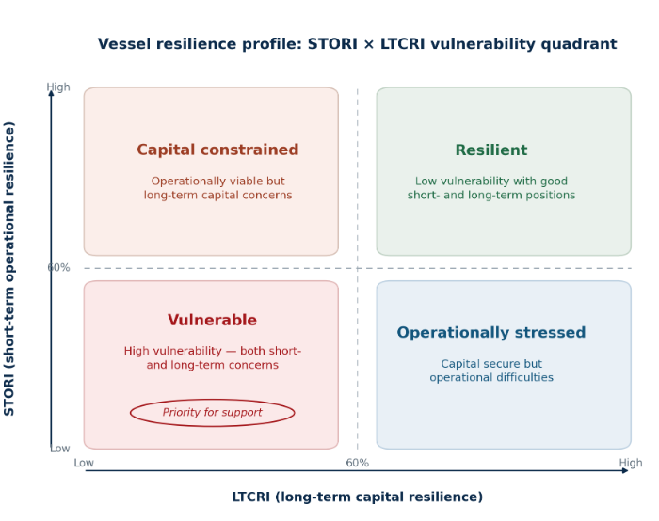

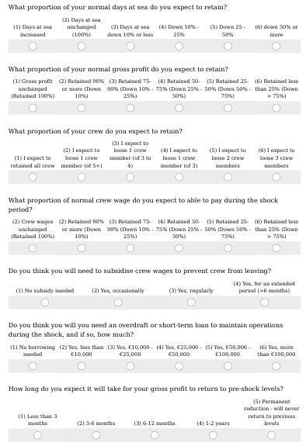

The Fleet Survey: Linking Theory to Evidence

Introduction
This chapter completes a sequence: chapter 1 set out the theory - the IPCC risk decomposition, Hallegatte's welfare-resilience framework, and Holling's distinction between bouncing back and shifting to a permanently lower state. The worked-example chapter then put that theory to work on real vessels and a real port, tracing the 2026 shocks through the Rmacro and Rmicro chain. What both rest on, however, are stylised assumptions and parameters drawn from secondary sources such as the AER and the BIM Port Reports. They cannot speak to the lived experience of those affected: which shocks actually hit, how hard, how the operator responded, whether public support helped, and what the operator fears next.
The fleet survey, developed for this study and reproduced in Appendix x, supplies that missing evidence. It is the evidential keystone for the fleet component of the report and is organised in two parts. The first part explains why the survey is needed, setting out the specific gaps it fills. The second part presents the results, addressing each module of the survey in turn, and in doing so delivers one of the project's fundamental requirements: a categorised catalogue of the shocks that have affected, and are expected to affect, the Irish seafood sector.
Noting that Section A of the survey simply records respondent details, the remainder of the survey is built to fill four gaps that secondary data leave open. Each maps to a module of the instrument. Past shocks (Sections B and C of the survey) record which hazards actually materialised, how severe they were, and how long recovery took, the enterprise-level vulnerability that fleet averages cannot show. Future shocks (Section F) capture the hazards owners themselves judge most likely and most concerning, grounding forward scenarios in the risk perceptions of those who manage the enterprises. Aid and support (Sections D and E) record what public schemes and private self-help actually did, and how effectively, supplying the response side of the framework. The resilience indices (Section G) provide the direct inputs for STORI and LTCRI, operationalising microeconomic resilience at the vessel level. The subsections below set out the survey's structure and how each module fills its gap.
A note on terminology: throughout, a 'shock' is a discrete, identifiable event or sustained condition that adversely affects the operation or viability of a seafood enterprise, consistent with the IPCC definition of a hazard. The survey instrument uses the same language, so respondents and analysts work with the same units.

Survey Structure and Theoretical Alignment
The survey comprises seven sections (A through G), each serving a distinct analytical purpose. Table x sets out the correspondence between survey sections and the theoretical elements of the resilience framework.
Table 1
Section | Title | Content | Survey Items | Framework Link
A | Respondent Info | Vessel identification, FPO membership | Q1–Q5 | Sample stratification
B | Shock Assessment | 22 named shocks + 5 user-defined: severity and recovery time for each | B1–B4 | IPCC hazard typology; Reng/Reco distinction
C | Impact Assessment | 20 impact categories for each respondent's top three shocks | C1–C3 | IPCC exposure and vulnerability components
D | Support Programmes | 26 BIM/EMFAF programmes; timeliness and effectiveness ratings; access barriers | D1–D5 | Rmicro policy levers; adaptive capacity building
E | Resilience Strategies | Actions taken without public support; self-identified success factors | E1–E2 | Microeconomic adaptive capacity; Rmicro building blocks
F | Future Outlook | 51 future shocks across four categories; likelihood × concern ratings | F1–F4 | Prospective IPCC hazard and exposure assessment
G | Financial Resilience | STORI components (G1, seven items) and LTCRI components (G2, eight items); future support needs (G3) | G1–G3 | Direct STORI/LTCRI index inputs; Hallegatte R_micro measurement

The Table summarises the survey structure and alignment with the resilience framework. The sequencing of sections is deliberate. The survey opens with interviewee details (Section A) and historical shock experience (Sections B and C) before moving to support and strategy (Sections D and E), then future risk (Section F), and finally the financial resilience indices (Section G). This progression mirrors the analytical logic of the welfare risk equation: it begins with the hazards that have actually materialised, traces their impacts and the responses they provoked, then looks forward to the hazards that respondents believe are coming, and concludes with the quantitative parameters needed to measure their current resilience. The order in which respondents work through the survey is also the order in which the data will be used in the analysis.

Capturing the Past: The Survey's Historical Shock Module

Design Rationale
The welfare risk equation developed in Chapter 1 (equation [7], W = p × E × V × (1/Rmacro) × (1/Rmicro)) contains terms that are, in principle, directly observable for historical events. For a shock that has already occurred, the probability p equals 1.0 by definition. The exposed value E is the landing value, vessel value, or income at risk, which is recorded in AER data and BIM Business of Seafood and Port Reports. What the secondary data sources cannot supply is V, the vulnerability of the specific enterprise, nor Rmicro, the vessel's microeconomic resilience. These are characteristics of individual enterprises, not fleet averages, and they are precisely what the survey is designed to measure.$W = p E V \left(\frac{1}{Rmacro}\right)× \left(\frac{1}{Rmicro}\right)$
The historical shock module (Sections B and C of the survey) approaches vulnerability measurement through two complementary lenses. Section B establishes the incidence, severity, and recovery time of a catalogue of 22 named shocks. Section C then examines the three shocks each respondent considers most significant in greater detail, identifying the specific impact pathways through which those shocks transmitted to their operation.

The Shock Catalogue
The 22 named shocks in Section B are organised into three sub-sections corresponding to the principal hazard categories identified in Chapter 1. Table 8 maps these sub-sections to the IPCC hazard taxonomy and to the worked examples of Chapter 2.
Table 2 Section B shock catalogue: typology and framework alignment
Survey  Sub-section | Shock Category | IPCC Hazard Type | Key Shocks Covered | Primary Framework Link
B1 | Policy & Regulatory | Regulatory | Brexit, quota reductions, bans, Hague Preferences loss, REM, landing obligation | Supply-side revenue shock; Reco challenge when permanent
B2 | Economic & Financial | Economic | Fuel price spikes, rising costs, market price volatility, loss of key markets | Cost-side margin compression; Reng challenge; share system transmission
B3 | Operational & Technical | Mixed | Equipment failure, crew shortage, spatial squeeze (ORE/cables), stock distribution shifts, storm frequency, Covid-19 | Operational continuity; STORI fishing activity and crew retention components
B4 | User-Defined | Any | Respondent-identified shocks not otherwise listed (up to five) | Sector intelligence; emerging hazard identification

The severity scale used in Section B (1 = Minor through 5 = Critical, with 6 = N/A) maps directly onto the vulnerability dimension of the IPCC framework. A severity rating captures the interaction of hazard intensity, exposure, and the enterprise's sensitivity: it is the respondent's own assessment of V × hazard magnitude for a specific event. The recovery time scale (from less than six months through to 'still recovering') captures the time dimension of engineering resilience: how quickly the system returned to equilibrium. A response of 'still recovering' is the survey's equivalent of the ecological resilience threshold breach described in the worked examples: a signal that the system has not returned to its pre-shock state and may have shifted to an alternative, lower-performance configuration.
Severity ratings from Section B will be used to estimate the distribution of V across the fleet for each shock type, supplying the enterprise-level vulnerability parameters that aggregate AER data cannot provide. The severity distribution by fleet segment (pelagic, polyvalent, specific) will allow the analysis to distinguish between segments that experienced the same shock very differently, which is precisely the kind of granular differentiation that the worked case studies in Chapter 2 showed to be critical for welfare loss estimation.

The Impact Assessment Module
Section C asks respondents to go deeper on their three most significant shocks, identifying which of 20 specific impact categories resulted and rating the severity of each. These 20 categories were designed to capture every pathway through which a shock can affect a fishing enterprise's operating account and strategic position. They cover the revenue side (reduced days at sea, increased steaming time, reduced access to grounds, reduced landing volumes, reduced catch quality, reduced price per kilogram, reduced market access, reduced shelf life, reduced total landing value) and the cost side (fuel consumption and cost increases, wage cost increases, gear, bait, repair, and fixed cost increases, as well as crew sourcing difficulties and crew number reductions).
The mapping of these 20 categories to the welfare risk equation is direct. Revenue-side impacts reduce the exposed value E or, equivalently, increase effective vulnerability V by reducing the fraction of normal revenue retained. Cost-side impacts reduce the gross profit available for sharing under the share system, compressing crew wages and moving the enterprise toward the elasticity threshold. The 20 categories are, in other words, the observable manifestations of the transmission channels described in Chapter 2's worked examples: the processing channel (market access, price, quality), the ancillary services channel (fuel, gear, repairs), and the household spending channel (crew wages, crew numbers).

Connecting Historical Experience to the Worked Examples
Chapter 2's three worked examples were deliberately chosen to span the major shock dimensions along which the Irish fleet's experience has varied: the 2026 mackerel quota cut (supply-side regulatory), the inside-six-mile trawling ban (supply-side regulatory, compounding), and the fuel-price spike (cost-side economic). Section B's 22 named shocks map onto these categories and beyond: Brexit and Hague Preference loss are supply-side regulatory shocks; the fuel price spikes, rising costs, and market price volatility items are cost-side economic shocks; the stock distribution changes and storm frequency items are the catching sector's climate-biological hazards.
The recovery time data from Section B can be used in conjunction with the Chapter 2 framework to estimate, for each major historical shock, the proportion of the fleet that demonstrated engineering resilience (recovered within one fishing season, consistent with high Reng) versus those whose recovery extended into the multi-year range (suggesting that ecological resilience thresholds may have been breached, consistent with low Reco). The sub-group of respondents who are 'still recovering' from one or more shocks are important in the analysis as a proxy for vessels that have been pushed into an alternative, lower-performance state: the real-world counterpart of the whitefish vessel (Vessel C) in the fuel-shock example of Chapter 2, whose capital base collapsed even as it kept fishing.

Looking Forward: Future Hazards and Prospective Risk
The IPCC AR6 framework is not merely a retrospective diagnostic tool. Its treatment of hazard, exposure, and vulnerability as dynamic, time-varying quantities gives it an inherently prospective character: the same decomposition that allows past shocks to be analysed also supports forward-looking risk assessment. Section F of the survey operationalises this prospective dimension.
Section F presents respondents with 51 future shocks organised into four categories:
- Policy and regulatory,
- Economic and financial,
- Operational and technical, and
- Climate and environmental:
Respondents are asked to rate each on two dimensions: the likelihood of it affecting their operation (on a five-point scale from very unlikely to very likely) and their level of concern about it (on a five-point scale from not concerned to extremely concerned). The product of these two ratings generates a priority score for each hazard:
Priority Score = Mean(Likelihood) × Mean(Concern) [8]
This priority scoring approach is consistent with standard risk matrix methodology and with the IPCC's treatment of risk as a function of hazard probability and consequence. Hazards with high scores on both dimensions are the ones that most warrant scenario analysis and resilience investment. Table 9 summarises the four Section F categories and their analytical purposes.
Table 2 Section F future hazard categories and their analytical roles
Section | Category | Examples | Analytical Purpose
F1 | Policy & Regulatory | ORE displacement, MPA exclusions, VME closures, further quota reductions, post-Brexit access changes, landing obligation constraints | Map spatial and regulatory hazard exposure; inform break-even threshold analysis under quota scenarios
F2 | Economic & Financial | Rising operating costs, fuel price volatility, interest rate increases, inflation, market price collapse, carbon pricing, credit access restrictions | Estimate break-even revenue under cost scenarios; identify segments with lowest economic resilience margins
F3 | Operational & Technical | Crew shortages, vessel obsolescence, gear technology mandates, decarbonisation requirements, digital/administrative burden | Assess structural vulnerabilities in fleet composition; link to LTCRI vessel renewal and debt structure components
F4 | Climate & Environmental | Sea temperature change, ocean acidification, species distribution shifts, increased storm frequency and intensity, harmful algal blooms | Assess long-run R_eco challenges; identify threshold conditions for regime shifts in both catching and aquaculture sectors

Connecting Future Hazards to the Analytical Aims
The future outlook module serves three purposes within the resilience assessment. First, it provides empirical grounding for the scenario selection that underpins the break-even revenue analysis (project aim iii). Rather than constructing scenarios from first principles, the scenarios modelled in the analysis will be anchored to the hazards that vessel owners themselves assess as most likely and most concerning, ensuring that the analytical outputs are grounded in the risk perceptions of the people who manage these enterprises day to day. Segments of the fleet that rate a particular hazard as both highly likely and extremely concerning are also likely to be the segments for which that hazard's vulnerability parameter V is highest, supplying a behavioural check on the econometric estimates.
Second, the future outlook data supports the simulation of future shocks (project aim iv). The likelihood ratings can be treated as survey-derived probability estimates for the welfare risk equation's p term. When combined with the STORI and LTCRI scores from Section G, they allow the analysis to simulate the welfare impact of a given hazard on the existing fleet, not at the aggregate level, but for individual vessels or clusters of vessels with known resilience profiles. A vessel in the Vulnerable quadrant facing a highly likely, highly concerning hazard is in a fundamentally different position from a Resilient-quadrant vessel facing the same hazard, and the framework quantifies that difference.
Third, the cross-tabulation of future hazard concern with current resilience scores will identify early warning patterns: vessels that are currently functioning adequately but whose combination of low resilience and high future hazard exposure places them at significant risk of threshold breach if the anticipated shocks materialise. This is the survey's contribution to project aim of ‘identifying critical thresholds and early warning indicators before they become crises’.

Climate Hazards and the Ecological Resilience Challenge
Section F4 (the climate and environmental hazard category) occupies a special place in the forward-looking analysis because climate hazards are, by their nature, directional. A single bad season, an unusual run of storm days or a short-lived temperature anomaly, is an engineering-resilience challenge: the enterprise absorbs the loss and resumes the following season. A sustained warming trend is qualitatively different: it is a structural, directional shift in the operating environment. If above-threshold sea temperatures and shifting species distributions become the norm rather than the exception, the affected enterprises, whether salmon farms facing thermal stress or the inshore and whitefish fleets relying on species whose ranges are moving northward, must either reorganise fundamentally or exit.
The F4 ratings will be analysed alongside the historical data from Section B3 (fish stock distribution changes, storm frequency) to identify whether respondents who have already experienced climate-related shocks assign higher likelihood and concern ratings to future climate hazards than those who have not. Such a pattern would suggest that direct experience with climate impacts has updated respondents' risk perceptions in ways that secondary data alone cannot capture. It would also identify the sub-population of the fleet for which climate resilience investment is most urgently needed: the vessels and port communities for which the transition from engineering to ecological resilience challenge is already underway.

Role of Public Support: Grant Aid, Training, and Technical Services

Support Programmes as Rmicro Policy Levers
The welfare risk equation identifies two independent pathways through which public policy can reduce the welfare impact of a shock. The first is through R_{macro}, the macroeconomic resilience of the port or regional economy, which can be strengthened through investments in processing infrastructure, species diversification, and institutional response capacity. The second is through R_{micro,} the microeconomic resilience of the vessel enterprise, which can be strengthened through interventions that build financial reserves, diversify income sources, reduce cost sensitivity, and improve human capital.
BIM's grant aid programmes, training services, and gear technology and sustainability services are, in this framework, instruments for increasing Rmicro at the vessel level. A fuel efficiency grant that reduces consumption intensity directly increases the enterprise's tolerance of fuel price shocks. A young fishers entry scheme that facilitates succession reduces the probability of crew shortage cascades. A Brexit Adjustment Reserve payment that enables rapid re-tooling for different species increases the enterprise's adaptive offset capacity: the Stage 1 component of the Rmicro calculation described in the worked examples.
Section D of the survey collects the evidence needed to evaluate how effectively these instruments have performed in practice. It covers 26 specific programmes across three categories: grant aid (12 schemes), training and education services (7 programmes), and gear technology and sustainability services (7 initiatives). For each programme, respondents are asked to rate both timeliness (on a five-point scale) and effectiveness (on a five-point scale). These ratings are complemented by four summary questions on overall grant aid accessibility, sufficiency, long-term resilience impact, and general effectiveness (D4.1–D4.4), and by a tick-box assessment of access barriers (D5).

What the Survey Measures and What It Enables
The timeliness and effectiveness ratings from Section D serve three analytical functions. The first is evaluative: they provide a systematic assessment of how each BIM programme is perceived by the sector it serves, enabling direct comparison across schemes and across fleet segments. The timeliness dimension is particularly important because the welfare risk equation shows that the welfare impact of a shock is determined not only by its magnitude but by how quickly the affected enterprise can access smoothing mechanisms. An effective grant that arrives a year after the shock has occurred does far less to reduce R_{micro} than the same grant available within the critical first season.
The second function is comparative: by combining Section D ratings with the STORI and LTCRI scores from Section G, the analysis can test whether grant recipients actually achieve higher resilience scores than non-recipients with otherwise similar characteristics. This is a direct test of whether the Rmicro policy lever is working as theory predicts or as the architects of the scheme intended. Propensity score matching will be used to control for selection effects (the possibility that vessels most likely to access grant aid are also more resilient for reasons unrelated to the grants themselves) and to isolate the causal impact of support programme participation.
The third function is diagnostic: the access barrier data from D5 identifies the mechanisms through which the R_{micro} policy lever fails to reach those who need it most. Barriers such as complex application processes, matching funding requirements, and lack of awareness systematically exclude the most financially constrained vessel operators: precisely those in the Vulnerable quadrant for whom the intervention is most needed. This diagnostic information directly informs the policy recommendations in later chapters.

Industry Self-Help: Section E
Section E complements Section D by documenting the actions that vessel owners took to manage shocks without public support. The checklist of self-help strategies (species diversification, gear changes, effort reduction, market development, fuel efficiency improvements, and others) maps directly onto the adaptive capacity components of the IPCC vulnerability framework. Where Section D measures the effectiveness of externally provided adaptive capacity, Section E measures the internally generated variety. The open-ended questions (E1 and E2) invite respondents to describe novel or sector-specific strategies that the structured checklist may not have captured.
The Section E data will be used to segment the fleet into enterprise types based on the combination of strategies deployed: those that relied primarily on self-help, those that combined self-help with public support, and those that relied primarily on public support. Combined with the STORI and LTCRI scores, this segmentation will shine a light on whether self-help and public support are substitutes or complements in building microeconomic resilience, a question with direct implications for programme design.

Deriving the Resilience Indices: STORI and LTCRI

Measurement Principle
Chapter 1 established the retention rate as the unified measurement principle for all indices in this report: a score of 1.0 represents full retention of pre-shock function, and a score of 0.0 represents total loss. This principle ensures that a STORI score of 0.75 means exactly the same thing whether it describes a vessel operating from Killybegs or Castletownbere (75% of pre-shock short-term operational resilience is retained) and that STORI and LTCRI scores can be directly compared, cross-tabulated, and aggregated without re-scaling.
Section G of the survey is the direct source of the data from which STORI and LTCRI are calculated. Unlike Sections B and C, which ask respondents about past shocks and their experienced impacts, Section G uses a prospective framing: it asks respondents to consider the three shocks they have identified as most significant in Section C and assess the likely financial impact if those shocks were to occur again. This prospective framing is deliberate. It measures the enterprise's current resilience capacity (how it would respond to a known shock given its current financial and operational position) rather than its historical response in circumstances that may have been very different. The analysis will use both the retrospective (Section B/C) and prospective (Section G) data, distinguishing carefully between what respondents experienced in the past and what they believe their current resilience would enable them to do in the future.

The Short-Term Operational Resilience Index (STORI)
STORI is calculated from seven items in Section G1, which ask about expected short-term operational impacts. Six of these items correspond to the six STORI components; the seventh (G1.5, Crew Wage Subsidy) provides supplementary information on the degree to which the owner is likely to support crew wages from personal resources during a shock, which informs the interpretation of the ST2 and ST5 scores. Table 10 sets out the STORI components, their measurement basis, and their weights.
The full STORI definition, component measures, composite formula, and weighting rationale are set out in Chapter 3 (Section 3.4). This section specifies only how the six components are populated from the survey's Section G1 responses.
Table 3 STORI components derived from Section G1
Code | Component | What It Measures | Survey Item | Weight
ST1 | Gross Profit Retention | Direct financial impact on vessel operating account; proportion of pre-shock gross profit retained | G1.2 | 0.20
ST2 | Crew Wage Retention | Share system absorption capacity; proximity to crew wage viability threshold | G1.4 | 0.25
ST3 | Financial Independence | Liquidity stress: inverse of short-term borrowing required to maintain operations | G1.6 | 0.15
ST4 | Fishing Activity Retention | Operational continuity: proportion of normal days at sea retained | G1.1 | 0.15
ST5 | Crew Retention | Direct measure of elasticity threshold proximity; crew loss triggers operational cascade | G1.3 | 0.15
ST6 | Recovery Speed | Engineering resilience (Reng): speed of return to pre-shock gross profit level | G1.7 | 0.10
 | STORI Composite | Weighted average of ST1–ST6; expressed as retention rate (0–1 scale) |  | 1.00

The Long-Term Capital Resilience Index (LTCRI)
LTCRI is calculated from eight items in Section G2, of which six map to the six LTCRI components. The additional two items (G2.7a and G2.7b) covering routine and capital maintenance retention provide supplementary data on the deferred maintenance that is a leading indicator of future capital deterioration but is not included in the weighted index itself: they inform the narrative analysis accompanying the index scores rather than the score calculation. Table 11 sets out the LTCRI components.
The full LTCRI definition, component measures, composite formula, and weighting rationale are set out in Chapter 3 (Section 3.5). This section specifies only how the six components are populated from the survey's Section G2 responses.
Table 4 LTCRI components derived from Section G2
Code | Component | What It Measures | Survey Item | Weight
LT1 | Net Profit Retention | After-debt-service profitability; proportion of pre-shock net profit retained | G2.1 | 0.20
LT2 | Loan Term Stability | Debt burden extension: inverse of years added to vessel mortgage or loan | G2.2 | 0.20
LT3 | Debt Structure Stability | Avoidance of short-to-long-term debt conversion; inverse of debt restructured | G2.3 | 0.15
LT4 | Vessel Renewal Timeline | Capital cycle maintenance: proportion of intended renewal timeline retained | G2.4 | 0.25
LT5 | Asset Value Retention | Capital preservation; expected change in vessel market value | G2.5 | 0.10
LT6 | Investment Plan Retention | Maintenance of capital investment intentions; inverse of investment deferred or cancelled | G2.6 | 0.10
 | LTCRI Composite | Weighted average of LT1–LT6; expressed as retention rate (0–1 scale) |  | 1.00

The Vulnerability Quadrant Framework
The STORI and LTCRI scores jointly position each vessel enterprise within the four-quadrant vulnerability framework developed in Chapter 1 and illustrated in Figure 1.3. Table 12 sets out the quadrant classification, its interpretation in terms of the Hallegatte framework, and the policy implications for each category. The threshold of 0.65 is used as the boundary between high and low resilience; this corresponds to a retention rate at which the enterprise is retaining more than two-thirds of its normal function on the relevant dimension.
Table 5 Vulnerability quadrant classification and policy implications
Quadrant | STORI | LTCRI | Interpretation | Policy Implication
Resilient | High (≥ 0.65) | High (≥ 0.65) | Absorbs short-term shocks and maintains long-term structural integrity | Capacity building; diversification incentives; good-practice dissemination
Capital Constrained | High (≥ 0.65) | Low (< 0.65) | Can manage immediate shocks but structural capital position is deteriorating | Investment grants; loan restructuring; vessel renewal support
Operationally Stressed | Low (< 0.65) | High (≥ 0.65) | Short-term liquidity and crew retention pressure despite adequate underlying capital | Short-term liquidity support; tie-up or cessation payments; crew retention schemes
Vulnerable | Low (< 0.65) | Low (< 0.65) | Exposed on both dimensions; even moderate shocks may breach elasticity thresholds | Comprehensive support package or managed exit; requires case-by-case assessment
The quadrant framework operationalises, at the vessel level, the distinction between Reng and Reco established in Chapter 1. STORI captures the enterprise's engineering resilience (its ability to absorb short-term perturbations and return to equilibrium) while LTCRI captures ecological resilience (its capacity to maintain its fundamental structural configuration across the multi-year investment cycle).

A vessel in the Resilient quadrant (high STORI, high LTCRI) possesses both forms of resilience; a vessel in the Vulnerable quadrant (low STORI, low LTCRI) is exposed to threshold breaches on both dimensions and is the fleet's equivalent of the whitefish vessel (Vessel C) in the Chapter 2 worked examples, which protected its crew in the short term while its long-term capital resilience collapsed.

Survey Analysis
The ultimate purpose of the survey is not descriptive but analytical: to supply the parameters, patterns, and evidence that enable the five core aims of the Resilience II project to be pursued within a theoretical framework. This section explains the correspondence between the survey's data streams and each of the five project aims. Table 13 provides a structured overview of these connections.
Table 6 Survey data streams and project aim mapping
Project Objective | Primary Survey Input | Analytical Method
Analyse actions taken by industry and public bodies in response to shocks | Section D (support programmes); Section E (resilience strategies) | Effectiveness ratings analysis; propensity score matching; STORI/LTCRI by support recipient status
Analyse historical data to identify patterns and trends in shock impacts | Section B (shock incidence/severity/recovery); Section C (impact categories) | Descriptive statistics; shock co-occurrence network analysis; factor analysis of impact categories
Estimate break-even revenue points under various scenarios | Section G (STORI/LTCRI components, especially G1.2, G1.4, G2.1); Section F (future shock ratings) | Threshold analysis using gross profit and crew wage retention scores; scenario modelling by fleet segment
Simulate future shocks to predict impact on profitability and sustainability | Section F (likelihood × concern ratings); Section G (prospective resilience questions) | Priority score matrix; Monte Carlo simulation using survey-derived vulnerability parameters
Identify critical thresholds and early warning indicators | Section G (recovery speed G1.7; crew wage retention G1.4; loan stability G2.2); Section B (recovery time) | Elasticity threshold modelling; logistic regression on Vulnerable quadrant membership; cluster analysis

Actions Taken in Response to Shocks (Aim i)
Understanding what industry and public bodies actually did in response to the major shocks of recent year, and whether those actions were effective, requires data that secondary sources cannot supply. The survey provides this through the combination of Section D (support programme timeliness and effectiveness ratings) and Section E (self-help strategies). Together, these sections populate the response component of the IPCC AR6 framework: the ways in which adaptation and mitigation actions shaped hazard, exposure, and vulnerability after the shock arrived.
The analysis will compare STORI and LTCRI scores across groups defined by their experience of specific support programmes, using propensity score matching to control for the selection effects that would otherwise confound this comparison. It will also use the Section E data to identify whether particular combinations of self-help strategies (for example, vessels that combined species diversification with fuel efficiency improvements) are systematically associated with higher resilience scores, independent of access to public support. This will allow the analysis to distinguish between resilience that has been built through public investment and resilience that has been built through enterprise-level adaptation, a distinction that matters for the design of future support programmes.

Patterns and Trends in Shock Impacts (Aim ii)
The shock catalogue (Section B) and impact assessment (Section C) together provide the dataset needed to identify patterns and trends in how different shock types affect different segments of the fleet. The analysis will estimate the incidence rate of each named shock by fleet segment and vessel length class, the severity distribution for each shock type, and the correlation between shock severity and recovery time. This last relationship is of particular theoretical interest: if higher severity ratings are systematically associated with longer recovery times, and particularly with 'still recovering' responses, it provides empirical support for the non-linearity at the elasticity threshold identified in Chapter 2. Shocks that exceed the threshold do not merely produce proportionally larger impacts; they produce qualitatively different outcomes from which recovery is structurally different.
Network analysis of shock co-occurrence patterns (which shocks tend to affect the same vessels simultaneously) will identify compound event risks that single-hazard assessments miss. The Chapter 2 worked examples showed how a quota cut coinciding with a fuel price spike can produce cascading effects far larger than either shock would generate alone; the Section B data will reveal the extent to which compound events have been a feature of the Irish fleet's actual experience.

Break-Even Revenue Analysis
The break-even revenue point for a fishing enterprise (the minimum landing value at which the enterprise can meet its costs, service its debt, and pay crew wages above the viability threshold) is not a fixed quantity. It varies with fuel prices, quota levels, market prices, and other economic pressures, and it differs substantially across fleet segments and individual vessels. The Section G data provides the vessel-specific inputs needed to estimate these break-even points at the enterprise level rather than the fleet average.
In the framework of Chapter 2, the break-even point corresponds to the elasticity threshold: the point at which one or more resilience components falls to zero and the operational cascade begins. For the catching sector, the relevant threshold is the crew wage viability threshold (the ST2/ST5 boundary in the STORI calculation); for vessel owners with significant capital commitments, the net profit retention threshold (LT1 in the LTCRI calculation) is also binding. The survey data will be used to estimate these thresholds for each fleet segment under the range of scenarios identified in Section F, providing the empirical basis for the break-even analysis that cannot be derived from aggregate AER data alone.

Future Shock Simulation (Aim iv)
The prospective dimension of the analysis (simulating the likely impact of future shocks on profitability and sustainability) requires both a probability structure over possible future states (supplied by the Section F likelihood ratings) and a vulnerability profile for each enterprise (supplied by the Section G STORI and LTCRI scores). When these two data streams are combined with the welfare risk equation, the result is a vessel-specific simulation model in which each enterprise's welfare loss under each plausible future scenario can be estimated from observable, survey-derived parameters.
The priority score matrix derived from Section F (equation 8) will determine the scenarios on which the simulation focuses resources. Scenarios that score highly across multiple fleet segments (where many vessel owners simultaneously rate a hazard as both likely and concerning) represent the systemic shocks for which sectoral-level analysis is most needed. Scenarios that score highly in only one segment represent sector-specific vulnerabilities that call for targeted interventions. The simulation will be run separately for each vulnerability quadrant, allowing the analysis to demonstrate not only the expected welfare impact of future shocks but the degree to which that impact varies with current resilience levels, and therefore the welfare return on resilience investment.

Critical Thresholds and Early Warning Indicators (Aim v)
The most direct application of the survey data to project aim v (identifying critical thresholds and early warning indicators) comes from the combination of Section B recovery data with Section G resilience scores. Vessels that are currently classified in the Vulnerable quadrant and that are also 'still recovering' from one or more major historical shocks are at highest risk of threshold breach under future hazards. Their combination of low current resilience and ongoing recovery burden means that the headroom between their current state and the operational cascade threshold is minimal.
Logistic regression will be used to identify the STORI and LTCRI component scores that most strongly predict Vulnerable quadrant membership, and threshold analysis will estimate the specific retention rate values at which the probability of cascade onset rises sharply. These estimated thresholds will serve as the early warning indicators described in project aim v: observable, measurable quantities that can be monitored across the fleet to identify enterprises approaching the critical boundary before they cross it. The Recovery Speed component (ST6) and the 'still recovering' responses from Section B are of particular interest here, because they measure not only where enterprises are today but the trajectory on which they are travelling: a vessel that is still recovering from a 2022 fuel shock while facing the prospect of 2026 quota reductions has a very different risk profile from one that has fully recovered.
The integration of these threshold estimates with the port-level analysis (which identifies ports where a concentration of Vulnerable-quadrant vessels is compounded by low Rmacro) will allow the analysis to identify geographic clusters of systemic risk: locations where individual vessel vulnerability and port-level economic fragility reinforce each other, creating conditions in which a single significant shock could trigger simultaneous cascade failures across multiple enterprises and the wider port economy. These geographic concentrations of compounded vulnerability are precisely the intervention priorities that the welfare risk framework, and the survey evidence that grounds it, are designed to reveal.

Part B: Results
The results are presented module by module, so that each answers the gap identified in Part A. The past-shock results open with the categorised catalogue of shocks that the project was required to deliver, presented as two tables. The reporting then turns to support effectiveness, to the pooled STORI and LTCRI evidence, and to what the set implies for the framework. Figures referenced here are those compiled from the pooled survey returns.

Resilience indices and cross-set themes: the pooled returns (Section G)
This sectino compiles the survey returns including the Short-Term Operational Resilience Index (STORI) and Long-Term Capital Resilience Index (LTCRI) responses from returns to the Irish Fishing Vessel Owner Survey, together with the shock and recovery narratives that surround them. The material feeds the vessel-level (microeconomic resilience) component of the Resilience II framework, where STORI captures engineering resilience (the capacity to absorb a shock and bounce back) and LTCRI captures ecological resilience (whether the enterprise holds its structural position or is pushed toward a permanently lower equilibrium or exit).
It is organised thematically rather than respondent by respondent. The STORI and LTCRI evidence is pooled across all returns and grouped under the resilience themes that recur across the set. Each return keeps an anonymous code (ISE, ISW, Ins or PO with a number). No vessel names, registration or external numbers, owner or skipper names, contact details, or named office-holders are reproduced, in line with the confidential treatment of the interview and survey data.
The table records the basis on which each Section G was completed and whether STORI and LTCRI can be computed from it.
Code | Section G basis | STORI | LTCRI
ISE-1 | Direct, partial (several items bracketed/blank) | Partial | Partial
ISE-2 | Direct (G2.1 blank) | Yes | Near-full
ISE-3 | Direct, full | Yes | Yes
ISE-4 | Direct, partial | Partial | Partial
ISE-5 | Direct (G1 only; G2 blank) | Yes | No
ISE-6 | Direct (G1 partial; G2 blank) | Partial | No
ISE-7 | Direct, full | Yes | Yes
ISE-8 | Direct (G2.2/G2.3 blank) | Yes | Near-full
ISE-9 | Live, realised figures (framing caveat) | Yes | Yes
ISW-1 | Inferred from narrative (all flagged) | Inferred | Inferred
ISW-2 | Direct, prospective | Yes | Yes
ISW-3 | Not completed | No | No
ISW-4 | Live, realised; G2 partial | Yes | Partial
Ins-1 | Direct, prospective | Yes | Yes
Ins-2 | Not completed | No | No
PO-NW | Adapted G, membership level | Yes | Yes
PO-SW | Adapted G, membership level | Yes | Yes
PO-3IF | Adapted G, membership level | Yes | Yes
PO-4SE | Adapted G, membership level | Yes | Yes
PO returns use a Section G adapted to membership level (raw-material retention, member profitability, fleet throughput, employment, cash-flow and recovery speed for G1; net margin, investment plan, quota/asset base and reinvestment capacity for G2). They are not directly comparable with single-vessel scores and are reported separately where the distinction matters.

Past shocks: severity and recovery (Section B)
These survey returns answer one of the project's fundamental requirements directly: a categorised catalogue of the shocks affecting the Irish seafood sector. Tables A1 and A2 present that catalogue, drawn from the survey's retrospective (Section B) and prospective (Section F) modules respectively, with the severity and priority methodology set out below.

Methodology: how severity and priority are calculated
Severity (Table A1). For each shock, severity is the arithmetic mean of the validly completed numerical severity ratings across all returns that rated it, on the scale 1 = minor to 5 = critical. Only correctly completed numerical answers (1 to 5) are counted: a blank, a dash, or an 'N/A' (6) answer is excluded from both the sum and the count, so a non-response neither raises nor lowers the mean. Where a respondent indicated that a shock affected them but gave no number (a bare 'Yes'), that response is treated as the scale midpoint, 3. The count of valid returns (n) is reported alongside each mean.
Priority (Table A2). For each prospective shock, respondents rate likelihood (1 to 5) and concern (1 to 5); the priority score is the product of the two means, out of 25. The same exclusion rule for invalid answers applies; the 'Yes = 3' substitution does not arise, as likelihood and concern are genuine numerical scales.
Table A1. Shocks evidenced retrospectively (Section B), ranked by mean severity
Shock | Severity | Recovery / note | Domain
Unexpected quota reductions | 4.0 | Most severe; 7 of 12 still recovering | Policy & regulatory
Fish-stock distribution shifts (warming) | 4.0 | Joint-highest severity; slow recovery | Climate & biological
Fuel price spikes (2022, 2026) | 3.9 | High severity; slow recovery | Economic & financial
Hague Preferences loss | 3.9 | 6 of 10 still recovering | Policy & regulatory
Brexit / TCA quota transfer | 3.6 | ~€43m/yr, €199m cumulative [VERIFY] | Policy & regulatory
Other rising costs | 3.6 | 7 of 13 still recovering | Economic & financial
Crew shortage / generational renewal | 3.6 | 5 of 11 still recovering; binding constraint | Operational & technical
National regulations (negative) | 3.6 | Regulatory burden | Policy & regulatory
Landing Obligation / choke species | 3.6 | Operational constraint | Policy & regulatory
Inside-six-mile trawling ban | 3.5 | Longest recovery (mean 5.0) | Policy & regulatory
Equipment / engine failure | ~2.0-2.5 | Absorbed rather than structural | Operational & technical
Mackerel quota reduction (2026) |  | Supply-side quota; ~€133m loss [VERIFY] | Policy & regulatory
Horse mackerel / blue whiting low quota |  | Supply-side volume; pelagic processing | Policy & regulatory
GED 2010 (eel / glass-eel regulation) |  | Supply-side, niche | Policy & regulatory
Increased storm frequency |  | Operational / lost days | Climate & biological
Salmon biological pressures / thermal stress |  | Production loss | Climate & biological
Exchange-rate / currency crises |  | Export value (e.g. Nigeria, US$) | Economic & financial
Withdrawal of bank credit / lending (User Def) |  | Mortgage-deferral credit red-flag | Economic & financial
Covid-19 demand & supply-chain shock |  | Demand loss + logistics backlog | Market & demand
Loss of key export markets (FR, ES, IT, Asia) |  | Demand-side | Market & demand
Insolvency of key downstream buyer (User Def) |  | Brexit-related demand-side casualty | Market & demand
Oyster market & food-safety shocks |  | Demand-side, species-specific | Market & demand
Table A2. Shocks identified prospectively (Section F), ranked by priority score
Future shock | Priority | Note | Domain
Vulnerable marine ecosystem (VME) closures | 24.3 | Highest score, narrow inshore/whitefish base | Policy & regulatory
Rising operating costs | 22.3 | Top broad-base worry; expected to intensify | Economic & financial
Further quota reductions | 21.9 | Broad base; also past | Policy & regulatory
Safety regulation changes | 21.4 | Narrower base | Policy & regulatory
Administrative / digital regulatory burden | 21.2 | Also flagged by PO returns | Policy & regulatory
Crew shortage / generational renewal | 20.6 | Broad base; also past; binding constraint | Operational & technical
Fuel price volatility | 19.9 | Broad base; also past | Economic & financial
General cost inflation |  | Cost-side margin | Economic & financial
Interest-rate / credit tightening |  | Capital / financing | Economic & financial
Landing Obligation constraints |  | Choke-species risk; also past | Policy & regulatory
Third-country / Hague items |  | Also past | Policy & regulatory
Vessel age / obsolescence |  | Capital renewal risk | Operational & technical
Fish-stock distribution shifts (warming) |  | Directional climate hazard; also past | Climate & biological
Increased storm frequency / intensity |  | Lost days; also past | Climate & biological
Salmon thermal stress |  | Production risk; also past | Climate & biological
Loss / weakening of export markets |  | Demand-side; also past | Market & demand
Section B asked respondents to rate each of a catalogue of past shocks for severity (1 minor to 5 critical) and recovery time (1 under six months to 5 still recovering). The figures below pool the fifteen vessel-level returns that rated Section B; the four PO returns use a membership-level adaptation with their own shock labels and are discussed separately at the end. A severity rating is the respondent's own reading of how hard the shock hit, and a recovery answer of 'still recovering' is the survey's direct marker of a shock that has not been absorbed, the past-shock equivalent of a breached ecological-resilience threshold.
Three shocks stand out on severity. Unexpected quota reductions are the most severe (mean 4.0 across twelve returns), followed closely by fish-stock distribution changes (4.0 across nine), fuel price spikes (3.9 across thirteen) and the loss of Hague Preferences (3.9 across ten). Brexit, national regulations, the landing obligation and crew shortage form a second band around 3.6 to 3.7. The lowest-rated past shocks are the salmon and tuna drift-net bans and environmental designations, which several returns mark as not applicable to their operation rather than low impact.
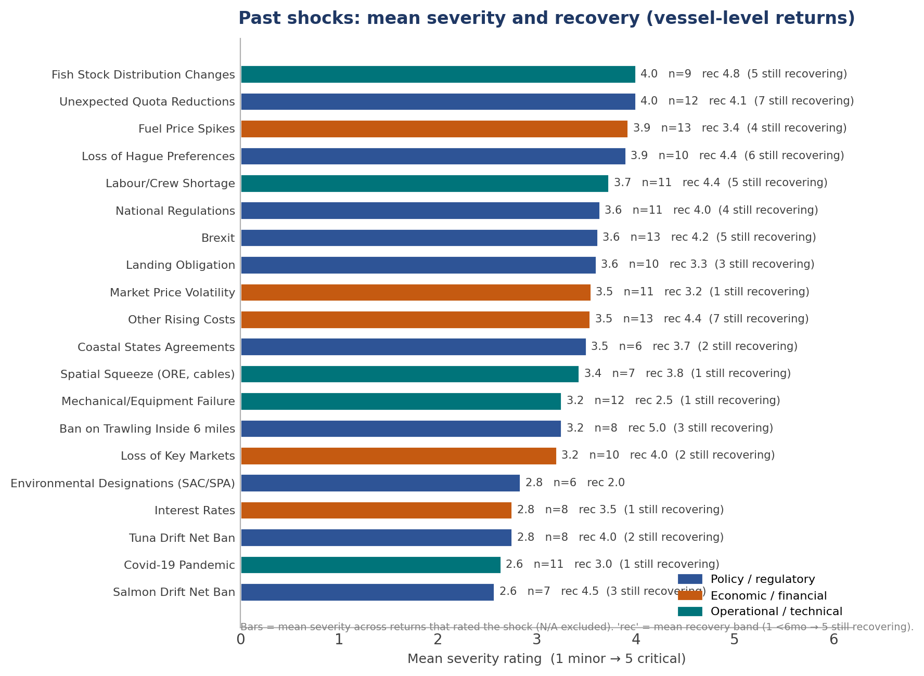
Figure 5. Past shocks ranked by mean severity, colour-coded by category, with mean recovery band and the count still recovering annotated. Vessel-level returns only.
Severity alone understates the picture, because the most severe shocks are also the slowest to recover from. Quota reductions (seven of twelve still recovering), the loss of Hague Preferences (six of ten), other rising costs (seven of thirteen) and crew shortage (five of eleven) combine high severity with recovery answers clustered at 'still recovering'. The inside-six-mile trawl ban records the longest recovery of all (mean 5.0), an unrecovered regulatory shock for the vessels it affects. By contrast, mechanical failure and environmental designations recover comparatively quickly (means around 2.0 to 2.5): they are absorbed rather than structural. The pairing of high severity with long, often open-ended recovery on the policy and quota shocks is the past-shock counterpart of the abandoned vessel-renewal plans seen in the LTCRI evidence: the same shocks that hit hardest are the ones from which the fleet has not bounced back.
PO returns rate their own membership-level shock list rather than the vessel catalogue, but converge on the same heaviest shocks: loss of fishing opportunity and quota reductions (rated critical, severity and recovery both 5), the coastal-states sharing failure and Brexit. They add an institutional shock the vessel returns cannot capture, the regulatory and enforcement burden, rated as a roughly tenfold rise in administrative and legal cost rather than a market hit.

Future shocks: likelihood, concern and priority (Section F)
Section F asked respondents to rate a longer catalogue of prospective shocks on two scales, the likelihood of the shock affecting their operation (1 very unlikely to 5 very likely) and their level of concern about it (1 not concerned to 5 extremely concerned). The product of the two mean ratings gives a priority score out of 25, following the standard risk-matrix logic used in the framework. The figures pool the vessel-level returns; the number of returns rating each shock (n) is given because some prospective shocks were rated by far fewer respondents than others, and a high score on a small n should be read with that in mind.
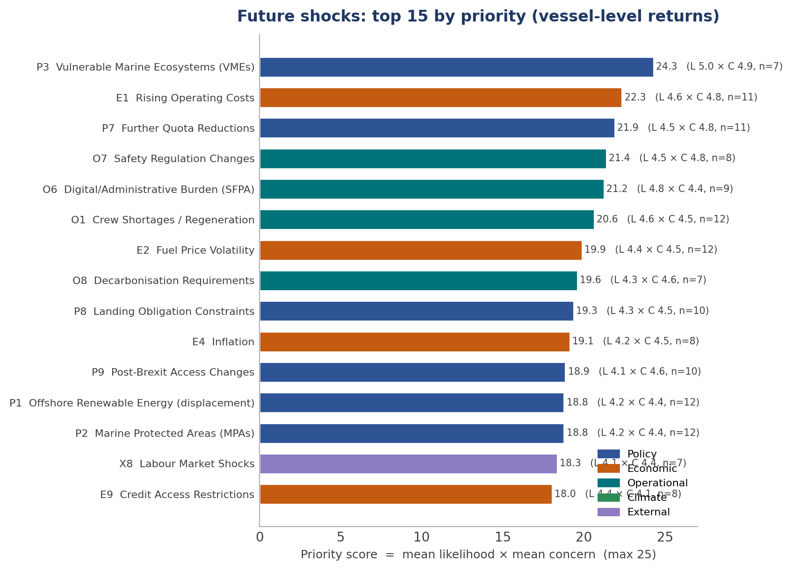
Figure 6. Future shocks ranked by priority score (mean likelihood x mean concern, out of 25). Marker colour shows the Section F category. The count of returns rating each shock is shown.
Rising operating costs (priority 22.3 across eleven returns), further quota reductions (21.9 across eleven), crew shortage and regeneration (20.6 across twelve) and fuel price volatility (19.9 across twelve) head the ranking on both a high score and a broad base of respondents, and are the forward hazards the fleet most consistently expects. Two shocks score higher still but on a narrower base: vulnerable marine ecosystem closures (24.3, seven returns) and safety regulation changes (21.4, eight returns), where a smaller group of mostly inshore and whitefish operators rate likelihood and concern at the ceiling. The administrative and digital burden associated with the regulator also ranks highly (21.2 across nine). The economic and operational categories therefore dominate the near-certain worries, while the spatial-squeeze and climate items carry the highest concern among the operators they bear on.
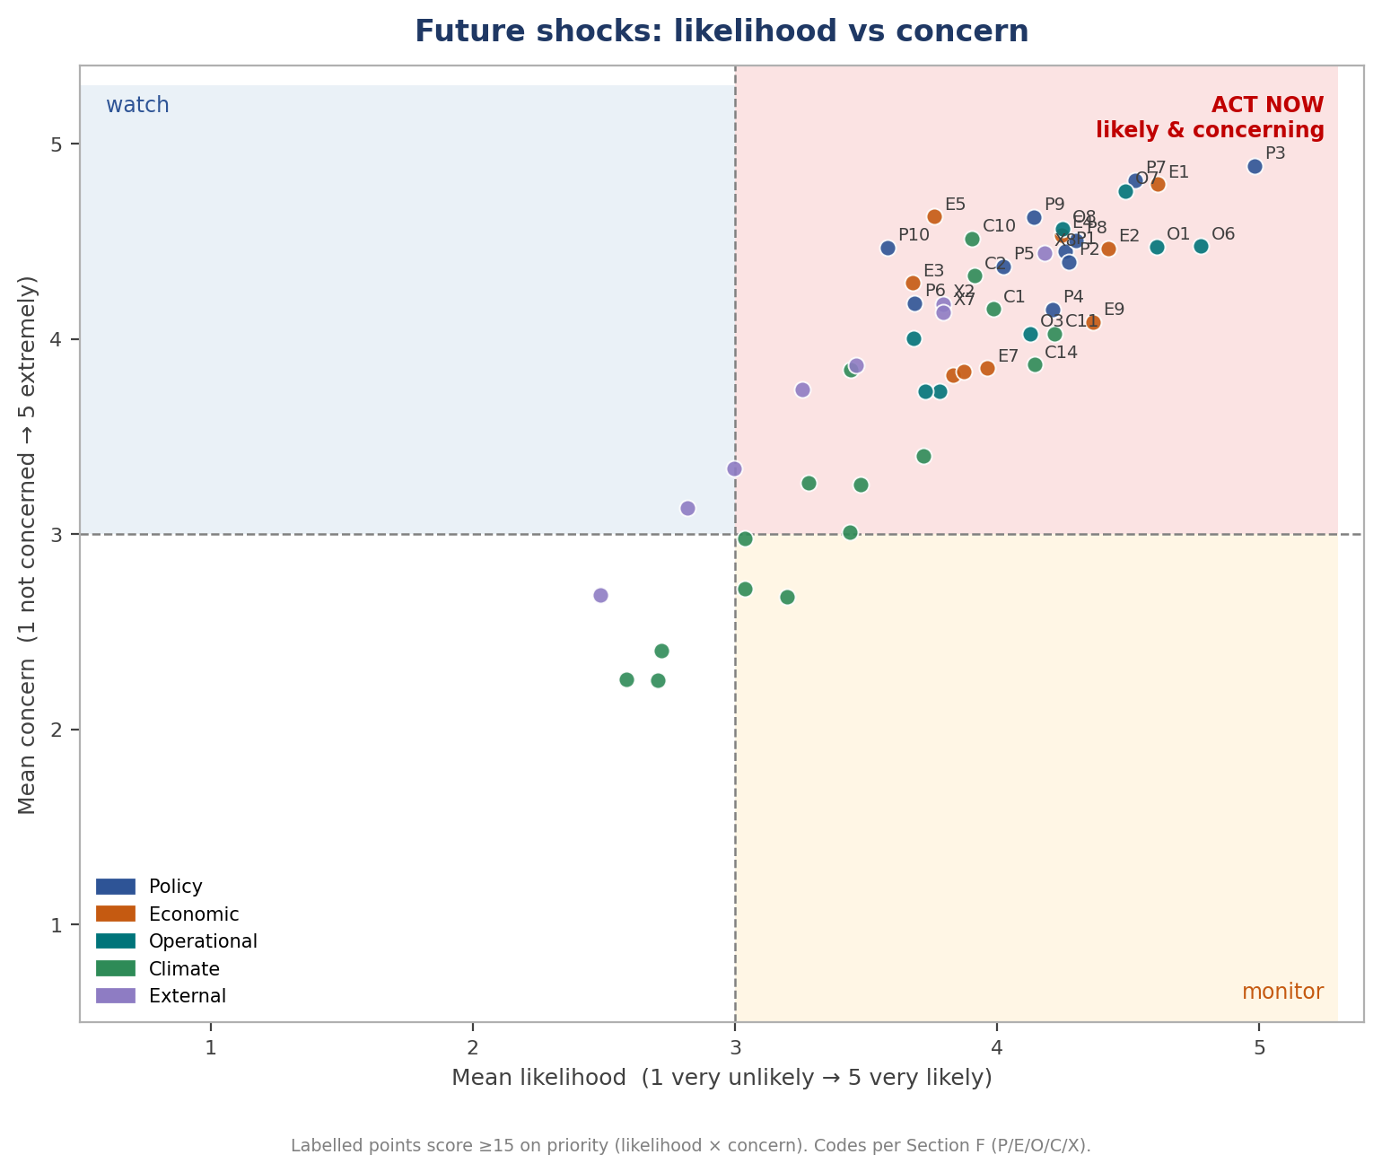
Figure 7. Each future shock plotted by mean likelihood against mean concern. The upper-right 'act now' quadrant holds the shocks rated both likely and concerning; high-priority points are labelled by their Section F code.
Plotting likelihood against concern shows how tightly the two move together: almost every shock the fleet considers likely it also finds concerning, so the points line up along the diagonal into the upper-right 'act now' quadrant rather than scattering. Very few shocks are seen as likely but not worrying, or worrying but unlikely. The cluster in the top-right corner, quota reductions, rising costs, crew regeneration, fuel, the administrative burden and the third-country and Hague items, is the fleet's consensus forward agenda. The handful of points sitting lower and to the left are the climate and external items that some operators do not yet see as imminent, even where concern is moderate.

The persistent shocks: past impact and future worry
The most policy-relevant pattern is the overlap between the shocks that have already hit hardest and those the fleet most expects ahead. Setting past severity and future priority on a common normalised scale shows a core of persistent shocks that score high on both: quota reductions, fuel and rising costs, crew regeneration, Brexit and the Hague and coastal-states question, and the climate-driven shift in species distribution. These are not one-off events the fleet has absorbed but standing conditions it expects to continue or intensify.
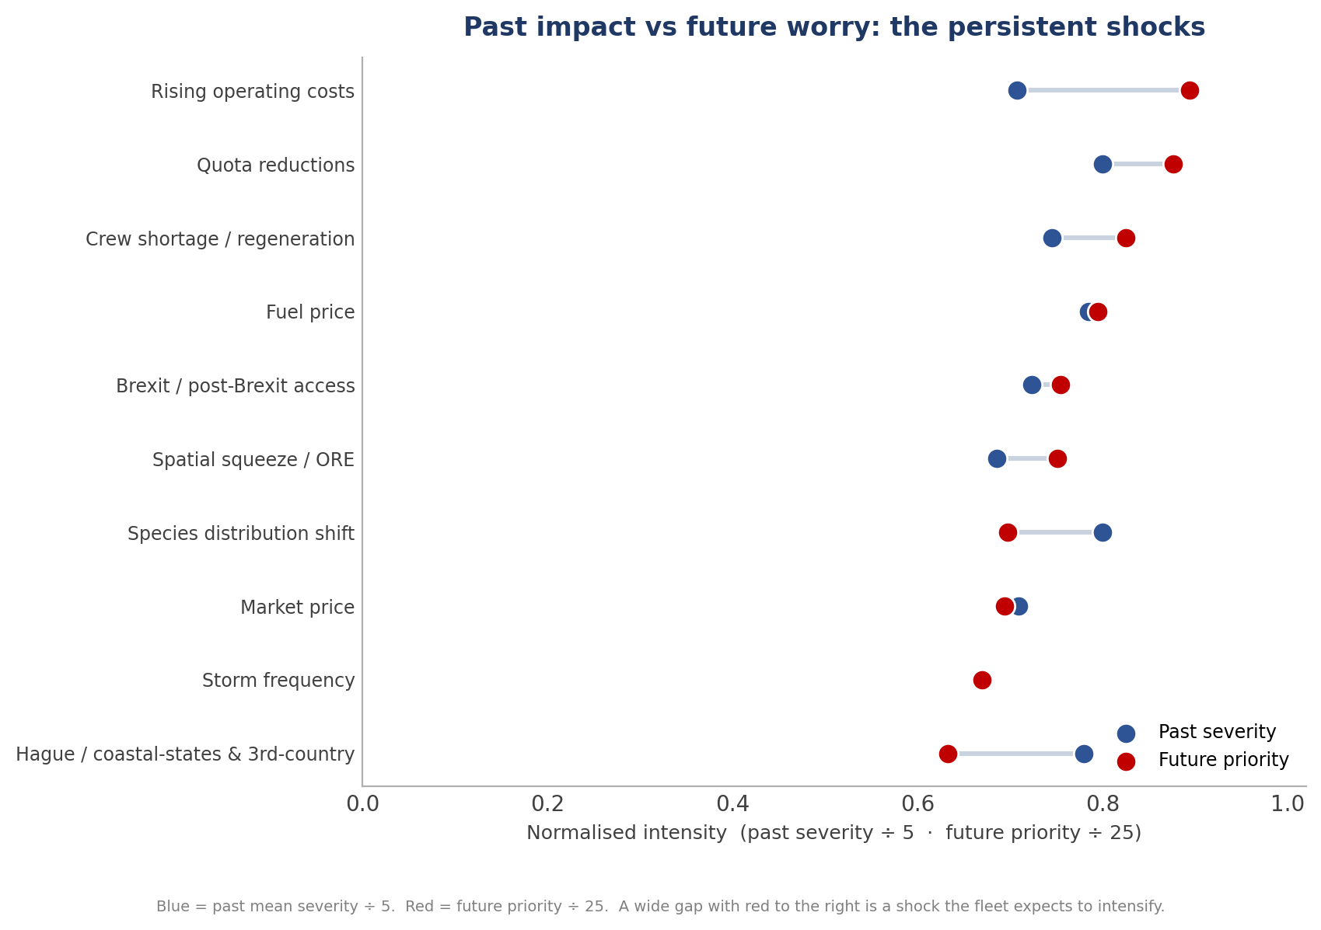
Figure 8. Persistent shocks shown as past mean severity (normalised) against future priority (normalised). A wide gap with the future marker to the right is a shock the fleet expects to intensify rather than fade.
Two readings matter for the framework. Where the future marker sits well to the right of the past marker, the fleet expects the shock to intensify: this is clearest for rising operating costs and for crew shortage and regeneration, both of which the returns treat as worsening structural pressures rather than past events. Where the two markers sit close together at a high level, the shock is a sustained condition the fleet has lived with and expects to persist, which is the pattern for quota reductions and fuel. The one shock where the past marker leads the future marker is the Hague and coastal-states question, which has already done its damage through realised quota loss even as it remains a high forward worry. Storm frequency appears as a future concern without a matching past-severity bar, because too few vessel-level returns rated it in Section B to aggregate, a reminder that the climate items are better evidenced on the forward scale than the historical one in this set.

Resilience Indices
Every index uses the retention-rate principle: 1.0 (100%) means full retention of pre-shock function and 0.0 (0%) means total loss. A score of 0.75 means the same thing on any item, namely that resilience held the welfare loss to 25% of the initial shock impact.
STORI (Section G1): the six short-term operational components
Code | Component | What it captures
ST1 | Gross profit retention (G1.2) | The most direct measure of financial impact: the share of normal gross profit retained during the shock.
ST2 | Crew wage retention (G1.4) | How far the share system transmitted the shock to the crew. Most heavily weighted (0.25) because crew wages set the elasticity threshold.
ST3 | Financial independence (G1.6) | Liquidity stress, measured by the scale of short-term borrowing required.
ST4 | Fishing activity retention (G1.1) | Operational continuity: whether the vessel kept putting to sea at normal levels (days at sea).
ST5 | Crew retention (G1.3) | Proximity to the viability threshold: crew held versus crew lost.
ST6 | Recovery speed (G1.7) | The time dimension of engineering resilience: how quickly gross profit returns to pre-shock levels.
G1.5 (crew wage subsidy, ST4 supplementary) is recorded for interpretation but does not enter the weighted index. Weights: ST2 0.25, ST1 0.20, ST3/ST4/ST5 0.15 each, ST6 0.10.
LTCRI (Section G2): the six long-term capital components
Code | Component | What it captures
LT1 | Net profit retention (G2.1) | After-debt-service performance: the residual available for capital accumulation. The link from short-term survival to long-term capital erosion.
LT2 | Loan term stability (G2.2) | Whether the debt term has been extended as a consequence of the shock.
LT3 | Debt structure stability (G2.3) | Conversion of short-term borrowing into long-term obligation.
LT4 | Vessel renewal timeline (G2.4) | The single most consequential long-term indicator, most heavily weighted (0.25): delay or abandonment of replacement.
LT5 | Asset value retention (G2.5) | Capital erosion through reduced market value of vessel and entitlement.
LT6 | Investment plan retention (G2.6) | Deferral or cancellation of planned investment in engines, gear, electronics and safety equipment.
G2.7a/b (routine and capital maintenance retention) are recorded as leading indicators of future capital deterioration but do not enter the weighted index. Weights: LT4 0.25, LT1/LT2 0.20 each, LT3 0.15, LT5/LT6 0.10 each. The 0.65 retention rate is the boundary between high and low resilience in the vulnerability-quadrant framework.

Short-term operational resilience (STORI): the evidence pooled
The short-term picture divides sharply. A minority of returns describe an operation still putting to sea at close to normal levels with gross profit and crew broadly intact. The majority describe heavy compression of profit, an idle or part-idle vessel, and a crew held in place only by the owner absorbing the shock. Below, each STORI component is read across all returns that scored it.
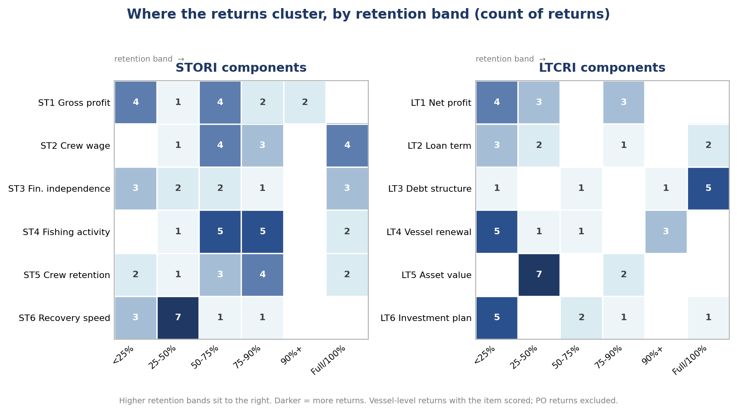
Figure 1. Where the returns cluster on each STORI and LTCRI component, by retention band. Darker cells hold more returns; higher retention sits to the right.

ST4 Fishing activity retention (days at sea)
Reduced days at sea is the most widely reported operational impact. Returns cluster at the middle and lower bands: several report days down 10 to 25% (ISE-1, ISE-3, ISE-6, ISE-8, Ins-1), and several more report a sharper fall of 25 to 50% (ISE-7, ISE-9, ISW-1, ISW-4). One digital return projects days down 50% or more under its priority shocks (ISW-2). A small number report activity unchanged (ISE-2, ISE-4). Where the fall is deep, the causes are mixed: quota-driven idle time with no alternative fishery (ISE-9, ISW-1), deliberate block fishing to control costs (ISW-1), and, in one inshore case, an exceptional weather year compounding the quota position (ISW-4, still tied up in mid-June).

ST1 Gross profit retention
Gross profit retention spans the full range. At the resilient end, two returns retained 90% or more (ISE-4, ISE-8) and one 75 to 90% (Ins-1). A central group retained 50 to 75% (ISE-7, ISW-1, plus ISE-9 and ISW-4 at the lower 25 to 50% band). At the severe end, several retained less than 25% or had turned loss-making (ISE-1, with a loss of around €500,000 since 2021; ISE-3; ISE-9; and the prospective ISW-2 return). The interview cases make the mechanism explicit: profit is squeezed from both sides as landings fall and fuel and other costs rise, and where there is no surplus the operation plateaus 'just about sustaining vessel and crew' (ISW-1).

ST2 Crew wage retention, and the share-system channel
The share system is the dominant transmission channel and recurs in almost every return. Because direct costs are taken off the top before the catch is shared, a cost or quota shock falls on the crew share first. Returns record crew wages retained at 50 to 75% (ISE-5 boundary case, ISE-9, ISW-1, ISW-2, ISW-4) and 75 to 90% (ISE-3, ISE-8, Ins-1), with a few reporting wages unchanged where the share held (ISE-2, ISE-7). The interview cases describe owners absorbing the shock in stages to defend the crew share: ceasing to deduct consumables, forgoing the owner share, drawing down the boat share, and finally subsidising fuel directly (ISE-9, on the order of €6,000 a month; ISW-4, the owner forgoing his own share). One pelagic return raised the crew share from 40% to 45% specifically to hold the crew together (ISE-6).
Supplementary item G1.5 (crew wage subsidy) corroborates this: extended subsidy of more than six months is reported by ISE-1, ISE-9, ISW-1, ISW-2 and ISW-4, and regular subsidy by ISE-5, ISE-6, ISE-8 and Ins-1. Owner subsidy of the crew share is therefore the single most common short-term coping mechanism in the set.

ST5 Crew retention, and the minimum-manning threshold
Crew retention is where several operations sit closest to the viability threshold. Outcomes range from full crew retained (ISW-1, Ins-1) and the expected loss of one of five or more (ISE-2, ISE-3, ISE-7, ISW-4) to the expected loss of three or more (ISE-5, ISE-6). The interview cases identify a hard operational floor: where a vessel is already at minimum safe manning, the loss of one further crew member stops it going to sea altogether (ISE-9, ISW-4). Recruitment difficulty is structural rather than purely financial. One operation reports being unable to recruit Irish crew at all, with the legal route for contract-scheme crew taking 17 months against two to four weeks elsewhere (ISW-4), and another reports failed recruitment even at offered wages of around €35,000 (ISE-9).

ST3 Financial independence (short-term borrowing)
Borrowing responses are bimodal. A group needed no short-term borrowing (ISE-8, ISW-1, ISW-4), but in two of these cases that reflects coping by other means rather than strength: capital raised by selling a vessel (ISW-1), and the household sustained by a spouse's income and the owner's forgone share (ISW-4). Others borrowed materially: €25,000 to €50,000 (ISE-2, ISE-7), €50,000 to €100,000 (ISE-5), and more than €100,000 (ISE-3, ISW-2). The most acute case could not borrow at all: short-term credit was required but the bank had withdrawn access, captured by a new G1.6 option added for the purpose (ISE-9).

ST6 Recovery speed
Recovery-speed answers are the clearest single signal of a shift from engineering to ecological resilience. A cluster expect recovery in one to two years (ISE-1, ISE-2, ISE-9, ISW-1, ISW-4, Ins-1), often conditional on an external event such as a coastal-states mackerel agreement (ISW-1). But four returns mark recovery as a permanent reduction that will never return (ISE-3, ISE-7, ISE-8, and ISE-9 trending that way), the survey's direct equivalent of a breached ecological-resilience threshold. Only one return expects recovery within three to six months (ISE-4).
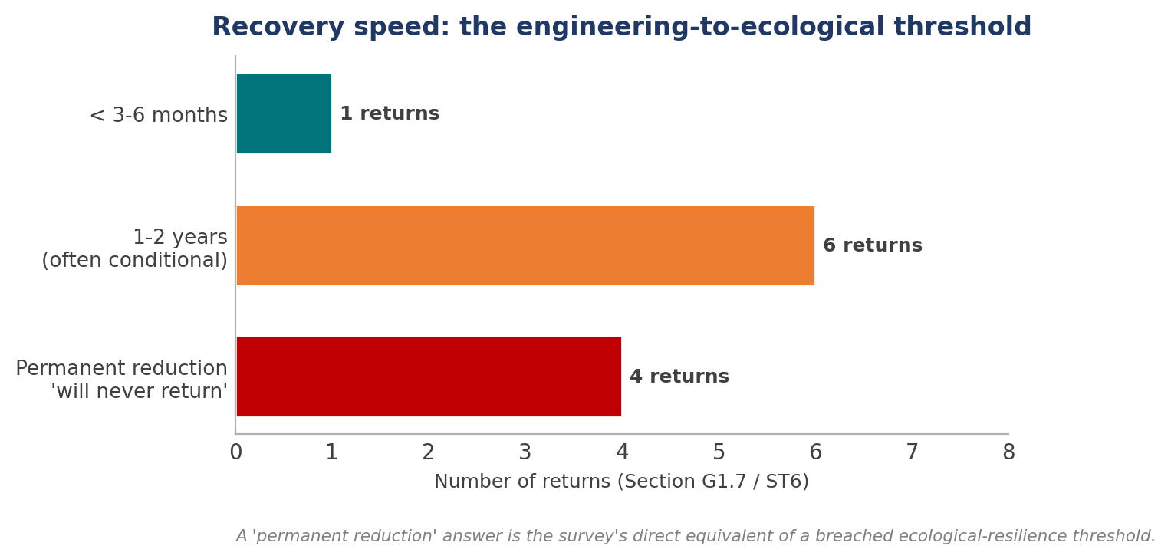
Figure 2. Recovery speed (ST6). A 'permanent reduction' answer is the survey's equivalent of a breached ecological-resilience threshold.

Long-term capital resilience (LTCRI): the evidence pooled
The long-term picture is where the set is bleakest, and where a striking pattern emerges: several operations that look solvent in the short term are deliberately disinvesting for the long term. The lasting cost of survival, in the LTCRI framing, is a capital cycle that has stalled.

LT1 Net profit retention
Net profit, after debt service, is markedly weaker than gross profit across the set, which is precisely the mechanism by which short-term survival becomes long-term erosion. Retention bands run from above 75% (ISE-4, ISE-7, ISE-8) through 25 to 50% (ISW-1, ISW-2, Ins-1) down to below 25% (ISE-3, ISW-4) and outright net loss (ISE-1, ISE-9). Where a vessel retains a healthy gross profit but a thin net profit, increased debt service on newly borrowed funds is the usual explanation.

LT2 and LT3 Loan term and debt structure
Debt responses split between operations carrying little or no debt and those restructuring heavily. Several report no extension and no conversion (ISE-2, ISE-8, ISW-1, the last by raising capital through asset sale rather than borrowing). At the other end, terms were extended by two to five years (ISE-7, ISE-9) or by more than five years (ISE-1, ISW-2), and debt was converted in bands from €25,000 to €50,000 (ISE-7) up to more than €100,000 (ISW-2), with one return facing full debt restructuring (ISE-3). One interview flags a mortgage-payment deferral that functions as a de facto debt conversion and a credit red flag even though the respondent recorded 'no conversion' (ISE-9).

LT4 Vessel renewal timeline
This most heavily weighted component is also the most consistently negative, which matters given the fleet's advanced age profile. A clear majority have no plans to replace the vessel or have pushed renewal out: 'no plans to replace' (ISE-3, ISE-4, ISE-7, ISW-4), renewal at more than 15 years (ISW-1, and ISW-2 in its adverse scenario), or 5 to 10 years (ISE-8, Ins-1 in its adverse scenario). Only the newest pelagic operation sits comfortably, having just renewed in 2021 and stating it will not replace again within the owner's working life (ISW-1). The inshore interview captures the structural cause directly: a wooden boat built in 1988 near the end of its life, with 'no money float in the industry' to replace it (ISW-4).

LT5 Asset value retention
Asset-value erosion is widespread and, in the worst cases, severe. Many returns expect a decrease of more than 25% (ISE-1, ISE-3 at 10 to 25%, ISE-7, ISE-8, ISW-2, ISW-4, Ins-1). The starkest is an inshore east return whose vessel and licence, valued at around €1.8m in 2025, are recorded as effectively nil in 2026 (ISE-1), and an interview vessel described as currently unsellable (ISE-9). The pelagic exception again stands apart: hull and kilowatt/tonnage entitlement value is judged robust and is actively being acquired, even as quota cuts reduce its earning power (ISW-1).

LT6 Investment plan retention, and deferred maintenance
Planned investment has been cancelled outright in a striking number of returns (ISE-2, ISE-3, ISE-7, ISE-8), with smaller deferrals of €25,000 to €50,000 elsewhere (ISE-1, ISE-9). The supplementary maintenance items sharpen the warning. Some operations are cutting maintenance (ISE-2 suspending non-essential routine maintenance and deferring all major overhauls; ISE-8 deferring all overhauls; ISE-7 cutting significantly), while others keep maintenance whole only because a certificate of compliance requires it (ISE-9, ISW-4). Deferred maintenance on an ageing hull is itself an accumulating operational risk, and the survey treats it as a leading indicator of capital deterioration rather than a discretionary saving.

Reading the returns through the vulnerability quadrant
Cross-tabulating STORI against LTCRI (high or low about the 0.65 boundary) sorts the returns into four broad positions. The set does not fall neatly into 'resilient' and 'vulnerable'; the most analytically useful group is the operations that are short-term solvent but long-term disinvesting, which a STORI reading alone would miss.
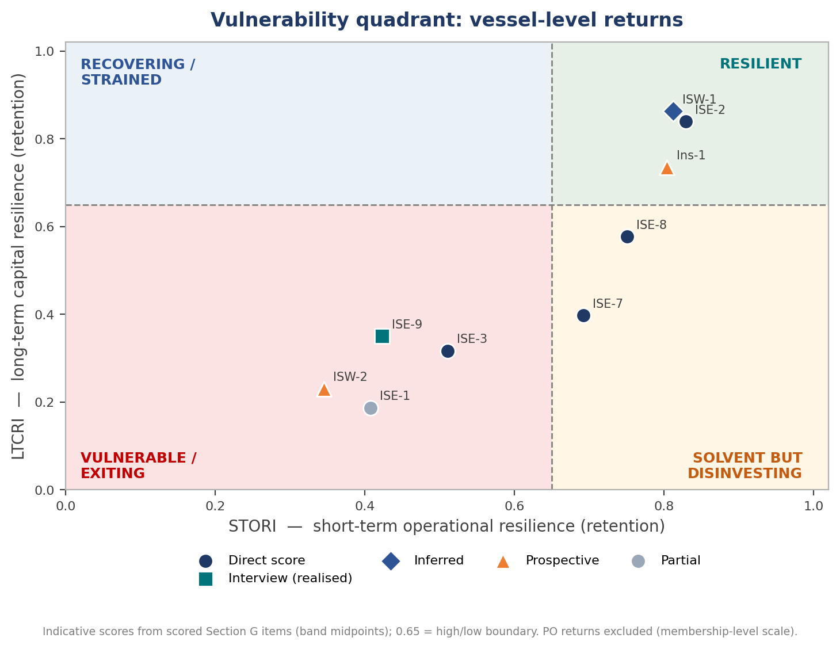
Figure 3. Vessel-level returns plotted on STORI (short-term) against LTCRI (long-term), about the 0.65 boundary. Scores are indicative, from the scored Section G items; marker shape shows the basis of each return.
Position | STORI / LTCRI | Returns that broadly fit | Reading
Resilient | High / High | ISW-1 (pelagic newbuild) | Adapted ahead of the shock through entitlement consolidation, diversification and value capture; thin margins but intact capital cycle.
Solvent but disinvesting | High / Low | ISE-4, ISE-8, Ins-1 (in part) | Putting to sea and broadly profitable now, but renewal deferred, investment cancelled and asset value falling. The lasting cost of survival.
Recovering / strained | Low / Mixed | ISE-2, ISW-4, ISE-6 | Coping through effort change, ground-shifting, household income or supported tie-up, with a one-to-two year recovery in view.
Vulnerable / exiting | Low / Low | ISE-1, ISE-3, ISE-7, ISE-9 | Profit collapsed or loss-making, recovery permanent, renewal abandoned: at or past the viability threshold, with managed exit the realistic endpoint.
Positions are indicative, drawn from the completed Section G items and the surrounding narrative. Returns scored prospectively (ISW-2, Ins-1) describe an expected position under their priority shocks rather than a realised one, and the two partial returns (ISW-3, Ins-2) cannot be placed.

Cross-set resilience themes
Seven themes recur across the returns, cutting across the inshore east, inshore west and PO material. They are the threads that the pooled STORI and LTCRI evidence above keeps returning to.

A common shock spine: Brexit, Hague Preferences and quota
Brexit, the loss of Hague Preferences and unexpected quota reductions form the shared backbone of the set, named among the three most significant shocks in the large majority of returns. The defining feature of these shocks, repeated explicitly, is that they are permanent and unrecoupable rather than cyclical. One PO ranks Brexit as the worst historical shock for precisely this reason (PO-4SE), and the argument has a sharp policy edge: subsidising an asymmetric loss only makes sense if recovery is possible. For the pelagic fleet the dominant blow is the collapse of the mackerel entitlement, traced to the failure of the coastal states to agree a science-based sharing arrangement, with ICES advising cuts of the order of 70 to 77% for 2026 (ISW-1, PO-NW, PO-3IF).

The share system as shock amplifier
The single most consistent mechanism in the set is the share system transmitting and amplifying shocks onto the crew. Because direct costs come off the top, a fuel or quota shock compresses the crew share first, pushing it toward the reservation wage and the point at which crew leave the fleet. Owners respond by absorbing the shock personally, in a recognisable sequence: dropping consumable deductions, forgoing the owner share, drawing down the boat share, and finally subsidising fuel or wages directly. This appears at vessel level (ISE-9, ISW-4, ISE-6) and is generalised at PO level as an 'overdraft-style' economics in which each trip funds the next and owners borrow at 9 to 11% to hold crew through fuel spikes, never recouped on the down-leg (PO-SW, PO-3IF, PO-4SE).
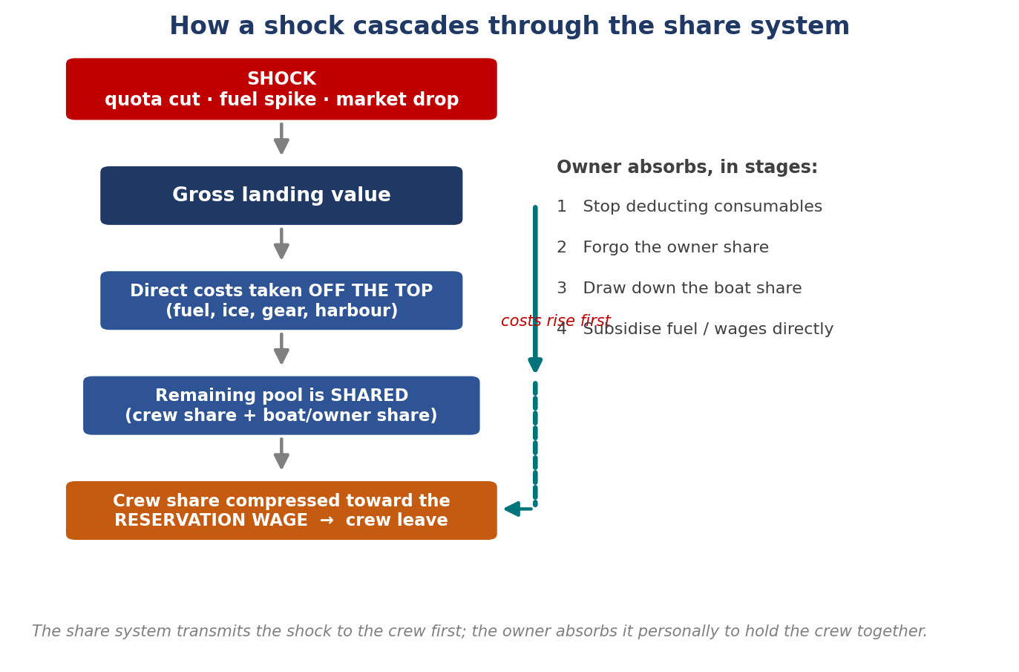
Figure 4. How a cost or quota shock cascades through the share system, and the staged sequence by which the owner absorbs it to hold the crew together.

Crew and generational renewal as a binding, non-financial constraint
Crew shortage is named as a top-rank shock in its own right by several returns (ISE-4, ISW-4, Ins-1) and as a structural future crisis by almost all. The constraint is largely external to fishing economics: a national shortage of skipper's tickets, entrants drawn to better-taxed offshore-wind work, slow and rigid routes for contract-scheme crew, and minimum-manning rules that turn the loss of one crew member into a tie-up. Even well-run operations that retain crew now describe regeneration as failing structurally (ISW-1), so the constraint caps the resilience of the resilient as well as the exposed.

Climate-driven stock redistribution and the spatial squeeze
Climate and space are moving from prospective to realised concerns. Species redistribution is reported as already operational, with stocks moving north, catches mixing and quality falling, and the northward movement of mackerel named as the physical root of the coastal-states dispute (ISW-1, PO-NW). The spatial squeeze (offshore renewable energy, marine protected areas, nature restoration, vulnerable marine ecosystems and cables) is the leading future threat for the inshore and is ranked by one PO above quota and even above climate, on the grounds that it is permanent and largely outside the sector's control (PO-4SE, Ins-1). One inshore return attributes direct displacement to offshore-renewable survey activity pushing the operation off its grounds (Ins-1).

Public support judged misdirected rather than merely insufficient
The criticism of public support is consistent and specific: the schemes are aimed at the wrong constraint. Grant aid funds efficiency, modernisation and the doing-up of acquired older vessels, while the binding problem is raw material (quota) and, for processors, the balance sheet. Brexit and pandemic emergency payments are widely credited with keeping operations in business in the moment, but are judged one-off against a recurring loss and ineffective at building resilience. The recurring asks are an annual rather than one-off Brexit payment, restoration of exploratory-fishing support to develop emerging climate-driven species, a quota-aggregation or consolidation route in place of decommissioning, tax incentives for new entrants, and a simpler, industry-designed grant process. Access barriers (complexity, matching-funding requirements, slow processing, restrictive conditions) are reported as systematically excluding the most constrained operators, who are precisely those in the vulnerable quadrant.

Adaptation: consolidation, diversification and value capture
Where operations have adapted successfully, three moves recur. The first is private consolidation of entitlement: selling a vessel to fund a newbuild and aggregating quota across boats to protect the crew share, the market acting where policy does not (ISW-1). The second is species diversification, most clearly the pivot to albacore tuna that now 'makes the year' for one pelagic operation, and seasonal flexibility across prawns, sprats and herring for an inshore operation (ISW-1, ISW-4). The third is value capture and market agility: landing tuna into Spain to retain quality and handling value, repositioning into a fresh-prawn niche, and diversifying export markets toward China after the Italian market collapsed (ISW-1, PO-4SE). A caution attaches to the first two: diversification is only as good as the development support behind it, and the migration of value to foreign ports is efficient for the vessel but is exactly the community-linkage leakage the wider framework is concerned with.

Institutional and structural risk above the vessel
A layer of risk sits above any single vessel. The producer organisations expect EMFAF support to end after 2028, and describe PO consolidation as the probable endgame against a long-shrinking membership, with one serving chairman candid about being 'the last chairman' of his organisation (ISW-1, PO-4SE). At the financial layer, a quota collapse impairs the value of the asset base and not just income, which weakens banking facilities; one PO reports a pillar bank turning 'nervous' and the risk being withdrawal of the facility rather than merely dearer credit (PO-3IF). Vertical integration, often assumed to build resilience, is reported to raise exposure instead, because an integrated operator cannot scale down linearly when a plant needs minimum throughput, whereas a standalone vessel can still land lower volumes at the highest price (PO-3IF).

What the set implies for the STORI and LTCRI framework
Three implications carry from the returns into the index design. First, the divergence between strong STORI and weak LTCRI in several returns confirms the value of measuring the two separately: a short-term reading alone would classify a disinvesting operation as resilient and miss the stalled capital cycle. Second, the recurring 'permanent reduction, will never return' answer on recovery speed, and the cluster of abandoned vessel-renewal plans, give the framework concrete real-world counterparts for a breached ecological-resilience threshold. Third, the share-system evidence supports the heavy weight placed on crew wage retention (ST2), since owner subsidy of the crew share is the most common coping mechanism in the set and the crew wage is where the elasticity threshold is reached first.
Data-quality items to reconcile against the master key before quantitative use: ISE-5 and ISW-1 carry flagged or wholly inferred Section G cells; ISE-8 has a double-ticked crew-retention item; ISW-2 ranks the same shock twice in Section C; the prospective returns (ISW-2, Ins-1) and the realised interview returns (ISE-9, ISW-4) should not be pooled into one distribution without adjusting for framing; ISW-3 and Ins-2 carry no Section G.

Conclusion
The Irish Fishing Vessel Owner Survey is not a general-purpose data collection exercise. It is a precisely targeted instrument, each section of which was designed to supply specific parameters, patterns, or evidence that the theoretical framework of Chapters 1 to 3 require but cannot derive from secondary data sources. Section B and C supply the enterprise-level vulnerability data that aggregate AER statistics cannot provide. Section D and E document the response side of the IPCC risk framework: what industry and public bodies actually did, and how effectively, in the face of major shocks. Section F generates the forward-looking hazard probability estimates needed for scenario analysis and shock simulation. Section G provides the direct inputs for the STORI and LTCRI index calculations that operationalise Hallegatte's microeconomic resilience parameter at the vessel level.
The principal aims of the Resilience II project (analysing response actions, identifying historical patterns, estimating break-even thresholds, simulating future shocks, and mapping critical warning indicators) each draw on specific survey data streams in identifiable, theoretically grounded ways. The chapters that follow will make these connections explicit as the analysis proceeds, always tracing the pathway from the survey item to the theoretical parameter to the analytical output. The goal is not merely to describe what vessel owners have experienced and how they feel about it, but to use their experience and perceptions to test and refine the resilience framework itself: ensuring that the model of how shocks propagate through the Irish seafood sector reflects the reality that those who work within it actually encounter.
Aspect | STORI (Short-Term) | LTCRI (Long-Term)
Resilience type | Engineering (R_{eng}) | Ecological (R_{eco})
Theoretical basis | Pimm (1984); Holling (1996) | Holling (1973); Zampieri (2021)
Hallegatte (2014) analogue | Instantaneous resilience | Dynamic resilience
Focus | Return to equilibrium | Adaptation to new equilibrium
Measure | Speed and completeness of recovery | Magnitude of permanent change
Financial account | Current / Operating | Capital / Balance Sheet
Timeframe | Within-season / annual | Multi-year / vessel lifecycle
Pre-Shock | Post-Shock | Retention | Interpretation
Gross Profit | Gross Profit | Rate
200000 | 200000 | 100% (1.00) | No impact
200000 | 170000 | 85% (0.85) | Minor impact
€200,000 | €150,000 | 75% (0.75) | Moderate impact
200000 | 100000 | 50% (0.50) | Significant impact
200000 | 50000 | 25% (0.25) | Severe impact
€200,000 | €0 | 0% (0.00) | Critical impact
Code | Measure | What It Captures | Scoring Basis
ST1 | Gross Profit Retention | Direct financial impact on vessel | % of pre-shock gross profit retained
ST2 | Crew Wage Retention | Share system absorption / crew viability | % of pre-shock crew wages retained
ST3 | Financial Independence | Liquidity stress | Inverse of borrowing required
ST4 | Fishing Activity Retention | Operational continuity | % of pre-shock days at sea retained
ST5 | Crew Retention | Proximity to elasticity threshold | % of crew retained
ST6 | Recovery Speed | Return to equilibrium | Inverse of recovery time
Component | Weight | Rationale
ST1: Gross Profit Retention | 0.2 | Direct measure of financial impact
ST2: Crew Wage Retention | 0.25 | Critical for crew retention under share system
ST3: Financial Independence | 0.15 | Indicator of liquidity stress
ST4: Fishing Activity Retention | 0.15 | Operational disruption measure
ST5: Crew Retention | 0.15 | Direct measure of elasticity threshold proximity
ST6: Recovery Speed | 0.1 | Speed of return to equilibrium
Total | 1
Code | Measure | What It Captures | Scoring Basis
LT1 | Net Profit Retention | After debt-service performance | % of pre-shock net profit retained
LT2 | Loan Term Stability | Debt term maintenance | Inverse of years added to loan
LT3 | Debt Structure Stability | Avoidance of debt conversion | Inverse of debt converted
LT4 | Vessel Renewal Timeline Retention | Capital cycle maintenance | % of original timeline retained
LT5 | Asset Value Retention | Capital preservation | % of vessel value retained
LT6 | Investment Plan Retention | Maintenance of capital investments | Inverse of deferred investment value
Component | Weight | Rationale
LT1: Net Profit Retention | 0.2 | Direct measure of long-term profitability
LT2: Loan Term Stability | 0.2 | Indicates debt burden extension
LT3: Debt Structure Stability | 0.15 | Short-term to long-term debt conversion
LT4: Vessel Renewal Timeline | 0.25 | Key indicator of capital cycle disruption
LT5: Asset Value Retention | 0.1 | Capital erosion measure
LT6: Investment Plan Retention | 0.1 | Deferred maintenance/upgrades
Total | 1

Resilience in the Processing and Aquaculture Sectors
This section presents the findings from the industry consultations conducted by the authors in late 2025 and during the first and second quarters of 2026. The results are presented by sector, beginning with Seafood Processing, followed by Aquaculture, and concluding with the Catching Sector. The order of presentation does not imply any ranking or priority.

Methodology employed for the industry consultation
In the response to the tender, the consultants undertook to carry out the data gathering element of the study by taking the following approach.
“Recognizing that the level of detail necessary for this part of the study is best achieved through direct consultation with the seafood industry, the approach proposed will employ a mixed-method approach combining data collection through interviews and surveys...” (extract from tender response)
The approach is qualitative and semi-quantitative, using Likert-scale questions to enable comparison of the relative significance attached by respondents to different issues and factors.
Given that the study sought to assess the resilience capacity of the Irish seafood sector as a whole, the data collection process was structured around three distinct industry subsectors: Aquaculture, Seafood Processing, and Catching. This approach reflects the structure of the industry in practice and enabled a more focused analysis, recognising that each subsector operates in a different context and faces its own specific challenges and opportunities.
The consultants completed the following tasks:
“…the development of appropriate questionnaires and interview templates and the undertaking of direct, person to person, semi structured interviews across the fishing, aquaculture, and fish processing subsectors of the seafood industry. (extract from tender response)
The data arising from this consultation exercise was then used inter alia, for the following purposes:
“These interviews will be used to develop a detailed list of examples of previous shocks to the seafood sector; their impact; and… the actions taken by industry and/or by public bodies in response to each shock.” (extract from tender response)
“Through these consultations, the actions taken in response to these past shocks will be collated, categorised, and evaluated based on both qualitative feedback from those affected and quantitative data from the seafood sector.” (extract from tender response)

Selection of industry participants
Following close consultation with the relevant sectoral managers within BIM and with representatives of the industry, lists of potential participants, seen as representative of each of the sub-sectors, were drawn up and passed to the steering committee for approval.
In the case of the aquaculture and processing sectors, each of the potential participants was written to by the Director of the ESSU, requesting their cooperation, establishing the bona fides of the consultants and setting out the rationale behind the study. A sample of the letter of introduction, is given as Appendix 01.
The consultants then followed up the initial BIM communication by emailing the potential contributors directly, (see Appendix 02 ) setting out the approach being taken, and attaching a link to the structured questionnaire/survey instrument (SI). The industry participants were invited to follow either of two pathways to interact with the study. On the one hand they could opt to complete the questionnaire and return it, or they could decide to have a discussion with the consultants, using the questionnaire/research instrument as an agenda/guidance note for the conversation. Sample examples of the questionnaires, each tailored to the particular industry subsection, are given in Appendix 03.
For the Irish Aquaculture Industry consultation, 23 stakeholders were invited to participate in the study, of whom 19 took part. A list of participants is provided in Appendix 04. Participants were offered two methods of engagement: 9 chose to take part in a structured consultation discussion with the authors and also submitted a form, in all 18 completed and returned the consultation questionnaire. The consultation process was conducted during January and February 2026.
In the case of the Irish Seafood Processing Industry, 27 players were invited to participate in the study. Ultimately, 25 actually took part (two invitees, citing extreme work pressure, declined the invitation). The names of the participants are included in Appendix 04.
Of the 25 participants that engaged with the seafood processing section of the study, 12 opted to have a structured discussion with the consultants. 13 players opted to complete and return the questionnaire, without having a direct conversation with the consultants. The industry consultation took place over November and December of 2025.
The discussions with the industry participants were recorded and summarised to give context and were also converted into completed questionnaires, so that their views could be compared directly with the responses of the other participants. The longer interviews also served to calibrate and ‘ground truth’ the questionnaire responses, a high degree of consistency was observed between the two sources indicating that the views being expressed were common to the full range of participants.
The approach to engaging participants from the Catching Sector differed slightly from that used for the other subsectors. Given the nature of the profession, many potential participants are frequently at sea and therefore less accessible for individual consultation. To maximise participation, the support of the Producer Organisations (POs) was sought to engage as many members as possible.
A series of facilitated group consultation sessions, both online and in person, were organised and moderated by Seaview Marine Consulting. During these sessions, participants were guided through the questionnaire and survey instrument, with each attendee completing and submitting an individual response at the conclusion of the session. This approach enabled broad participation while ensuring that individual perspectives were captured and recorded.

Profile of the participants
Great care was taken during the process of selecting candidates to be invited to participate in the industry study to ensure, insofar as possible, that the major segments of both the aquaculture and seafood processing sectors were adequately represented.
In the case of the seafood processors, the definitions of processor type, used by BIM, (i.e. Finfish, Shellfish, Whitefish, Pelagic and Smoked) were used to organise and guide the choice of candidates to be invited. It was also seen as important that the key representative bodies also be consulted and their views taken aboard, both to provide important context and encourage industry participation.
It may be seen from Figure 01 A-F all of the principal species caught, farmed, or imported by the Irish seafood industry were well represented among the participants. The processor cohort included both export-oriented businesses and companies primarily focused on supplying the domestic Irish market. In addition, participants reflected a broad cross-section of the seafood value chain, with businesses serving the wholesale, retail, and hospitality (HORECA) sectors. All of the main species caught, farmed or imported were also well represented within the group of participants. In addition, the participating processors represented both exporter-oriented operators and companies that were focussed on supplying the domestic Irish market. Further, in terms of the market segment serviced by the participants, demonstrate a widespread across wholesale, retail and HORECA. The exporting processors reported a heavy reliance on wholesale markets overseas.

Figure 01A Type of Seafood Processed Figure 01B % of Product Exported

Figure 01C % of Product to Domestic Market Figure 01D Markets Served by Processors

Figure 01E Export Markets served by Processors

Figure 01F Type of Fish Processed

Figure 01G Source of Raw Product of Processors

Engaging with the Coops and to a lesser extent, the Producer Organisations in the context of seafood processing was also valuable for the study as it recognised the strong and important connection between the processing segment and the catching segment. Although they are distinct parts of the overall industry, they are organically and commercially linked at many levels. The participants in the study represent well in excess of half the value of the Irish fish processing sector and all of the major species processed in Ireland are covered in the spread of the people who contributed.
The same is generally true for the aquaculture segment and hence the representative organisation for Irish aquaculture (IFA Aquaculture) was also closely consulted as part of the industry consultative process. More than three quarters of the total first sale value of the Irish aquaculture sector is represented by the spread of participants. Four aquaculture types were chosen for analysis as part of the scope of the study. Marine salmon farming ( 5 participants), intertidal oyster cultivation (5 participants), Rope grown mussels (4 participants) and Bottom Grown mussels (4 participants), were the included . Whilst other aquaculture types are practiced in Ireland, they were considered either too small, too early in their development or represented by just a single operator, making their inclusion in the study impractical.
Similarly, with regards to the catching sector…To be completed by MK once the sessions have been held

Design of the survey instruments
The design of the survey instruments was informed by the findings of the initial resilience study, Provision of a Scoping Study to Support the Delivery of an Analysis of the Resilience of the Seafood Sector 2024 (Resilience 1). It was also shaped by the resilience framework developed by the authors for the current study, as outlined in Chapter 1. This framework provides a clear definition of resilience and establishes how the concept can be applied and assessed within the specific context of the Irish seafood sector.
In all cases it was decided to base the industry commercial performance analysis on the available and published data sets and studies created by BIM (and the other relevant state agencies) and not to attempt to duplicate that data collection process in the questions posed in SI’s employed in this study.

Overview of the rationale underpinning the Survey Questionnaire structure
The first part of all of the survey instruments (SI’s) is retrospective in nature and sets out to capture, characterise and rank the major shocks which have perturbed the sector over the last twenty years. How the shocks impacted on the businesses of the participants and what actions, if any, they took or assistance they availed of, to mitigate those impacts is then examined. The participants were first asked to identify themselves and, via a series of questions, to ‘place’ their company within their industry segment and to outline the general nature of their trading patterns.
To act as an aide-memoir and to facilitate the process, the participants were given a prompt list of the major historic shocks which were identified in the first resilience study (Resilience 1.) and the participants were asked to add and rate any further shocks they felt were relevant and of sufficient importance to warrant inclusion and characterisation.
They were then asked to focus on the three shocks they considered as being the most significant for their company and to indicate the impact pathway, to estimate the severity of the shock and to evaluate mitigation efforts taken by themselves and/or by the state.
The SI then shifted to a forward-looking perspective and participants were asked to evaluate a range of potential future challenges in terms of their likelihood of occurrence and their potential severity of impact. Participants were also invited to submit additional possible challenges and to evaluate those. These questions map on to the Hazard-exposure-vulnerability transmission pathway set out in Chapter 1 of this study.
The next section of the SI was concerned with vulnerability, and participants were asked to self-evaluate their businesses in terms of their preparedness to face the impacts of potential future challenges. This estimate of ‘preparedness’ maps across to the concept of ‘adaptive capacity’ as set out in Chapter 1.
A recommendation from the first resilience study (Resilience 1) was that a particular focus be placed on evaluating future challenges associated with climate change and a section of the SI interrogated participants in this regard.
Resilience 1 also suggested that spatial squeeze, arising from the establishment of MPA’s and Offshore Wind Farms be given special consideration and this is addressed in the catching SI.
“it is recommended that spatial squeeze, arising from the creation of Marine Protected Areas and the rise of offshore wind farming… be studied and the vulnerability of the … sector to those future shocks be assessed.” (extract from Resilience 1.)
After discussion with industry, it was considered that these likely future marine developments were not as relevant to the fish farmers or the seafood processors, at least in the short or medium term, and so they were not featured in any great depth in the SI’s for these segments.
The final sections of the study concern themselves with questions around the human capital associated with the participant’s business and an assessment of the level of optimism (or lack of it) that the participant felt concerning the future prospects for business success for their enterprise.
In all, six closely related but distinct SI’s were developed (see Appendix 03) for the SI study templates. These were: one for the processing sector, one for catching and four for aquaculture. There was only minor variation between the four aquaculture SI’s, reflecting the differing nature of some of the shocks experienced by the individual sub-segments.
Because modelling of the possible future performance of the key commercial fish stocks is part of the catching sector analysis and the industry interaction with the study was via structured group sessions facilitated by the PO’s, the SI for this segment of the study was more granular in nature, in comparison to the SI’s for processing and aquaculture. Notwithstanding, it did follow the same general pattern and approach, to allow for meaningful inter comparability across the components of the broader Irish seafood sector.

Results and discussion arising from the industry consultations
This section presents and discusses the findings from the industry consultations undertaken with representatives of the Seafood Processing and Aquaculture sectors. The aquaculture participants included producers operating across the principal Irish aquaculture systems, namely salmon farming, rope-grown mussel production, bottom-grown mussel production, and oyster cultivation. Together, these participants represent a significant proportion of the Irish seafood value chain and provide insights from businesses operating in diverse production, processing, and market environments.
The consultations explored participants’ perspectives on the current resilience of their businesses and subsectors, the principal risks and challenges they face, and their capacity to respond to future economic, environmental, regulatory, market, and operational shocks. While each subsector operates within its own distinct context, a number of common themes emerged alongside issues unique to particular species or industry segments.
The findings presented below combine both qualitative insights from the consultation discussions and semi-quantitative data derived from the survey responses. The results provide an evidence-based assessment of the factors influencing resilience across the Seafood Processing and Aquaculture sectors and identify areas where actions may strengthen the long-term sustainability and adaptability of the Irish seafood industry.

Part 1. Seafood Processing

The Retrospective view
Seafood processors who participated were asked to identify their top three shocks to their sectors that have impacted their business As may be seen from Figure 02 below there was clear consensus amongst the seafood processors as to what were the two major shocks to their sector over the last twenty years or so. The number 1 shock was Brexit, and the number 2 shock was the Covid 19 pandemic. Identifying the number 3 shock was not as clearcut a process.
Perhaps surprisingly, the Great Economic Depression of 2010 emerged as the number 3 shock. Even though it occurred twenty-five years ago it has left a strong impression on the processor group.

Figure 02 Top retrospective shocks identified by seafood processors

Focussing on the shock ranked as Number 1 by the Irish Seafood Processors: Brexit
Brexit was a complex and deep-seated shock that adversely impacted the Irish seafood processing sector across a wide range of fronts (see Figure 03). Having said that, one area of impact stands out clearly from the others and that is access to raw material, which in this case equates to cuts in quota arising from the UK leaving the EU.
Brexit, according to the processing respondents also caused a significant increase in costs, which is not really a surprising finding, given that the loss of raw material would drive up costs across a number of budget headings and the complications in logistics for exports also added to transport and compliance costs.

Figure 03 Ranked impacts of Brexit ( No. of respondents)

The complex and multilayered nature of the Brexit shock is visible from Figure 03. It also shows that the impacts were not uniformly experienced by the respondents. Those processors depending on the ‘quota-cut’ stocks felt the loss of raw material most keenly, while those without that exposure cited rising costs and disruption to market access as their principal pain points.
Brexit would also seem to have been a cloud without any silver lining, as apart from the extra funding made available under the Brexit Adjustment Reserve (BAR), none of the respondents reported any positive element to the shock.
Breaking down the impacts into their individual components was revealing. Firstly, the SI looked at the financial implications for the processing companies

Figure 04 Impact of Brexit on the Cash Flow of Seafood Processors ( % of respondents)

Despite the BAR, the impact of Brexit on cash flow was reported as being quite severe. Those indicating problems in the ‘moderate’, severe’ and ‘extreme’ ranges far outweighed those less affected.

Figure 05 Impact of Brexit on the profit of Seafood Processors ( % of respondents)

Profitability reduction followed a similar, but slightly more negative pattern to the cash flow hit. Only a very small number of respondents said that they had not taken a knock to their profitability.

Figure 06 Impact of the reduction of price due to Brexit on Seafood Processors ( % of respondents)

The price data is interesting and at first sight somewhat counter intuitive. It shows that Brexit was not really a market shock, it was in fact predominantly a raw material and logistics shock. All of the processors experienced increases in their operating costs, a depressing of their profits and a difficult stretching of their cash flows.
In fact, during the interviews a number of participants reported price rises, but they stressed that these did not compensate for the loss of quota and/or the sharp increase in costs associated with the shock.

Figure 07 Impact of the increase in production costs due to Brexit on Seafood Processors ( % of respondents)

As one might expect, those processors exposed to a reduction in raw material also reported a sharp increase in costs. With lower throughput in their plants to absorb their fixed costs, efficiencies of production fell and costs per unit increased as a result of the lower volumes. Those processors less exposed to the reduction in raw material availability were spared these volume/efficiency related cost increases and so their experience of the Brexit shock was comparatively more benign with regard to cost increases.

Figure 08 Impact of the Brexit on the balance sheet of Seafood Processors ( % of respondents)

The damage to company balance sheets (see Figure 08), is illustrative of the uneven way the Brexit shock impacted on the sector. Those not exposed to the quota cuts were able to find solutions, albeit expensive ones, to the logistical disruptions they were subjected to and thus protect their balance sheets.
Those exposed to the quota cuts were left facing permanently reduced turnover and reduced operating efficiency due to lack of raw material supply. For them this is an R-eco scenario, for the others it is R-eng.

Figure 09 Impact of the reduction in raw material availability due to Brexit on Seafood Processors ( % of respondents)

The reported situation concerning access to raw material (Figure 09) follows a similar pattern to the balance sheet impact. About half of the processors were not badly impacted, but the other half were severely disadvantaged.

Figure 10 Impact of market contraction due to Brexit on Seafood Processors ( % of respondents)

The issue of market contraction (Figure 10), at first sight, seems at odds with the reported situation concerning price. However, the face-to-face interviews gave context and explained that this was more of a temporary phenomenon associated with disruptions in the route to market rather than any lasting contraction in the marketplace for Irish processed seafood products.

Figure 11 Impact of the disruption in route to market due to Brexit on Seafood Processors ( % of respondents)

As Brexit bedded in and the restrictions at British ports servicing the EU markets began to bite, the Irish seafood processors reported significant levels of disruption until new routes were established. Those respondents less reliant on exports did not suffer as badly and this mixed nature of the sector is reflected in Figure 11 above.

Figure 12 Impact of the transport cost increases due to Brexit on Seafood Processors ( % of respondents)

Figure 12 highlights a clear trend of increased transport costs associated with Brexit. Respondents reported that, although the initial disruption eased and alternative routes to market were established, transport costs remained significantly higher than pre-Brexit levels. Transportation was consistently identified as one of the areas most affected by these increased costs.

Summary of the insights on the impacts of Brexit gained from the industry consultation
- The Brexit shock was an entirely negative experience, with no upside reported by the Irish seafood processors, despite the provision of the BAR funds
- No positive opportunities, arising from the shock, were reported
- For the pelagic processors its impacts were deeply in the R eng zone rather than R eco, at least for the foreseeable future. Any improvement was seen as being contingent on long term stock recovery, which is an uncertain prospect
- Brexit brought with it increased costs across a range of overheads

Responses by the Seafood Processors to the Brexit shock
Seafood processors were asked to outline their different responses to Brexit and to indicate their level of success in counteracting the shock.

New Markets
Because Brexit was more of a raw material and logistics type shock, the responses to this query were varied and somewhat confused ( Figure 13). Notwithstanding, a majority of respondents did cite their efforts as being ‘very successful’ or ‘moderately successful’.

Figure 13 Level of success in attempting to find new markets ( % of respondents)
Based on the face-to-face interviews and the context they provided, it may be inferred that the respondents who opted to seek out new markets were attempting to diversify away from the UK market and to find markets more easily accessible to Irish producers.

Figure 14 Level of success in attempting to bolster cash flow ( % of respondents)

In the event of a major shock, most businesses switch their focus away from longer terms strategic issues and concentrate on surviving in the short term. Successfully managing cash flow is absolutely key in these circumstances and the graphic above shows that the Irish processors followed this path and were, broadly speaking, successful in their efforts to maintain sufficient levels of solvency. This speaks to good levels of adaptive capacity from a financial point of view.

As with cash flow management, attempting to reduce overhead is a typical response when facing into a severe shock situation. The data from the respondents show that virtually all of them did take some action or actions to reduce their costs, with varied levels of reported success (Figure 15).

Figure 15 Level of success in attempting to reduce cost base and find savings ( % of respondents)

Once again, the face-to-face interviews provided some context as to why some respondents met with little success despite their best efforts. Basically, some of the processors, particularly the pelagic operators, face a situation where they have a base block of fixed costs that are intractable and without enough turnover to cover these costs, they are in a difficult situation unless they can find alternative sources of raw material to effectively be the ‘grist for their mill’.

Figure 16 Level of success in attempting to change route to market ( % of respondents)

Figure 16 above shows that most of the respondents did take action to change their route to market post Brexit and that, in general, they managed to do this successfully. Feedback from the interviews suggest that many respondents opted to describe their action as ‘moderately successful’ because they were left with a residual situation that was not as convenient or cost effective as the pre-shock situation.
For example, some of the new routes shortened shelf life and cost more to avail of than the original solutions.

Figure 17 Level of success in attempting to change product mix

The standout feature of the Figure 17 above concerning efforts to pursue a strategy of changing product mix as a response to the Brexit shock is that a significant portion of the respondents chose not to pursue this action. This reinforces the message coming through from the respondents that Brexit was a shock primarily centred around access, or the lack of it, to raw material and long-term disruption of the route to market. Whilst some respondents did try changing their product mix, they do not report especially high levels of resultant success.

Focussing on the shock ranked as Number 2 by the Irish Seafood Processors: Covid 19
COVID-19 was identified by respondents as the second most significant shock affecting the seafood processing sector. The pandemic disrupted supply chains, workforce availability, logistics, and market demand, creating significant challenges for processors. The consultations examined the extent of these impacts and assessed the effectiveness of the actions taken by businesses to adapt to and manage the effects of the pandemic.

Figure 18 Impacts/Effects of Covid 19 shock reported by Seafood Processors (no. of respondents)

It may be readily seen from Figure 18 above that the processing sector felt the shock from Covid 19 in quite a different manner when compared to their experience with Brexit.
Covid 19 was a shorter term, sharp disruptive shock, whose main negative feature was disruption to market access and interruption of the route to market. Whereas Brexit’s most prominent and enduring feature was long term loss of raw material supply, especially for the pelagic processors.

Figure 19 Impacts/Effect of Covid 19 shock on cash flow reported by Seafood Processors (% of respondents)

Given how suddenly Covid 19 restrictions were imposed, it is perhaps surprising that the negative impact it had on cash flow was not even more severe than reported in figure 19 above. Some segments of the processing sector were particularly severely affected, with Nephrops processors providing a notable example. In addition to experiencing a collapse in demand within key markets, discussed later in this section, processors were required to continue purchasing catches from fishers. As a result, they incurred significant cash-flow pressures while simultaneously bearing the cost of storing unsold product in cold storage facilities until those markets reopened.

Figure 20 Impacts/Effect of Covid 19 shock on profit reported by Seafood Processors (% of respondents)
Whilst the impact on cash flow was negative, it was at least comparatively short lived. Loss of profits (Figure 20) due to Covid 19 showed a starker, longer term picture as may be seen from the graphic above. The majority of the sector reported that their profits had been moderately or severely impacted, whilst only a very few emerged unscathed from the shock.

Figure 21 Impacts/Effect of Covid 19 shock of reduction in price reported by Seafood Processors (% of respondents)
It is interesting to note that the loss of profits illustrated in Figure 20, does not seem to be directly related to any great drop in prices arising from Covid 19. A substantial majority of the respondents reported that their prices had not been affected at all or had only seen a mild or moderate decline (Figure 21).

Figure 22 Impacts/Effect of Covid 19 shock on increased production cost reported by Seafood Processors (% of respondents)
The conundrum of what caused the profit losses attributed to the Covid 19 shock is largely resolved when one considers Figure 22 above, which explores the influence the pandemic had on the production costs of the respondents. A substantial proportion of them reported extreme and severe cost increases arising from Covid 19 and these would have inevitably depressed profits, as reported. An example of the sort of cost increases seen at the time, was the skyrocketing of the cost to get a refrigerated container of pelagic product to market in comparison to the pre-pandemic price.
Figure 23 below, rounds out the financial impact picture of the COVID-19 pandemic. It may be seen that the respondents report a largely moderate degree of damage to their balance sheets, despite the heavy loss of profits. From this it may be reasonably deduced thus the impacts of COVID-19, whilst severe, were relatively short lived in nature. This demonstrates that the industry’s adaptive capacity and subsequent resilience was in the Reng area rather than in the Reco zone.
Figure 23 Impacts/Effect of Covid 19 shock on balance sheet reported by Seafood Processors (% of respondents)
Notwithstanding, the fact last there were no quota cuts associated with the COVID-19 pandemic, it may be seen from figure 23 below, that some of the respondents did experience a difficulty in maintaining their raw material supply. This may be largely explained by the breakdown in the supply chain of imported seafood. Any more than the disruption experienced by the Irish seafood exporters; the companies dependent on seafood imports were also equally disrupted. Conversely, some sectors of the Irish seafood processing industry, such as the salmon farmers, were largely unaffected by the pandemic as they were able to freeze production temporarily and then resume supply to their export markets when the transportation logistics resolved themselves after the pandemic. Similarly, those businesses supplying multiple retail stores with domestically sourced products were also largely unaffected.

Figure 24 Impacts/Effect of Covid 19 shock on reduction in raw material reported by Seafood Processors (% of respondents)
The picture emerging concerning the impact of COVID-19 on the market for processed Irish seafood products is also a mixed one. It may be seen from figure 25 below, thus virus certain segments of the industry we're very badly affected by market contraction or market closure whilst others we're not so severely impacted. In particular, those segments of the industry heavily dependent on the HORECA market in Europe experienced a particularly torrid time during the COVID-19 pandemic. Those respondents supplying the multiple retailers both domestically and within the broader EU marketplace fared much better. Some even reported a slight uptick in their businesses as consumers switched to home entertaining to substitute for the closure of restaurants and cafes during lockdowns.
Figure 25 Impacts/Effect of Covid 19 shock on market contraction reported by Seafood Processors (% of respondents)
Figure 26 below captures the respondents’ views concerning the temporary loss of market opportunity experienced by some segments of the processing sector during the pandemic. As discussed above, some segments, notably those whose output was mainly destined for the EU HORECA market, experienced a very sharp impact.

Figure 26 Impacts/Effect of Covid 19 shock on access to routes to market reported by Seafood Processors (% of respondents)
Also as discussed above, the survey bore out the views expressed during the face-to-face meetings concerning the very sharp increase in transportation costs experienced by the sector. A worldwide scarcity of refrigerated containers emerged during the pandemic as units were stockpiled in ports around the world, causing severe disruption to the supply chain for shipborne perishable foods.

As figure 27 below shows, the disruptions in the supply chain led to sharp transport cost increases for some of the seafood processing sectors, whilst others were much less severely affected.

Figure 27 Impacts/Effect of Covid 19 shock on transport costs reported by Seafood Processors (% of respondents)

Summary of the insights on the impacts of Covid 19 gained from the industry consultation
- Different segments of the Irish seafood processing industry had widely differing vulnerabilities
- Whitefish, farmed oysters and Nephrops were heavily dependent on the HORECA segment of the EU market and displayed little adaptive capacity in the face of its closure
- Pelagic processors were exposed/vulnerable to disruption in their route to market arising from the shortage of refrigerated containers
- Albeit to a greater or lesser extent, all of the respondents reported increased operating costs and decreased profits arising from the pandemic
- Although extremely challenging at the time, Covid 19’s effects were relatively short lived, and the sectors response was in the R-eng range rather than the R-eco zone.

Analysis of the Irish seafood processors’ responses to Covid 19.
Despite the fact that disruption to market access was cited by a substantial proportion of the respondents as a major impact of Covid 19, it may be seen from Fig 28, that relatively little success was enjoyed by those that attempted to change the market for their products. The proportion of players that reported no success, little success or did not try to change is decisively higher than those that did attempt this mitigating action. It is difficult to state why the action enjoyed little long-term success, and it may be seen from the subsequent trade statistics (Source BIM Business of Seafood) that, generally speaking, once the pandemic was over the historic trade flows reasserted themselves and status-quo ante was reestablished.

Figure 28 The relative success of attempting to find new markets in response to Covid 19 (% of respondents)
In contrast, Figure 29 below concerning actions taken by the respondents to bolster their cash flows, shows a much more definitive picture. The majority of the respondents did take action, and they did report some degree of success as a result.

Figure 29 The relative success of attempting to bolster cash flow in response to Covid 19 (% of respondents)

Reduction or control of costs is a constant preoccupation of all of the respondents whether facing a pandemic or not. Figure 30 below demonstrates how challenging this objective can be, especially in a crisis. About half of the respondents reported none or very little success, whilst the other half did manage to make some progress in reducing their cost bases. It may be taken as read that the companies reporting the least success are the same companies that reported the worst loss of profits and most negative balance sheet impacts displayed above.

Figure 30 The relative success of attempting to reduce cost base in response to Covid 19 (% of respondents)

A similar pattern of mixed success emerges from the respondents regarding their efforts to change their routes to the market as may be seen from Figure 31 below. We know from reporting at the time that a number of processors, who would have been suppliers to the HORECA segment domestically and in the EU, put vans on the road and started selling directly to the public and enjoyed some success in doing so.

Figure 31 The relative success of changing route to market in response to Covid 19 (% of respondents)
Attempts by respondents to change their product mix appeared to meet with relatively little success as may be seen from figure 32 below. A significant proportion of respondents did not attempt this form of mitigation and from commentary it would seem that they took a ‘wait and see’ approach betting that the pandemic would run its course within a reasonable timeframe and thereafter they could revert to their normal business patterns.

Figure 32 The relative success of attempting to change product mix in response to Covid 19 (% of respondents)

Summary of the insights on the responses of the Irish seafood processors to Covid 19 gained from the industry consultation

- The majority of the respondents reported success in managing their cash flows during Covid 19. An ability to maintain adequate cash during a crisis is a good indicator of fundamental adaptive capacity
- Similar to cash management, the bulk of the respondents also reported some success with regard to reducing or at least tightly controlling costs during the pandemic, another indication of strong, if not overly inventive, adaptive capacity
- The sector appears to have displayed more imagination and ingenuity, all aspects of successful adaptive capacity, in terms of seeking alternative routes to market and indeed alternative markets, although those efforts may have been short lived and were not necessarily pursued post pandemic.

Focussing on the shock ranked as Number 3 by the Irish Seafood Processors: The Great Economic Depression (GED) of 2010

Figure 33 The effects of GED2010 on seafood processing (no. of respondents)

The profile of impact of the GED 2010 shock was quite different to the profiles of the Brexit and the Covid 19 shocks. Its major pain points were a reduction in prices, increased costs and to a lesser extent, disruption to the marketplace and access to it.
As this shock occurred some 25 years ago, and detailed information is no longer readily available, the consultation findings are presented in summary form. The discussion focuses on the principal impacts and industry responses rather than providing a detailed account of the sequence of events.

Financial Impacts of GED2010
Figures 43A-E (reported as % of respondents) capture the financial impacts GED 2010 had on the Irish Seafood Processing Sector as recalled by the respondents to the study.

Figure 34A The impact of GED on cashflow Figure 34D The impact of GED on price

Figure 34B The impact of GED on profits Figure 34E The impact of GED on production costs

Figure 34C The impact of GED on the balance sheet

Summary of the financial impacts
- GED 2010 had a strong negative impact on the prices respondents could charge for their products
- Simultaneously, the processors saw substantial increases to their costs, leading to a tight squeeze on profitability
- Cash was also difficult to manage as the depression brought about a general credit squeeze.
- Notwithstanding, the sector did show considerable financial resilience as damage to the company balance sheets was reported as being largely moderate.

Summary of the general marketing and logistics impact of GED 2010
Figures 35A-D (reported as % of respondents) capture the general marketing and logistics impact of GED 2010 had on the Irish Seafood Processing Sector as recalled by the respondents to the study.

Figure 35A Raw product availability Figure 35C Market contraction

Figure 35A Disruption in route to market Figure 35A Transport cost increase

Summary of the general marketing and logistics impact of GED 2010
- Severe difficulties with the market, both in terms of contraction and access were reported. Because of the broad societal impact of the GED 2010, consumers curtailed their eating out habits and also opted for the most economical meal solutions they could find. This caused acute problems for processors strongly exposed to the domestic market.
- Because the depression was both domestic and global, the exporters also felt the pinch as EU consumer spending on seafood products was also sluggish.

Summary of the actions taken by the processors in response to the GED 2010
Figures 36A-D (reported as % of respondents) captures the relative success (% of respondents) of the actions taken by seafood processors in response to GED 2010 as recalled by the respondents to the study.

Figure 35A The relative success of Figure 35B The relative success of bolstering cash flow
attempting to find new markets

Figure 35D The relative success of changing route to market
Figure 35C The relative success of reducing cost base.

Summary of the actions taken by the seafood processors in response to the GED 2010
- The processors did show considerable adaptive capacity in terms of the financial management during the crisis. They reported substantial success in terms of driving out costs and strengthening their cash flow positions
- They were also active and moderately successful in terms of their approach to the market and reported significant success levels in terms of finding new markets and improving their access to existing markets.

General Summary Seafood Processing
Arising from the experience of weathering all of the three shocks examined in some detail above, the respondents emphasised a number of key insights.
- For the most part, the Irish Seafood producers demonstrated considerable adaptive capacity in terms of their financial acuity, by being able to cut their costs, bolster their cash flows and shore up their balance sheets, whilst under extreme pressure
- From the interviews, there was a consensus that Brexit (and the subsequent quota cuts to safeguard stock recover) was likely to have the deepest and longest lasting negative impacts of all three of the ‘big shocks’
- This ‘semi-permanent’ negative impact of Brexit was most acutely felt by the pelagic processors, although all of the sectors had been negatively affected to a greater or lesser degree.

Seafood Processing

A qualitative, semi-quantitative review of state-led actions to mitigate the impacts of the shocks

“Through these consultations, the actions taken… (by the state)… in response to these past shocks will be collated, categorised, and evaluated based on … qualitative feedback from those affected…” (Extract from the response to tender)
Via the qualitative and semi-quantitative sectoral survey methodology, this section considers the efficacy of the state’s various responses and efforts in support of the seafood processing sector. In effect, the section sets out to look at the tools at the state’s disposal and how well those tools worked in the eyes of the beneficiaries.
In almost all circumstances (with the exception of the Covid 19 pandemic) the state has abided by the constraints set out by the Common Fisheries Policy and its implementing regulations, so as not to contravene state aid laws and thereby distort the marketplace. These constraints have, from time to time, frustrated the Irish seafood industry who have sought more direct government intervention in the past, into areas such as fuel and/or wage subsidies or direct subsidies following natural catastrophes. Also, the state of the Irish economy and how much leeway the exchequer could afford at particular points in time has often been a constraining factor.
The Covid 19 pandemic was a highly unusual shock in that the government intervened with widespread direct working capital subsidies to maintain employment and preserve social cohesion. In general, it may be seen from the graphic above that the respondents felt that these supports had been effective and they were also praised in the face-to-face consultations.

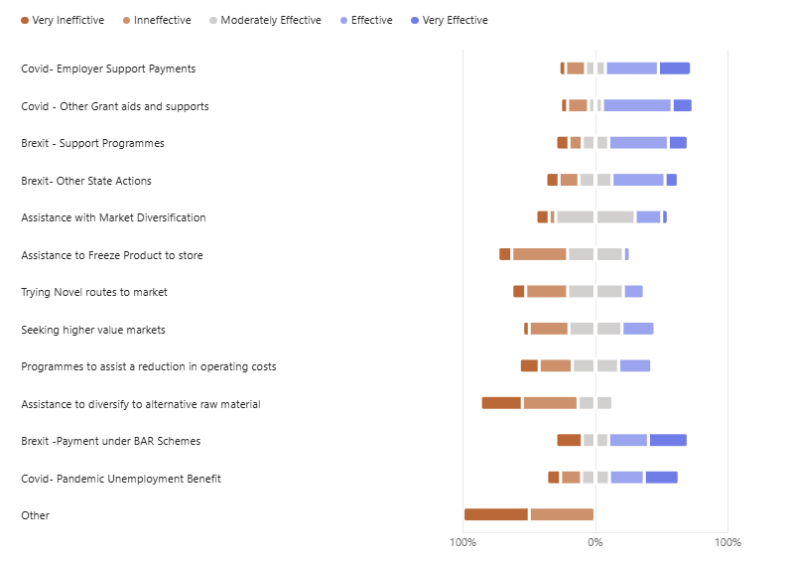
Figure 36 The reported effectiveness of state actions taken
Other state co-sponsored support schemes did not garner quite the same level of support and were given a poor efficacy rating by the respondents. These included state sponsored efforts to assist with the costs of temporarily putting product into freezers and diversifying raw material sources. Finding novel routes to higher value markets and reducing operating costs, received a somewhat more favourable response, although they were not universally approved.
In the graphic above, the ‘other’ category concerned an expression of dissatisfaction towards a BIM scheme to assist with capital expenditure for automation and modernisation. It is not clear if the source of disgruntlement was connected with the manner of the scheme’s administration or about its impact in terms of the actions it was designed to encourage.
In one of the face-to-face interviews, frustration was expressed about the fact that the processor had invested heavily in automation, utilizing the BAR scheme and then subsequently learned about the heavy quota cuts being pursued in the pelagic sector to protect the stocks, rendering the investment, in their view, somewhat superfluous.
There is not a perfect corelation between the views expressed by the respondents in the section of the questionnaire dealing with the ‘three big shocks’ and this more general section of the questionnaire, which does not interrogate based on a particular shock.
In the shocks section they did report that they had enjoyed some success in terms of finding new markets and better routes to market, but that positivity did not entirely follow through to the section evaluating the efficacy of state actions.
Notwithstanding, based on the interviews and the response to the SI, the sector essentially expressed the view that state financial assistance was an important component of their adaptive capacity and that it had assisted them greatly, sometimes in very tough times.

Seafood Processing: The prospective view emerging from the Irish seafood processing sector

Probability of recurrence and potential severity of impact
Having reviewed the past, the participants in the study were then asked to carry out a future looking exercise. It had several dimensions. In the first instance, they were to try to look into the future and to assess the challenges they saw coming down the line that the sector might have to cope with. This part of the enquiry also had two dimensions. The first was to estimate the likelihood of a particular named challenge becoming a shock and the second was to give that potential challenge a severity rating.
By combining likelihood and severity, a ‘heat map’ can be created. This approach is commonly employed as a technique in risk management and is useful in guiding players in the sector as to where to prioritise resource deployment in the preparation of mitigating measures to ease the impact of potential future shocks. Risk heat maps visualize risk plotting likelihood (frequency/probability) on one axis and severity (impact/consequence) on the other axis, usually on a grid. Color-coding (green/yellow/red) is used to highlight high-priority risks that require immediate mitigation, providing a "big picture" view of sector’s threat landscape.

1.2.4 Likelihood
SI Question 34 (Below), dealt with the likelihood component. Unsurprisingly, given the results of the ‘top three shocks’ section, the sector believes that there is a high likelihood of further reductions in raw material supply and that the supply available will be more expensive. They further predict sharp prolonged increases in energy and labour costs. Difficulties with the markets, both in terms of logistics and access were also seen as likely. Regulatory issues, currency fluctuation and the impact of AI and automation were also prominent.
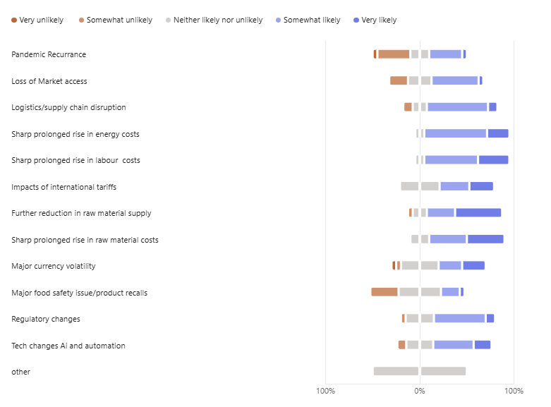
Figure 37 The reported likelihood of shocks in the future

Severity of Impact
In general, the severity predictions mapped on to the likelihood predictions quite closely, as may be seen from the responses to SI Question 36 above. Not surprisingly, given recent events and the enduring negative legacy from Brexit, concerns about raw material availability at reasonable cost, dominate the concerns of the players in the sector. Increasing costs in general are also seen as having potentially severe impacts.
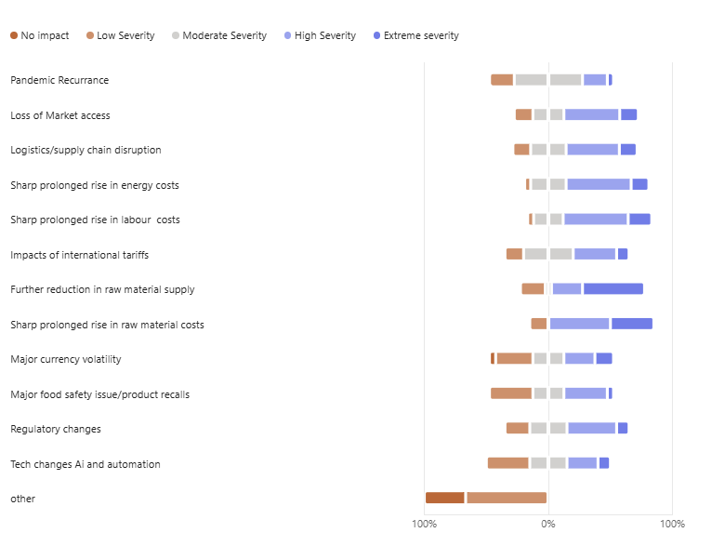
Figure 37 The reported potential impact of different shock in the future

Preparedness (Adaptive Capacity) of Seafood Processors for Future Shocks
A key component of resilience is the ability of businesses to anticipate, prepare for, and respond effectively to future disruptions. To assess this capacity, seafood processors were asked to indicate their level of agreement with a series of statements relating to business confidence, investment intentions, operational agility, automation, artificial intelligence, and future growth plans. The results presented in Figure 38 provide an insight into how prepared processors believe they are to withstand and adapt to future shocks, while also highlighting areas of strength and potential vulnerability within the sector.

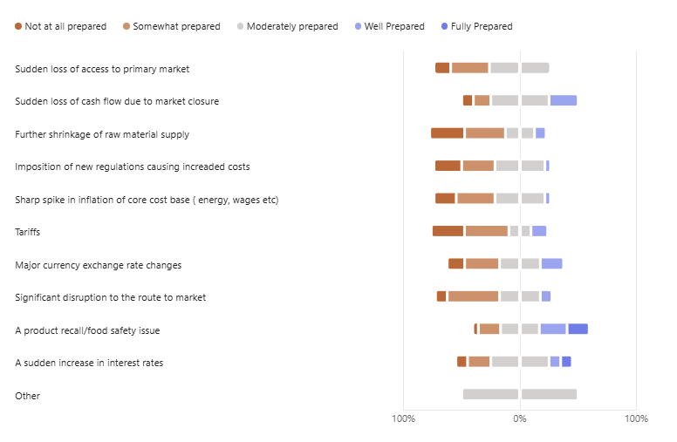
Figure 38 The reported preparedness of the seafood processors to future shocks
As with the assessments of likelihood and severity, Figure 38 shows that participants identified the same issues as both their greatest vulnerabilities and the challenges they considered most likely to occur and most likely to have severe consequences for their businesses.
Respondents reported low to very low levels of preparedness for a number of key risks, including further reductions in raw material supply, continued inflationary pressures within their cost base, the introduction of additional restrictive regulations, disruptions to logistics and market access, and the imposition of trade tariffs. These findings suggest that processors perceive significant exposure to a range of external factors over which they have limited control.
In contrast, respondents expressed a greater degree of confidence in their ability to manage product food safety incidents, cash-flow challenges, and currency fluctuations. While these risks remain important, processors generally considered themselves better equipped to respond to them based on existing systems, experience, and management practices.
Overall, the results indicate that processors do not believe their current adaptive capacity is sufficient to fully address the challenges they view as both the most probable and the most potentially damaging. This gap between perceived risk and preparedness represents an important consideration in assessing the resilience of the sector.
The findings from the survey instruments were reinforced during the face-to-face consultation discussions. Participants consistently described a sector that feels under considerable pressure. There was a strong view that the industry had already endured significant disruption as a result of COVID-19 and Brexit and had worked hard to maintain viability through those shocks, from which many businesses were only beginning to recover. Against this backdrop, the recent reductions in pelagic and Nephrops quotas were widely perceived as a further setback. Many participants described a sense of fatigue and frustration, reflecting what could best be characterised as a degree of “battle weariness” following a prolonged period of successive shocks and challenges.

Climate Change
In the response to tender the following statement was made:
“…climate change impacts be studied and the vulnerability of the Irish seafood sector to those future shocks be assessed.” (source: response to tender)
In the case of the Irish Seafood Processing Sector, it was quickly established during the direct interview phase that the issue of climate change, whilst of interest, was of less direct relevance to processing than it was to primary production by way of catching and aquaculture. The processing sector was, generally speaking, only as vulnerable to climate change as any other land-based manufacturing and export enterprise and that is reflected in the questions asked and answered below.
Notwithstanding, the link between processing and climate-change-moderated impacts on wild catch is captured in the final question below. The response to tender also specified investigation into the related topics of marine spatial squeeze arising from the creation of MPA’s and the introduction of marine wind farms. These developments are not seen by the processing industry participants as being likely to have any significant direct impact on seafood processing, other than how they might affect yields from the catching sector and so they were not included in the SI for seafood processing. They are dealt with in depth in the catching sector chapters.
Not surprisingly, the climate change related threat raising the most concern was the fear that warming sea water temperatures will drive key pelagic stocks further north and make them increasingly inaccessible to the Irish fleet.
Disruption and delays to transportation of products, leading to loss of shelf life and increased costs were also significant causes for concern. During the face-to-face interviews the topic of mitigation was discussed, but the processors expressed the view that they had a limited capacity in this regard as the issues involved (stock migration, ferry sailings, power outages and elevated insurance premia) were largely outside their control.
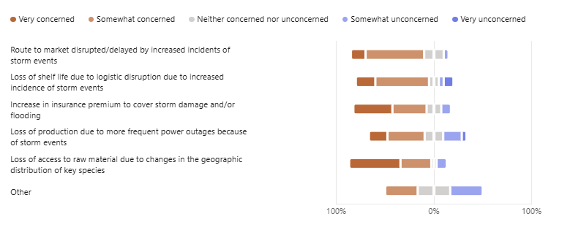
Figure 39 The reported level of concern of the seafood processors to climate change
A key aspect of the consultation was to examine the seafood processor’s views relating to their current and future HR arrangements.
Respondents displayed a degree of confidence on the part of the participants that their HR structures were generally robust and fit for purpose. It was noteworthy that there was a high degree of agreement that ongoing investment in staff development was very important and also that they were looking to the state for additional support to resource that need. This finding underpins the importance of the training supports to the sector currently offered by BIM and other bodies and indicates desire on the part of the sector to see this provision expanded further.

Future management of Human Resources
An important aspect of the consultation was to ascertain how adequate they felt their current health and safety process were, and where the participants felt extra training resources, if available, should be concentrated.
Need some words here about graph below
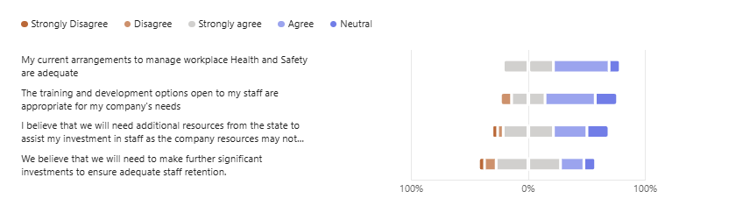Figure 40 The level of agreement of respondents with regard to current health and safety , training and resources.

Figure 40 presents respondents’ views on the adequacy of current health and safety arrangements, staff training, and organisational resources within the seafood processing sector. Overall, the findings indicate a relatively positive assessment of these areas, with most processors expressing confidence in their existing health and safety practices and the capabilities of their workforce. However, the results also highlight areas where respondents believe additional investment in training, skills development, and resources may be required to strengthen operational resilience and ensure that businesses are adequately equipped to respond to future challenges and opportunities.
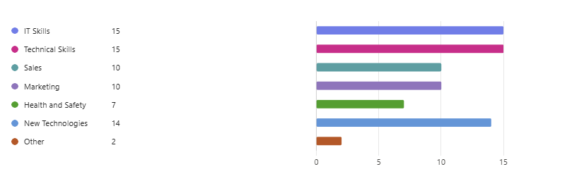
‘Other’ was quality assurance and foreign languages
Figure 42 The training needs identified by seafood processors.
It was interesting to note that the participants felt that investment in staff development in IT skills, technical skills and the introduction of new technologies should be strongly prioritised, rather than the more traditional business areas such as sales and marketing (Figure 42). This finding resonates strongly with views expressed in the face-to-face interviews that urgent investment in new technologies, (such as robotic systems enabled for AI and machine learning) to improve efficiency and drive out costs was a vital strategy for the sector.

Business Sentiment
The following results explore seafood processors’ views on the future preparedness and competitiveness of their businesses. Respondents were asked to assess a range of factors associated with long-term resilience, including business confidence, investment intentions, automation, artificial intelligence, operational agility, and the capacity to adapt and grow. The findings provide an indication of how well positioned processors believe they are to respond to future challenges and opportunities within an evolving seafood sector.
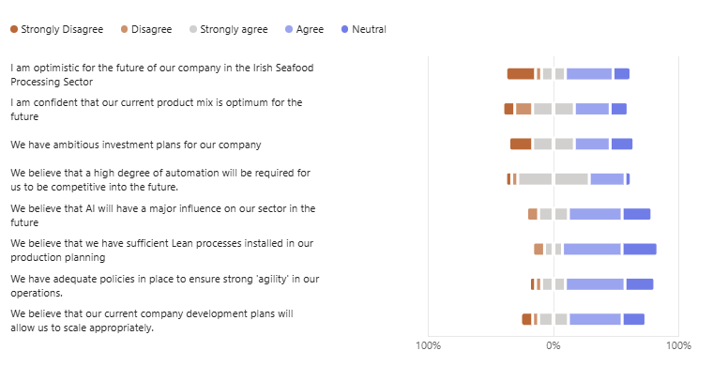
Figure 43 Business sentiment reported by seafood processors.
The responses of participants regarding the future prospects of their businesses were broadly positive, despite the significant concerns expressed elsewhere in the consultation about the availability and security of raw material supplies.
Overall levels of optimism were high, although a small but nevertheless noteworthy proportion of respondents expressed a strongly pessimistic outlook. These views were concentrated among processors with a significant dependence on pelagic species, many of whom are still adjusting to the implications of the recent substantial quota reductions. Nevertheless, the number of companies reporting ambitious investment plans suggests that confidence in the long-term future of the sector remains generally robust.
A particularly striking finding was the strong consensus among respondents that increased automation and the widespread adoption of artificial intelligence (AI) technologies will be critical features of the sector’s future development and competitiveness.
More generally, respondents expressed confidence in their current product portfolios and considered their operational policies and business development planning to be broadly appropriate for the challenges and opportunities they expect to face in the years ahead.

Part 2. The Aquaculture Sector
The Irish aquaculture sector is quite diverse, being a mix of farmed fed finfish (mostly salmon) and farmed unfed shellfish (oysters and mussels (farmed in two systems, suspended rope culture and bottom grown culture). There is also a longstanding history of rainbow trout production (largely consolidated into one producer) and a nascent seaweed farming sector.
For the purposes of this study, the concentration will be on the four main types of production, described above. Because they are so radically different, each is afforded its own sub analysis as well as a more general sectoral commentary, where meaningful.
Part 2A Resilience within the Irish Salmon Farmed Sector
Part 2B Resilience within the Oyster Sector
Part 2C Resilience within the Bottom Grown Mussel Sector
Part 2D Resilience within the Rope Grown Mussel Sector

Part 2A: Resilience within the Irish Farmed salmon sector

The Retrospective view – Salmon Farming
The Irish farmed salmon sector has been in production for more than 50 years, having been started by BIM in circa 1975 in the Little Killary as an experiment. It is the single most valuable element of the Irish seafood sector and its organically certified output is widely recognised as the premium grade of farmed salmon globally.
Its recent production history, in terms of volume and value is set out below. In terms of volume of output, the sector actually reached its peak output in circa 2021, reaching an annual volume of just under 25k metric tonnes.
Table 7 Irish Farmed Salmon volume and value 2015 to 2024 (BIM Annual Survey)
2015 | 2016 | 2017/T | 2018/T | 2019/T | 2020/T | 2021/T | 2022/T | 2024/T | 2024/T
13,477 T | 16,718 T | 18686 T | 12044 T | 11567 T | 13181 T | 13214 T | 11862 T | 9289 T | 13877 T
€M  92,267 | €M 105,997716 | €M 134,927870 | €M 97,282392 | €M 109,005515 | €M 123,770246 | €M 106,108320 | €M 101,550851 | €M 94,753683 | €M 138,364549

Need more words here introducing the shocks diving in does not work! You need to tell the reader what the shocks were first by interpreting the graph
The farmed salmon producers represent something of an outlier within Irish seafood as a whole, in terms of their perception of what were the major shocks that the industry experienced over the last 20 to 25 years. For them, biological incidents in the form of fish diseases or naturally occurring parasites ranked higher than large scale societal/political shocks such as Brexit or even Covid 19.
In fact, they weathered those societal shocks with relative ease and displayed considerable adaptive capacity in dealing with their impacts. Their Achilles heel lies in unexpected incidences of fish health issues which negatively impact on their key production indices. As a result, the three main shocks identified by the respondents are unique to salmon farming and are not shared by the rest of the Irish seafood sector at all. As set out in Figure 44 below, those shocks were; The occurrence of Amoebic Gill Disease (AGD), continued incidence of Pancreatic Disease (PD) and coming up third, being locked out of eligibility for capital grant aid for some six years.
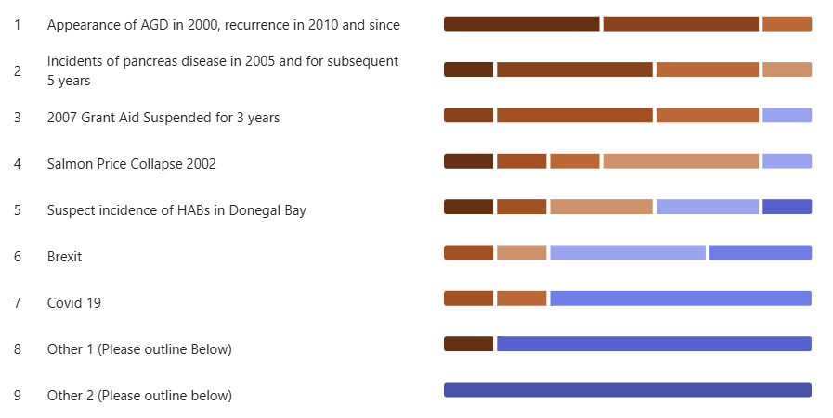
Figure 44 Major shocks to the salmon farming sector as identified by the industry
From a resilience study standpoint, it is reasonable to group shocks 1 and 2 together as they are both fish health shocks leading to stock losses and compromised growth in the remaining fish populations. An examination of Figs 101* and 102* , show that the salmon farmers experienced the two shocks in a very similar way. The major impacts were lower stock survival and subsequently a reduced biomass for sale.
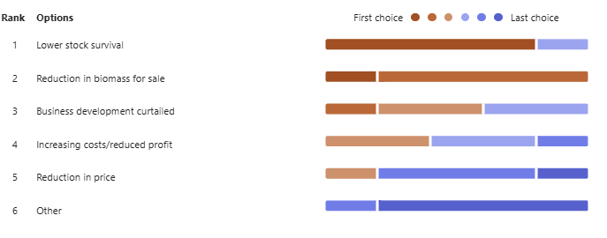
Figure 45 General impacts of AGD on the salmon farmers

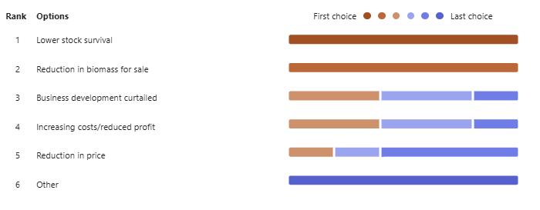
Figure 46 General impacts of PD on the salmon farmers
This finding neatly illustrates the fact that in salmon farming, good stock performance is the fundamental key to success and that any shock that adversely affects the stocks will have a disproportionately large impact on the success and survival of the sector.
In contrast, an examination of Fig 103* above, detailing the impacts that shock number 3 had on the sector, offers a different narrative. In that case the respondents identified ‘Curtailed business opportunities’ and a deterioration in their margins as the major impacts.
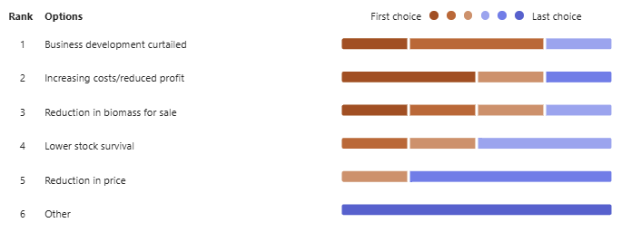
Figure 47 General impacts of being locked out of grant aid had on the salmon farmers
Not surprisingly, a similar picture emerged when the correspondents reported on the impacts the shocks had on the key business indicators of their enterprises. Figures 48 and 49 below are very similar, citing increases in production costs, reduction in turnover.
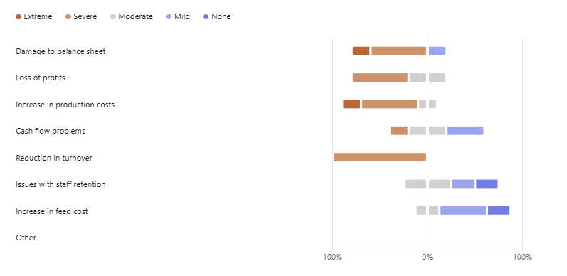
Fig 48 Business impacts of AGD on key indices in salmon farming

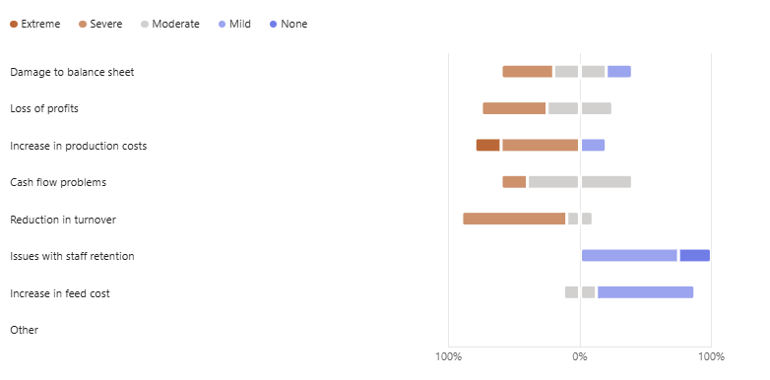
Fig 49 Impact of PD on key indices in salmon farming
Unsurprisingly, figure 49 below shows a different set of impacts, when the correspondents considered the effects of the sector being locked out of grant aid for a long period.
Notwithstanding, in common with AGD and PD a major severe impact that emerged was increased production costs. However, in this instance the cost increase was not due to poor stock performance but arose because of an inability to invest in more modern technology to improve feeding performance and other husbandry enhancing technology. In effect this was a lost opportunity’ type cost, as the respondents viewed that they would have been more cost competitive sooner had they had access to the full range of grant aid. This nuance was elucidated during the face-to-face interviews.
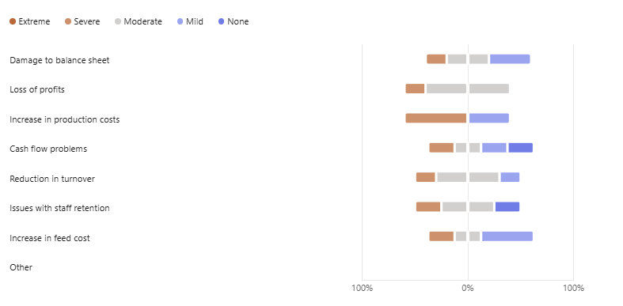
Figure 49 Impact on being locked out of grant aid on key indices in salmon farming

Summary
A qualitative, semi-quantitative review of state-led actions to assist the farmed salmon sector to mitigate the impacts of the shocks
“Through these consultations, the actions taken… (by the state)… in response to these past shocks will be collated, categorised, and evaluated based on … qualitative feedback from those affected…” (Extract from the response to tender)
Via the qualitative and semi-quantitative sectoral survey methodology, this section considers the efficacy of the state’s various responses and efforts in support of the Irish Salmon Growing sector. In effect, the section sets out to look at the tools at the state’s disposal and how well those tools worked in the eyes of the beneficiaries.
In almost all circumstances (with the exception of the Covid 19 pandemic) the state has abided by the constraints set out by the Common Fisheries Policy and its implementing regulations, so as not to contravene state aid laws and thereby distort the marketplace. These constraints have, from time to time, frustrated the Irish seafood industry who have sought more direct government intervention in the past, into areas such as fuel and/or wage subsidies or direct subsidies following natural catastrophes. Also, the state of the Irish economy and how much leeway the exchequer could afford at particular points in time has often been a constraining factor.
Figure 50 below captures the respondents views concerning the relative efficacy of various state programmes put in place to assist the sector. It should be borne in mind that the salmon farmers were locked out of access to almost all forms of grant aid due the licensing and compliance issues concerning Ireland’s implementation of the EU’s Birds and Habitats directives and that this unfortunate circumstance will have coloured the respondents’ attitudes, at least to some extent.
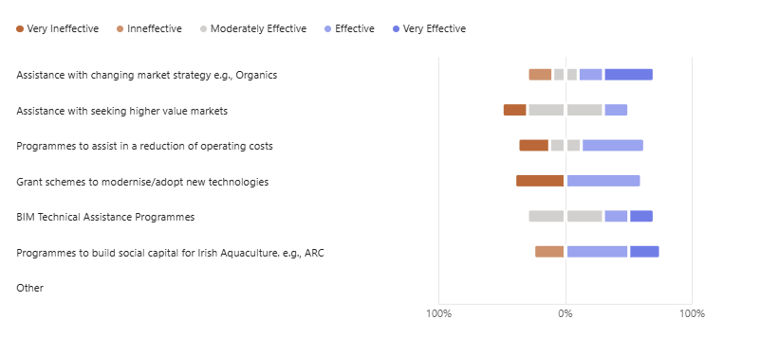
Figure 50 Review of the efficacy of state actions to mitigate shocks to the salmon sector
Approximately one-third of respondents expressed a negative view, while around two-thirds considered this form of support to be effective. Insights from the face-to-face consultations suggest that this negative sentiment was driven less by dissatisfaction with the grant aid itself and more by ongoing concerns regarding eligibility criteria and access to support.
Support for the strategy of promoting organic certification also remained relatively strong. However, opinions were more divided regarding assistance aimed at identifying and developing new higher-value markets. Discussions during the consultations revealed that many respondents considered themselves to have a strong understanding of market opportunities due to the international nature of their business. There was a widely held view that no significant untapped “golden bullet” market exists and that demand for high-value organic certified seafood already exceeds current production capacity. In particular, respondents noted that they could sell substantially greater volumes of organic certified fish if additional licences were available to support expansion.
Grant aid programmes designed to improve operational efficiency and reduce costs also received predominantly positive ratings. As with technology investment grants, the relatively small level of negative sentiment appeared to stem primarily from concerns regarding eligibility requirements rather than the value of the support programmes themselves.

The prospective view emerging from the Irish Salmon Farming Sector

Probability of recurrence and potential severity of impact
The participants in the study were asked to carry out a future looking exercise. It had several dimensions. In the first instance, they were to try to look into the future and to assess the challenges they saw coming down the line that the sector might have to cope with. This part of the enquiry had two dimensions. The first was to estimate the likelihood of a particular named challenge becoming a shock and the second was to give that potential challenge a severity rating.
By combining likelihood and severity, a ‘heat map’ can be created. This approach is commonly employed as a technique in risk management and is useful in guiding players in the sector as to where to prioritise resource deployment in the preparation of mitigating measures to ease the impact of potential future shocks. Risk heat maps visualize risk plotting likelihood (frequency/probability) on one axis and severity (impact/consequence) on the other axis, usually on a grid. Color-coding (green/yellow/red) is used to highlight high-priority risks that require immediate mitigation, providing a "big picture" view of sector’s threat landscape.
As with the other sectors of the Irish seafood industry the salmon farming respondents were asked to rate the likelihood of occurrence of the challenges/threats highlighted in the earlier section of the SI. The likelihood of a threat materialising into a shock is set out below.

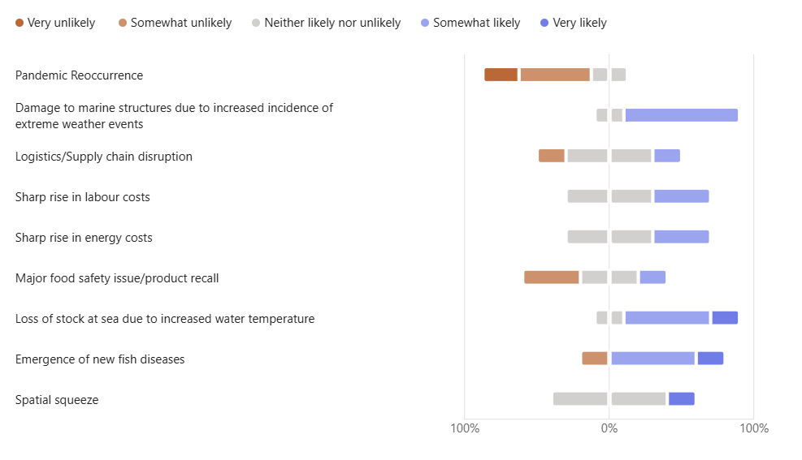
Figure 51 Likelihood of threat occurring

The salmon farmers were confident that a recurrence of a pandemic was unlikely, but they were strongly of the opinion that climate change was going to generate shocks for them in the form of increased frequency of bad weather events and the emergence of new fish diseases and stock losses due to rising seawater temperatures. They were also concerned about rises in production costs and inflation. Spatial squeeze was also seen as an issue, but in the interviews, this was clarified as being about local resource competition and existing Natura 2000 designations, rather than the rise of wind energy and the planned creation of marine protected areas, which are significant issues for the catching sector.
The predicted severity of impact was then estimated below.
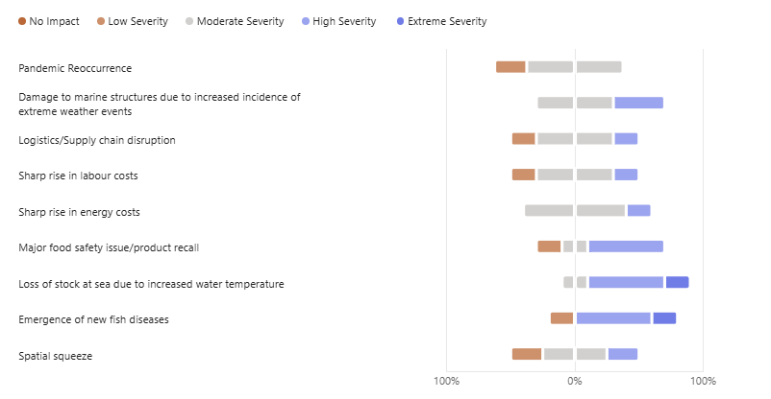
Figure 52 Severity of potential threat
The potential challenges most feared by the salmon farmers were centred around issues that would adversely affect stock performance, such as the emergence of new diseases and temperature related stock losses. This is not surprising given the very high levels of working capital invested in their fish stocks, especially as they approach harvest size. They also demonstrated an appreciation for the severe impact that a product recall can have on a food producers’ reputation, having said that they did not rate the likelihood of occurrence of such a challenge as very high.
Create the heat map and add short commentary

An evaluation of the level of Preparedness (adaptive capacity) of the respondents
Salmon farmers were also asked to estimate their level of preparedness which, inter alia, is an indication of their ‘adaptive capacity’ to deal with a range of possible future challenges.
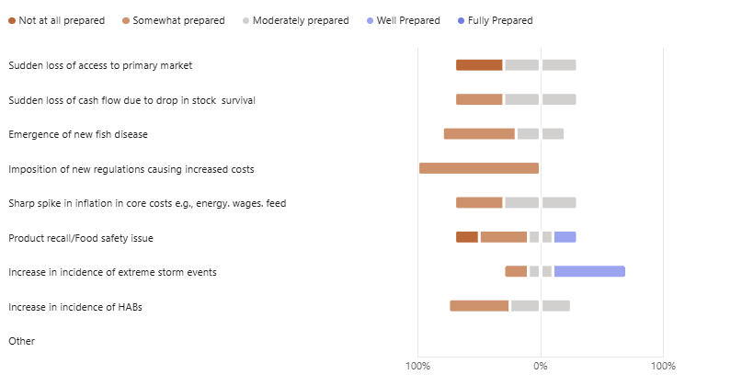
Figure 53 Level of preparedness of Salmon growers to future threats
The respondents unanimously flagged their vulnerability to the imposition of unforeseen regulations, which is understandable given their somewhat fraught experiences in this domain. Most recently they were temporarily shut out of the American market due to an obscure and avoidable issue concerning cross-compliance with certain US wildlife protection regulations. Wee bit more detail, from stored material
They also signalled their vulnerability to new fish diseases and HAB’s but interestingly showed confidence with regard to successfully dealing with an increased incidence of storm events, which is somewhat counter intuitive. It does indicate resilience in the face of a difficult threat, despite the fact that they also rate this challenge as being high, both in terms of likelihood and severity of impact.

Salmon Growers attitude towards Climate Change
In the response to tender the following statement was made:
“…climate change impacts be studied and the vulnerability of the Irish seafood sector to those future shocks be assessed.” (source: response to tender)
The SI then moves to consider climate change effects and their potential impact on marine salmon farming.
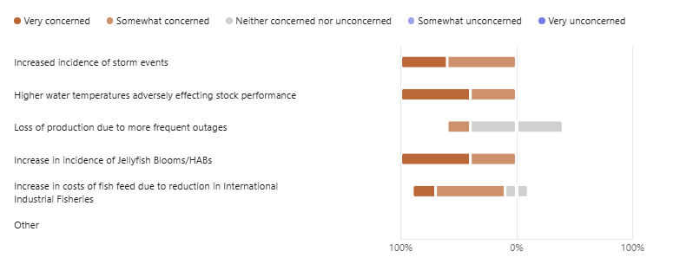
Figure 54 Level of concern for named threats
The answers to question 35 of the SI are revealing in the context of a discussion around resilience/adaptive capacity, especially when considered in tandem with the answers to questions SI questions 29 to 31.
The respondents say that they are ‘very concerned’ or ‘concerned’ about an increased incidence of storm events. Yet in answer to much the same question, they suggest that they are relatively well prepared to deal with this issue. Thus, we can see that this threat is well understood and the mitigating response has been well prepared, creating planned targeted adaptive capacity and hence resilience.
Conversely, the respondents, whilst expressing concern, feel it necessary to flag their lack of preparedness to deal with HAB’s and increasing water temperatures. This is understandable as these are intractable issues and very difficult to deal with. It is noted that BIM and the farmers are collaboratively prioritising technical development and innovation projects to find solutions for these issues. This findings from this study suggest that this approach represents good resource prioritisation.
Future human resource development in the Irish salmon farming sector
This section examines human resource issues within the Irish salmon farming sector, including health and safety, workforce availability, training and development and resources and training requirements. 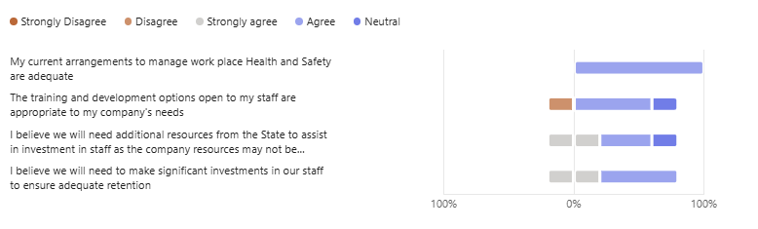
Figure 55 Human Resource Part 1 (check this is the same title as the other sectors)

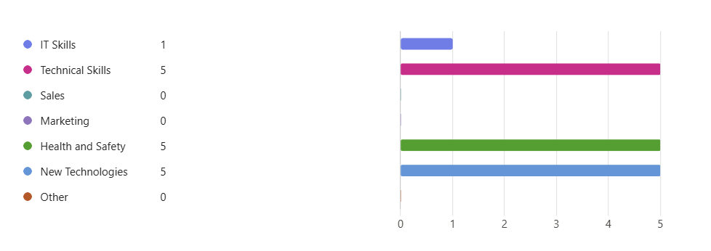
Figure 56 Human Resource Part 2
The study respondents are very consistent in their responses to the questions in this section. They are confident in their workplace H&S arrangements, although they do see the need for continuous investment in their staff, indicating that they are not complacent in this regard. This approach is underpinned in their response to the secondary question where they prioritise training in H&S as well as in technical skills and in the introduction of new technologies.
Business Sentiment and Key future Trends
The final section of the prospective section of the consultation deals with business sentiment and the likely future trends that the Irish salmon farmers will be dealing with.
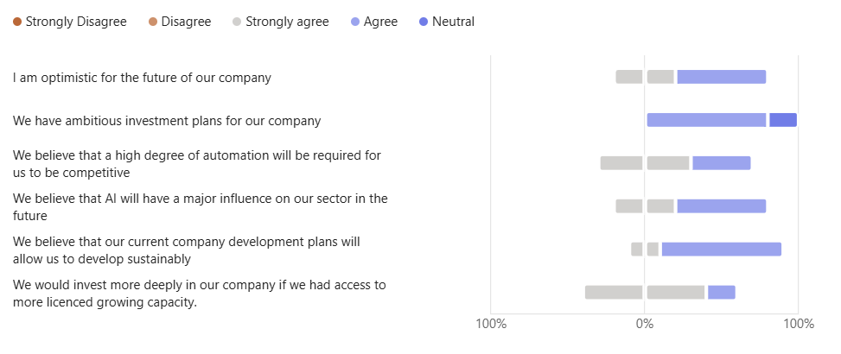
Figure 57 Business Sentiment
The salmon farmers responses to this set of questions are in marked contrast to the responses from the seafood processors. Their level of optimism and confidence in their future prospects is higher and there is a pent-up desire to invest more in their enterprises, albeit constrained by the difficulties being encountered in delivering robust determinations to longstanding licence renewal applications. In common with the responses of other subsectors of the Irish seafood industry to the same questions in this study, they also foresee increasing automation and the application of AI as being major future trends.

Summary of findings from the farmed salmon sector
The Irish farmed salmon sector has been subject to many shocks over the last fifty years or so. The fact that it is still in existence and is the single most valuable seafood product in the Irish seafood industry is a testament to its fundamental resilience.
That resilience or adaptive capacity has changed radically over the period. In 2001 when the global salmon market dipped sharply due to marginal overproduction, largely emanating from Norway, it suffered a severe shock and it demonstrated an R-eco type equilibrium response dropping down to about two thirds of its former size in terms of output volume, a level which it has maintained, more or less since.
Following a correction in the rate of supply side growth, the global salmon market has remained either in supply-demand equilibrium or in marginal undersupply ever since, keeping prices at favourable levels. Due to deep rooted production constraints, common to all of the producing countries, this situation is likely to prevail for the foreseeable future, with low or limited rates of production expansion set against steadily growing demand.
Since the price collapse of 2001, the sector has faced shocks of a different kind. The salmon farmers were left largely unscathed by Brexit and Covid 19, they were resilient to the impacts those shocks had on the rest of the seafood sector, as discussed above.
What has caused the sector real distress has been the incidence of biologically derived threats in the form of fish diseases and naturally occurring parasites requiring urgent treatment. The industry is technologically innovative and is adept at developing solutions to these challenges. But with each new development comes the need to invest to stay current and by being kept out of the level of grant aid provision available to other parts of the Irish aquaculture sector for a prolonged period, the salmon farmers were relatively disadvantaged. In effect, their adaptive capacity was suppressed, and this slowed their response time in dealing with those emerging biological and environmentally derived threats. This explains why the sector holds the BIM Technical Development Programme in high regard, as it trials and thereby ‘de-risks’ investment in emerging new techniques and technologies.
From a policy formation perspective, it is informative to understand that the salmon farmers have relatively low vulnerability with regard to marketing and finance. They are plugged into a high value global market niche which is in undersupply.
Their primary vulnerability lies in threats that are biological or environmental in nature, and these are likely to be exacerbated by climate change. Prioritising investment into measures to strengthen their adaptive capacity to deal with such challenges would represent an optimal use of available resources.

Resilience in the Irish Oyster Farming Sector
Oyster farming is a very different process when compared to salmon farming, the stocks feed themselves from naturally occurring zoo and phytoplankton in the water column. It is relatively low tech, although that is changing, and its production is largely located in the intertidal zone in estuaries on sites that are subject to periodic pollution episodes arising from agricultural runoff and exposure to pathogenic microorganisms released by delinquent human wastewater treatment systems.
These vulnerabilities are clearly revealed by the choices the oyster farmers made in selecting their top three shocks over the last twenty-five years. A review of fig 200* below illustrates this.
The oyster farmers cited repeated episodes of Norovirus contamination as their most significant shock/threat. Next in line was Covid 19 and third was staffing recruitment and retention problems, in the face of a broader national economy in near full employment.
Shock number 4 (‘water pollution in general’) was also a contamination issue and hence is closely related to shock number 1, as indeed is shock number 5 (HAB’s). Thus, it may be seen that water borne pollution bringing microbial contamination and/or HAB’s with it, is the central preoccupation for Ireland’s oyster farmers.
This places them in an intractable and deeply unjust situation. The pollution is none of their doing; they are at the receiving end of the system as the rivers empty into the sea and they have not contributed to the problem in any way. Numerous EU Directives require that the status of Irish rivers be brought into good standing, but decades of gross underinvestment in water treatment facilities have created an enormous problem that it is taking years to address. The Irish state is obligated to improve estuarine water quality and Ireland’s oyster farmers should be able to pursue their business in safe and clean environment, unfortunately progress towards this objective is slow and in the meantime the oyster farmers remain very vulnerable.
Although it was ranked as shock number three, the authors of the report take the view that attracting and retaining staff in the context of an economy in near full employment is not really a shock in the classic sense. It is certainly an ongoing challenge for Ireland’s oyster farmers and has already been the subject of in-depth analysis by BIM. This analysis is contained in the BIM study entitled ‘A skills gap review of the Irish aquaculture industry’. Hence it is not proposed to discuss it further in this research.
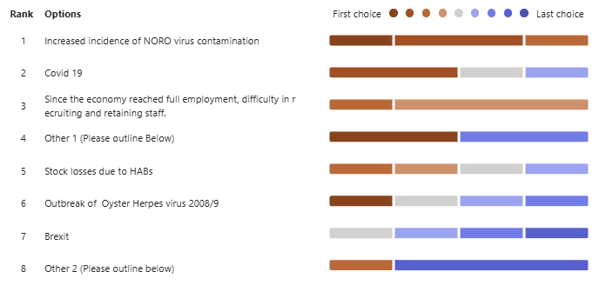
Figure 58 Ranking of shocks identified by the oyster farmers
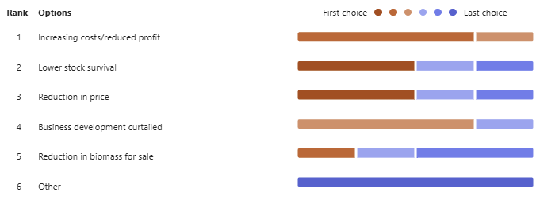
Figure 59 Impact of Norovirus contamination
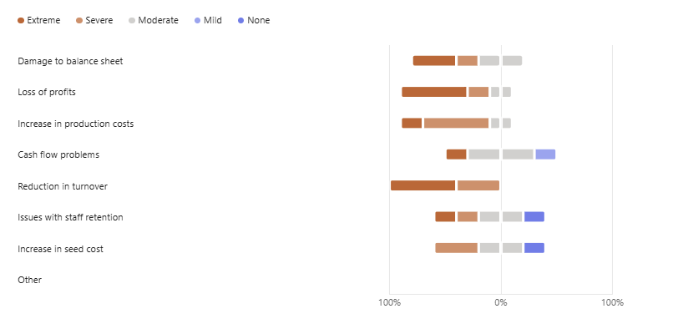
Figure 60 Severity of impact of Norovirus contamination.
It may be seen from the figure above that the impacts of a norovirus contamination episode are quite severe. Turnover is sharply reduced as the stock cannot be sold, costs rise and as a consequence profits are driven down, and the balance sheet is negatively impacted.
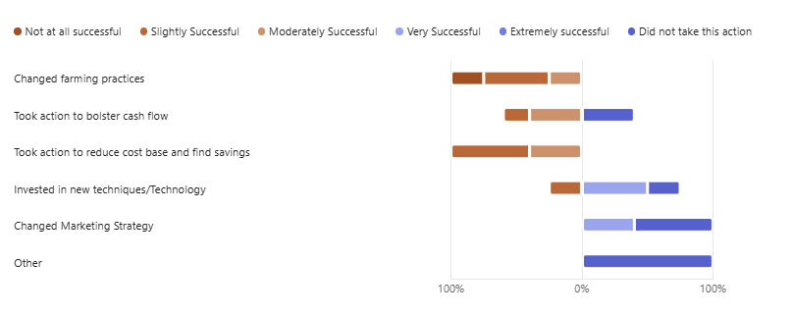
Figure 61 Actions attempted to mitigate Norovirus contamination
The figure above demonstrates how invidious a situation the oyster farmers find themselves in as they await the building of the necessary infrastructure to prevent contamination of their farms. They have attempted to change their practices but have met with little success as the root cause is entirely out of their control.
Similar to the staff recruitment and retention issue, the impacts of Covid 19 on the Irish Oyster farming sector were the subject of a special case study in the predecessor study to this one “XXXXXXXXXX”.
The responses from industry had not changed in the interim and no new insights emerged. So, the authors decided, in the interests of brevity and to avoid repetition not to pursue the issue further in this study.
Although not specifically discussed, all of the responses from the respondents are included as an appendix XXX to the study.

Oyster Farming
A qualitative, semi-quantitative review of state-led actions to mitigate the impacts of the shocks

“Through these consultations, the actions taken… (by the state)… in response to these past shocks will be collated, categorised, and evaluated based on … qualitative feedback from those affected…” (Extract from the response to tender)

Via the qualitative and semi-quantitative sectoral survey methodology, this section considers the efficacy of the state’s various responses and efforts in support of the seafood processing sector. In effect, the section sets out to look at the tools at the state’s disposal and how well those tools worked in the eyes of the beneficiaries.

In almost all circumstances (with the exception of the Covid 19 pandemic) the state has abided by the constraints set out by the Common Fisheries Policy and its implementing regulations, so as not to contravene state aid laws and thereby distort the marketplace. These constraints have, from time to time, frustrated the Irish seafood industry who have sought more direct government intervention in the past, into areas such as fuel and/or wage subsidies or direct subsidies following natural catastrophes. Also, the state of the Irish economy and how much leeway the exchequer could afford at particular points in time has often been a constraining factor.

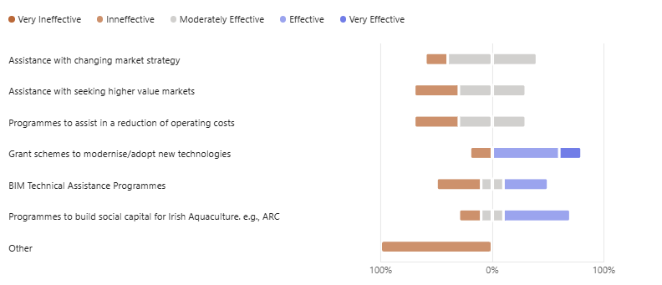Figure 62 An evaluation of the efficacy of actions taken by the state to mitigate shocks
As was the case with the salmon farming respondents, the oyster farmers rated BIM’s technical assistance programme quite highly as well as the grant aid programmes to modernise and adopt new technologies.
They were not as enthusiastic about programmes to change their marketing strategy or to assist in finding new markets. As was highlighted in the previous case studies, Irish oyster farmers are, in general, highly dependent on the French market and on a small number of wholesale buyers to access it. As a result, they are vulnerable to being ‘price takers’ when that market is in marginal oversupply.
There are higher value markets in the far east but the barriers to accessing those markets are not inconsiderable. Sophisticated transportation logistics, complex customs arrangements and rigorous food safety compliance must all be mastered, if a producer is to successfully exploit these markets and not everyone is in a position to do this.
The Aquaculture Remote Classroom (ARC) and the Taste of the Atlantic social capital building programmes received positive ratings. These programmes are longer term in their perspective and approval for them demonstrates a maturity of view amongst the respondents.
The ‘other’ finding in Fig 2004* above refers to the difficulty of accessing grant aid when the farmer is short of cash flow making it challenging to find the matching funding necessary to unlock the grant scheme. This is an understandable point of view, but the state is constrained by the rules of the CFP in terms of the permissible levels of grant aid and in any case is not allowed to give 100% grant aid.

The prospective view emerging from the Irish Oyster Farming Sector

Responses from the Irish Oyster farmers to the SI concerning the Probability of recurrence and potential severity of impact
The participants in the study were asked to carry out a future looking exercise. It had several dimensions. In the first instance, they were to try to look into the future and to assess the challenges they saw coming down the line that the sector might have to cope with. This part of the enquiry had two dimensions. The first was to estimate the likelihood of a particular named challenge actually becoming a shock and the second was to give that potential challenge a severity rating.

By combining likelihood and severity, a ‘heat map’ can be created. This approach is commonly employed as a technique in risk management and is useful in guiding players in the sector as to where to prioritise resource deployment in the preparation of mitigating measures to ease the impact of potential future shocks. Risk heat maps visualize risk
plotting likelihood (frequency/probability) on one axis and severity (impact/consequence) on the other axis, usually on a grid. Color-coding (green/yellow/red) is used to highlight high-priority risks that require immediate mitigation, providing a "big picture" view of sector’s threat landscape.

Likelihood of occurrence
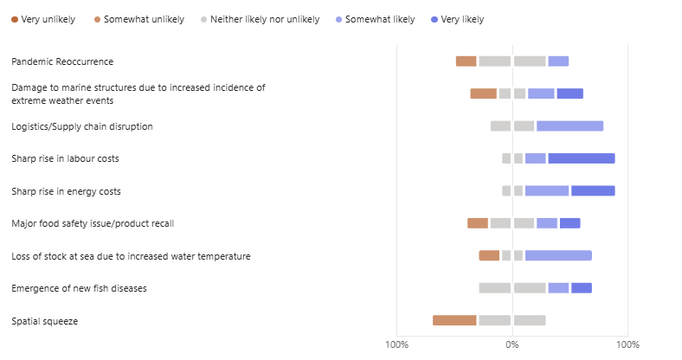
Figure 63 Likelihood of occurrence
The oyster farmers views on the likelihood of various shocks recurring or challenges materialising were less unanimous than the salmon farmers or the seafood processors. They were evenly split concerning the possible recurrence of a pandemic and they also held divergent views around the topic of storm damage.
On other topics they were much more cohesive, such as their view that there is a high likelihood of labour and energy costs rising sharply and of further supply chain disruption. They were also concerned about stock losses and food safety incidents, which is not surprising considering the difficulties they have had in dealing with Norovirus.
There was a noticeable divergence on the issue of spatial squeeze, which may reflect the varying degree of local resource competition depending on location.
Severity of Impact
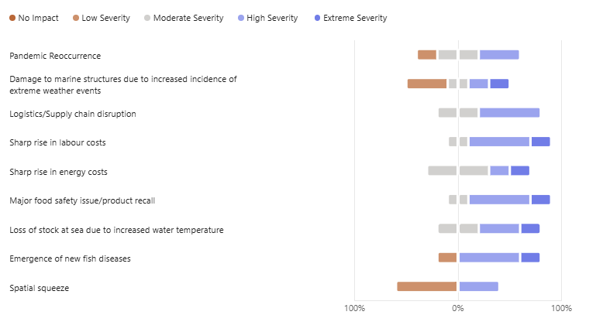

Figure 64 Severity of Impact
The severity rating attributed to the challenges by the oyster farmers closely matched the probability rating, insofar as those risks rated as likely were also seen as yielding severe impacts. Those rated as less likely to occur/reoccur were not seen as having such potentially severe impacts.
Insert heat map and comments

An evaluation of the level of Preparedness (adaptive capacity) of the respondents. Oyster farmers views on their ‘adaptive capacity
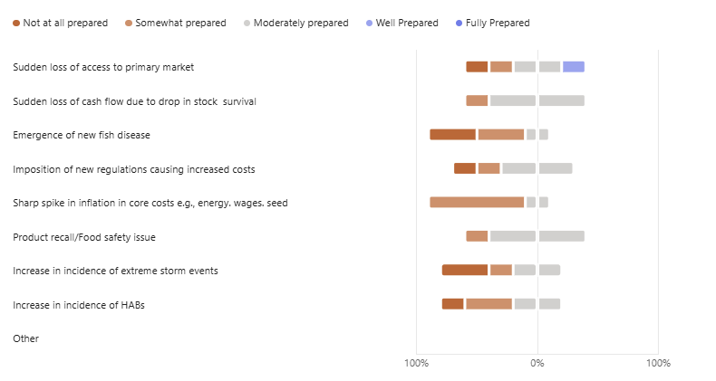Figure 65 Preparedness amongst the oyster farmers
In answering question 33 above, the Irish oyster farmers indicated strongly that they feel unprepared for most of the challenges facing them. This lack of confidence in their preparedness, which extended across the whole range of possible challenges, was in sharp contrast to the more positive attitude concerning their ‘adaptive capacity’ reported by the salmon farmers. This lack of confidence in their level of preparedness is a concerning issue for the Irish oyster farming sector in the context of its apparently relatively low resilience and its prospects for future sustainable development.

Oyster farmers attitude towards Climate Change
In the response to tender the following statement was made:
“…climate change impacts be studied and the vulnerability of the Irish seafood sector to those future shocks be assessed.” (source: response to tender)

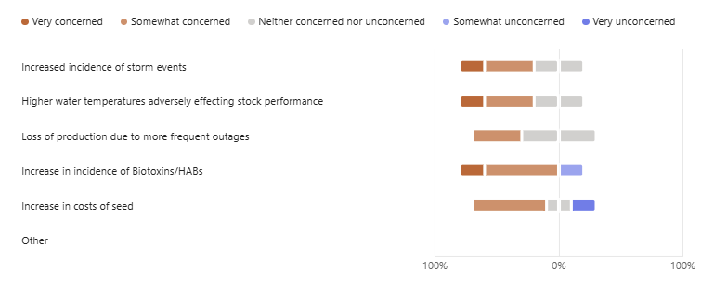
Figure 66 Climate change and oyster farming in Ireland
The Irish oyster farmers expressed high levels of concern regarding the likely impacts of climate change on their enterprises. Overall, their level of concern appeared to be on a par with that displayed by the salmon farmers, despite the divergence between the sectors concerning preparedness.

Oyster farmers views on their HR development plans
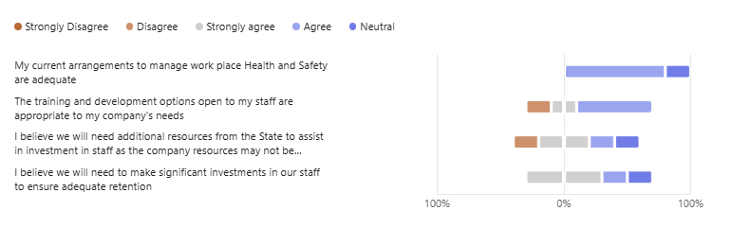
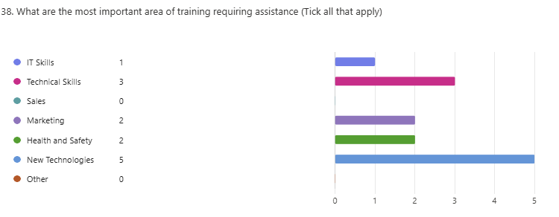
Figure 67 Human Resources in Oyster Farming
As with the processors and the salmon farmers, the oyster growers were confident in their arrangements to handle workplace H&S issues. They also believed that significant investment into staff development was going to be important and that they would look to the state to assist them in this regard.
There was unanimous agreement that staff development should have a strong focus on the adoption of new technologies and an upgrading of technical skills. They did not attach a high priority to developing IT related skills and they were also quite muted about developing sales and marketing skills.

Oyster farmers business Sentiment and key future trends
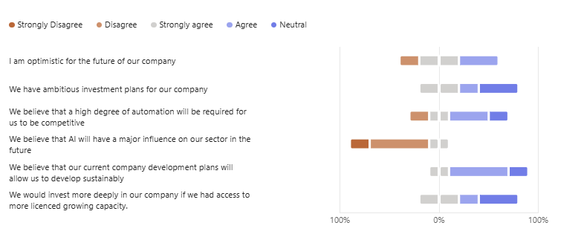
Figure 68 Oyster farmers Business Sentiment

Mirroring their high levels of concern and their worries about unpreparedness expressed earlier, the oyster farmers were also generally less optimistic about future prospects and less bullish about investment than their processing and salmon farming colleagues.
Interestingly, they were also of the view that AI was not going to be very important in their future, and they were less convinced about the necessity for increased automation, a very different view in comparison with their peers in other parts of the Irish seafood sector.
Summary of the consultation on the farmed oyster sector
Having weathered the Covid 19 storm, albeit with considerable help from the state, oyster growers rate persistent water-borne Norovirus contamination as their current number 1 shock
They point to repeated failures of the Irish State’s wastewater treatment systems discharging into bays all around the coast
The Irish farmed oyster sector is over reliant on the French oyster market; its route to that market is suboptimal and disadvantageous to small indigenous producers
Profit margins are tight as costs have risen quite sharply, especially wages, fuel and seed mussels from hatcheries in France, these are overheads which the growers have limited power to influence and they are unable to pass them on to their customers
From the interviews accompanying the SI, it became evident that there is a view held by a number of Irish growers that an ‘excessive proportion’ of the sector, is now in French ownership
Whilst they acknowledge that this is quite legal under EU law, they express concern that the owners have a limited ambition for the development of their sites, wishing to use them as ‘fattening stations’ only, and keeping most value adding activities reserved for their home locations.
The growers have also expressed concern that the state has not adequately resourced its own aquaculture licensing department, as many of the licences awarded some years ago are once again up for renewal
They fear excessive delays in the renewal process as any question over their right to occupy their sites scares off banks and other credit providers

Resilience in the Irish Rope Grown (RG) Mussel Sector
Insert Herbie table and put in short few comments about the production history which one??
In common with the oyster farmers, the RG mussel farmers did not rate either Covid 19 or Brexit in their list of top three shocks, although they did benefit from both the general government support packages and a special scheme at the time of the pandemic. Their Covid 19 experience has been documented in a special case study in the predecessor study into resilience in Irish seafood “Provision of a Scoping Study to support the delivery of an Analysis of the Resilience of the Seafood Sector” to this research.
In the case of Covid 19, once the initial draconian restrictions were lifted, the RG Mussel sector recovered very quickly, demonstrating an R-eng resilience. However, more deeply rooted, long term systemic challenges have remained to continue to trouble the sector once the Pandemic ran its course.
The figure below sets out the respondent’s views as to which shocks have been the most significant. The number 1 shock is centred around security of tenure and the farmers fears that there will be long delays in the process of renewing their aquaculture site licences. Shocks 2 and 3 are biological and may also be linked to climate change.
In the case of shock one, the farmers fear that in the event of a delay they will suffer from lack of investment due to the uncertainty over their security of tenure; that they will be excluded from EU grant aid programmes and that their credit facilities will be reduced or withdrawn.
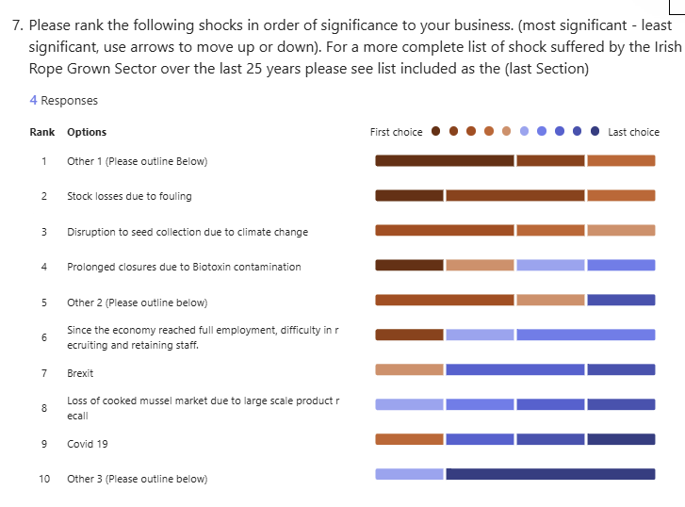
Figure 69 Ranked shocks in the RG Mussel sector

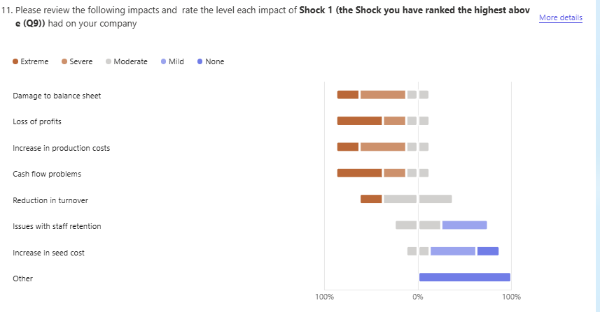
Figure 70 Impacts of aquaculture licensing delays
The figure above captures the farmers fears and current experiences quite well. They report a general decline across all of their key business indices lading to substantial damage to their businesses.
The second and third shocks are biological/environmental in nature and are essentially closely related. Fig 202* and Fig 303* are very similar and demonstrate a key vulnerability of the RG Mussel sector.
That is that the RG mussel farmers are entirely dependent on, but not in control of their growing environment. The farmers rely on placing collectors in the sea to catch naturally occurring mussel larvae populating the water column to provide their source of juvenile stock. Conversely, they try to avoid, in so far as possible, having their stocks exposed to blooms of the larvae of naturally occurring fouling organisms. The timing of these patterns of activity have usually been reasonably stable and the farmers have generally been able to balance one activity with the other.
In what may be a climate change related phenomenon, these patterns have become more variable and this has disrupted the farming cycle.
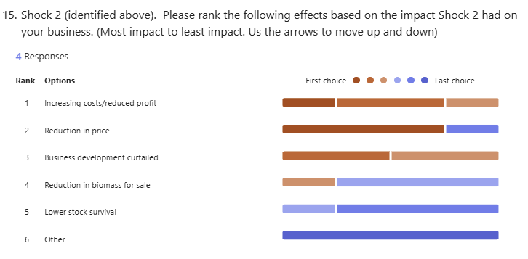
Fig 80 Relative impacts arising from increased fouling of stock

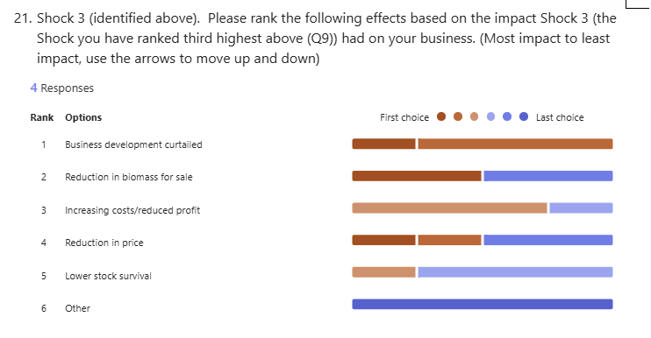
Fig 81 Effects caused by changing pattern of seed availability

Similarly, if figures 304* and 305* are considered together, closely related issues can be observed. The farmers invested in new techniques and technologies and shifted their patterns of activity in terms of when they scheduled harvesting and when they attempted seed mussel collection. All of these actions revolve around the farmers attempting to run their farms based on improved levels of environmental data and increased awareness of what was happening in the water column. This extra data is being generated by the introduction of much enhanced monitoring of what is happening in the water column adjacent to the growing sites. These monitoring programmes are being jointly run by the industry with support from BIM and the MI. Whilst the problems were not fully eliminated, moderate success was reported by the correspondents and it is hoped that they will enjoy more success as their detailed understanding of their sites and the dynamics of the plankton therein becomes deeper and deeper.

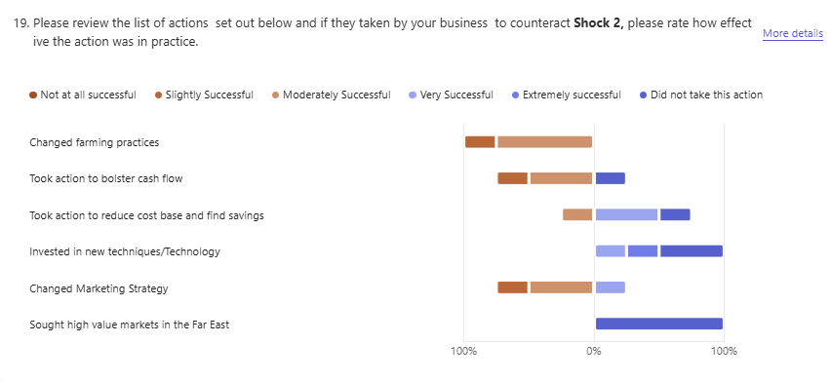
Fig 82 Actions taken by the farmers to counteract excessive fouling
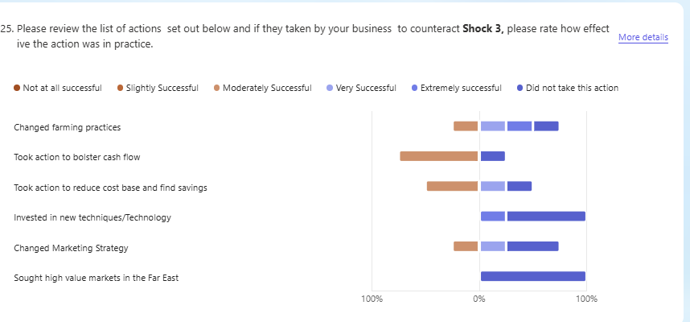
Fig 84 Actions taken by the farmers to poor success in seed mussel collection.

Rope Grown Mussel Farming
A qualitative, semi-quantitative review of state-led actions to mitigate the impacts of the shocks

“Through these consultations, the actions taken… (by the state)… in response to these past shocks will be collated, categorised, and evaluated based on … qualitative feedback from those affected…” (Extract from the response to tender)

Via the qualitative and semi-quantitative sectoral survey methodology, this section considers the efficacy of the state’s various responses and efforts in support of the seafood processing sector. In effect, the section sets out to look at the tools at the state’s disposal and how well those tools worked in the eyes of the beneficiaries.

In almost all circumstances (with the exception of the Covid 19 pandemic) the state has abided by the constraints set out by the Common Fisheries Policy and its implementing regulations, so as not to contravene state aid laws and thereby distort the marketplace. These constraints have, from time to time, frustrated the Irish seafood industry who have sought more direct government intervention in the past, into areas such as fuel and/or wage subsidies or direct subsidies following natural catastrophes. Also, the state of the Irish economy and how much leeway the exchequer could afford at particular points in time has often been a constraining factor.

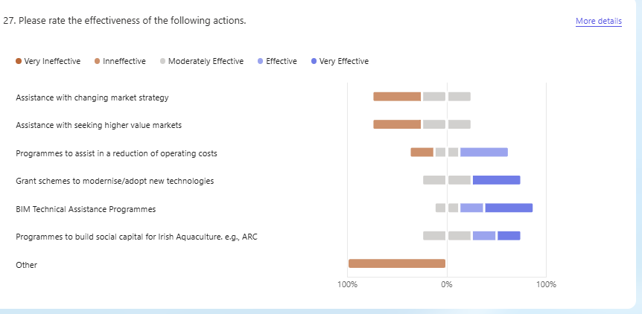
Figure 85 Actions taken by the state
The responses from the mussel farmers are consistent with their conviction that their major long-term challenges are concerned with licensing and environmental/biological factors; hence their relatively high rating given for ‘assistance to adopt new technologies’, BIM Technical Assistance Programmes and ‘building social capital’ programmes.
It is interesting that they reported relatively low levels of efficacy in terms of ‘changing marketing strategy’ and ‘seeking higher value markets’, despite the fact that these were seen as were key issues during the Covid 19 episode. It may be that it is difficult to achieve lasting change in regard to these intractable challenges or that the old adage that ‘the urgent drives out the important’ comes into play here. Thus, as the traditional markets reopened after the pandemic, the producers’ focus shifted back towards their immediate problems and away from longer term issues.
The case study in “Provision of a Scoping Study to support the delivery of an Analysis of the Resilience of the Seafood Sector” demonstrated that the RG Mussel sector does have a key market related vulnerability, but their rapid recovery in the post Covid 19 era shows that this vulnerability is transitory when societal conditions are closer to the norm. But there is a longer term issue, in one of the face-to-face interviews a view was expressed to the effect that the main French consumers of mussels were an aging cohort and that the succeeding generation of buyers were looking for a more convenient product form as they did not have the time or skill set to handle fresh mussels in the shell. It is probably fair to say that this is more of a long-term trend in the marketplace, rather than a shock as such.

The prospective view emerging from the Irish Rope Mussel Farming Sector
Probability of recurrence and potential severity of impact
Having reviewed the past, the participants in the study were then asked to carry out a future looking exercise. It had several dimensions. In the first instance, they were to try to look into the future and to assess the challenges they saw coming down the line that the sector might have to cope with. This part of the enquiry also had two dimensions. The first was to estimate the likelihood of a particular named challenge becoming a shock and the second was to give that potential challenge a severity rating.

By combining likelihood and severity, a ‘heat map’ can be created. This approach is commonly employed as a technique in risk management and is useful in guiding players in the sector as to where to prioritise resource deployment in the preparation of mitigating measures to ease the impact of potential future shocks. Risk heat maps visualize risk plotting likelihood (frequency/probability) on one axis and severity (impact/consequence) on the other axis, usually on a grid. Color-coding (green/yellow/red) is used to highlight high-priority risks that require immediate mitigation, providing a "big picture" view of sector’s threat landscape.

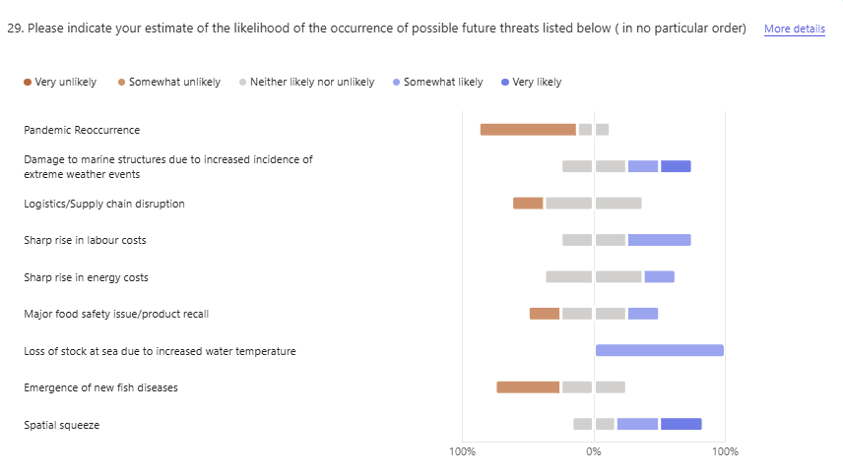
Figure 86 Likelihood of shock materialising
The respondents view as to which threats had the greatest likelihood of occurring were interesting. Despite having just lived through one, they felt it was unlikely that there would be a recurrence of a pandemic, with an accompanying disruption to the logistics and route to market. They continued with this view in their estimate of the severity of impact should such a scenario actually unfold, rating the impact as being moderate to low.
They were more concerned about increasing water temperatures, rises in energy and labor costs and increased incidence of damage due to extreme weather events. They felt that the likelihood of a major food safety issue arising was low, but they did rate the severity of impact of such an event, should it, occur as being high. This finding serves to calibrate the judgment of the respondents as it closely mirrors the historic track record of the sector.

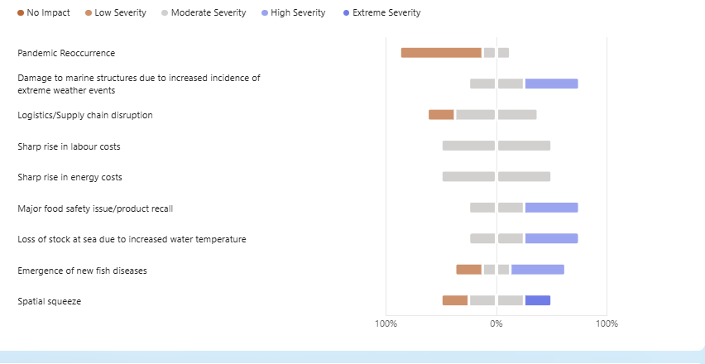
Figure 87 Severity of impact, should shock materialise.
Generate and insert heatmap and short commentary

An evaluation of the level of Preparedness (adaptive capacity) of the respondents. Rope mussel farmers views on their ‘adaptive capacity’.
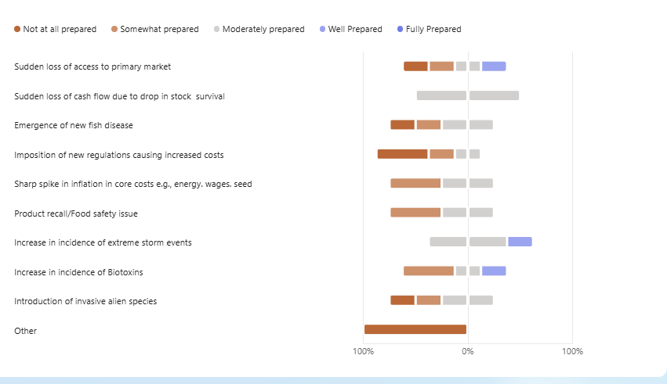
Figure 88 Preparedness to deal with future challenges
The respondents’ views on their relative preparedness to deal with a range of possible future challenges displayed a deep lack of confidence in their adaptive capacity. With the exception of managing a cash flow crisis and weathering increasingly forceful weather events, they indicated that were largely unprepared for most of the other potential challenges that were likely to come their way.
It should be acknowledged that the growers have suffered a prolonged period of poor prices for their products and that this may have coloured their views and made them more pessimistic than usual.

Rope mussel farmers attitude towards Climate Change
In the response to tender the following statement was made:
“…climate change impacts be studied and the vulnerability of the Irish seafood sector to those future shocks be assessed.” (source: response to tender)

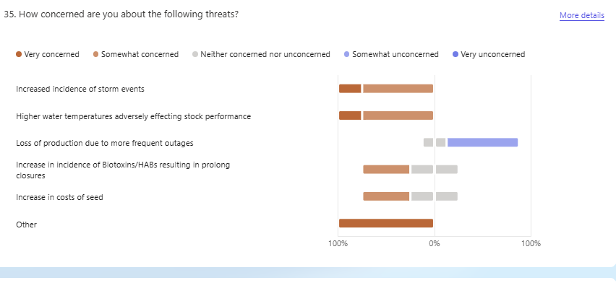
Fig 89 Climate change
It is evident from fig 310* above that the mussel farmers are fearful of the negative impacts that climate change may have on their farms. The only issue not worrying them is the possibility of increased power outages, which is not surprising given the nature of their production system.
The responses to this section of the SI closely map the responses to the preparedness questions and paint a picture of a sector that is currently feeling somewhat vulnerable and a bit ‘down on their luck’.

Rope Mussel farmers views on their HR development plans
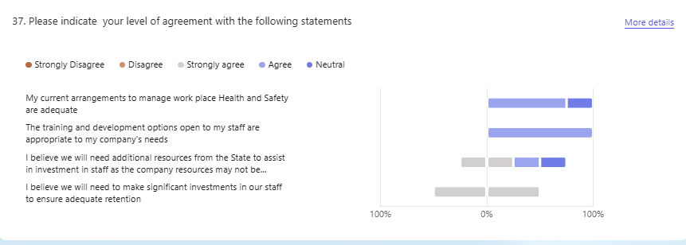

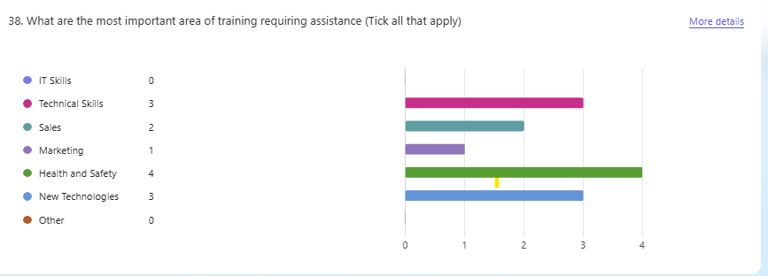
Fig 90 Human Resources
The rope grown muscle respondents were more sanguine when it came to their views concerning human resources. In general, they were confident that their staff were adequately trained and that they had access to appropriate further training for existing staff or for new entrants.
It was interesting to note that they foresaw the need for additional training in technical skills, Health and Safety and in new technologies. Their prioritization in this regard was quite different from the oyster farmers.

Rope mussel farmers Business Sentiment and key future trends
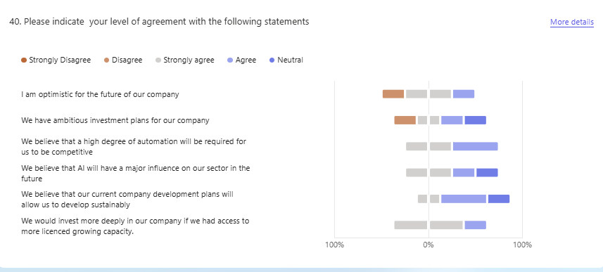
Figure 91 Business sentiment and key future trends
Unsurprisingly, given the previous answers, the RG mussel growers expressed a mixed level of optimism with regard to the future. Having said that, it was interesting that a majority of the companies still stated that they had ambitious investment plans for their operations, indicating an admirable degree of tenacity and an intention to continue to trade in the rope grown muscle sector.
Like the salmon farmers, the RG mussel growers saw the need for increased automation and expressed the view that artificial intelligence will have a major influence in their sector in the future. They also indicated that they would invest more deeply if they had access to more licensed growing area.

Summary and Highlights of the RG Mussel growers’ responses.
In this study, the RG mussel farmers did not rate either Covid 19 or Brexit highly in their list of top three shocks, although they did benefit from both the general government support packages and they availed of a special scheme at the time of the pandemic

The number 1 shock identified by the respondents is centred around security of tenure and the farmers fears that there will be long delays in the process of renewing their aquaculture site licences. Shocks 2 (excessive fouling) and 3 (poor success with mussel spat collection) are biological/environmental in nature and may also be linked to climate change.

The mussel farmers did pursue progress through improving their techniques and technology in dealing with fouling and mussel spat collection, and although the problems were not fully eliminated, moderate success was reported by the correspondents

It is hoped that they will enjoy more success in the future as their detailed understanding of their sites and the dynamics of the plankton populations therein becomes deeper and deeper

In assessing the efficacy of state interventions, (aside from the Covid 19 special schemes) the respondents awarded relatively high ratings to ‘Assistance to adopt new technologies’, The BIM Technical Assistance Programme and ‘The BIM Building Social Capital’ programmes

The respondents’ views on their relative preparedness to deal with a range of possible future challenges displayed a deep lack of confidence in their adaptive capacity
It is evident from their responses that the mussel farmers are fearful of the negative impacts that climate change may have on their farms in the future

Notwithstanding, a majority of the companies stated that they had ambitious investment plans for their operations, indicating an admirable degree of tenacity and an intention to continue to trade in the rope grown muscle sector

Resilience in the Bottom Grown (BG) Mussel Sector
Although they generate the same end product, (Mytilus edulis or the black Mussel) the RG mussel sector and BG mussel sector are very different and need to be considered individually. The differences are very apparent in the responses given by the respondents to the SI.
At a very basic level, the two distinct methods of culture make for different challenges. The RG growers use a suspended system keeping the stock off the seabed, largely out of reach of the natural predators of the mussels, such as starfish and green shore crabs. Starfish, for example, are voracious predators of mussels, especially juvenile or seed mussels, and can decimate mussel beds in a matter of days, if left unchecked or the mussel stock is not removed.
Also, the two culture types generally source their juvenile stocks by different means. The BG growers depend on finding and fishing naturally occurring ‘seed mussel’ beds and then relaying the juveniles for on growing in licenced aquaculture plots. The occurrence of these seed mussel beds is an irregular phenomenon, and they tend to be ephemeral, with a limited time frame for exploitation. As discussed previously, the RG growers ‘collect’ their seed from the water column using suspended collectors.
The two sectors are also structured differently and service different seafood market segments. There is very substantial Dutch investment in the Irish BG industry and virtually the entire Irish BG mussel output goes directly, in bulk, to Holland where it is processed and combined with mussels from other sources. Then it largely goes into the Moules et Frites HORECA segment of the European seafood market.
As a consequence, the Irish BG mussel producers do not tend to pay much attention to marketing issues, aside from product quality, as the ultimate destination for their produce is determined before they even fish for the seed mussels. They are in effect vertically integrated as a form of ‘franchised supplier’, plugged into a much larger EU mussel industry. This structural difference can be clearly seen in Fig 400* below.

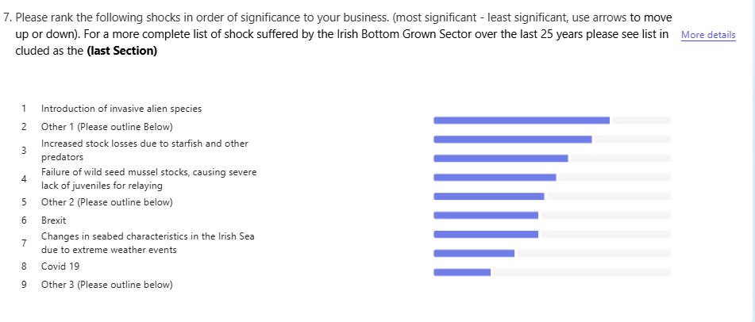
Figure 92 Ranking of shocks by respondents
Covid 19 and Brexit rank low down in their list of shocks. In the case of Covid 19, they had harvested and delivered almost all of their stocks before the restrictions were imposed, so it barely impacted on them. Similarly, Brexit did not impact much either as they largely ship their product live in special vessels straight to Yerseke in Holland and so they did not get snarled up to any great extent in the transportation chaos of Brexit.
Thus, in considering the Irish BG mussel sector, considerations around seeking higher value or alternative markets or route to market are largely irrelevant.
That is not to say that the sector does not have shocks to cope with, the BG mussel growers have their fair share of challenges.
The shocks rated 1 and 2 above by the respondents can actually be combined and examined together. Shock 1 related to a specific incident and set of circumstances, while shock 2 is more general. However, both relate to unsympathetic application of various regulations to the sector that have had the effect of either delaying the ability of the BG mussel growers to fish for seed mussel or reducing their opportunity to fish by way of closing areas, previously open, or restricting activity in other ways.
Being able to fish for and harvest seed mussels for relaying is the cornerstone of the current BG mussel sector and anything that prevents or disrupts that activity has a severely detrimental effect on the business.
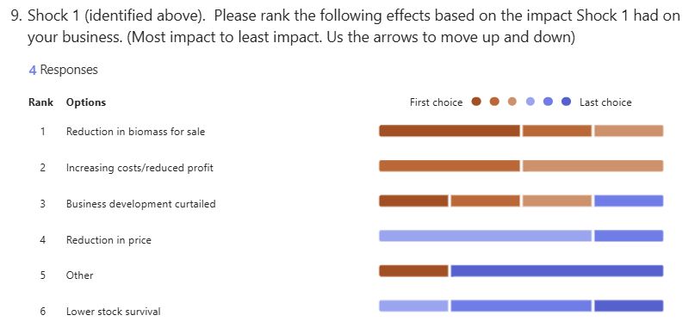
Figure 93 Shock No 1. Effects of introduction of alien invasive species
The detection of a single example of an invasive species, the slipper limpet (Crepidula fornicata) in a Wexford seed bed led to the shutdown of the traditional autumn fishery in 2025, dealing a severe blow to the industry.
The closure of the fishery was carried out, in the first instance, to attempt to comply with S.I. No. 374/2024 - European Union (Invasive Alien Species) Regulations 2024, brought into effect from July 2024. Repeated intensive resurveying by BIM failed to find any other examples, suggesting that there was no ‘established population’ of the slipper limpet present, (an important legal distinction). A deeper examination of the particular Statutory Instrument revealed a number of problematic legal lacunae and a lack of clarity as to where the legal vires lay in terms of control of the fishery.
Eventually, the fishery was opened in November 2025, but the biomass available to fish was by then sharply reduced, as was the opportunity to go fishing, due to the onset of seasonal winter storms. This outcome was especially unfortunate as there was strong sea mussel spatfall in 2025, the first in a number of years, and the growers really needed the seed mussel to restock their beds.
The BG mussel growers see this incident, (despite the best efforts of the Department of Agriculture, Food and the Marine and its agencies, which the BG growers acknowledge) as an example of an unsympathetic application of a flawed piece of regulation, which impacted heavily on their sector.
A similar pattern of effects may be seen in fig 402* below dealing with the Shock rated as number 2 by the BG growers. They cited a number of what they saw as ‘heavy-handed’ regulatory impositions concerning inter alia actions by the Sea Fisheries Protection Agency and other bodies, restricting surveying for seed mussel, the closure of certain previously available fishing areas and inflexibility in the authorisation of deploying novel seed mussel collection structures.
The BG mussel growers do have an excellent liaison structure with Government and the agencies in the form of the Bottom Grown Mussel Consultative Forum (BGMCF) and it is hoped that progress can be made to resolve some or all of these issues through the use of its good offices.
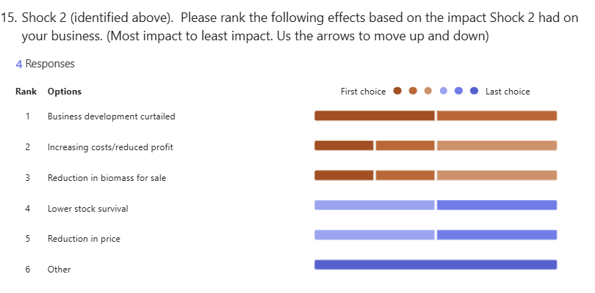
Figure 94 Shock No 2. Effects of unsympathetic application of regulations

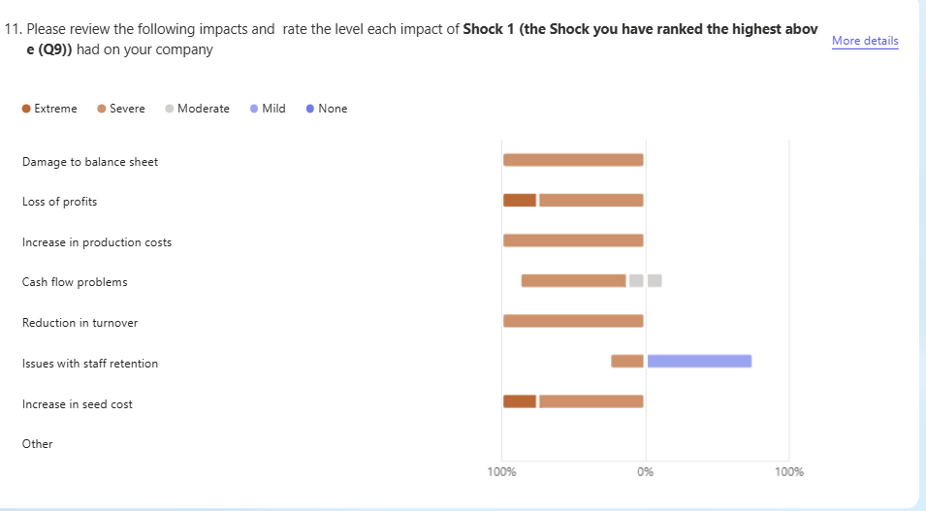
Figure 95 Severity of impact of delay of 2025 seed mussel fishery
As one might expect, Fig 402 and 403 above show a similar pattern as they both relate to the unforeseen and negative impacts of unsympathetic regulation as discussed above.
There was no point in discussing the industry responses under these circumstances as the only option open to the BG Growers was compliance.
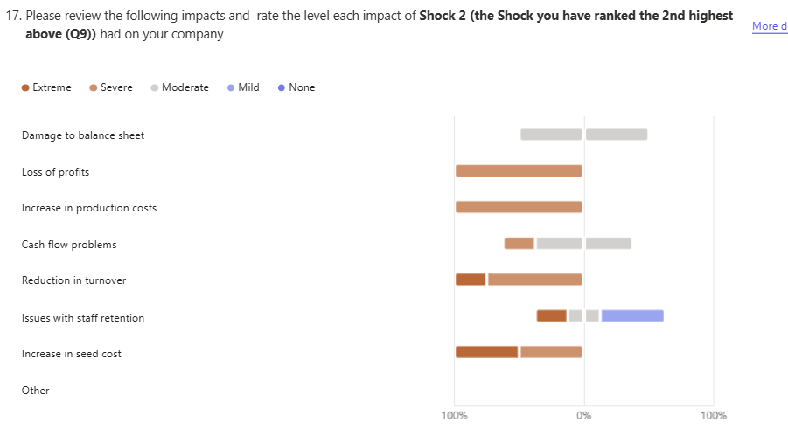
Figure 96 Severity of impact of unsympathetic imposition of regulation

BG Mussel Growers
A qualitative, semi-quantitative review of state-led actions to mitigate the impacts of the shocks

“Through these consultations, the actions taken… (by the state) … in response to these past shocks will be collated, categorised, and evaluated based on … qualitative feedback from those affected…” (Extract from the response to tender)

Via the qualitative and semi-quantitative sectoral survey methodology, this section considers the efficacy of the state’s various responses and efforts in support of the seafood processing sector. In effect, the section sets out to look at the tools at the state’s disposal and how well those tools worked in the eyes of the beneficiaries.

In almost all circumstances (with the exception of the Covid 19 pandemic) the state has abided by the constraints set out by the Common Fisheries Policy and its implementing regulations, so as not to contravene state aid laws and thereby distort the marketplace. These constraints have, from time to time, frustrated the Irish seafood industry who have sought more direct government intervention in the past, into areas such as fuel and/or wage subsidies or direct subsidies following natural catastrophes. Also, the state of the Irish economy and how much leeway the exchequer could afford at particular points in time has often been a constraining factor.

The respondents’ views of the efficacy of state actions in support of their sector are set out in Fig 405* below. As mentioned earlier this sector is not really concerned with marketing or route to market actions, so those can be largely disregarded.
It was interesting to note their strong approbation of: the BIM Technical Assistance Programme, (which includes the operation of the T-Burke survey vessel), the modernisation/adopt new technologies scheme and BIM’s social licence building efforts. They were also positive about programmes to assist with reductions in operating costs.
This outcome suggests that the suite of state support measures, to assist with the development of enhanced adaptive capacity, largely delivered by BIM, are valued by the sector and are appropriately targeted.
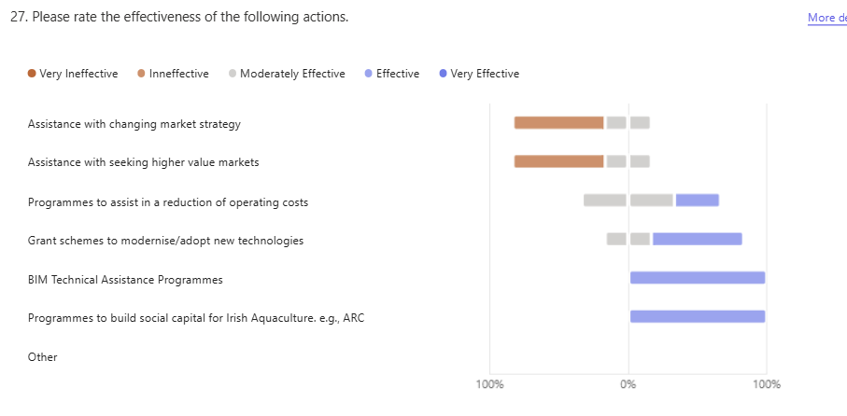
Figure 97 Efficacy of State Actions to assist the BG mussel sector

The Prospective View of the BG Mussels Growers
Probability of recurrence and potential severity of impact
Having reviewed the past, the participants in the study were then asked to carry out a future looking exercise. It had several dimensions. In the first instance, they were to try to look into the future and to assess the challenges they saw coming down the line that the sector might have to cope with. This part of the enquiry also had two dimensions. The first was to estimate the likelihood of a particular named challenge becoming a shock and the second was to give that potential challenge a severity rating.

Based on the contents of fig 406 below, the BG growers think that a pandemic recurrence is not likely, nor is a food safety or product recall scenario. They do predict loss of fishing days due to climate change, and they are expecting further disruptions to their supply chains. Increases in costs are predicted, but not with a high degree of certainty.
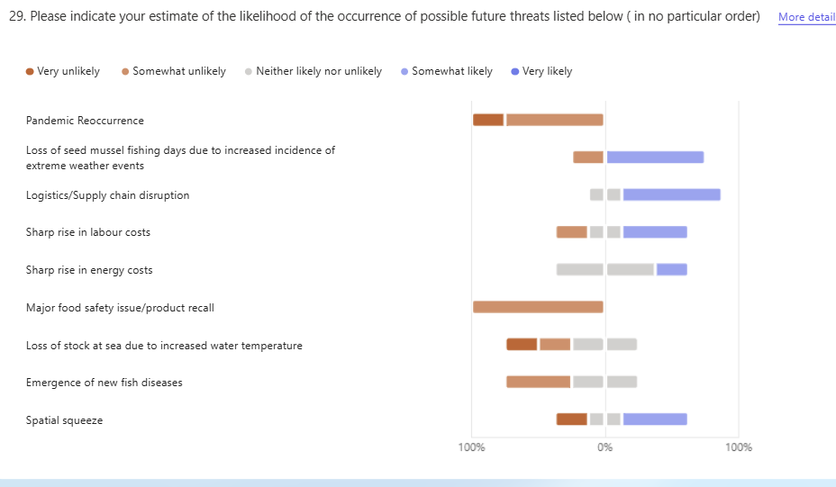
Figure 98 Likelihood of Occurrence of Future Shocks

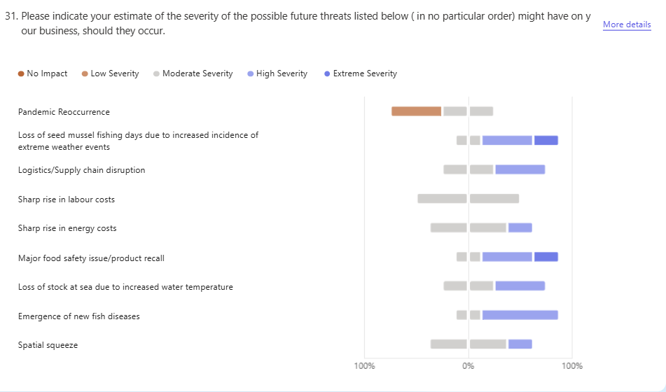
Figure 99 Severity of impact should shocks materialise
From the figure 407 above it may be seen that the BG growers feel that: a new fish disease, stock loss due to warmer water or a major food safety incident, though unlikely to happen, would have severe impacts if they did.
Reflecting their somewhat benign experience with Covid 19, they don’t expect another pandemic and even if one did materialise, they don’t fear its impact. They are very worried about loss of fishing days and supply chain disruption.
By combining likelihood and severity, a ‘heat map’ can be created. This approach is commonly employed as a technique in risk management and is useful in guiding players in the sector as to where to prioritise resource deployment in the preparation of mitigating measures to ease the impact of potential future shocks. Risk heat maps visualize risk plotting likelihood (frequency/probability) on one axis and severity (impact/consequence) on the other axis, usually on a grid. Color-coding (green/yellow/red) is used to highlight high-priority risks that require immediate mitigation, providing a "big picture" view of sector’s threat landscape.
Insert heat map and comment

An evaluation of the level of Preparedness (adaptive capacity) of the BG mussel growers
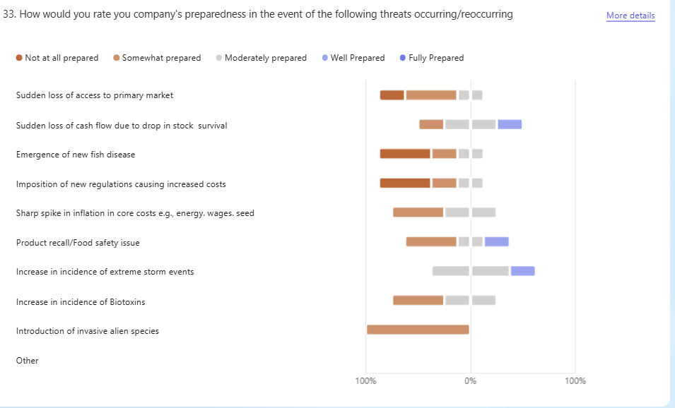
Figure 100 Adaptive Capacity in the BG mussel sector
The responses of the BG growers to the list of possible future threats that might materialise closely mirrors their recent experiences, as set out above. They feel unprepared and are nervous of any further future regulations being imposed on them, due to invasive alien species, novel fish diseases or other unexpected causes. Such incidents have been painful in the very recent past and are fresh in their memories
Interestingly, they are sanguine about an increased incidence of storm events, which is somewhat counter intuitive, but may be a reflection of confidence in their own technical capabilities. They also feel quite well prepared to cope with cash flow crises, which is a good indicator of fundamental commercial adaptive capacity
They do report vulnerability with regard to dealing with cost increases and control of the impacts of inflation on their operations. This is understandable as they are highly exposed to fuel price increases in terms of running their shipboard/fishing operations. Their response to the SI question about loss of access to their primary market is instructive as their response confirms that they are, essentially, totally dependent on their current arrangements.
Climate Change
Fig 409* below summarises the respondents’ views concerning the possible impacts of climate change in the near to medium term.
The responses concerning increased incidence of extreme weather events are mixed but do not suggest a high degree of anxiety. The growers are more worried about climate change adversely affecting seed availability and to a lesser extent, water conditions that might adversely affect stock survival or performance. As with the RG mussel growers they display a low level of concern regarding any increases in power outages, which is not surprising considering the nature of their operations.
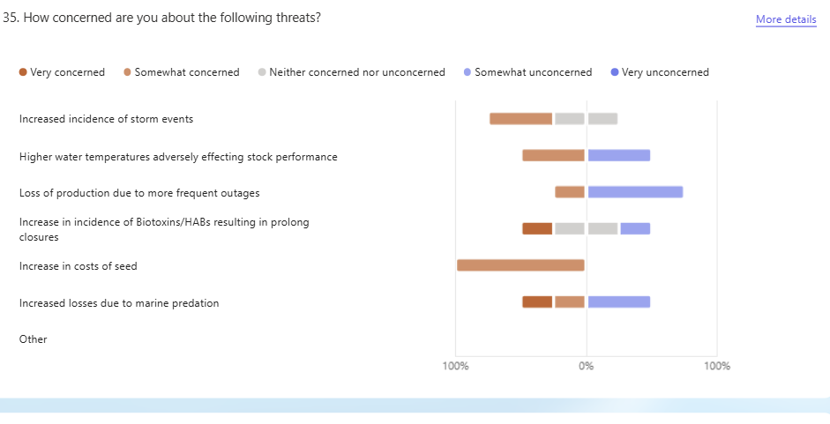
Figure 101 Climate Change related concerns
Human Capital
The responses of the BG mussel growers regarding their current levels of staff competence, set out in Fig 410* are positive and consistent with a sector that operates under a Certificate of Competence (CoC) regime overseen by the Dept of transport.
The respondents do acknowledge the need for ongoing staff development, and they anticipate the need for ongoing support in this regard.
In common with the salmon farmers, but less so with the oyster and RG growers, they see the need to upskill in ‘Technical skills’, use of ‘New Technologies’ and continued investment in occupational Health and safety.
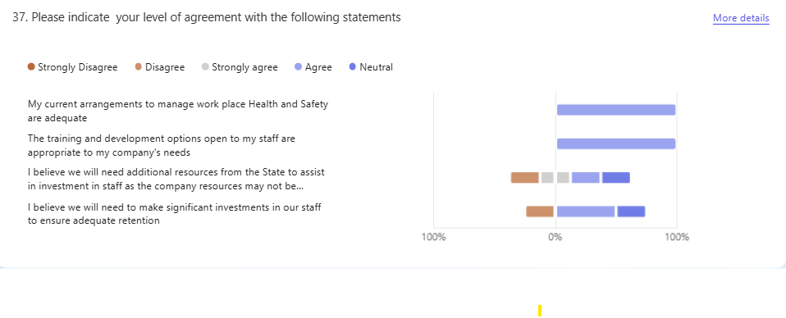
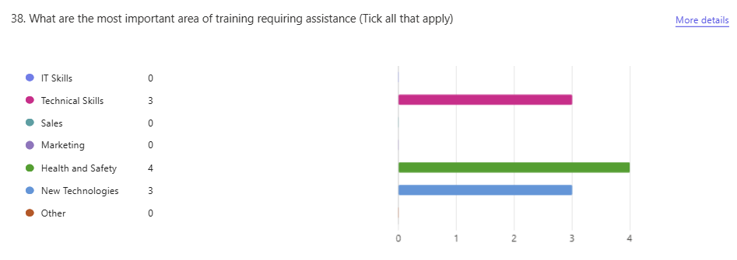
Figure 102 Human Capital in the BG Mussel Sector
Business Sentiment
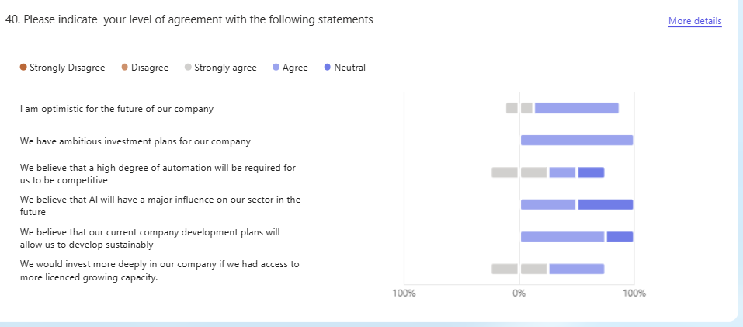
Figure 103 BG mussel growers business sentiment
The BG mussel growers are more optimistic about their future prospects than either the RG mussel growers or the oyster farmers and are on a par with the salmon farmers in this regard. This may be seen from Fig 411* above and it is somewhat unexpected given their disappointments concerning the seed mussel fishery over the last few years. To an extent their confidence may stem from having well financed parent companies in Holland, but they are also being proactive in their own future development
Notwithstanding, based on the interviews, the BG growers reported that they had enjoyed a period of stable prices and that they were managing to extract somewhat better yields from the limited volume of seed mussels that they had managed to obtain. They also expressed the view that the era of relying solely on wild seed mussel beds as a source of juveniles was drawing to a close and that in the near future, they expected to enjoy a supplemental and more reliable flow of juveniles from ‘artificially’ gathered mussel seed, similar to the RG farmers.
Summary and Highlights of the BG Mussel growers’ responses.
Although they generate the same end product, (Mytilus edulis or the black Mussel) the RG mussel sector and BG mussel sector are very different. At a very basic level, there are two distinct methods of culture and that makes for different challenges
The Irish BG mussel producers do not tend to pay much attention to marketing issues, aside from product quality, as the ultimate destination for their produce is determined before they even fish for the seed mussels. They are in effect vertically integrated as a form of ‘franchised supplier’, plugged into a much larger EU mussel industry
Covid 19 and Brexit rank low down in their list of shocks. In the case of Covid 19, they had harvested and delivered almost all of their stocks before the restrictions were imposed, so it barely impacted on them. Similarly, Brexit did not impact much either
Being able to fish for and harvest seed mussels for relaying is the cornerstone of the current BG mussel sector and anything that prevents or disrupts that activity has a severely detrimental effect on the business
The detection of a single example of an invasive species, the slipper limpet (Crepidula fornicata) in a Wexford seed bed led to the shutdown of the traditional autumn fishery in 2025, dealing a severe blow to the industry
Eventually, the fishery was opened in November 2025, but the biomass available to fish was by then sharply reduced, as was the opportunity to go fishing, due to the onset of seasonal winter storms. This outcome was especially unfortunate as there was strong sea mussel spatfall in 2025, the first in a number of years, and the growers really needed the seed mussel to restock their beds.
Eventually, the fishery was opened in November 2025, but the biomass available to fish was by then sharply reduced, as was the opportunity to go fishing, due to the onset of seasonal winter storms. This outcome was especially unfortunate as there was strong sea mussel spatfall in 2025, the first in a number of years, and the growers really needed the seed mussel to restock their depleted licenced growing beds.
The BG mussel growers do have an excellent liaison structure with Government and the agencies in the form of the Bottom Grown Mussel Consultative Forum (BGMCF) and it is hoped that progress can be made to resolve some or all of these issues through the future use of its good offices.
It was interesting to note their strong approbation of: the BIM Technical Assistance Programme, (which includes the operation of the T-Burke survey vessel), the modernisation/adopt new technologies scheme and the social licence building efforts. They were also positive about programmes to assist with reductions in operating costs.
This outcome suggests that the suite of state support measures, to assist with the development of enhanced adaptive capacity, largely delivered by BIM, are valued by the sector and are appropriately targeted.
The BG mussel growers indicated strong approbation for the BIM Technical Assistance Programme, (which includes the operation of the T-Burke survey vessel), the modernisation/adoption of new technologies scheme and the social licence building efforts. This outcome suggests that the suite of state support measures, to assist with the development of enhanced adaptive capacity, largely delivered by BIM, are valued by the sector and are appropriately targeted
In common with the salmon farmers, but less so with the oyster and RG growers, the BG mussel farmers see the need to further invest in ‘Technical skills’ and the use of ‘New Technologies’
The BG mussel growers are more optimistic about their future prospects than either the RG mussel growers or the oyster farmers and they are on a par, more or less, with the salmon farmers in this regard.

PART 3

CREST - BIO ECONOMIC MODEL

FOR RESILIENCE TESTING

Part 3 CREST Bio-economic Model

Purpose and scope
The Capacity, Resilience and Economic Shock Transmission (CREST) model is a fleet-segmented bio-economic model of the Irish capture fishing fleet, developed to project the economic value of landings over the period 2024–2036 and to transmit exogenous biological, regulatory and market shocks through to disaggregated fleet-segment economic outcomes. Unlike a stock-assessment model, CREST does not estimate population status; and unlike a whole-economy model, it does not represent inter-sectoral or macroeconomic adjustment. Its object of analysis is the fleet itself; the distribution of landed value, effort and profitability across fleet segments and species categories under a defined scenario. In this respect CREST belongs to the established tradition of European policy-facing bio-economic models, while occupying a distinct methodological position within it.

Model class and architecture
CREST is a recursive, deterministic, partial-equilibrium projection model. Its computational core is a sequential pipeline rather than a simultaneous equilibrium or a closed simulation loop. Exogenous stock trajectories (derived from the most recent analytical assessments and projected forward under alternative fishing-mortality scenarios) define the available landings for each species category. A bycatch-ratio bridge partitions category value between assessed and non-assessed components. A Cobb–Douglas catch-production function (Clark, 1990) then allocates category totals across fleet segments as a function of segment catchability, effort and stock biomass, subject to an exact reconciliation constraint that preserves category-level totals. Projected effort is converted to days-at-sea, and a cost module resolves segment-level gross profit. Causality runs in one direction throughout: the fleet does not influence the resource, and downstream economic outcomes do not feedback to upstream stock or allocation quantities.
This open-loop structure is a deliberate design choice rather than a simplification of convenience. The Irish fleet accounts for a small share of total fishing mortality on the principal shared stocks it exploits, so its catch decisions exert negligible influence on stock dynamics, and the relevant biological signals are appropriately treated as exogenous forcings. The fleet is likewise broadly price-taking for the majority of its target species, accounting for only a small share of global supply, so that ex-vessel prices may in general be treated as exogenous; the principal exception, Northeast Atlantic mackerel, is described in Section 3. Calibration uncertainty on the bycatch ratios is propagated by a non-parametric bootstrap; this is, however, explicitly a partial measure of predictive uncertainty and is not represented as the total forecast uncertainty of the model.

Relation to established bio-economic frameworks
CREST shares its catch-production core with the two principal European policy-facing bio-economic frameworks - FISHRENT (Salz et al., 2011) and FLBEIA (García et al., 2017) - and with the bio-economic module underpinning the Annual Economic Report on the EU Fishing Fleet (STECF, 2023). The Cobb–Douglas production specification, the biomass-elasticity (“stock–catch”) coefficients, and the cost-accounting structure all follow conventions established in those frameworks and in the Data Collection Framework on which the Annual Economic Report rests. FLBEIA is itself constructed upon the FLR computational framework (Kell et al., 2007), which provides a modelling lineage common to much of this literature.
CREST nevertheless departs from these frameworks in several respects that together define its methodological niche. First, it operates in the value domain: it receives a revenue forecast directly from the upstream assessed/non-assessed bridge and applies prices internally only to recover target tonnages, whereas FISHRENT, FLBEIA and the Annual Economic Report module project catch volumes and apply prices to obtain revenue; an inversion that is appropriate for a price-taking fleet. This price-taking treatment is relaxed for Northeast Atlantic mackerel, for which the model applies a volume-dependent (inverse-demand) ex-vessel price in place of a fixed one. As a material participant in the mackerel fishery, the Irish fleet is not treated as a pure price-taker for this stock: aggregate landings are permitted to exert downward pressure on price, so that projected mackerel revenue responds to harvest volume, falling proportionately less than landings when the available quota contracts, and rising less than proportionately when it expands, rather than scaling linearly at a constant price. Second, it enforces structural reconciliation to category-level revenue, rescaling segment shares to match category totals exactly, in contrast to the bottom-up construction with ex-post reconciliation used elsewhere. Third, and most fundamentally, it is open-loop: it neither closes the management feedback loop that defines a Management Strategy Evaluation, nor represents the dynamic capital, investment and effort-allocation behaviour that FLBEIA and FISHRENT simulate. CREST is, in consequence, a projection model conditioned on exogenous scenarios rather than a dynamic simulation or an optimisation model.

Equilibrium scope
The partial-equilibrium boundary is intrinsic to CREST’s purpose and warrants explicit statement. Questions concerning the propagation of a fishery shock through a regional or national economy (the reallocation of labour and capital across sectors, the adjustment of wages and prices, and the resulting effects on output, employment and welfare) fall outside the model’s scope and are the province of general-equilibrium methods: principally computable general equilibrium (CGE) models and, where the anticipatory behaviour of forward-looking agents under uncertainty is central to the question, dynamic stochastic general equilibrium (DSGE) models (Lucas, 1976). CREST is complementary to, rather than a substitute for, such methods; indeed, the fleet-level output it produces constitutes precisely the sectoral shock vector that a regional CGE would require as an input. The choice of a partial-equilibrium framework reflects both the analytical question i.e. the internal distribution and transmission of shocks within the fleet, and the empirical reality that the fishing sector forms a small component of the wider Irish economy.

Shocks, resilience and validation
The modelling of shocks and resilience in fisheries spans several distinct traditions. Formal viability and co-viability analysis (Doyen et al., 2012; Maynou, 2014) operationalises resilience as the capacity of a system to remain within a set of joint biological and economic constraints through time under uncertainty. A separate, indicator-based literature on social–ecological vulnerability assesses the exposure, sensitivity and adaptive capacity of fishing communities and national economies to climatic and governance shocks (Allison et al., 2009; Cinner et al., 2018). A third strand examines the transmission of production shocks through global seafood production and trade networks (Gephart et al., 2017). CREST contributes a transmission layer to the European bio-economic lineage: it propagates an exogenous shock (for example, a quota reduction, a stock decline, a fuel-price increase or a gear restriction) through to segment-level economic outcomes and reads resilience from the resulting distribution of profitability and capacity utilisation across the fleet. Its resilience vocabulary derives from the viability tradition rather than from the social–ecological or trade-network literatures, and a planned extension is intended to express this explicitly as a viability-constrained capacity diagnostic.
The model’s validation philosophy follows the empirical, prediction-oriented standard articulated in the recent management-evaluation literature. Out-of-sample (hindcast) testing against a withheld year provides an objective basis for accepting or rejecting the projection (Kell et al., 2016), while the treatment of calibration uncertainty as a bounded sensitivity rather than a complete uncertainty budget is consistent with the risk-equivalence and empirical-validation framework set out by Kell and colleagues (Fischer et al., 2023; Kell et al., 2024). This situates CREST’s within the same methodological approach as contemporary stock-assessment and management-procedure evaluation, notwithstanding its distinct economic focus.
In summary, CREST is a recursive, partial-equilibrium, scenario-conditional bio-economic projection model that adopts the catch-production core and accounting conventions of the established European frameworks, deliberately forgoes their biological feedback and behavioural-optimisation machinery, and adds an explicit shock-transmission layer terminating in fleet-segment economic outcomes. It addresses a circumscribed and policy-relevant question - how exogenous biological, regulatory and market shocks are distributed across the Irish fleet, and what this implies for the capacity and resilience of its constituent segments - and is designed to interoperate with the stock-assessment models that supply its inputs and the general-equilibrium models that may be built on its outputs.

Biological Module
To be completed – Laurie Kell

Stock-level TAC and landings-volume projection

Introduction
Projection of national fisheries revenue requires, as a first step, a coherent year-by-year projection of fishing opportunities for each of the key stocks fished by the Irish fleet. Ireland's commercial sea fisheries landings are governed by two distinct species categories: quota species managed under the EU Common Fisheries Policy (CFP), and non-quota species outside that framework. In 2024, Irish vessels landed approximately €254 million in total. This breaks down across three structurally distinct groups:
Group A — Twelve individually modelled quota stocks (€161m, 63.5% of total). Ireland holds material quota shares in 61 CFP-managed stocks. Of these, 12 are designated as assessed stocks (A stocks) in CREST and are projected individually: ALB/AN05N (albacore), ANF/07. and ANF/56-14 (anglerfish), BOR/678- (boarfish), HKE/571214 (hake), JAX/2A-14 (horse mackerel), LEZ/07. (megrim), MAC/2CX14- (mackerel), NEP/07. and NEP/5BC6. (Nephrops), WHB/1X14 (blue whiting), and WHG/7X7A-C (whiting). These were selected because Ireland holds a significant national quota share in each, and together they account for the dominant share of revenue from the Trawl Midwater (TM), Demersal Trawl (DTS), and Beam Trawl (TBB) fleets that form CREST's core.
Table 3 Group A assessed stocks individually projected by CREST, 2024 landings.
Stock code | Common name | Landed volume (t) | Landed value (€m)
NEP/07. | Nephrops (Div. 7) | 7,176 | 55.28
MAC/2CX14- | Mackerel | 50,771 | 46.91
WHB/1X14 | Blue whiting | 62,478 | 16.39
HKE/571214 | Hake | 2,914 | 10.75
ANF/07. | Anglerfish (Div. 7) | 3,108 | 10.01
ALB/AN05N | Albacore tuna | 4,003 | 9.38
BOR/678- | Boarfish | 19,999 | 5.35
LEZ/07. | Megrim (Div. 7) | 1,248 | 3.66
ANF/56-14 | Anglerfish (Div. 5/6) | 412 | 1.39
WHG/7X7A-C | Whiting (Div. 7b–k) | 666 | 1.01
JAX/2A-14 | Horse mackerel | 1,778 | 0.77
NEP/5BC6. | Nephrops (Div. 5/6) | 67 | 0.47
TOTAL |  | 155,620 | 161.37

Group B — Forty-nine non-assessed (NA) quota stocks (€18m, 7.1% of total). The remaining 49 CFP quota stocks, including haddock sub-stocks, Celtic Sea and North Atlantic herring, sole, plaice, cod, saithe, pollack, and ling, are not individually projected in CREST. Ireland's quota share in each is typically small, and the cost-benefit of developing individual stock projections for these species was not judged to justify the additional modelling effort. While all are occasionally targeted, many of these stocks are also caught as bycatch alongside the targeted A-stock fisheries. Their combined value is estimated in aggregate using the bycatch-ratio bridge described in Chapter 4, which derives non-assessed demersal and pelagic revenue as a stable proportion of the corresponding assessed revenue.
Table 4 Group B quota stocks treated as bycatch in CREST (top 12 of 49 by 2024 landed value).
Stock code | Common name | Landed volume (t) | Landed value (€m)
HAD/7X7A34 | Haddock (Div. 7b–k) | 2,119 | 4.35
HAD/5BC6A. | Haddock (Div. 5b/6a) | 1,003 | 2.29
LEZ/56-14 | Megrim (Div. 5b/6) | 249 | 1.19
SOL/07A. | Sole (Div. 7a) | 75 | 1.15
HAD/6B1214 | Haddock (Div. 6b) | 418 | 0.99
HER/5B6ANB | Herring (Div. 5b/6bN) | 2,452 | 0.98
HAD/07A. | Haddock (Div. 7a) | 531 | 0.96
HER/1/2- | Herring (Subareas 1/2) | 2,141 | 0.89
SOL/7HJK. | Sole (Div. 7h–k) | 62 | 0.84
COD/7XAD34 | Cod (Div. 7b–k) | 186 | 0.76
SOL/7FG. | Sole (Div. 7f–g) | 43 | 0.59
COD/5BE6A | Cod (Div. 5b/6a) | 124 | 0.58
37 further stocks |  | — | 2.43
TOTAL (49 stocks) |  | — | 17.99
Group C — Non-quota species (€75m, 29.5% of total). Shellfish (edible crab €19m, lobster €12m, scallop €8m, whelk €8m), sprat, razor clams, and other unmanaged species make up the remainder. These are caught almost exclusively by the Other Fleets segment — pot vessels, dredgers, and inshore passive gear — which operates under no TAC constraint and are driven by entirely different effort dynamics. In 2024, 98.6% of non-quota species value was landed by the Other Fleets segment; the combined share attributable to TM, DTS, and TBB was negligible. CREST does not project Group C species individually: their revenue is covered by the Other Fleets residual treatment in the fleet allocation module (Chapter 5).
Table 5 Group C non-quota species excluded from CREST projections (top 15 of > 280 species by 2024 landed value).
Species | Landed volume (t) | Landed value (€m) | Primary fleet
Edible crab | 7,305 | 19.09 | Other Fleets
European lobster | 655 | 12.20 | Other Fleets
Great Atlantic scallop | 2,693 | 7.91 | Other Fleets
Whelk | 4,419 | 7.84 | Other Fleets
European sprat | 16,838 | 4.83 | Other Fleets
Palaemonid shrimps | 228 | 3.48 | Other Fleets
Sword razor shell | 537 | 3.12 | Other Fleets
Palinurid spiny lobsters | 53 | 1.81 | Other Fleets
Razor clams | 312 | 1.65 | Other Fleets
Velvet swimcrab | 373 | 1.03 | Other Fleets
Turbot | 78 | 0.96 | Other Fleets
John dory | 130 | 0.84 | Other Fleets
European pilchard/sardine | 3,154 | 0.84 | Other Fleets
Lemon sole | 216 | 0.74 | Other Fleets
Flat oysters | 134 | 0.67 | Other Fleets
~265 further species | — | 9.89 | Other Fleets
TOTAL | — | 74.90
Group C accounts for 29.5% of total national Irish landings value in 2024. In 2024, 98.6% of non-quota species value was landed by the Other Fleets segment (pot vessels, dredgers, inshore passive gear). The TM, DTS, and TBB fleets that form CREST's core account for a negligible share of Group C landings. Source for all three tables: STECF annual landings data (2024); CREST Landings 24 module.
For each of the twelve A stocks, two outputs are required at annual resolution: a projected total allowable catch (TAC) in tonnes, and a projected landed volume, which may differ from the TAC due to incomplete quota uptake, quota swaps, and reporting conventions. The remainder of this chapter specifies the multi-stage projection chain for these outputs.
The framework parallels the policy module of FISHRENT (Salz et al., 2011, Section 2.4), which similarly distinguishes near-term TAC advice from biological projections under alternative target harvest ratios, and the management procedure model of FLBEIA (García et al., 2017, Section 2.2), where harvest control rules are applied to a stock projection within a Management Strategy Evaluation loop.

TAC projection

Information sources
Two input streams condition the TAC projection. The first is the published EU advice and Council decision series. For each stock, the most recent ICES advice and the Council-agreed TAC are recorded year by year over the historical record. The resulting series is treated as deterministic and is not re-estimated within the present module. The second stream is the CREST Biological Model (CBM) output. For each of the twelve Assessed or A-stocks, a CBM projection is available under alternative harvest control rule scenarios:
- F at maximum sustainable yield (F_{MSY}),
- F at status-quo levels (F_{SQ}),
- F at a fraction of status-quo (50 per cent or 75 per cent), and
- an alternative regime scenario.
Each CBM projection produces an annual TAC trajectory over the horizon, conditional on the specified harvest control rule.

From scientific assessment units to management quota areas
ICES conducts stock assessment and produces advice at the level of the scientific assessment unit, which reflects the biological population unit used in the analytical model. The European Commission and Council, however, set fishing opportunities through quota management units that may aggregate several ICES assessment units, or parts thereof, into a single total allowable catch. The two levels of organisation do not always coincide, and the module must bridge them.
For seven of the twelve modelled stocks - albacore (ALB/AN05N), blue whiting (WHB/1X14), boarfish (BOR/678-), horse mackerel (JAX/2A-14), mackerel (MAC/2CX14-), monk in area 6 (ANF/56-14) and hake (HKE/571214) - the ICES assessment unit corresponds directly to the management quota area on a one-to-one basis, and the CREST Biological Model (CBM) trajectory for the assessment unit is used without modification.
For three of the twelve modelled stocks - anglerfish (ANF/07.) megrim (LEZ/07.) and whiting (WHG/7X7A-C) the TAC is obtained by summing the advice from two separate assessments:
Atlantic anglerfish in ICES division 7 is managed under a single TAC (ANF/07.) but assessed as two separate stocks: Lophius piscatorius (monkfish; mon.27.78abd) and Lophius budegassa (anglerfish; ank.27.78abd). The module reconstructs the management-unit TAC by summing the two CBM trajectories:
$$TAC\left(ANF/07., t\right) = \left[CBM\left(ank.27.78abd, t\right) + CBM\left(mon.27.78abd, t\right)\right]$$
The same direct sum applies to megrim (LEZ/07.), which is the aggregate of meg.27.7b-k8abd and meg.27.8c9a such that:
$$TAC\left(LEZ/07., t\right) = \left[CBM\left(meg.27.7b-k8abd, t\right) + CBM\left(meg.27.8c9a., t\right)\right]$$
The TAC for whiting in ICES divisions 7b–ce–k draws on the core western stock (whg.27.7b-ce-k) and on a spatially allocated share of the North Sea and Channel stock (whg.27.47d). The management-unit total is constructed as:
$$TAC\left(WHG/7X7A-C, t\right) = \left[CBM\left(whg.27.7b-ce-k, t\right) + CBM\left(whg.27.47d, t\right)\right]$$
For the final two modelled stocks, NEP/07 and NEP/5BC6, the assessment is based on a series of Functional Units, five in the case of NEP/5BC6 (nep 6 - NO FU, nep.fu.11, nep.fu.12, nep.fu.13 and, nep.FU.13*) and eight in the case of NEP/07 (Nep.7-NO FU, nep.fu.14, nep.fu.15, nep.fu.16, nep.fu.17, nep.fu.19, nep.fu.2021, nep.fu.22).
The final correction in the transition from scientific advice to TAC setting focuses on the geographic footprint of the ICES assessment in relation to the stock management unit. In five of the twelve management quota areas, the geographic footprint of the ICES assessment unit does not coincide precisely with the boundary of the EU management area. In these cases, the aggregated CBM trajectory is scaled by an additional coverage multiplier m(k) before being carried forward as the management-area TAC:
$$TAC\left(k, t\right) = m\left(k\right) × \sum_{j ∈ \{assessment units contributing to k\}}{CBM\left(j, t\right)}$$
where the sum collapses to a single term for the seven one-to-one stocks. The multiplier m(k) represents the fraction of the total ICES assessment-unit harvest attributable to the relevant EU management area boundary, derived from the historical quota-allocation record. Calibrated values are: JAX/2A-14, m = 0.863 (86.3 per cent of the hom.27.2a3a4a5b6a7a-ce-k8 trajectory); ANF/56-14, m = 0.361 (36.1 per cent of anf.27.3a46); HKE/571214, m = 0.562 (56.2 per cent of hke.27.3a46-8abd); ANF/07., m = 0.790 (79.0 per cent of the ank.27.78abd + mon.27.78abd sum); LEZ/07., m = 0.911 (91.1 per cent of the meg.27.7b-k8abd + meg.27.8c9a sum). For the remaining seven management areas the assessment-unit boundary coincides with the EU management area and m(k) = 1.000.

Reconciliation diagnostic
For each of the twelve assessed stocks, the module maintains a parallel observed block recording the Council-agreed TAC for each year in the historical overlap window (currently 2020–2026). These values are held as static inputs and are independent of the CBM projection and share-chain calculations. They provide the ground truth against which the predicted TAC series can be evaluated directly.
The comparison is performed at the segment level rather than for individual stocks. For each year t in the overlap window, observed and predicted values are aggregated separately into a Pelagic total and a Demersal total. The relative error is defined as:
$$ε\left(s, t\right) = 1 - \frac{P\left(s, t\right)}{O\left(s, t\right)}$$
where P(s, t) is the sum of predicted TACs across all stocks in segment s in year t, and O(s, t) is the corresponding sum of Council-agreed TACs. A positive value indicates underestimation; a negative value indicates overestimation.
Over the 2022–2026 window, Pelagic errors are negligible - below 0.01 per cent in absolute value in every year. Demersal errors are small: +6.3 per cent (2022), +5.5 per cent (2023), +0.05 per cent (2024), +1.7 per cent (2025), and −3.4 per cent (2026). The pattern is consistent with the known tendency for Council to make modest upward adjustments to some demersal TACs relative to ICES point advice in mixed-fisheries negotiations, which the share-chain parameters do not fully capture.
The reconciliation block updates automatically when the observed TAC inputs are refreshed following a new Council decision. It is a diagnostic rather than a correction mechanism and does not affect the projection for forecast years beyond the overlap window. Where errors exceed a configurable threshold (default ±10 per cent at the segment level), a flag is raised to prompt review of the share-chain parameters before the projection is used for policy analysis.

Estimating the EU Quota
The stock-level TAC projected in the previous section is the international total allowable catch; the quantity agreed for the entire stock across all parties with an interest in it. For the four internationally-shared stocks (albacore, blue whiting, horse mackerel and mackerel) this total is divided among several Coastal States, only one of which is the European Union; for the remaining stocks the European Union is effectively the sole manager. A sequence of deductions is therefore applied to convert the international TAC into the European Union quota available for distribution among Member States.
For each modelled stock k and projection year t, the EU quota is computed as:
${EU}_{quota}\left(k, t\right) = {TAC}_{int}\left(k, t\right) × σ_{EU+UK}\left(k\right) × \left(1 - u\left(t\right)\right) × \left(1 + l\left(k\right)\right)$ (3.x)
where the four terms are applied in sequence. First, TAC_int(k, t) is the projected international TAC handed over from the TAC projection section. Second, σ_EU+UK(k) is the combined European Union and United Kingdom share of the international TAC; the complementary share accrues to third-party Coastal States, principally Norway, the Faroe Islands, Iceland and Greenland. This deduction is material only for the four internationally-shared stocks; for the EU-internal stocks σ_EU+UK is unity and the step is inert. Third, (1 − u(t)) removes the United Kingdom's share under the post-Brexit Trade and Cooperation Agreement (TCA); the UK share u(t) was phased in year by year over the adjustment period to 2024 and is held fixed at its agreed level from 2025 onward. Fourth, (1 + ℓ(k)) applies the landing-obligation set-aside: under the catch-quota regime introduced by Article 15 of the Common Fisheries Policy, the quota notionally covers all catch, including fish discarded at sea rather than landed, and the term ℓ(k), a small negative proportion held in the model's set-aside column, removes the fraction of the quota reserved for unlanded at-sea discards, leaving the portion expected to be landed.
The residual is the European Union quota, which the following section apportions to Ireland.

Reconciliation diagnostic
As with the international TAC, the module maintains a parallel block of observed EU quota allocations for the historical overlap window (2020–2026) and benchmarks the projection against it. The comparison is performed at the segment level: predicted and observed EU quotas for the twelve stocks are aggregated separately into Pelagic and Demersal totals, and a relative error is computed for each segment and year as
$ε\left(s, t\right) = 1 - \frac{{EU_quota}_{pred}\left(s, t\right)}{{EU_quota}_{obs}\left(s, t\right)}$ (3.x)
A positive value of ε indicates that the projection falls short of the observed allocation. Over the 2022–2026 window the Pelagic projection reproduces the observed allocation to within one per cent in every year. The Demersal projection shows larger shortfalls in 2022 (+7.0 per cent) and 2023 (+6.8 per cent), narrowing to below 0.1 per cent from 2024 onward. The early-year Demersal discrepancy arises because one Demersal stock — whiting in divisions 7b–c and e–k — enters the projection only from 2024, so the predicted Demersal total for 2022 and 2023 omits a stock that is present in the observed total; once that stock is populated from 2024, the discrepancy closes. As with the TAC reconciliation, this block is a diagnostic rather than a correction: it does not feed back into the projected quota.

Estimating the Irish Quota

Landings-volume projection
The projected Irish TAC is the formal limit on landings, but actual landed volume in each year differs from TAC because of incomplete quota uptake, swaps between member states, discards, and reporting lag. The present module specifies a landings-to-TAC conversion that projects expected landings volume from TAC, conditional on the observed historical relationship between the two.

Landings ratio
For each stock k, a year-specific landings ratio λ(k, t) is estimated from the historical record:
$λ\left(k, t\right)=\frac{L_{obs\left(k, t\right)}}{TAC_{obs\left(k, t\right)}}$ (1.3)
where $L_{obs}$ is the observed landed volume and $TAC_{obs}$ is the Council-agreed Irish TAC, both in tonnes. For Nephrops stocks, the landings ratio is interpreted as the realised uptake of the national Nephrops quota inclusive of inter-functional-unit transfers. For the assessed finfish stocks, the ratio is interpreted as the realised uptake of the relevant species-specific Irish share.
In plain terms
Quota and catch aren't the same number. Ireland is given a tonnage limit for each stock each year - the TAC - but the fleet rarely lands exactly that. Sometimes it lands less because weather, gear constraints or market conditions limit fishing; sometimes it lands a bit more because quota gets swapped or topped up mid-year. The landings ratio λ(k, t) is simply observed landings divided by the agreed TAC - a single number that records what fraction of the quota was actually taken.
A ratio near 1.0 means the quota was fished out; a ratio of 0.7 means only seventy per cent of it was landed; a ratio above 1.0 reflects net inflows of quota from swap partners. The ratio sits between effort and market on one side and the formal limit on the other - it absorbs everything that prevents the fleet from landing exactly the quota.
Two cases get special wording. Nephrops is managed as one national pot covering several functional units, so the ratio for a Nephrops stock measures how fully that pooled quota was taken across all of them - internal transfers between functional units wash out. For the assessed finfish stocks (hake, anglerfish, megrim and the rest), the ratio measures uptake against the specific Irish share for that species, which can differ from the international TAC by the φ(k) coefficient introduced earlier.

Projection formula
For projection years, expected landings volume is computed as
$L_{proj\left(k, t\right)}= TAC_{IE\left(k, t\right)}· λ_{ref\left(k\right)}$ (1.4)
where $λ_{ref\left(k\right)}$ is the reference-year landings ratio, by default the most recent observed value (typically λ(k, 2023)). The reference year is exposed as a configuration parameter; alternative choices include a multi-year pooled mean or a separate ratio for under-quota and over-quota years.
This specification embeds the assumption that the historical uptake pattern persists over the projection horizon. The assumption is defensible at short horizons but would need revisiting if the underlying drivers of incomplete uptake (effort constraints, market conditions, quota swaps) changed materially. The FLBEIA effort model hierarchy (García et al., 2017, Section 4.2.2) provides a more general treatment in which uptake is endogenised through the SMFB or SSFB effort dynamics. The present module adopts the simpler reference-year scaling because the downstream consumers operate at the segment-aggregated value level and are not sensitive to the stock-level realised-effort dynamics required by the FLBEIA alternatives.
In plain terms
Once the quota for each forecast year is known, the next step is asking: how much of it will the fleet actually land? The model takes a simple shortcut - multiply the projected quota by the uptake fraction observed in the most recent year on record (2023 by default). If 2023 landed 85 per cent of the hake quota, the projection assumes every future year will also land 85 per cent. That is equation (1.4).
This is a deliberate choice, not an oversight. The reference year is configurable: a multi-year average smooths out unusual years, and a split ratio (one number for years the fleet exceeded quota, another for years it fell short) is also available. Each option trades simplicity for sensitivity to a different kind of historical pattern.
The assumption that historical uptake carries forward is fine for a year or two, but it can drift over a thirteen-year horizon if the things that drive incomplete uptake change - fleet capacity shrinks, markets reprice, or quota-swap arrangements with other member states are renegotiated. A more elaborate framework (the FLBEIA models referenced here) would let uptake respond endogenously to those drivers, but the present module's downstream consumers care about segment-aggregated revenue, not stock-by-stock effort, so the extra machinery would not change the numbers they see.

Observed landings holdout
For the years in which both projected and observed landings are available, a holdout diagnostic compares the two. For 2020–2023, the projection generated by equation (1.4) using λ_ref = λ(2023) reproduces observed landings volumes to within approximately five per cent on average across the twelve stocks. The largest single-stock residual is on albacore (ALB/AN05N), where realised landings vary substantially year-on-year due to fluctuating directed-fishery participation; this residual decreases when the reference-year landings ratio is replaced by a multi-year pooled mean.

Outputs and the link to the bycatch-ratio bridge
The module produces two output series per stock per year over the projection horizon 2024–2036:
- Projected Irish TAC, $TAC_{IE\left(k, t\right)}$, in tonnes;
- Projected Irish landings volume, $L_{proj\left(k, t\right)}$, in tonnes.
For downstream consumption by the bycatch-ratio bridge described in Chapter 2, the landings-volume series is monetised into a stock-level revenue series using a price vector p(k, t) representing projected stock-specific euros per tonne. With the exception of North-East Atlantic mackerel, whose ex-vessel price is determined endogenously under the inverse-demand specification of §5.10, the projection-period price vector is held constant at the calibration-window mean price, computed from observed landed value and observed landed volume over the calibration window:
$p_{ref\left(k\right)}= Σ_{t}L_{obs\left(k, t\right)}·\frac{P_{obs\left(k, t\right)}}{Σ_{t}L_{obs\left(k, t\right)}}$ (1.5)
where $P_{obs\left(k, t\right)}$ is the observed unit price (euros per tonne) in year t and the sums run over the calibration window. The resulting projected stock-level revenue is
$R_{proj\left(k, t\right)}= L_{proj\left(k, t\right)}· p_{ref\left(k\right)}$ (1.6)
and is aggregated to the segment-level assessed revenue series by summing over the constituent stocks of each segment:
$V_{A_{pel\left(t\right)}}= Σ_{\left\{k ∈ Pel A\right\}R_{proj\left(k, t\right)}}$ (1.7)
$V_{A_{dem\left(t\right)}}= Σ_{\left\{k ∈ Dem A\right\}R_{proj\left(k, t\right)}}$ (1.8)
In plain terms
The module outputs two numbers per stock per year: how big the Irish quota is (TAC) and how much of it is actually expected to be landed. Both are measured in tonnes. They differ because boats don't always take every tonne they're allowed - quota gets traded between countries, gear and weather limit effort, and not every species is targeted every year.
Chapter 4 however needs revenue, not tonnes. To convert, we multiply each year's projected landings by an average price per tonne for that stock. The price comes from history: we sum total landed value over the calibration window, divide by total landed tonnes over the same window, and hold the result flat across the projection. That is equation (1.5). The same price applies to every forecast year - we are not predicting prices, just locking in a reasonable recent average. Equation (1.6) is the multiplication itself, stock by stock, year by year.
The last step adds the stocks together by segment. The five Pelagic assessed stocks sum to one Pelagic assessed-revenue number per year (1.7); the seven Demersal assessed stocks sum to one Demersal assessed-revenue number per year (1.8). These two segment-level series are what Chapter 2 takes as its starting point - everything stock-specific is collapsed before the bycatch ratio is applied.

Hand-off to next module
The two segment-level assessed revenue series $V_{A_{pel\left(t\right)}}$ and $V_{A_{dem\left(t\right)}}$ produced by equations (1.7) and (1.8) constitute the primary input to the bycatch-ratio bridge described in Section 2. There, each segment assessed revenue is projected forward to the corresponding non-assessed revenue via the calibrated bycatch ratio (equations 2.2 for Demersal and 2.3 for Pelagic), and the two are combined with the Atlantic herring residual $K_{pel}$ = ${\bar{V}}_{H}$ to yield the five category-level revenue projections that feed the fleet allocation module described in Chapter 3.
The interface between Chapter 1 and Chapter 2 is one-way: the present module emits $V_{A\left(s, t\right)}$ for s ∈ {Pelagic, Demersal} (and the Nephrops sub-aggregate of the Demersal segment, which Chapter 2 carries through to Chapter 3 as a separate category), and Chapter 2 consumes them in its equations (2.2) and (2.3). No information flows back from Chapter 2 to Chapter 1 in the present specification. This decoupling parallels the separation of the biological and the value-bridge modules in FLBEIA (García et al., 2017, Section 2.1) and the separation of Biology and Interface modules in FISHRENT (Salz et al., 2011, Section 2.3).

Editable parameters and scenario configuration
Three parameters are exposed as configurable inputs for sensitivity and scenario analysis:
(1) The harvest scenario indicator S (default F_SQ; alternatives F_MSY, F_SQ 50%, F_SQ 75%, Regime), governing which MSE projection is read by equation (1.2).
(2) The Irish share coefficients φ(k) for the twelve assessed stocks. Changes to international quota allocation rules can be simulated by adjustment of these coefficients.
(3) The reference year for the landings ratio $λ_{ref\left(k\right)}$ in equation (1.4) (default 2023). Multi-year pooled means or stock-specific overrides are admissible.
The price vector $p_{ref\left(k\right)}$ is calibrated on the historical record and is not directly editable, but the calibration window is itself configurable, providing indirect control over the projection-period prices. The mackerel price is the exception: under §5.10 it is governed by a reference price P*, a reference harvest H*, an overshoot multiplier m, and a price-flexibility coefficient φ, all of which are exposed as scenario parameters.

Summary
A stock-level TAC and landings-volume projection module has been specified for the twelve assessed Irish stocks (five Pelagic and seven Demersal). The module splices near-term Council-agreed TAC advice with medium-to-long-term Management Strategy Evaluation projections, scaled to the national share by per-stock Irish share coefficients, with a carry-forward fallback for stocks not covered by MSE. Projected landings volume is obtained from projected TAC via a reference-year landings ratio. The resulting stock-level landings-volume series is monetised by a calibrated stock-specific price vector and aggregated to the Pelagic and Demersal assessed revenue series that feed Chapter 2. The framework parallels the policy and biological modules of FISHRENT (Salz et al., 2011) and FLBEIA (García et al., 2017), specialised to a value-domain projection pipeline.

A bycatch-ratio bridge from assessed to total landings value

Introduction
Forecasting national fisheries revenue requires a projection of all landed species value. Standard stock-assessment frameworks, however, produce projections only for a small set of formally modelled (assessed) species: in the Irish case, twelve stocks managed under the European Common Fisheries Policy and assessed by the International Council for the Exploration of the Sea (ICES). The remaining species, which together account for a substantial share of landed value, are not individually assessed or projected in the model. Species-by-species projection for the non-assessed set is infeasible because of the lack of stock–recruitment relationships and reliable abundance indices.
A bridging step is therefore required between the assessed projection and the total landed value. The present module specifies and calibrates such a bridge. For each of two segments - Pelagic and Demersal - it projects the non-assessed (NA) landed value from the assessed (A) landed value via a zero-intercept bycatch-ratio model:
$V_{NA\left(s, t\right)}= V_{A\left(s, t\right)}· r\left(s, t\right)+ K\left(s\right)$ (2.1)
where $V_{A}$ and $V_{NA}$ denote assessed and non-assessed landed value in segment s and year t, r is a bycatch ratio defined as $\frac{1 - α}{α}$ with α the share of segment value attributable to assessed species, and K is a flat additive residual used only for the closed Atlantic herring component of the Pelagic segment.
The bridging framework is methodologically parallel to the joint-production assumption underlying the FISHRENT (Salz et al., 2011) and FLBEIA (García et al., 2017) Cobb–Douglas catch production functions, in which non-targeted species are taken in proportion to the effort deployed for targeted species. Where those frameworks model joint production at the technical level via a single production function with multiple outputs, the present module operates at the aggregated economic level: it estimates the value coefficient r(s, t) linking targeted and non-targeted revenue, rather than the production coefficients of the underlying gear–stock interactions.
In plain terms: When fishers go out to catch a target species (say, Nephrops), they will always catch other species in the same nets; that's just the physical reality of mixed fisheries. The current EU bio-economic models (FISHRENT and FLBEIA) handle this at the gear level: they write down a single equation describing how a vessel's effort produces catches of several species simultaneously, with the bycatch quantity tied to the targeted quantity through the technical properties of the gear. CREST does the same conceptual thing - bycatch is proportional to targeted activity - but at a higher level. Instead of modelling the physics of how nets catch multiple species, it just looks at the money: it estimates a ratio saying, "for every euro of targeted-species revenue this fleet segment earns in year t, it earns r(s,t) euros of non-targeted-species revenue alongside it." This means that model shares the same underlying intuition (you can't have one without the other) as FISHRENT and FLBEIA but expressed as a value ratio rather than a gear-by-stock catch equation.

Segmentation
The model is applied separately to two segments of the AER Species Group II classification:
- Pelagic: mackerel, blue whiting, boarfish, horse mackerel, albacore, herring, sprat, and other small pelagics.
- Demersal: hake, anglerfish (monkfish), megrim, whiting, Nephrops, haddock, cod, and other demersal species.
Five Pelagic stocks and seven Demersal stocks constitute the assessed (A) set: ALB/AN05N, WHB/1X14, BOR/678-, JAX/2A-14 and MAC/2CX14- for Pelagic; HKE/571214, ANF/56-14, ANF/07., LEZ/07., WHG/7X7A-C, NEP/5BC6. and NEP/07. for Demersal. Their landed value in the projection period is forecast at the stock level upstream of the present module from Management Strategy Evaluation outputs and stock-level price assumptions; the present module treats $V_{A}$ as a known input.
Approximately twenty Pelagic and one hundred and seventy non-assessed Demersal species are landed alongside the assessed set. Their joint value is estimated by equation (2.1).

Functional form
Demersal segment
For the Demersal segment, the bycatch ratio is specified as a constant:
$V_{NA_{dem\left(t\right)}}= V_{A_{dem\left(t\right)}}· {\bar{r}}_{dem}$ (2.2)
with ${\bar{r}}_{dem}$ the pooled mean bycatch ratio over the calibration window. The calibration window is the full historical record available, 2008–2022 (n = 15), and the calibrated value is ${\bar{r}}_{dem}$ = 0.348. The constant-ratio specification is supported by three diagnostic results on the historical record: (i) the slope of r against year is not significantly different from zero over the full window; (ii) sub-window pooled slopes are stable (coefficient of variation approximately five percent); (iii) residual first-order serial correlation is close to zero (r₁ = −0.03), consistent with a well-specified independent-errors model.
Pelagic segment
For the Pelagic segment, two structural features require separate treatment.
First, the Atlantic herring component of Pelagic non-assessed landings has been decoupled from the directed quota-managed fishery following the closure or severe precautionary restriction of the Celtic Sea and Irish Sea herring stocks. The post-collapse residual reflects small-scale coastal activity that is largely invariant to mackerel or blue whiting fishing effort. Modelling herring value as a fraction of Pelagic assessed value would incorrectly force it to scale with mackerel-driven revenue. It is therefore carved out and modelled as a flat exogenous strip $K_{pel\left(t\right)}= {\bar{V}}_{H}$, with default value ${\bar{V}}_{H}$ = €1.89 M per year (the 2021–2023 mean), per-year editable to permit scenarios for stock recovery or further decline.
Second, the non-herring Pelagic non-assessed ratio has been shown to drift upward over time. A structural-break test (Chow, 1960) on the 2008–2022 series identifies a single significant break at 2012 (F = 8.87, p = 0.005). On the post-break sub-sample 2012–2022 a regression of r against year yields a statistically significant slope (p = 0.005). The constant-ratio specification is therefore rejected on the post-break sub-sample, and a linear trend is adopted for forward projection:
$V_{NA_{pel\left(t\right)}}= V_{A_{pel\left(t\right)}}· r_{pel\left(t\right)}+ {\bar{V}}_{H}$ (2.3)
with
$r_{pel\left(t\right)}= a + b · t for t ≤ t_{terminal}; r_{pel\left(t\right)}= r_{terminal} for t > t_{terminal}$ (2.4)
and the calibrated parameter values a = −7.031, b = 0.00035 per annum (i.e. 0.0350 percentage points per year), terminal year $t_{terminal}$ = 2031, and frozen terminal ratio r_terminal = 0.0753. All three are exposed as configuration parameters.
In plain terms: Until 2012, the share of Pelagic landings made up of non-assessed species - everything outside the formally stock-assessed list - was roughly stable from year to year. After 2012 that share began climbing, and statistical tests confirm the change is real rather than noise: a Chow test detects a single regime change at 2012, and a regression on the years that follow finds the upward drift significant at the 0.5 percent level.
Because the post-2012 picture is one of steady growth rather than fluctuation around a constant, treating the bycatch ratio as a fixed number would understate non-assessed revenue in later years. We therefore fit a straight line to the 2012–2022 data and project it forward: each year, the ratio is the previous year plus a small upward step. The slope works out to about 0.035 percentage points per year - small in absolute terms but compounding over a thirteen-year horizon.
To prevent the line from extrapolating indefinitely, the ratio is frozen at its 2031 value (7.53 percent) for all subsequent years. The freeze year, the frozen ratio, and the slope are all editable, so scenarios with a later freeze, a steeper trend, or a different terminal value can be run without changing the model code.

Interpretation
The bycatch ratio r is a technical coefficient of the segment's joint production function in the sense of FISHRENT (Salz et al., 2011, Section 2.5) and FLBEIA (García et al., 2017, Section 4.4.2) but estimated at the value rather than the volume level. In both reference frameworks, joint production is modelled by writing each species catch as $q · E^{α}· B^{β}$, with q the segment–species catchability and E the effort deployed for the targeted stock. The non-targeted catch per unit of targeted catch in any year is then $q_{NA}·\frac{B_{NA_{NA}^{β}}}{\left(q_{A}· B_{A_{A}^{β}}\right)}$, which evolves with the relative biomasses and effort allocation. The present module aggregates over all non-assessed species and over within-segment effort heterogeneity, reducing the joint-production map to a single value-domain coefficient r per segment per year. The trend in r is interpretable as the aggregate drift of this implicit ratio under the prevailing technology, gear-selectivity rules and management regime.
In plain terms
Think of each fishing trip as producing a basket of species, not a single target. The boat sets out for, say, hake or mackerel, but its gear also catches whatever else happens to be swimming in the same water. The bycatch ratio r is a compact way of summarising how much of that incidental catch - by value, not by tonnage - comes along with the targeted, formally assessed species.
Why "by value" rather than "by tonnage"? The reference frameworks we draw on (FISHRENT and FLBEIA) track each species in tonnes, then multiply by a price to get revenue. We work directly in revenue. The two approaches agree in principle but differ in convenience: at the value level, a single ratio per segment per year captures the joint effect of which species are abundant, what gear the fleet is using, what regulations are in force, and how the catch is priced - without having to specify each of those moving parts individually.
A drifting r therefore tells a story about the fleet, not just the fish. If r rises over time, it means the value of incidental catch is growing relative to the value of the assessed catch - perhaps because gear selectivity has loosened, perhaps because non-assessed species are becoming more commercially valuable, perhaps because management has shifted what counts as a target species. The model treats r as an empirical summary of all these forces combined; the Pelagic trend captured in equation (2.4) is the observed direction of that combined drift.

Calibration

Calibration windows
The Pelagic and Demersal calibration windows are determined separately. For Demersal, the full available historical record 2008–2022 is used, supported by stability diagnostics (Section 2.3.1). For Pelagic, the Chow break test identifies a structural break at 2012; the calibration window is restricted to the post-break sub-sample 2012–2022 to avoid contamination by the pre-collapse herring-dominated regime. The 2023 observation is held out from both calibration windows for out-of-sample validation.

Pooled-ratio estimator
For each segment, α is estimated as the pooled value share of assessed species over the calibration window:
$α\left(s\right)=\frac{Σ_{t}V_{A\left(s, t\right)}}{Σ_{t}\left[ V_{A\left(s, t\right)}+ V_{NA\left(s, t\right)}\right]}$ (2.5) with the bycatch ratio derived as $r\left(s\right)=\frac{\left(1 - α\left(s\right)\right)}{ α\left(s\right)}$.
For the Pelagic segment the calibration is performed on the non-herring component, with the Atlantic herring residual subtracted from $V_{NA}$ prior to pooling.
The pooled-ratio estimator is mathematically equivalent to the zero-intercept linear regression $V_{NA}= r$· $V_{A}$ when the data cluster is far from the origin, with the advantage of being invariant to heteroskedasticity in the level. Earlier specifications of this bridge employed an ordinary least-squares regression V_total = m · V_A + b + ε. That specification was shown to be statistically degenerate in the Pelagic case: with α close to unity (approximately 0.97), V_total approaches V_A by construction, forcing the regression slope towards unity and the coefficient of determination towards one regardless of the data-generating process. The diagnostic was confirmed by strong negative first-order serial correlation in the OLS residuals (r₁ = −0.62) on the Pelagic sample, the textbook signature of model misspecification (Durbin and Watson, 1950). The zero-intercept ratio form is robust to this degeneracy.

Out-of-sample validation
Validation is performed on the 2023 observation, which is held out from both calibration windows. Applying the calibrated parameters to the actual 2023 assessed value yields a predicted total of €87.5 M for the Pelagic segment against €85.2 M observed (−2.7 % residual) and €128.5 M for the Demersal segment against €124.2 M observed (a −3.5 % residual). Both residuals are within sampling tolerance and provide independent support for the calibrated parameter values.

Uncertainty quantification
Sampling uncertainty in the calibrated parameters is propagated to the projected non-assessed value via a non-parametric bootstrap. For the Pelagic trend, the regression coefficient pair (a, b) is resampled by drawing eleven calibration-year residuals with replacement and refitting the trend; for the Demersal constant ratio, r̄ is resampled by drawing fifteen calibration-year ratios with replacement and re-pooling. One thousand replicates are generated and the projected $V_{NA\left(s, t\right)}$ distribution is summarised at the 2.5 and 97.5 percentiles.
The Pelagic bootstrap confidence intervals are asymmetric because V_NA is a non-linear function of r through the bycatch-ratio transformation: r is the calibrated quantity but V_NA = V_A · r is the reported one, and small differences in r near the calibrated value of 0.05 compress on the lower side and expand on the upper side. The Demersal bootstrap CIs are essentially symmetric because the larger calibrated r̄ (approximately 0.35) sits in a region where the V_NA function is locally linear.
The bootstrap captures sampling uncertainty in the calibrated parameters only. It does not capture: (i) projection-period uncertainty in V_A, which is propagated from upstream Management Strategy Evaluation outputs and is treated as deterministic by the present module; (ii) structural uncertainty in the choice of specification (constant ratio versus linear trend versus higher-order); (iii) regime-shift uncertainty in the terminal-year freezing assumption; (iv) deterministic-by-choice uncertainty in the Atlantic herring strip V̄_H. The reported CIs should be interpreted as a lower bound on total predictive uncertainty.

Editable parameters and scenario configuration
Five parameters are exposed as configurable inputs for sensitivity and scenario analysis:
- The Atlantic herring strip V̄_H (default €1.89 M per year, editable per-year);
- The Pelagic terminal year t_terminal (default 2031);
- The Pelagic frozen terminal ratio r_terminal (default 0.0753, computed from a + b · t_terminal);
- The Pelagic scenario toggle (default "Trend"; alternative "Constant" reverts to a flat 0.0245 bycatch ratio derived from the 2012–2022 pooled mean, suppressing equation 2.4);
- The Pelagic and Demersal calibration windows (defaults 2012–2022 and 2008–2022 respectively).
The Demersal segment has no editable structural parameters by design: its constant-ratio specification is fully determined by the calibration window.
The configurability conventions follow the FLBEIA harvest control rule paradigm (García et al., 2017, Section 4.2.6), in which the control parameters governing the projection are deliberately exposed at the module interface to permit Management Strategy Evaluation sweeps.

Outputs and the link to the fleet allocation module
For each forecast year 2024–2036, the module emits five category-level revenue projections together with their 95 percent bootstrap confidence intervals:
- Pelagic assessed ($V_A_pel$), no CI (treated as deterministic);
- Pelagic non-assessed ($V_{NA_{pel}}$), with CI;
- Demersal assessed excluding Nephrops ($V_{A_{dem_{ex_{neph}}}}$), no CI;
- Demersal non-assessed ($V_NA_dem$), with CI;
- Nephrops, no CI.
Total per-segment and grand-total projections are derived downstream. Confidence intervals on totals are propagated by adding the segment lower and upper bounds, a conservative additive bound that is slightly wider than the joint percentile would yield. The grand total for the projection horizon assumes a Status-Quo F harvest scenario unless the upstream Management Strategy Evaluation is run under an alternative target.

Hand-off to next module
The five category-level revenue projections produced by the present module constitute the primary input to the fleet allocation module described in Chapter 3. There, each category total V(c, t) is distributed across thirteen fleet segments via the Cobb–Douglas catch production function specified in equation (3.1), with category-level biomass elasticities, segment-level catchability, and a basket-CPUE effort closure.
The interface between the two modules is therefore one-way: Chapter 2 produces the five-revenue series V$\left(c, t\right)for c ∈ \left\{Pel A, Pel NA, Dem A ex-Neph, Dem NA, Nephrops\right\}$, and Chapter 3 consumes them in its equation (3.6) (segment-level revenue allocation). No information flows back from Chapter 3 to Chapter 2 in the present specification. This decoupling is by design: Chapter 2 produces national-level category totals that are conditioned only on upstream stock projections and on the calibrated bycatch ratios; the distribution of those totals to fleet segments is treated as a separate, structurally posterior step. The arrangement parallels the separation of Biology and Interface modules in FISHRENT (Salz et al., 2011, Sections 2.3 and 2.5) and the separation of biological and fleet operating-model components in FLBEIA (García et al., 2017, Section 2.1).
A consequence of the one-way decoupling is that fleet-level effort or capacity constraints simulated in Chapter 3 do not feed back into the Pelagic trend $r_{pel\left(t\right)}$ or the Demersal constant ${\bar{r}}_{dem}$. In the present specification these coefficients are conditioned on historical effort, technology and regulatory regime, and are not updated within-projection by fleet behaviour. Closing this loop - for example by making r(s, t) a function of the segment effort vector produced by Chapter 3 - is a candidate extension and is discussed under limitations below.

Limitations
Three limitations of the present specification bear on its forward application.
- Migration between assessed and non-assessed sets. If a non-assessed species comes under formal stock assessment over the projection horizon and is consequently re-classified to the A set, the calibrated bycatch ratio applied to a now-smaller non-assessed pool will overstate $V_{NA}$. Mitigation: the editable terminal-ratio override and the per-year herring strip permit downward adjustment of the projection.
- Decoupling of herring residual. The flat strip ${\bar{V}}_{H}$is robust to the 2023 holdout but would fail if the herring residual continued the pre-2017 decline. Per-year edits of ${\bar{V}}_{H}$ allow this to be modelled but require an exogenous trajectory.
- Static joint-production coefficients. The Pelagic trend and the Demersal constant are conditioned on historical fleet behaviour and management regime and are not updated by within-projection changes in fleet effort or capacity. A more general specification, in which r(s, t) is a function of segment effort produced by Chapter 3, would close the biological–economic feedback loop in the sense of FLBEIA (García et al., 2017, Section 2.1, Links among and within components). This extension is not currently implemented.

Summary
A zero-intercept bycatch-ratio bridge has been specified and calibrated to project non-assessed Irish fisheries revenue from assessed revenue over a thirteen-year horizon. The Pelagic segment adopts a linear-trend bycatch ratio on the 2012–2022 post-break calibration window with a terminal-year freeze, plus a flat Atlantic herring strip. The Demersal segment adopts a constant pooled bycatch ratio on the 2008–2022 full window. Both specifications are statistically supported by Chow break tests, slope-constancy tests, residual diagnostics and out-of-sample validation on the 2023 holdout. Calibration uncertainty is propagated to the projected non-assessed value via a non-parametric bootstrap with 1 000 replicates. The five resulting category-level revenue series feed Chapter 3 as the primary input to the thirteen-segment Cobb–Douglas fleet allocation step. The framework is methodologically aligned with FISHRENT (Salz et al., 2011) and FLBEIA (García et al., 2017), specialised to a value-domain bridge between assessed-stock projections and a fleet-level allocation module.

A bio-economic allocation framework for the Irish capture fleet

Introduction
The economic performance of mixed fisheries is determined jointly by the dynamics of the exploited stocks, the technical characteristics of the fleet, and the management regime under which they operate. To forecast landed value at the level of individual fleet segments under alternative stock trajectories and total allowable catch (TAC) scenarios, the present module distributes total category-level revenue, obtained from an upstream assessed/non-assessed bridge model (see Sections 1–8), across a thirteen-segment partition of the Irish capture fleet. Allocation is driven by a stock-elasticity catch production function with segment-specific catchability and category-specific biomass elasticity.
The model is methodologically aligned with two established bio-economic frameworks. FISHRENT (Salz et al., 2011) employs a Cobb–Douglas catch production function of the form $Catch = a · Effort^{b}· Biomass^{c}· \left(1+d\right)$ at the segment–species level, used both forward (effort-driven catch prediction) and inverted (catch-driven effort prediction) according to the management regime selected. FLBEIA (García et al., 2017), an R package built on the FLR libraries, similarly adopts a Cobb–Douglas specification at either stock or age-class resolution, writing total catch as $C = q · E^{α}· B^{β}$ where α is the effort elasticity, β the biomass (stock) elasticity, and q the catchability coefficient associated with the prevailing technology.
The present module follows the Cobb–Douglas tradition of these frameworks but adopts a simplified specialisation: the effort exponent α is fixed at unity, and inter-segment effort allocation is closed by a basket-CPUE rule rather than treated as an independent dynamic system. This is appropriate to the Irish setting, in which a single effort metric (kilowatt fishing days, kWFD) is well measured for all modelled segments and a complete categorical revenue forecast is available from the upstream bridge.
Four design choices distinguish the present module from a fully general Cobb–Douglas implementation: (i) the fleet partition is exhaustive, with a residual segment absorbing all gear codes not explicitly modelled, ensuring structural coverage of the national landings total; (ii) the biomass elasticity β is estimated at the category level, with default values drawn from STECF working group convention; (iii) inter-segment effort dynamics in the projection period are closed by a basket-CPUE rule rather than left as free variables; and (iv) within-category reconciliation to upstream revenue totals is imposed structurally.

Fleet partition and aggregation
The Irish capture fleet is partitioned into thirteen segments in the current version of the module. Ten of these were present in the preceding model generation: nine defined by Annual Economic Report gear type and length-band codes following the standard STECF classification (DFN1824, DFN2440, DTS1824, DTS2440, TBB1824, TBB2440, TM1824, TM2440, TM40xx) plus a residual (Other Fleets) segment aggregating all gear types not individually classified. The current version promotes three previously-residual sub-18-metre gear aggregates to explicit segments: DFN0018 (drift and fixed netters below 18 metres), DTS0018 (demersal trawlers and seiners below 18 metres), and TM0018 (pelagic trawlers below 18 metres). The residual segment (other fleets) in the current version consequently contains shellfish gear (dredgers, hooks, and pot-based gear), as well as a number of inshore segments that primarily depend on shellfish stocks. The catchability of this residual with respect to the five quota-managed categories is set to zero on grounds of empirical instability rather than structural absence of targeting: the residual contributes at most two per cent of any quota-managed category value in any year, with a coefficient of variation exceeding 75 per cent across the calibration window, rendering Cobb–Douglas calibration unreliable.
The Other Fleets consists of: Dredgers (DRB0010, DRB1012, DRB1218, DRB1824, DRB2440), Pots & Traps (FPO1218, FPO1824, FPO2440), Hooks (HOK0010, HOK1012, HOK1218, HOK2440), Polyvalent passive gears only (PGP1012), Active and passive gears (PMP1012, PMP1218, PMP1824), Purse seiners (PS0010, PS1824, PS2440) and Beam trawlers under 10m ( TBB0010).
The introduction of an explicit residual segment is methodologically important. Earlier versions of the present model (V3.2 and predecessors) applied a coverage-correction scalar to scale category totals down to the share historically captured by the named nine segments, leaving the residual implicit. The current version names twelve segments and treats Other Fleets as an explicit thirteenth segment carrying the residual share. The present specification instead allocates the residual share to a thirteenth fleet (Other Fleets), allowing structural reconciliation to the national category total and avoiding the silent re-attribution of unmodelled landings to the named segments.
Six biological categories are carried through the allocation: assessed pelagic species (Pelagic (A)), non-assessed pelagic species (Pelagic (NA)), assessed demersal species excluding Nephrops (Demersal (A)), non-assessed demersal species (Demersal (NA)), Nephrops, and a sixth category, Others, comprising shellfish, crab, and lobster landings. The first five categories are linked to stock biomass via the Cobb–Douglas production function. The Others category is not subject to biomass dynamics: the relevant species are not covered by formal stock assessments, so no biomass index is available and the biomass elasticity is set to zero. The entire Others allocation accrues to the shellfish-gear residual segment; no Cobb–Douglas calibration is applied.

Catch production function
For each segment s, category c, and year y, the catch (in tonnes) is specified as
$C\left(s, c, y\right)= q\left(s, c\right)· E\left(s, y\right)· SSB{\left(c, y\right)}^{β\left(c\right)}$ (3.1)
where C is catch, q the segment-by-category catchability coefficient, E the segment effort (kW Fishing days: kWFD), SSB the spawning stock biomass for category c in year y, and β(c) the category-specific biomass elasticity. The effort elasticity is fixed at unity, a special case of the general Cobb–Douglas form $C = q · E^{α}· B^{β}$ (FLBEIA equation 26 in García et al., 2017) with α = 1. This specialisation is consistent with the FLBEIA default in the absence of externally estimated effort elasticities (García et al., 2017, Section 5.1).
Equation (3.1) is the canonical Spence (1996) stock-elasticity production function, in which β < 1 corresponds to hyperstability (catch per unit effort remains elevated as biomass declines, typical of schooling pelagics), β = 1 to proportional response, and β > 1 to hyperdepletion (typical of dispersed demersal aggregations). Default values follow STECF convention: β = 0.1 for Pel A and Pel NA, β = 0.8 for Dem A ex-Neph, Dem NA and Nephrops. All five values are exposed as configuration parameters, allowing sensitivity analysis under alternative elasticity assumptions.

Calibration of catchability
Catchability coefficients q(s, c) are calibrated against a single reference year $y_{ref}$ by inversion of equation (3.1):
$q\left(s, c\right)=\frac{C_{obs\left(s, c, y_{ref}\right)}}{\left[ E_{obs\left(s, y_{ref}\right)}· SSB{\left(c, y_{ref}\right)}^{β\left(c\right)}\right]}$ (3.2)
where $C_{obs}$ and $E_{obs}$ are observed catches (tonnes) and effort (kWFD) in the reference year. The reference year is by default 2023, the most recent year with complete coverage in the national landings and effort datasets.
This single-reference-year calibration follows the FLBEIA convention (García et al., 2017): q is estimated as the ratio between observed catch and the product of effort and stock abundance. The approach is parsimonious but produces q = 0 for any segment with either zero observed catch or zero observed effort in the reference year, which removes that segment from the projection. Three of the thirteen segments in the present application (DFN24–40, TBB18–24, TM18–24) fall into this category at the 2023 reference. Multi-year pooled calibration is a candidate extension.
Spawning stock biomass values are taken at the category level by aggregation of constituent stocks. For Pel A the five aggregated stocks are albacore (ALB), blue whiting (WHB), boarfish (BOR), horse mackerel (JAX), and mackerel (MAC). For Dem A ex-Neph the five aggregated stocks are anglerfish 5-6-14 (ANF/56-14), hake (HKE), whiting (WHG), anglerfish 07 (ANF/07) and megrim (LEZ). For Nephrops the two stocks are NEP/5BC6 and NEP/07. Stock-level SSB is pre-multiplied by the Irish share coefficient (the proportion of EU TAC allocated to Ireland) before aggregation.
Non-assessed categories (Pel NA and Dem NA) have no stock-level SSB series by definition. Per the FLBEIA convention for assessed-by-bycatch species (García et al., 2017, Section 4.4.2) and the FISHRENT assumption of joint production (Salz et al., 2011, Section 2.5), they inherit the SSB series of their assessed counterpart: Pel NA inherits Pel A and Dem NA inherits Dem A ex-Neph. The underlying assumption is that non-assessed species are taken predominantly as bycatch in gears targeting assessed species, and that their availability therefore tracks the biomass of the targeted stocks.
Two structural zeros are applied. First, the Others category carries no Cobb–Douglas catchability for any segment, since shellfish landings bypass the production function entirely and are allocated as a direct pass-through. Second, the Other Fleets residual segment carries zero catchability for all five quota categories, justified by empirical instability of the effort-normalised catch series (coefficient of variation exceeding 75 per cent for Pelagic A effort) and observed contribution below two per cent of any category total.

Effort projection
The catch production equation (3.1) constitutes one constraint per category–year, with thirteen unknown segment efforts per year. The system is under-determined, in line with FISHRENT (Salz et al., 2011, Section 2.5), which addresses this via a separate behavioural module (vessel investment, days-at-sea constraints), and with FLBEIA, which provides several alternative effort models (SMFB, SSFB and others) at the third level of its function hierarchy (García et al., 2017, Section 4.2.2).
In the present application, effort is closed by a basket-CPUE rule. Each segment is treated as a single-effort multi-species fishery: it deploys one effort budget per year (kWFD), and its catches across the five categories are realised simultaneously as a consequence of its q-profile and prevailing biomass. The projected segment effort is then defined by
$E\left(s, y\right)= E\left(s, y_{ref}\right)·\frac{CPUE_{basket\left(s, y_{ref}\right)}}{CPUE_{basket\left(s, y\right)}}$ (3.3)
with the basket CPUE
$CPUE_{basket\left(s, y\right)}= Σ_{c}q\left(s, c\right)· SSB{\left(c, y\right)}^{β\left(c\right)}$ (3.4)
Equation (3.3) has a direct biological interpretation: if the biomass-weighted productivity of a segment basket falls in year y relative to the reference, the segment fishes proportionally harder to maintain its reference-year catch volume; conversely, if stocks rebuild, less effort is required. The closure is invariant to overall scale and depends only on relative biomass changes across categories, making it robust to absolute biomass uncertainty.

Allocation and reconciliation
The forecast effort and catchability profiles together generate category-level catches by segment. To reconcile these with the upstream category revenue forecast, allocation proceeds in two steps.
First, segment-level shares within each category are computed as
$w\left(s, c, y\right)= q\left(s, c\right)·\frac{E\left(s, y\right)}{Σ_{\left\{s^{'}\right\}q\left(s^{'}, c\right)}· E\left(s^{'}, y\right) }$ (3.5)
The biomass term $SSB{\left(c, y\right)}^{β\left(c\right)}$ is identical across all thirteen segments within a given category–year and therefore cancels in the ratio. The share w(s, c, y) is dimensionless and the sum across segments is unity by construction.
Second, segment-level revenue is recovered by rescaling the upstream category total V(c, y) by the share:
$R\left(s, c, y\right)= w\left(s, c, y\right)· V\left(c, y\right)$ (3.6)
By construction, the thirteen-segment subtotal within each category–year equals the upstream category total exactly. Reconciliation is structural rather than approximate. This contrasts with the FISHRENT approach, in which segment-level revenues are accumulated bottom-up from segment catches and prices and reconciliation with national or EU-level aggregates is verified ex post (Salz et al., 2011, Section 3.6), and with FLBEIA, in which segment effort and catches are projected forward without a top-down revenue constraint.
A consequence of the rescaling step is that segment catches at the reference year are not reproduced exactly: the basket-CPUE effort closure (equation 3.3) followed by share-based reallocation (equation 3.5) redistributes within categories by relative catchability rather than by observed historical mix. Aggregate reconciliation holds at the category level for every year, but individual cell predictions at the reference year carry a fit residual whose magnitude depends on the spread of catchability across segments. This is interpreted as a feature of the multi-species single-effort assumption rather than a misspecification.

Out-of-sample validation
Validation is performed by re-calibrating q on a year $y_{ref}$ distinct from the holdout year $y_{hold}$, then comparing predicted category–segment revenues against observed values. When $y_{ref}= y_{hold}$, prediction equals observation at the aggregate level by construction of equation (3.2); only the cell-level fit residual described in Section 3.6 is informative.
For a genuine out-of-sample test, the canonical protocol is $y_{ref}= y_{hold}- 1$, i.e. train on the previous year, test on the holdout. This protocol matches the convention used in FISHRENT for ex-post calibration verification and in FLBEIA Management Strategy Evaluation loops (García et al., 2017, Section 2.2). A multi-year sweep of the protocol over the available historical range (2015–2023) yields a distribution of holdout errors that characterises the model's predictive performance under stable management.

Properties and limitations
The specification has four structural properties worth noting:
- Coverage. Every euro of upstream category revenue is allocated to exactly one segment × category cell. No leakage, no implicit re-attribution.
- Reconciliation. Segment subtotals within categories equal upstream category totals exactly for every forecast year. The reconciliation is structural and does not require an ex-post adjustment.
- Biomass response. Forecast effort responds to projected stock dynamics via the basket-CPUE closure (equation 3.3). The strength of the response is controlled by the category-specific elasticity β(c) and can be varied for sensitivity analysis.
- Editability. Elasticities, reference year, calibration window and holdout year are exposed as configuration parameters for interactive scenario testing.
Five limitations are also acknowledged:
- Single-reference-year q calibration: segments without reference-year observations are dropped from the projection. This is inherited from the FLBEIA default; a pooled multi-year estimator would improve robustness but is not currently implemented.
- The basket-CPUE closure assigns each segment a single effort budget per year, distributed across categories by relative catchability. This is appropriate for the multi-species single-effort character of the Irish capture fleet but does not capture seasonally sequential fisheries of the kind FLBEIA addresses with its SSFB function (García et al., 2017, Section 4.2.2).
- Non-assessed categories inherit the SSB of their assessed counterpart. This is defensible under the joint-production assumption but would need revisiting for any non-assessed species whose dynamics decouple materially from the targeted assessed stock.
- The residual segment in the current model generation is restricted to dredgers, hooks, and pot-based gear following the explicit promotion of the three sub-18-metre segments described in §3.2. The residual now captures principally shellfish-targeting vessels. The catchability of this residual with respect to all five quota-managed categories (Pel A through Nephrops) is set to zero by design: empirical analysis of observed landings data confirms that these gear types contribute at most two-tenths of one per cent of any quota-managed category, with positive values reflecting classification boundary effects rather than genuine targeting. The Others category allocation is a direct pass-through rather than a Cobb–Douglas calibration, as described above.
- Forecast prices for all stocks other than North-East Atlantic mackerel are held constant at the calibration-window mean. NEA mackerel is treated separately under the inverse-demand specification of §5.10, which makes its ex-vessel price endogenous in total international harvest. The flat-price treatment of the remaining stocks is shared with the base FISHRENT specification before the optional price-elasticity module is engaged (Salz et al., 2011, Section 3.6).

Position in the bio-economic literature
The Cobb–Douglas catch production function has a long history in fisheries economics (Clark, 1990) and forms the catch-production core of both FISHRENT (Salz et al., 2011) and FLBEIA (García et al., 2017), the two principal EU-policy-facing bio-economic frameworks, as well as the BEMEF module used in the Annual Economic Report on the EU Fishing Fleet (STECF, 2023). The present module differs from these frameworks in four respects.
First, the upstream model is value-domain rather than tonne-domain. FISHRENT, FLBEIA and BEMEF all project catch volumes in tonnes and apply prices to obtain revenue. The present module receives a revenue forecast directly from the upstream assessed/non-assessed bridge (Sections 1–8) and applies a price vector internally only to back-calculate target tonnages for the effort projection. This inversion is methodologically appropriate for a price-taking fleet across most target species: Irish landings represent less than 15 per cent of global supply for the principal demersal and pelagic stocks, so Irish catch decisions do not move equilibrium prices in those markets. The exception is North-East Atlantic mackerel, whose ex-vessel price is treated as endogenous in §5.10 because the Irish fleet's harvest share is material to total international supply. Where price is exogenous, forecasting value directly is equivalent to forecasting volume multiplied by an exogenous price, but more parsimonious. An alternative volume-first pathway - implemented as the Fleet Distribution 24 v2 Vol variant - is retained as a diagnostic comparator and yields a 10 per cent higher 2024 revenue forecast under identical stock and effort assumptions, driven primarily by differences in Pelagic A and Pelagic NA projections. The value-first pathway described in the present section is the production specification.
Second, structural reconciliation to category-level revenue is enforced. FISHRENT computes revenue bottom-up from segment catches and prices; reconciliation with national aggregates is checked after the fact. BEMEF uses a top-down quota-allocation approach but does not enforce per-category accounting identities at the segment level. The present module rescales segment shares to match category totals exactly. This trades cell-level historical fidelity for aggregate reconciliation, an appropriate trade when the model's primary output is segment-level revenue under value-domain TAC scenarios.
Third, the fleet partition is exhaustive by construction. FISHRENT and FLBEIA leave fleet coverage as a data-conditioning issue. BEMEF covers fleet segments with incomplete data by suppression or partial estimation. The present module makes the residual segment explicit and allocates to it on the same terms as the named segments, which preserves the national accounting identity at every year of the projection.
Fourth, the short-term projection structure follows AER/BEMEF more closely than FISHRENT or FLBEIA in several respects: variable costs are scaled by days at sea (DAS) in both BEMEF and CREST; the activity coefficient in BEMEF is an inverse Cobb–Douglas expression structurally equivalent to the basket-CPUE closure in equation (3.3); and both frameworks use a fixed reference period rather than a dynamic equilibrium. Two differences from BEMEF remain: BEMEF uses observed EUMOFA import/export price changes to update forecast prices on all species, whereas CREST holds prices at the calibration-window mean except for NEA mackerel, whose price is determined endogenously under the inverse-demand specification of §5.10; and BEMEF scales non-variable costs by vessel count rather than a price index. The vessel-count scaling remains an open item for a subsequent release. The effort metric used throughout is kilowatt-fishing-days (kWFD), the product of vessel engine power and time at sea, following the AER/BEMEF standard. This captures both vessel capacity and fishing time, unlike days at sea alone (which ignores vessel power differences across size classes) or vessel count (which conflates active fishing capacity). Comparative analysis across the three metrics confirmed that catch-per-unit-effort allocation shares are insensitive to effort metric choice when the same metric is used for both calibration and forecasting, validating kWFD as the reference metric.
None of these differences are objections to FISHRENT, FLBEIA or BEMEF, all of which are appropriately specified for their respective use cases. Rather, they reflect the particular requirements of a value-domain top-down disaggregation problem with strict revenue reconciliation to upstream forecasts, implemented for a small price-taking fleet in a national-accounts reporting context.

Summary
A thirteen-segment Cobb–Douglas allocation module has been specified for the Irish capture fleet, following the bio-economic conventions established by FISHRENT (Salz et al., 2011) and FLBEIA (García et al., 2017). Catch is specified as C = q · E · SSB^β with category-specific biomass elasticity. Catchability is calibrated from a single reference year. Forecast effort is closed by a basket-CPUE rule that makes each segment respond to projected stock dynamics in proportion to its catchability profile. Allocation to segment–category revenue cells is reconciled to upstream category totals by structural rescaling. The module differs from its precedents principally in adopting a value-domain orientation, in enforcing exact aggregate reconciliation, and in making the residual fleet coverage explicit via a thirteenth Other Fleet segment.

A biomass-indexed days-at-sea forecast for the Irish capture fleet

Introduction
Forecasting the cost structure and decommissioning economics of the Irish capture fleet requires segment-level projections of annual fishing effort, measured in days at sea. Such projections complement the revenue-domain allocation module described in Chapter 3: where that module distributes total category revenue across fleet segments, the present module projects the effort each segment must deploy to maintain its target catch under a given stock-trajectory scenario.
The module adopts a Cobb–Douglas catch production function, consistent with the frameworks employed in FISHRENT (Salz et al., 2011), FLBEIA (García et al., 2017), and the BEMEF component of the Annual Economic Report nowcasting methodology (STECF, 2023). Two effort-closure rules are implemented and may be selected by the analyst: a basket-CPUE closure structurally analogous to the BEMEF rolling sea-days formula (STECF, 2023, eq. 3a), and a TAC-inversion closure analogous to the effort inversion in FISHRENT (Salz et al., 2011, eqs. 10–11). Both are described below.

Fleet partition and catchability
The fleet partition is identical to that of Chapter 3: thirteen explicit segments, comprising DFN0018, DFN1824, DFN2440, DTS0018, DTS1824, DTS2440, TBB1824, TBB2440, TM0018, TM1824, TM2440, TM40XX, and Other Fleets. The Other Fleets segment serves as the shellfish residual and carries q = 0 under the default calibration window. Catchability coefficients $q\left(s,c\right)$ are shared with Chapter 3 and are not re-estimated independently here. They are defined for each segment s and biological category c as
$\hat{q}\left(s,c\right)=\frac{\left(\sum_{t∈T}{V\left(s,c,t\right)}\right)}{\left(\sum_{t∈T}{E\left(s,t\right)}⋅SSB{\left(c,t\right)}^{γ\left(c\right)}\right)}$ (4.1)
where V(s,c,t) is observed landed volume in tonnes; E(s,t) is observed effort in kilowatt fishing days; SSB(c,t) is category-aggregated spawning stock biomass; γ(c) is the category-specific biomass elasticity; and T = {y* − W + 1, …, y*} is the calibration window of width W ending at reference year y*. This is the pooled ratio estimator of Chapter 3, equivalent to a zero-intercept ordinary least-squares regression of V on $E⋅SSB^{γ}$ over the calibration window.

Catch production function
For each segment s, category c, and year y, the catch production function is
$C\left(s,c,y\right)=q\left(s,c\right)⋅E\left(s,y\right)⋅{SSB\left(c,y\right)}^{γ\left(c\right)}$ (4.2)
with effort exponent fixed at unity (α = 1), following the FLBEIA default (García et al., 2017, Section 5.1). The biomass elasticities follow STECF convention: γ = 0.1 for assessed and non-assessed pelagic categories, γ = 0.8 for assessed demersal, non-assessed demersal, and Nephrops.
Equation (4.2) is the Spence (1996) stock-elasticity production function. The biomass exponent γ(c) controls the strength of the stock–effort relationship: γ < 1 corresponds to hyperstability, in which catch per unit effort remains elevated as biomass declines (typical of schooling pelagic species); γ = 1 corresponds to proportional response; γ > 1 to hyperdepletion, in which catch per unit effort collapses faster than biomass (typical of dispersed demersal species). The default values γ = 0.1 for pelagics and γ = 0.8 for demersals follow STECF convention and are consistent with the values adopted in Chapter 3.
The assumption α = 1 is justified by data constraints: the Irish effort series provides reliable observations from 2008 for most segments, but series of sufficient length and quality to estimate α independently by segment are not available. Setting α = 1 is a standard fallback, as confirmed by the FLBEIA conditioning utility calculate.CBparam (García et al., 2017, Section 5.1).

Catchability calibration
The pooled ratio estimator in equation (4.1) extends the single-reference-year inversion of FLBEIA ($q = \frac{V}{\left(E⋅B^{β}\right)}$at one year t) to a window of W years. This is the same multi-year pooling approach implicit in FISHRENT, where catchability parameters are calibrated over a historical window. Setting W = 1 recovers the single-year FLBEIA default; values of W = 3 to 8 produce more stable estimates for segments with volatile single-year catches. For any segment with zero observed volume or effort in every year within T, the resulting q = 0 removes that segment from the forecast (a known limitation inherited from the FLBEIA convention).

Effort closure: the basket-CPUE rule
The catch production equation (4.2) is under-determined when a segment targets multiple categories simultaneously with a single effort budget. The basket-CPUE closure anchors each segment’s effort to its observed reference-year level and scales it inversely with the change in aggregate catch-per-unit-effort:
$E\left(s,y\right)=E\left(s,y^{*}\right)⋅\frac{Φ\left(s,y^{*}\right)}{Φ\left(s,y\right)}$ (4.3)
where the basket CPUE is defined as
$Φ\left(s,y\right)=\sum_{c}{q\left(s,c\right)⋅{SSB\left(c,y\right)}^{γ\left(c\right)}}$ (4.4)
and y* denotes the reference year. $E(s,y*)$is the observed reference-year effort in kilowatt fishing days.
This closure is structurally equivalent to the BEMEF rolling sea-days formula (STECF, 2023, eq. 3a):
$E\left(s,t+1\right)=E\left(s,t\right)⋅\left[\frac{\sum_{a}{L_{t,a}⋅P_{t+1,a}⋅θ_{a}}}{\sum_{a}{L_{t,a}⋅P_{t,a}⋅θ_{a}}}⋅{\left(\frac{{TAC}_{t+1,a}}{{TAC}_{t,a}}\right)}^{χ_{a}}⋅{\left(\frac{{SSB}_{t+1,a}}{{SSB}_{t,a}}\right)}^{-γ_{a}}-1\right]⋅\frac{L_{t,TAC}}{L_{t,total}}+1$ (4.5)
Equations (4.3) and (4.5) agree in structure (both update effort by a ratio of biomass-weighted productivities ) but differ in three respects. First, the BEMEF formula is a rolling one-step-ahead update; equation (4.3) anchors to a fixed reference year, avoiding error compounding over a thirteen-year horizon. Second, the BEMEF formula incorporates price changes and TAC changes explicitly; equation (4.3) subsumes these through the upstream revenue forecast. Third, the BEMEF formula includes a TAC-species share term; the present module handles this structurally through the zero-q treatment of the shellfish residual. The basket-CPUE closure is preferred over the FISHRENT investment-and-decommissioning module (Salz et al., 2011, Section 3.5, eq. 31) because vessel-level cost and capital data required by that module are not available at segment resolution.

Effort closure: the TAC-inversion rule
The second closure inverts the catch production function against each category’s target landings to derive the implied effort:
$E\left(s,c,y\right)=\frac{TAC\left(c,y\right)⋅q\left(s,c\right)}{{SSB\left(c,y\right)}^{γ\left(c\right)}⋅\sum_{s}{q\left(s,c\right)}}$ (4.6)
where TAC(c,y) is forecast category landings in tonnes, derived from the upstream revenue forecast divided by a calibrated price vector. Because a segment fishes multiple categories simultaneously, per-category effort estimates in equation (4.6) are aggregated by a catch-composition weight to obtain segment-level effort:
$E\left(s,y\right)=\sum_{c}{E\left(s,c,y\right)⋅w\left(s,c\right)}$ (4.7)
with volume-share weight
$w\left(s,c\right)=\frac{V_{ref}\left(s,c\right)}{\sum_{c}{V_{ref}\left(s,c\right)}}$ (4.8)
The weight w(s,c) is the proportion of segment s’s total landings attributable to category c in the reference year. This aggregation is the discrete counterpart of the joint-production assumption underlying both FISHRENT and FLBEIA, in which a single effort budget realises catches of multiple species simultaneously in proportion to their historical composition. The FLBEIA SMFB effort model (García et al., 2017, Section 4.2.2) handles the same problem via profit maximisation under TAC constraints; the present module adopts the simpler volume-share weighting because vessel-level cost and price data required for profit maximisation are not available.

Price-independent effort inversion: separation of volume and revenue
The TAC-inversion closure derives segment-level effort from predicted landings volumes, not from predicted revenues. This separation is deliberate and follows the implementation adopted in both FISHRENT (Salz et al., 2011) and FLBEIA (García et al., 2017), where fishing effort is determined by the biological and technical relationship between biomass and catchability, and revenue is computed as a downstream product of the resulting catches at market prices.
In FISHRENT, effort in each period is obtained by inverting the catch equation against an exogenous TAC allocation, with prices entering only at the profit-calculation stage (Salz et al., 2011, eq. 10). In FLBEIA, the SMFB effort model similarly solves for effort given a target fishing mortality or TAC constraint; prices affect the economic output module but not the effort dynamics (García et al., 2017, Section 4.2.2). In both frameworks, raising the price of a species does not increase the effort deployed to catch it, because the quantity to be caught is fixed by the TAC, not by revenue.
The CREST Days Forecast module adopts the same structure. Predicted landings volumes for Pelagic A, Demersal A, and Nephrops categories are sourced directly from the stock-trajectory module, which produces TAC-consistent volume forecasts independently of price. The days-at-sea forecast under TAC-inversion is therefore price-independent: a change in, for example, the mackerel price does not alter the forecast days at sea, but does alter the forecast revenue, gross profit, and net present value calculations downstream. This allows the model to be used correctly for price-scenario analysis, for example, an increase in mackerel price produces a proportional increase in gross profit without inducing a spurious increase in fishing effort or operating costs.
Two categories, Pelagic NA and Demersal NA, retain a revenue-based volume derivation because these non-assessed stocks do not have individual species volume estimates. Their contribution to the total TAC-inversion effort signal is minor (Pelagic NA ≈ 3% and Demersal NA ≈ 15% of total category revenue at the 2022 reference year), and the price-coupling effect on total effort for these categories is correspondingly small.

Choice of effort closure method and reference-year calibration
The module supports two effort closure rules: the basket-CPUE rule of equation (4.3) and the TAC-inversion rule of equation (4.6). The user selects which rule drives the segment-level effort forecast via a dropdown toggle in the Days Forecast worksheet. The choice reflects the management context: the TAC-inversion rule treats the regulatory quota as the binding constraint on fishing effort, while the basket-CPUE rule treats biomass-weighted productivity as the proximate driver. Both rules are exposed under the same toggle so that scenario analysis can be conducted under either behavioural assumption without modifying the underlying calibration.
Both rules are anchored to the same reference year y* (user-set) at which observed segment-level effort is taken as given. Equation (4.3) collapses to E(s, y*) = E(s, y*) by construction at the reference year, and equation (4.6) produces a segment effort identical to the reference-year observation once weights w(s, c) and catchabilities q(s, c) are calibrated jointly against the same window. Both modes therefore reproduce observed fleet-level days at sea exactly at the reference year. This calibration property allows the module to be checked against historical data at a single point and provides a consistent base from which the two rules diverge in the projection period.
The fleet-level DAS forecast is disaggregated to thirteen named segments (DFN0018, DFN1824, DFN2440, DTS0018, DTS1824, DTS2440, Other Fleets, TBB1824, TBB2440, TM0018, TM1824, TM2440, TM40XX) in proportion to each segment's observed share of total fleet DAS at the reference year. Under the TAC-inversion rule, the segment-level efforts produced by equation (4.6) and aggregated by equation (4.7) sum exactly to the fleet total by construction. Under the basket-CPUE rule, equation (4.3) is applied per segment using each segment's own biomass-weighted productivity index Φ(s, y), so the resulting segment-level series scale independently with their respective stock baskets. In both modes the segment shares are recalculated whenever the reference year is changed, and the disaggregated forecasts inherit the calibration property of the fleet total.

Converting from kWFD to days at sea
Equation (4.7) produces effort in kilowatt fishing days, because the catchability coefficients in equation (4.1) are calibrated against that metric. Equation (4.3), the basket-CPUE rule, is anchored directly to observed reference-year DAS and does not pass through this conversion. To convert to days at sea, a segment-specific engine-power intensity ratio is applied:
$ρ\left(s\right)=\frac{\sum_{t:DAS\left(s,t\right)>0}{kWFD\left(s,t\right)}}{\sum_{t:DAS\left(s,t\right)>0}{DAS\left(s,t\right)}}$ (4.9)
where the summation excludes years with zero reported DAS to avoid contamination by reporting gaps. The forecast days at sea is then
$DAS\left(s,y\right)=\frac{E_{kWFD}\left(s,y\right)}{ρ\left(s\right)}$ (4.10)
Under the basket-CPUE closure the conversion is bypassed entirely: equation (4.3) is anchored to observed reference-year effort expressed directly in days at sea, so the ratio ρ(s) never enters the calculation and the forecast inherits the DAS unit from its anchor. Under the TAC-inversion closure the intermediate effort from equations (4.6)–(4.7) is in kilowatt fishing days (because the catchability coefficients in equation (4.1) are calibrated against that metric), and the conversion in equation (4.10) is required.

Cross-method consistency check
Section E2 of the Days Forecast worksheet provides a diagnostic cross-check between the two effort-closure outputs. For each broad gear group (DFN, DTS, TBB, TM, Other Fleets) and each forecast year, the check computes the implied share of total fleet effort under the currently selected method and compares it against the segment's share of total fleet kW-per-vessel-day, where kW-per-vessel-day is defined as the ratio of observed kWFD to observed DAS at the reference year y*. A large divergence between effort shares and kW-power shares indicates that the selected closure is concentrating forecast activity in segments whose engine-power intensity is inconsistent with the implied fleet composition. The check does not constrain the forecast; it is a post-hoc diagnostic intended to flag implausible segment distributions before results are passed to the cost and decommissioning modules.

Worked example: 2024 forecast under TAC-inversion
Table 4.1 illustrates the consistency check for the 2024 forecast year under the TAC-inversion closure. The two columns to compare are the effort share (the proportion of total forecast fleet DAS attributed to each gear group by the TAC-inversion equations ) and the kW-power share (the proportion of total fleet kWFD attributable to the same group in 2024) derived from the Effort Cube at the reference year.
Table 4.1. Cross-method consistency check, 2024 forecast (TAC-inversion closure). Effort shares are reference-year values from Section E; kW-power shares are year-specific from the Effort Cube.
Gear group | Effort share (ref yr %) | kW-power share 2024 (%) | Divergence (pp)
DFN | 5.03 | 4.34 | +0.69
DTS | 31.54 | 90.54 | −59.00
TBB | 3.28 | 2.84 | +0.45
TM | 3.38 | 0.46 | +2.92
Other Fleets | 56.76 | 1.82 | +54.94
Note: Effort shares are fixed at the reference year (user-set) from Section E rows 91–103 aggregated by gear group. kW-power shares are year-specific totals from Fleet Distribution 24 v2 via the Effort Cube.
The DTS group accounts for 31.5% of reference-year forecast effort but 90.5% of total fleet engine power in 2024 - a divergence of −59 percentage points. This indicates that, under the TAC-inversion closure, the demersal trawler and seiner segments are being allocated substantially less forecast effort than their engine-power intensity would imply. Conversely, the Other Fleets group is assigned 56.8% of forecast effort against a kW-power share of only 1.8%.
These divergences do not indicate an error in the forecast. They arise because the kW-per-vessel-day metric and the TAC-inversion effort shares measure different things: the former reflects the engine-power composition of the fleet, while the latter reflects the quota-implied effort distribution given catchability coefficients and volume-share weights calibrated at the reference year. A large divergence for a particular group indicates that the group's quota allocation and catchability structure imply a level of activity that differs substantially from what its engine power alone would suggest; for example, because the group targets a disproportionately large share of a high-biomass category, or because its vessels are systematically more or less powerful than the fleet average.
The diagnostic is most useful when the two closure methods are compared side by side: if the effort shares under basket-CPUE and TAC-inversion agree, the fleet composition implied by both behavioural assumptions is internally consistent. Where they diverge, the analyst should examine whether the diverging group's catchability or volume-share weights are driving the result.
A separate question - whether the TAC-inversion closure is biologically appropriate for a given segment - cannot be answered from the kW-power divergence alone, since the kW-per-vessel-day metric reflects engine-power composition rather than the quota-implied effort distribution. Segment-level appropriateness is better assessed by (i) the side-by-side comparison of basket-CPUE and TAC-inversion forecasts for that segment, where persistent disagreement may indicate that one of the two behavioural assumptions does not hold (for example, TAC-inversion is a closer fit for pelagic shoaling species, where catch rates scale predictably with biomass, than for spatially patchy demersal stocks), and (ii) the segment-level out-of-sample residuals reported in §4.10, where systematically larger residuals under one closure for a given gear group provide direct evidence that that closure is mis-specified for the segment.

Analyst note: selection of TAC-inversion as the preferred closure method
The TAC-inversion closure (equation 4.6) is preferred over the basket-CPUE closure (equation 4.3) for the following reasons.
First, the Irish capture fleet operates under a TAC management regime in which quota is the binding constraint on fishing activity. The TAC-inversion rule is structurally consistent with this regime: it derives segment-level effort from the quota allocation implied by the upstream revenue forecast, given each segment's catchability coefficients and historical volume-share weights. The basket-CPUE rule, by contrast, anchors effort to observed reference-year activity scaled by biomass productivity - a behavioural assumption more appropriate for data-limited or effort-managed fisheries where quota does not bind.
Second, the cross-method consistency check in Section E2 flags a substantial structural mismatch under the basket-CPUE closure. Under basket-CPUE, demersal trawlers and seiners (DTS) are assigned approximately 31.5% of total forecast fleet days at sea, against a kW-power share of 90.5% - a divergence of −59 percentage points for the 2024 forecast year. DTS vessels account for the large majority of total fleet engine power; an effort allocation that assigns them only one third of fleet days is inconsistent with the physical composition of the fleet. Under TAC-inversion the effort shares and kW-power shares are materially closer, indicating that the TAC-implied effort distribution is more consistent with the observed engine-power structure of the fleet.
Third, the basket-CPUE closure produces implausibly high effort for the TM segment in the outer forecast years. In 2036, basket-CPUE projects 1,075 days at sea for TM40XX, compared with 569 days under TAC-inversion. Given that the TM segment is small and operates under a modest quota allocation, the basket-CPUE figure - which doubles over the projection horizon because TM's stock basket does not deteriorate sharply - is not credible as a management-scenario forecast.
One caveat applies. The TAC-inversion closure is only as reliable as the upstream TAC and revenue projections it depends on. Anomalous quota allocations in the revenue module will propagate directly into effort and cost forecasts. The TM and Other Fleets segments in particular show large percentage divergences in the Section E2 consistency check, and the TAC inputs for these segments should be verified before the TAC-inversion results are used as primary inputs to the cost and decommissioning modules.
This note records the rationale applied at the time of this analysis. The method selector (cell J4 of the Days Forecast 24 V2 worksheet) remains available for sensitivity testing under the basket-CPUE assumption.

Goodness-of-fit analysis
Section H of the Days Forecast worksheet reports goodness-of-fit statistics for the two segments for which sufficient historical observations are available: the TM (trawl and midwater) fleet and the DTS (demersal trawlers and seiners) fleet. Statistics are computed over the period 2010–2023, excluding 2020 (COVID-19 suppression) and any year in which observed DAS is zero.
For each segment, the following statistics are reported: mean error (ME), mean absolute error (MAE), root mean squared error (RMSE), mean absolute percentage error (MAPE), coefficient of determination (R²), Pearson correlation coefficient (r) with two-tailed p-value, Theil's U2 statistic (the ratio of model RMSE to the RMSE of a naïve no-change forecast), and the t-statistic and two-tailed p-value for a test of zero mean bias. All statistics update automatically when the method selector (cell J4) or reference year (cell E4) is changed.
Under the basket-CPUE closure, both segments fit closely: TM achieves R² = 0.957, MAPE = 3.0%, and Theil U2 = 0.124; DTS achieves R² = 0.940, MAPE = 2.6%, and Theil U2 = 0.129. In both cases Theil U2 is well below unity, indicating the model outperforms a naïve no-change forecast, and the bias t-tests are not significant (p > 0.10), confirming no systematic over- or under-prediction.
Under the TAC-inversion closure, fit statistics differ by segment and reference year. The statistics in Section H reflect whichever closure is currently active and should be re-read after any change to J4 or E4. The basket-CPUE closure is retained as the goodness-of-fit benchmark because its effort anchoring directly tracks observed DAS; under TAC-inversion the effort is quota-implied rather than anchored to observed activity, so divergence from observed DAS is partly structural rather than a model error.

Final output table
Section F of the Days Forecast worksheet presents the forecast days at sea disaggregated to the thirteen named segments across the full projection horizon. Each cell is a direct pass-through from the Section E forecast (rows 91–103), preserving whatever closure method is active at the time of reading. Section F is the intended interface for downstream modules: the cost forecast and decommissioning model read segment-level DAS from this table rather than from the working rows of Section E, providing a stable, clearly-labelled output range that is insulated from any future restructuring of the intermediate calculation sections.

Out-of-sample validation
Validation is performed against the historical record 2010–2023. The basket-CPUE closure produces predicted days at sea whose year-to-year variation is substantially smaller than observed. This is a structural property: with γ = 0.1 for pelagic categories, a thirty per cent decline in SSB produces only a three per cent change in basket CPUE, leaving forecast effort nearly flat. The observed variation over the same period reflects price signals, fuel cost shocks, quota utilisation decisions, and the 2020 COVID-19 suppression - none of which enter equation (4.3). The model tracks the biomass-driven component of effort dynamics, not the economic and behavioural component. This is a deliberate design choice consistent with the module’s purpose of multi-year biomass-scenario forecasting.

Properties and limitations
The specification has three structural properties worth noting.
- First, consistency with Chapter 3. Catchability coefficients are shared, and changes to the calibration window W and reference year y* propagate to both modules simultaneously.
- Second, dual closure modes. The basket-CPUE and TAC-inversion closures are selectable, supporting comparison between an effort-anchored and a quota-implied forecast.
- Third, stable kWFD-to-DAS conversion. The engine-power intensity ratio ρ(s) is calibrated from the full historical record with anomalous zero-DAS years excluded.
Four limitations are also acknowledged.
- First, segments with zero reference-year activity. Segments with q = 0 across the calibration window are excluded from the forecast. At the default calibration window of W = 1, this affects DFN2440, TBB1824, and TM1824.
- Second, no price or cost sensitivity at the effort-closure stage. Neither closure responds to fish prices, fuel costs, or fleet investment when computing effort. Downstream revenue and gross profit do respond to the NEA mackerel price under the inverse-demand specification of §5.10, consistent with the price-independent effort inversion described in §4.5.1.
- Third, fixed engine-power intensity. The ratio ρ(s) is held constant; fleet renewal or decommissioning will alter engine-power composition over the forecast horizon.
- Fourth, Other Fleet exclusion. The shellfish residual carries q = 0 and does not contribute to the quota-based effort forecast.

Summary
A two-mode days-at-sea forecast module has been specified for the thirteen-segment Irish capture fleet. Catchability coefficients are shared with Chapter 3 and calibrated by a pooled ratio estimator over a configurable window, consistent with the FLBEIA convention extended to multi-year pooling. Two effort closures are provided: a basket-CPUE rule structurally equivalent to the BEMEF nowcasting formula adapted for fixed-horizon projection, and a TAC-inversion rule consistent with FISHRENT and FLBEIA with volume-share category aggregation. Effort in kilowatt fishing days is converted to days at sea via a segment-specific engine-power intensity ratio calibrated from the historical record. The module is validated against observed fishing days 2010–2023.

Fleet-level cost - profitability forecast

Introduction
Forecasting the economic sustainability of the Irish fleet requires projecting operating costs alongside the revenue and effort forecasts generated by Chapters 3 and 4. This chapter specifies a cost-and-profitability module that produces segment-level operating accounts for each segment and year over the projection horizon 2027–2036. Combined with the revenue projections from Chapter 3 and the days-at-sea forecasts from Chapter 4, the module yields gross profit forecasts at segment resolution.
The cost specification follows the AER/STECF standard account format (Prellezo et al., 2024; STECF, 2023), which distinguishes six cost lines corresponding to the Data Collection Framework (DCF) reporting categories: energy costs, personnel costs, repair and maintenance, other variable costs, other non-variable costs, and opportunity cost of physical capital. This taxonomy is adopted without modification to ensure consistency with the AER benchmarking data and to maintain comparability with FISHRENT-based analyses of EU fleets (Salz et al., 2011; Rybicki et al., 2020).
The module follows the long-run proportionality assumption standard across EU fleet bio-economic models: in the long run, all fishing costs are assumed proportional to effort, implying a constant marginal cost of effort; in the short term there are fixed costs because there is a certain number of vessels in the fleet, but in the long run the number of vessels can change proportionally to fishing effort, so the fixed costs change proportionally to the number of vessels (Salz et al., 2011; STECF, 2023). This convention, adopted in FISHRENT and the STECF long-run analyses, is applied here over the 2027–2036 horizon.

Notation
Let s index fleet segments, y index forecast years, and y* denote the baseline reference year, consistent with Chapters 3 and 4. The following variables are defined throughout this chapter.
$E\left(s, y\right)$: forecast days at sea for segment s in year y, from Chapter 4.
E*(s): observed days at sea for segment s in the baseline year y*.
$f\left(y\right)$: fuel price in year y (€/litre).
$π\left(y\right)$: general consumer price index in year y (base year y* = 100).
$r_{n\left(y\right)}$: nominal interest rate in year y, proxied by the yield on 10-year government bonds following AER convention (STECF, 2023).
$A(s)$: value of physical capital (asset value) for segment s at year y* (€).
$κ_{j\left(s\right)}$: baseline cost per day at sea for cost line j ∈ {E, C, R, O} at prices of year y* (€/DAS).
Φ(s): baseline non-variable cost for segment $s$ at year $y* \left(\frac{€}{year}\right)$.

Variable cost scaling
Following FISHRENT (Salz et al., 2011, Section 3.3) and the FLBEIA economic module (García et al., 2017, Section 6), variable costs are expressed as a baseline cost rate per day at sea, scaled by the ratio of the forecast-year price index to the baseline price index. Energy costs use a fuel-specific deflator; all other variable costs use a general CPI deflator, consistent with the AER methodology (STECF, 2023, Annex II).
Energy costs:
$C_{E\left(s,y\right)}= κ_{E\left(s\right)}· E\left(s,y\right)·\frac{f\left(y\right)}{f\left(y*\right)}$ (5.1)
Personnel costs:
$C_{C\left(s,y\right)}= κ_{C\left(s\right)}· E\left(s,y\right)·\frac{π\left(y\right)}{π\left(y*\right)}$ (5.2)
Repair and maintenance:
$C_{R\left(s,y\right)}= κ_{R\left(s\right)}· E\left(s,y\right)·\frac{π\left(y\right)}{π\left(y*\right)}$ (5.3)
Other variable costs:
$C_{O\left(s,y\right)}= κ_{O\left(s\right)}· E\left(s,y\right)·\frac{π\left(y\right)}{π\left(y*\right)}$ (5.4)
with baseline rates defined as:
$κ_{j\left(s\right)}=\frac{C_{j\left(s,y*\right)}}{E*\left(s\right),j} ∈ \left\{E, C, R, O\right\}$ (5.5)
The distinction between the fuel deflator in equation (5.1) and the general price deflator in equations (5.2)–(5.4) follows standard AER/DCF practice and is also implemented in FISHRENT (Salz et al., 2011, eq. 28), which treats fuel as a separately tracked input whose cost dynamics may diverge from general consumer price inflation - as observed across the 2008 and 2022 energy price shocks. The proportionality of variable costs to days at sea is consistent with FISHRENT's production cost module and with the FLBEIA long-run cost function, both of which treat crew, fuel, and other variable costs as strictly proportional to fishing effort in multi-year projections (Salz et al., 2011, Section 3.3; García et al., 2017, Section 6.2).

Non-variable costs
Non-variable costs - insurance, mooring, port fees, and administrative costs - are assumed fixed in real terms per vessel and scale with the general price level, consistent with FISHRENT's fixed-cost block (Salz et al., 2011, Section 3.4) and the AER non-variable cost reporting category:
$C_{N\left(s,y\right)}= Φ\left(s\right)·\frac{π\left(y\right)}{π\left(y*\right)}$ (5.6)
where Φ(s) is the observed non-variable cost for segment $s$ in year y*, sourced from the DCF historical accounts. In FISHRENT, fixed costs include vessel costs such as administrative costs, insurance, and maintenance costs, and are directly proportional to the number of vessels (Salz et al., 2011). Equation (5.6) holds vessel numbers constant within each segment; fleet adjustment is handled separately by the CREST decommissioning module.

Opportunity cost of capital
The opportunity cost of holding physical capital follows the AER convention (STECF, 2023; Prellezo et al., 2024): it is the product of the segment's asset value and the nominal interest rate on 10-year government bonds, used as a proxy for the return on a low-risk alternative investment:
$C_{K\left(s,y\right)}= A\left(s\right)· r_{n\left(y\right)}$ (5.7)
This is structurally equivalent to the opportunity cost formulation in FISHRENT (Salz et al., 2011, eq. 30), which computes capital costs as asset value multiplied by a user-specified discount rate. The AER convention of using nominal 10-year bond yields is applied here; analysts may substitute a real rate for constant-price scenario analysis.

Total costs and gross profit
Total operating costs for segment s in year y are:
$TC\left(s,y\right)= C_{E\left(s,y\right)}+ C_{C\left(s,y\right)}+ C_{R\left(s,y\right)}+ C_{O\left(s,y\right)}+ C_{N\left(s,y\right)}+ C_{K\left(s,y\right)}$ (5.8)
Gross profit is:
$GP\left(s,y\right)= R\left(s,y\right)- TC\left(s,y\right)$ (5.9)
where R(s, y) is the forecast revenue for segment s in year y, from the Chapter 3 fleet allocation module.

Baseline calibration
Baseline cost rates κ_j(s) and non-variable costs Φ(s) are calibrated from the AER/DCF historical accounts for 2012–y*. For each segment and cost line, the baseline rate is the observed cost in year y* divided by observed days at sea in the same year (equation 5.5). The asset value A(s) is the observed capital value from the DCF accounts at year y*.
For three segments - DFN2440, TBB1824, and TM1824 - that reported zero days at sea in the baseline year y*, the days-at-sea denominator in equation (5.5) is replaced by the mean of observed non-zero days at sea within the calibration window [y*−W+1, y*], consistent with the treatment of these segments in Chapter 4. This produces a non-zero cost rate while preserving the proportionality structure of equations (5.1)–(5.4).

Projection periods and exogenous inputs
Three periods are distinguished. First, the historical period (2012–y*): costs and revenues are observed DCF values, presented for comparison only. Second, the near-term period (y*+1 to y*+3): costs are projected from the y* baseline by fuel price and CPI ratios, with days at sea held at y* levels, and revenue from Chapter 3. Third, the forecast period (y*+4 to y*+13): costs follow equations (5.1)–(5.8) with days at sea from Chapter 4 and revenue from the Chapter 3 Spence-model allocation.
Exogenous inputs required are: fuel price f(y), CPI π(y), nominal interest rate r_n(y), and the management scenario selector driving the Chapter 1 stock trajectory. In the baseline scenario, f(y) and π(y) are held constant at their y* values from CSO national accounts, and r_n(y) is set to the nominal 10-year Irish government bond yield at the time of analysis.

Segments covered
The cost module covers nine named fleet segments: TM40XX, DFN1824, DFN2440, DTS1824, DTS2440, TBB1824, TBB2440, TM1824, and TM2440. Four segments - DFN0018, DTS0018, TM0018, and Other Fleets - are excluded from the disaggregated profit-and-loss accounts owing to data limitations in the DCF cost series for these groupings. Their combined revenue contribution is captured in the fleet-level total reported in Chapter 3.

Ex-vessel price of North-East Atlantic mackerel
The ex-vessel price of North-East Atlantic (NEA) mackerel is not treated as a fixed parameter in CREST. Because mackerel constitutes the dominant species by landed weight in the Irish pelagic fleet, and because the Irish fleet represents a material share of total international harvest, aggregate landings exert downward pressure on market price at higher harvest levels. A constant-price assumption would overstate revenues under high-TAC scenarios and understate the economic cost of over-exploitation. CREST instead specifies an inverse price–quantity relationship grounded in the price-flexibility literature, consistent with the revenue functions employed across the principal EU bioeconomic modelling frameworks (Salz et al., 2011; García et al., 2017; Ulrich et al., 2011).

Price-flexibility specification
The ex-vessel price in year y is specified as:
$P\left(y\right)= P* · {\left(\frac{H\left(y\right)}{H*} \right)}^{-φ}$ (5.10)
where P(y) is the ex-vessel price (€/tonne) in year y; P* is the reference ex-vessel price (€/tonne) at reference harvest H*; H(y) is total international harvest of NEA mackerel in year y (tonnes); H* is the reference international harvest (tonnes), set to the total realised catch in the baseline year y*; and φ is the price-flexibility coefficient (dimensionless, φ > 0), measuring the proportional change in price per unit proportional change in quantity.
Equation (5.10) is a constant-flexibility inverse demand function in which the own-price elasticity with respect to quantity is −1/φ at all harvest levels (Anderson, 1977, Ch. 3–4). The specification is algebraically equivalent to the inverse demand form used in bioeconomic surplus-production modelling and is consistent with the revenue structures of FISHRENT (Salz et al., 2011, §4.2), FLBEIA (García et al., 2017, §6), and the Fcube mixed-fisheries framework (Ulrich et al., 2011). When φ = 1, price varies in inverse proportion to harvest; values φ < 1 imply a less than proportional price response (inelastic flexibility), and values φ > 1 imply a more than proportional response. The treatment parallels the price-shock scenario analysis applied to NEA mackerel in Rybicki et al. (2020), which applied FISHRENT to the Irish and German pelagic fleets and documented fleet-level sensitivity to ex-vessel price variation at Irish break-even margins.
In the absence of externally estimated demand elasticities for the Irish landing share, the inverse-demand parameterisation is the standard tractable closure, consistent with the AER/STECF convention of treating ex-vessel prices as exogenous scenario inputs calibrated to observed reference values (STECF, 2023, Annex II).

Parameterisation
Reference harvest and baseline year. The baseline year is y* = 2020. The reference harvest H* = 1,026,050 tonnes is the total ICES-recorded realised catch for NEA mackerel in y*, aggregated across all harvesting nations (ICES, 2021).
Price-flexibility coefficient. A central value of φ = 0.7 is adopted, consistent with mid-range empirical estimates for small pelagics in the North-East Atlantic. Sensitivity analysis is conducted over φ ∈ {0.3, 0.5, 0.7, 1.0}, spanning inelastic to unit-flexible price response. This range brackets the assumptions applied in price-scenario analyses for comparable pelagic species in the FISHRENT and Fcube modelling traditions (Salz et al., 2011; Ulrich et al., 2011; Rybicki et al., 2020).
Reference price. The reference price P* is subject to a three-tier sensitivity reflecting uncertainty in the appropriate ex-vessel price for Irish-landed mackerel in y*. The low tier (€760/t) reflects the CSO declared average ex-vessel value for 2020, which may understate the true economic value where transfer pricing operates within vertically integrated fleet–processing structures. The central tier (€1,020/t) is the midpoint of the declared and market-value estimates and is used as the baseline in headline revenue projections. The high tier (€1,280/t) reflects the BIM market-value estimate for 2020; together the low and high tiers bound the sensitivity analysis. The three-tier approach is consistent with the price-scenario methodology of Rybicki et al. (2020) and the AER price-series conventions (STECF, 2023).

Harvest adjustment for international overshoot
Realised international harvest of NEA mackerel has consistently exceeded the sum of nationally allocated TACs — a well-documented structural feature of this fishery arising from the non-participation of certain coastal states in the quota arrangement (ICES, 2021; STECF, 2023). Because the price received by any single national fleet is determined by total international supply, a fixed overshoot multiplier m is applied:
$H\left(y\right)= m · Ĥ\left(y\right)$ (5.11)
where Ĥ(y) is the modelled aggregate international harvest derived from the Irish landing scaled by the Irish quota share, and m = 1.25 is calibrated to the observed ratio of total realised international catch to total allocated TAC over the reference period. The use of a fixed multiplier follows the quasi-exogenous effort closure convention of Fcube (Ulrich et al., 2011) and FISHRENT (Salz et al., 2011, eq. 10), in which structural deviations from quota are treated as a calibrated parameter rather than an endogenous behavioural response.

Sensitivity space and scenario labelling
CREST evaluates every combination of the two sets of parameters is computed — all 3 three reference-price tiers paired with all 4 flexibility values yielding twelve price paths for years y* through the projection horizon. Each scenario is labelled by tier and flexibility value: for example, scenario H 0.7 denotes the high reference-price tier with φ = 0.7. Table 5.1 reports the implied ex-vessel price in 2026 under each of the twelve scenarios, illustrating the joint sensitivity of projected revenue to price-level and flexibility assumptions.
Table 5.1. Projected ex-vessel price of NEA mackerel in 2026 (€/tonne) under the 3 × 4 sensitivity matrix. Rows: reference-price tier. Columns: price-flexibility coefficient φ. Overshoot multiplier m = 1.25; reference harvest H* = 1,026,050 t (y* = 2020). All values rounded to the nearest €/t.

Anchor \ φ | 0.3 | 0.5 | 0.7 | 1.0
Low (€760/t) | 1,029 | 1,259 | 1,541 | 2,086
Central (€1,020/t) | 1,381 | 1,690 | 2,068 | 2,800
High (€1,280/t) | 1,733 | 2,121 | 2,595 | 3,514

Properties and limitations
Three structural properties are noted. First, AER/DCF consistency: the six cost lines and formula structure follow the AER/STECF convention (STECF, 2023), ensuring comparability with published EU fleet benchmarks. Second, integration with Chapters 3 and 4: revenue flows directly from Chapter 3 and days at sea from Chapter 4, so changes to stock scenarios or the effort-closure method propagate automatically through both revenue and cost paths. Third, literature alignment: the cost module is structurally equivalent to the cost blocks in FISHRENT (Salz et al., 2011, Sections 3.3–3.4) and the FLBEIA economic module (García et al., 2017, Section 6), differing only in that investment dynamics and vessel-entry/exit are handled by a separate module.
Four limitations are also acknowledged. First, no vessel-count adjustment: fleet composition within segments is held constant; decommissioning and entry are modelled separately. Second, constant engine-power intensity: the kWFD-to-DAS conversion ratio ρ(s) from Chapter 4 is fixed at its historical mean; fleet renewal is not captured within this module. Third, fixed non-variable cost structure: the non-variable/variable cost ratio is anchored at y*; structural changes in port fees, insurance premia, or regulatory levies are not modelled. Fourth, price-taking: the fleet is assumed to be a price-taker in input and output markets; no market feedback from fleet-level effort changes to input prices is captured - a standard assumption in FISHRENT and FLBEIA long-run projections (Salz et al., 2011; García et al., 2017).

Summary
A segment-level operating account model has been specified for nine named segments of the Irish capture fleet. Variable costs scale proportionally with forecast days at sea, deflated by a fuel price index (energy) or a general consumer price index (all other variable lines), following the long-run proportionality convention standard in EU fleet bio-economic models - FISHRENT, FLBEIA, and the AER. Non-variable costs scale with the consumer price index. The opportunity cost of capital follows the AER convention of applying the nominal 10-year government bond yield to observed asset values. Gross profit is the difference between Chapter 3 revenue and total forecast costs, with Chapter 4 days at sea determining the effort-driven cost base.

Port-level allocation of projected fisheries landing value

Introduction
The preceding modules project Irish fisheries revenue at the level of the national fleet: Chapter 3 produces stock-level TAC and landings-volume trajectories; Chapter 4 bridges assessed to total landings value for the Pelagic and Demersal segments; and Chapter 5 allocates that value to thirteen fleet segments. All of these outputs are national aggregates. They describe the total value of what Irish vessels land but carry no information about where those landings come to port.
For regional economic analysis and policy, port-level disaggregation is essential. Employment multipliers, supply-chain impacts, and regional GVA contributions are port-specific quantities: a landing in Killybegs supports a different economic ecosystem from a landing in Howth or Castletownbere. The present module performs this disaggregation. It takes the national stock-level landing-value projections produced by Chapter 3 and allocates them across ten named Irish ports — together with a residual “Other” category — using a fixed, value-based port allocation matrix calibrated from administrative data.
The module is explicitly downstream and terminal: it receives projected revenue from Chapters 3–5 but emits no feedback to those modules. Its primary output is a matrix of port-level projected landing values over the full 2018–2036 horizon. The downstream consumer of these projections is the Killybegs regional impact module (described in §8.6 below), which converts the Killybegs landing-value trajectory into estimates of gross value added and employment using economic multipliers calibrated from BIM/Oxford Economics (2019).

Port coverage
The module covers ten named Irish landing ports: Clogherhead, Howth, Kilmore Quay, Dunmore East, Union Hall, Castletownbere, Dingle, Ros an Mhíl, Killybegs, and Greencastle.
An eleventh category, “OTH”, is defined as the arithmetic residual between the national total and the sum of the ten named-port values. By construction, the eleven categories sum to the national total in every projection year: the partition is exhaustive and leakage-free.
In the reference year 2018, the distribution of national commercial fishing landing value across these ports was as follows: Killybegs (37.2 per cent, €83.2 million), Castletownbere (19.9 per cent, €44.5 million), OTH residual (16.2 per cent, €36.1 million), Clogherhead (8.7 per cent, €19.4 million), Kilmore Quay (7.5 per cent, €16.7 million), Greencastle (3.4 per cent, €7.5 million), Howth (2.7 per cent, €6.1 million), Ros an Mhíl (2.5 per cent, €5.5 million), Union Hall (1.1 per cent, €2.5 million), Dingle (0.8 per cent, €1.8 million), and Dunmore East (less than 0.1 per cent). These figures reflect the strong pelagic concentration at Killybegs and the mixed-demersal character of south-western ports.

Port allocation shares

Data source
Port allocation shares are calibrated from the Sea Fisheries Protection Authority (SFPA) annual landings statistics for the 2024 reference year. The SFPA is the competent national authority responsible for collating sea-fisheries data under Council Regulation (EC) No 1224/2009 (the EU Fisheries Control Regulation). Under Articles 62–64 of that Regulation, registered buyers and auction centres are required to submit sales notes electronically to the SFPA within 48 hours of each first sale. The SFPA microdata record, for each transaction, the harbour of landing, the species, the landed weight, and the first-sale price. The data therefore constitute an administrative census of all first-sale transactions at port level rather than a sample survey, which is a methodologically important property: the allocation shares are computed from the full population of recorded landings rather than an estimate subject to sampling error. The SFPA data published at sfpa.ie/Data-Resources are the definitive fish landings statistics for Ireland (CSO, 2021).

Share definition
For each of the twelve assessed stocks k (five Pelagic and seven Demersal) and each port p, the allocation share is defined as:
$ω(k,p)=\frac{V{}_{SFPA}(k,p,2024)}{V{}_{SFPA}(k,•,2024)}$ (8.1)
where V_SFPA(k, p, 2024) is the SFPA-recorded landed value (in euros) of stock k at port p in 2024 and V_SFPA(k, •, 2024) is the national total for that stock in the same year. By construction:
$\sum_{p}{ω(k,p)}=1 for all k$ (8.2)
Shares are defined on a value basis (euros) rather than a volume basis (tonnes). This choice is internally consistent with the upstream revenue projections, which are also denominated in euros. A volume-based share matrix would introduce a price-distribution assumption across ports; a value-based matrix avoids this by working directly in the same metric as the upstream inputs.

Projection formula
For each stock k, port p, and forecast year t ∈ {2018, …, 2036}, the projected port-level landing value is:
$V(k,p,t)=ω(k,p)×V{}_{proj}(k,t)$ (8.3)
where V_proj(k, t) is the projected national landing value for stock k in year t, derived from Chapter 3 (equations 3.5–3.6). The port-level stock values are summed across stocks to give total port landing value:
$V(p,t)=\sum_{k}{V(k,p,t)}$ (8.4)
By equations (8.2) and (8.3), the sum across ports of V(p, t) equals the national total in every forecast year. Reconciliation is structural and exact — no ex-post scaling is required.

Static share assumption
The allocation matrix ω(k, p) is held constant over the full projection horizon 2018–2036. All forecast-year port values are computed by applying the 2024-calibrated shares to the time-varying national stock projections. This assumption embeds the view that the relative distribution of each stock’s landings across ports remains stable over the projection period. No fleet relocation, port-capacity change, or species-range shift is modelled.
The static-share assumption is analogous to the fixed joint-production coefficient adopted in the bycatch-ratio bridge (Chapter 4) and the fixed effort-share structure of the fleet allocation module (Chapter 5). It is appropriate for a medium-run projection in which no specific management or infrastructure change is anticipated, and it has the practical advantage of making the port-level projections fully transparent: a user who observes a change in port-level projected value can attribute it entirely to the upstream national stock trajectory, not to any assumed reallocation of effort across ports.
Revision of the matrix is straightforward: updating the calibration year from 2024 to a more recent SFPA annual return requires only the replacement of the share vector ω(k, p) in the scenario configuration block.

Calibration and validation
The module is calibrated in a single step: the share vector ω(k, p) is read directly from the 2024 SFPA annual landings data for the twelve assessed stocks. No model estimation is required beyond this tabulation.
Validation is performed by applying the 2024-calibrated shares to the Chapter 3 stock-level projections for 2018 — the earliest year for which a full SFPA cross-section is available in the model — and comparing the resulting port-level totals against the SFPA-recorded historical values for that year. In 2018, the SFPA-recorded national total commercial fishing landing value was approximately €223 million. Applying the 2024 shares to the 2018 Chapter 3 national projection reproduces port-level values that are broadly consistent with the SFPA 2018 cross-section. Killybegs, whose share is dominated by pelagic stocks (blue whiting 81.9 per cent, mackerel 82.7 per cent, horse mackerel 80.7 per cent, boarfish 73.0 per cent), shows the closest correspondence, reflecting the stability of the pelagic landing pattern at that port over the calibration interval.
Discrepancies between the 2024-calibrated and 2018-observed port shares — most visible for Dunmore East, where the 2024 share falls below 0.1 per cent — reflect genuine changes in the spatial distribution of landings between years and should be interpreted as a feature of the static assumption rather than a model error. The OTH residual absorbs all such discrepancies by construction.

Downstream use: Killybegs regional impact module
The Killybegs landing-value projection V(Killybegs, t) produced by equation (8.4) provides the primary input to a separate regional impact module, implemented in the “Killybegs 2018 V2” worksheet. That module translates projected commercial fishing landing value at Killybegs into estimates of gross value added and employment for the Border region, using the input-output multipliers calibrated by BIM/Oxford Economics (2019) for the commercial fishing sub-sector at the port.
The BIM/Oxford Economics study found that, in 2018, commercial fishing at Killybegs generated €72.7 million in direct turnover, supporting 380 direct jobs and €40.3 million in direct GVA. When indirect and induced effects are included, this activity sustained 615 total jobs and €64.5 million in total GVA across the Border economy, implying a GVA multiplier of 1.6 (BIM/Oxford Economics, 2019, Figure 16). The ratio of total GVA to direct turnover was 88.7 per cent at the 2018 base.
The Killybegs regional impact module applies these ratios to the CREST-projected Killybegs landing value series. Projected landing values are indexed to the 2018 baseline via the ratio V(Killybegs, t) / V(Killybegs, 2018), and this index is applied to the BIM 2018 GVA and employment benchmarks to generate year-by-year regional GVA and supported-employment trajectories. The indexation preserves the absolute anchoring of the BIM estimates while allowing the projected trajectory to depart from the 2018 base in response to scenario-driven changes in national stock projections.
A note on reconciliation. The CREST-projected value for Killybegs in 2018 (€83.2 million) exceeds the BIM-reported commercial fishing turnover for the same year (€72.7 million) by approximately €10.5 million (14 per cent). This gap reflects two sources of difference. First, the CREST value covers all assessed and non-assessed species arriving at Killybegs, inclusive of the bycatch-ratio bridge (Chapter 4); the BIM turnover figure covers the commercial fishing sub-sector as defined in the survey, which may exclude certain vessel categories and species. Second, the 2024-calibrated port share is applied to a national total derived from the Chapter 3 projection rather than directly from the 2018 SFPA outturn. The Killybegs regional impact module bridges these two baselines explicitly via a reconciliation row, and all multiplier-based projections are anchored to the BIM 2018 benchmark rather than the CREST 2018 estimate.

Outputs
For each forecast year t ∈ {2018, …, 2036} and each port p, the module produces:
- V(k, p, t): projected landing value of stock k at port p, in euros (stock-by-port cell values in the Onshore Mat worksheet, rows 3–16);
- V(p, t): projected total landing value at port p across all stocks, in euros (aggregate port rows, rows 47–59);
- V(Killybegs, t): the Killybegs landing-value series consumed by the downstream regional impact module.
Outputs are available for the scenario currently selected in the scenario configuration block (rows 94–108 of the Onshore Mat worksheet), which governs the upstream Chapter 3 harvest scenario.

Limitations
Three limitations of the present specification bear noting.
First, the static share assumption embeds no port-level dynamics. Changes in fleet composition, vessel registration, harbour infrastructure, or species distribution that alter the spatial pattern of landings over the projection horizon are not captured. The 2024 calibration year represents a single snapshot; years in which pelagic quota surges or demersal effort shifts temporarily concentrate landings at particular ports will be mis-assigned.
Second, the value-based share matrix conflates price and volume effects. If the unit price of a stock differs systematically across ports — for example, because small pelagics landed at Killybegs attract a different ex-vessel price than those landed elsewhere — the value share will not equal the volume share. The volume output series (to the extent it is used) therefore inherits an implicit port-specific price assumption that is not modelled explicitly.
Third, the BIM/Oxford Economics (2019) multipliers used in the Killybegs regional impact module were estimated for the reference year 2018 using a static input-output framework. They are applied here as fixed ratios over the 2018–2036 projection horizon. Structural changes in the regional supply chain — investment cycles, sectoral wage growth differentials, changes in the proportion of catch sold locally versus exported — will alter these multipliers over time. The projections should therefore be interpreted as indicative trajectories conditional on the 2018 economic structure rather than as unconditional forecasts of regional GVA.

Summary
A port-level landing-value allocation module has been specified for the Irish commercial fishing fleet. The module applies a static, value-based share matrix — calibrated from the 2024 SFPA administrative census of first-sale transactions at ten named Irish ports — to the national stock-level landing-value projections produced by Chapter 3. The resulting port-level trajectories sum exactly to the national total in every forecast year by construction. The Killybegs projection feeds a downstream regional impact module that converts landing value into regional GVA and employment estimates using input-output multipliers from BIM/Oxford Economics (2019). Three limitations are acknowledged: the static share assumption, the value–volume conflation, and the fixed multiplier structure.

Linking to Socio-economic estimates
To be completed……………………………………………………………………………………………………………………………

Response Effectiveness, Roadmap and Recommendations

DRAFT - INCOMPLETE
This concluding chapter draws the report's findings into the project's action-oriented deliverables: a method for grading the effectiveness of responses to shocks, a roadmap of actions for future shocks, and a set of policy recommendations. The targeting logic and the instrument menu are reinforced by the World Bank study Unbreakable (Hallegatte et al., 2017), cited for the structure of its argument.

Grading the Effectiveness of Responses
Each response (a grant scheme, a market diversification, a self-help action) is scored on three components, each 1 to 5, drawn from the survey: timeliness (did it reach the enterprise within the critical window?), effectiveness (did it materially reduce the impact?), and resilience contribution (did it build lasting resilience, or only bridge the moment?).
The Response Effectiveness Score (RES) is the mean of the three. Bands: A (4.0-5.0) keep and scale; B (3.0-3.9) keep with redesign; C (2.0-2.9) redesign substantially; D (1.0-1.9) discontinue or replace.

Table 6 Worked grading of responses from the report's evidence.
Response | Timely | Effect. | Resil. | RES | Grade
Brexit Adjustment Reserve payments | 4 | 4 | 2 | 3.3 | B
Fuel emergency / cost support | 4 | 4 | 2 | 3.3 | B
General BIM grant-aid process | 2 | 3 | 3 | 2.7 | C
BIM training & certification | 2 | 2 | 2 | 2.0 | C
Owner self-subsidy of crew wages | 5 | 4 | 1 | 3.3 | B
Move to high-value prime species | 3 | 4 | 4 | 3.7 | B
Fuel-efficiency / engine renewal | 3 | 4 | 5 | 4.0 | A
Market diversification (processing) | 3 | 4 | 4 | 3.7 | B
The pattern is the report's central support finding: emergency cash is timely and effective but does not build resilience, while enterprise-level efficiency investment scores highest on lasting resilience. This is what the project's method is designed to surface: what works, and what does not.

A Roadmap of Actions for Future Shocks
The roadmap pairs, for each shock domain, an observable early-warning trigger with graded actions at the two policy levers: port and sector (Rmacro) and vessel and enterprise (Rmicro). Triggers draw on the report's threshold findings: the fuel-absorption point near EUR 0.70 per litre, the crew-wage viability threshold, and minimum safe manning.
Table 7 Roadmap of actions by shock domain.
Shock domain | Early-warning trigger | Port / sector action (Rmacro) | Vessel / enterprise action (Rmicro)
Supply-side quota cut | Quota notification; mackerel/pelagic share above threshold | Quota-management measures; processing-throughput support; attract foreign landings | Diversification grants; income-smoothing; targeted transition payments
Cost-side fuel spike | Quay-wall price above ~€0.70/litre for >1 month | Fuel-cost relief tied to duration above threshold | Fuel-efficiency investment; engine-renewal grants; crew-wage bridge
Market / demand loss | Export value to key market falls sharply | Market-development & route diversification support | Value-over-volume support; new-market entry aid
Climate / biological | Storm days or temperature anomaly above norm; stock shift | Spatial-planning response; port adaptation | Gear/vessel adaptation; aquaculture thermal mitigation
Operational / crew | Vessel near minimum safe manning | Sector-wide recruitment & training reform | Young-fisher entry; succession support

Policy Recommendations
- Measure resilience at vessel resolution, not fleet average. The detection-failure finding shows aggregate averages miss enterprises heading for exit; adopt STORI and LTCRI as standing indicators.
- Redesign support for timeliness and resilience, not just disbursement. Emergency cash is decisive but does not build resilience, and the grant process is judged slow and misdirected; tie support to the critical shock window and to durable resilience gains.
- Target the Vulnerable quadrant. Direct vessel-level support to enterprises low on both indices, and port-level investment to ports combining low Rmacro with a concentration of vulnerable vessels. This is based on cost-benefit analysis where the same avoided loss yields a larger welfare benefit where resilience is low (World Bank: $3.4m of well-being benefit per $1m avoided in a low-resilience province, against $1.4m in a high-resilience one).
- Treat the crew constraint as structural. Recruitment fails even at competitive wages; address housing, childcare and succession, not pay alone.
- Distinguish Type I from Type II shocks in policy design. A localised disruption and a sector-wide one call for different responses; substitution capacity, including foreign landings into processing, is the key lever for the latter.
- Extend the framework to processing and aquaculture. Apply the same retention-rate logic to those sectors as data allows, so resilience is measured consistently across the whole seafood economy.

A Tiered Menu of Resilience Instruments
The following Table (based on Hallegatte et al., 2017, Figure O.4) sets out a menu of resilience instruments tiered by the size of the shock and the resources of the affected unit. It maps closely onto the Rmicro and Rmacro levers of the roadmap above.

Table 8 Resilience instrument menu, after Hallegatte et al. (2017), adapted to the seafood sector.
Instrument | Seafood-sector counterpart | Lever
Financial inclusion (savings, credit) | Vessel reserves, accessible working capital, fair credit access | Rmicro
Revenue diversification | Species and market diversification; value-over-volume | Rmicro
Insurance / mutual funds | Sector mutual or insurance schemes against fuel and market shocks | Rmicro
Adaptive social protection | Timely, scalable transitional support keyed to the shock window | Rmicro / Rmacro
Reserve funds / contingent finance | Fiscal capacity for rapid transitional support at sector level | Rmacro
Universal access to early warning | Shared early-warning triggers (the roadmap's trigger column) | Rmacro

References
Allison, E.H., Perry, A.L., Badjeck, M.-C., Adger, W.N., Brown, K., Conway, D., Halls, A.S., Pilling, G.M., Reynolds, J.D., Andrew, N.L. & Dulvy, N.K. (2009) Vulnerability of national economies to the impacts of climate change on fisheries. Fish and Fisheries, 10(2), 173–196.
Anderson, L.G. (1977). The Economics of Fisheries Management. Johns Hopkins University Press, Baltimore.
Asheim, G.B., Zuber, S. and Mitra, T. (2020) 'Measurement of Resilience', Journal of Economic Theory, 189, 105104.
BIM (2024) The Business of Seafood 2024. Dublin: Bord Iascaigh Mhara.
BIM/Oxford Economics (2019). The Economic Impact of the Seafood Sector: Killybegs. Bord Iascaigh Mhara, Dun Laoghaire. Prepared by Oxford Economics.
Cinner, J.E., Adger, W.N., Allison, E.H., Barnes, M.L., Brown, K., Cohen, P.J., Gelcich, S., Hicks, C.C., Hughes, T.P., Lau, J., Marshall, N.A. & Morrison, T.H. (2018) Building adaptive capacity to climate change in tropical coastal communities. Nature Climate Change, 8, 117–123.
Chow, G.C. (1960) Tests of equality between sets of coefficients in two linear regressions. Econometrica, 28(3), 591–605.
Clark, C.W. (1990) Mathematical Bioeconomics: The Optimal Management of Renewable Resources, 2nd edn. Wiley, New York.
Cobb, C.W. and Douglas, P.H. (1928) A theory of production. American Economic Review, 18, 139–165.
Council Regulation (EC) No 1224/2009 of 20 November 2009 establishing a Community control system for ensuring compliance with the rules of the common fisheries policy. Official Journal of the European Union L 343, 22.12.2009, pp. 1–50.
CSO (2021). Fish Landings: Background Notes. Central Statistics Office, Dublin. Available at: www.cso.ie/en/methods/surveybackgroundnotes/fishlandings/
Doyen, L., Thébaud, O., Béné, C., Martinet, V., Gourguet, S., Bertignac, M., Fifas, S. & Blanchard, F. (2012) A stochastic viability approach to ecosystem-based fisheries management. Ecological Economics, 75, 32–42.
Durbin, J. and Watson, G.S. (1950) Testing for serial correlation in least squares regression. I. Biometrika, 37(3/4), 409–428.
European Commission (2022) Annual Economic Report on the EU Fishing Fleet (AER 2022). STECF Report 22-06. Luxembourg: Publications Office of the European Union.
European Commission (2023) Annual Economic Report on the EU Fishing Fleet (AER 2023). STECF Report 23-07. Luxembourg: Publications Office of the European Union.
Fischer, S.H., De Oliveira, J.A.A., Mumford, J.D. & Kell, L.T. (2023) Risk equivalence in data-limited and data-rich fisheries management: an example based on the ICES advice framework. Fish and Fisheries, 24(2), 231–247.
Gamperl, A.K. et al. (2023) 'The Atlantic Salmon's Incremental Thermal Maximum is a More Relevant and Sensitive Indicator of Family-Based Differences in Upper Temperature Tolerance', Aquaculture, 574, 739629.
García, D., Sánchez, S., Prellezo, R., Urtizberea, A. & Andrés, M. (2017) FLBEIA: a simulation model to conduct bio-economic evaluation of fisheries management strategies. SoftwareX, 6, 141–147.
García, D., Prellezo, R., Sánchez, S., Andrés, M., Urtizberea, A. and Carmona, I. (2017). Technical manual for FLBEIA, a R package to conduct Bio-Economic Impact assessments using FLR (version 1.15). AZTI-Tecnalia.
Gephart, J.A., Deutsch, L., Pace, M.L., Troell, M. & Seekell, D.A. (2017) Shocks to fish production: identification, trends, and consequences. Global Environmental Change, 42, 24–32.
Grafton, R.Q., Doerr, L., Horne, J. and Keenan, J. (2019) 'Resilience: Three Rs for Water Management', in Donoso, G. (ed.) Water Policy in Chile. Cham: Springer, pp. 53–65.
Hallegatte, S. (2014) Economic Resilience: Definition and Measurement. World Bank Policy Research Working Paper 6852. Washington, DC: The World Bank.
Hallegatte, S., Bangalore, M., Bonzanigo, L., Fay, M., Kane, T., Narloch, U., Rozenberg, J., et al. (2017). Unbreakable: Building the Resilience of the Poor in the Face of Natural Disasters. Climate Change and Development Series. Washington, DC: World Bank.
Holling, C.S. (1973) 'Resilience and Stability of Ecological Systems', Annual Review of Ecology and Systematics, 4, pp. 1–23.
Holling, C.S. (1996) 'Engineering Resilience versus Ecological Resilience', in Schulze, P.E. (ed.) Engineering within Ecological Constraints. Washington, DC: National Academy Press, pp. 31–43.
Hvas, M. et al. (2024) 'Acute Stress-Induced Mortality in Big Atlantic Salmon at High Temperatures is Associated with Insufficient Oxygen Uptake Capacity', Journal of Thermal Biology, 119, 103778.
ICES (2021). Mackerel (Scomber scombrus) in subareas 1–8 and 14, and in Division 9.a (the Northeast Atlantic and adjacent waters). ICES Advice on fishing opportunities, catch, and effort. doi:10.17895/ices.advice.7720.
IPCC (2012) Managing the Risks of Extreme Events and Disasters to Advance Climate Change Adaptation. A Special Report of Working Groups I and II of the Intergovernmental Panel on Climate Change. Cambridge: Cambridge University Press.
IPCC (2014) Climate Change 2014: Impacts, Adaptation, and Vulnerability. Contribution of Working Group II to the Fifth Assessment Report. Cambridge: Cambridge University Press.
IPCC (2021) Climate Change 2021: The Physical Science Basis. Contribution of Working Group I to the Sixth Assessment Report. Cambridge: Cambridge University Press.
IPCC (2022) Climate Change 2022: Impacts, Adaptation, and Vulnerability. Contribution of Working Group II to the Sixth Assessment Report. Cambridge: Cambridge University Press.
Keatinge, M. (2024) A Scoping Study to Support the Delivery of an Analysis of the Resilience of the Seafood Sector. Report prepared for Bord Iascaigh Mhara (BIM).
Kell, L.T., Mosqueira, I., Grosjean, P., Fromentin, J.-M., Garcia, D., Hillary, R., Jardim, E., Mardle, S., Pastoors, M.A., Poos, J.J., Scott, F. & Scott, R.D. (2007) FLR: an open-source framework for the evaluation and development of management strategies. ICES Journal of Marine Science, 64(4), 640–646.
Kell, L.T., Kimoto, A. & Kitakado, T. (2016) Evaluation of the prediction skill of stock assessment using hindcasting. Fisheries Research, 183, 119–127.
Kell, L.T., Mosqueira, I., Winker, H., Sharma, R., Kitakado, T. & Cardinale, M. (2024) Empirical validation of integrated stock assessment models to ensuring risk equivalence: a pathway to resilient fisheries management. PLoS ONE, 19(7), e0302576.
Lucas, R.E. (1976) Econometric policy evaluation: a critique. Carnegie-Rochester Conference Series on Public Policy, 1, 19–46.
Maynou, F. (2014) Co-viability analysis of Western Mediterranean fisheries under MSY scenarios for 2020. ICES Journal of Marine Science, 71(7), 1563–1571.
Pimm, S.L. (1984) 'The Complexity and Stability of Ecosystems', Nature, 307, pp. 321–326.
Prellezo, R., Sabatella, E.C., Virtanen, J., et al. (2024). Scientific, Technical and Economic Committee for Fisheries (STECF) - The 2024 Annual Economic Report on the EU Fishing Fleet (STECF 24-07). Publications Office of the European Union, Luxembourg.
Reisinger, A., Howden, M., Vera, C. et al. (2020) The Concept of Risk in the IPCC Sixth Assessment Report: A Summary of Cross-Working Group Discussions. Geneva: Intergovernmental Panel on Climate Change.
Rybicki, S., Hamon, K.G., Simons, S. and Temming, A. (2020). To Fish or Not to Fish - Economic Perspectives of the Pelagic Northeast Atlantic Mackerel and Herring Fishery. Frontiers in Marine Science, 7, 625.
Salz, P., Buisman, E., Soma, K., Frost, H., Accadia, P. and Prellezo, R. (2011). FISHRENT: Bio-economic simulation and optimisation model for fisheries. LEI Report 2011-024, LEI Wageningen UR, The Hague.
SFPA (annual). Statistics: Annual Landings Data. Sea Fisheries Protection Authority, Dublin. Available at: www.sfpa.ie/Data-Resources
Spence, A. M. (1996). Cost reduction, competition, and industry performance. Econometrica, 49(5): 1187–1209.
STECF (2023). Scientific, Technical and Economic Committee for Fisheries - Annual Economic Report on the EU Fishing Fleet (STECF 23-07). Publications Office of the European Union, Luxembourg. doi:10.2760/423534.
Stien, L.H. et al. (2021) 'Summer is Coming! Tackling Ocean Warming in Atlantic Salmon Cage Farming', Marine Drugs, 19(6), 305.
Ulrich, C., Reeves, S.A., Vermard, Y., Holmes, S.J. & Vanhee, W. (2011) Reconciling single-species TACs in the North Sea demersal fisheries using the Fcube mixed-fisheries advice framework. ICES Journal of Marine Science, 68(7), 1535–1547.
Zampieri, M. (2021) 'Reconciling the Ecological and Engineering Definitions of Resilience', Ecosphere, 12(2), e03375.

Appendices
- BIM Letter of Introduction
- Consultant communication to participants
- Survey and Qualitative Semi-structured Instruments used.
- List of Respondents

List of Contributors – Seafood Processing
Yvonne McCarron Atlanfish Ltd
Andy Mulloy Connemara Seafoods
Donagh Good Good Fish Company
Daniel McCarthy Star Seafoods
Anne Gallagher Gallagher Bros ( Fish Merchants) Ltd
Paul Phillips Clogherhead Fishermen's Co-Op
mag Kirwan Goatsbridge fish processors
Colman Keohane Keohane seafoods
Cathal Sexton CS Fish Limited
Carol Harrington Shellfish Ireland
Alan Walsh Ballycotton Seafood
Liam Roche Cill Chiaran Eisc Teo
Ian Rockabill Seafood
Catherine Mc Manus Mowi Ireland
John McGuiness Killybegs Seafoods
Birgitta Curtin Burren Smokehouse
Sean Griffin Galway and Aran Fishermens co-op
Norah Parkes KFO Crab Coordinator
John Lynch Irish South and East PO
Brendan Byrne IFPEA
Dominic Rihan KFO
John D O'Kane Foyle & Greencastle Coop
John Nolan Castletownbere Fishermens Coop
Patrick Murphy IS&W
Anne Gallagher Gallagher Bros (Fish Merchants) Ltd
Sean Gavin Irish Seaspray

List of Contributors – Aquaculture
Contributors from the Irish Salmon Farming Sector
Liam Roche Cill Chairan Eisc Teo
Gerry o Donohue Mannin Salmon
Catherine McManus Mowi Ireland
Sara Mc Evoy Mannin Bay Seafarms
Anne Gallagher Oceanfarm
Contributors from the Irish Oyster Growing Sector
Ita Harty Dungarvan Shellfish Ltd
Edward Gallagher Irish Premium Oysters
Elsa Kelly Atlantic Clams Ireland Ltd
Clíona Mhic Giolla Chuda Bia Mara (Déise) Teo.
Des Moore Bells Isle Seafood
Contributors from the Irish Bottom Grown Mussels Sector
Michael Havelin Tullyshellfish
Bram Verwijs Emerald Mussels
Kate Dempsey IMSC
William Dingemans Cresent Seafoods
Contributors from the Irish Rope Grown Mussels Sector
Finian O Sullivan Bantry Harbour Mussels Ltd
Colin Whooley RWB Rope Mussels Ltd
John Harrington Kush Seafarms
Joan Mulloy Blackshell Mussels

Equation [4] , see equation 14 in Hallegatte (2014).
Equation [5] , see equation 31 in Hallegatte (2014).
Two stocks follow a modified share calculation. Blue whiting (WHB/1X14) applies a fixed EU+UK coefficient and incorporates a Member State quota-transfer term directly at this step. Whiting (WHG/7X7A-C) applies a fixed coefficient together with a spatially-allocated share of the adjacent North Sea and Channel stock, and enters the projection only from 2024. In both cases the structure of the cascade is otherwise as described.
Mod 1: Section B, rows 37–41 of Days Forecast 24 V2

